MATERNITY AND INFANT CARE.

The database contains over 120,000 references with abstracts to journal articles from over 550 international English language journals, books, and grey literature relating to the midwifery profession, pregnancy, labour, birth, postnatal care, and neonatal care and the first year of an infants life. Database coverage is from the mid 1980s onwards.

HOW DO I ACCESS MATERNITY AND INFANT CARE?

- Like all our electronic resources, Maternity and Infant Care is accessed through the Library Catalogue.
- Type Maternity and Infant Care in the search box, choose ‘Electronic Library’ from the right drop-down menu and click ‘Go’.
- Connect to the database by clicking on the link in the centre of the screen.

HOW DO I USE MATERNITY AND INFANT CARE?

Click on ‘Advanced Search’ as this will allow you to refine your search terms

Clicking on the ‘Limits’ will allow you to refine your search further

Save the citation to a folder
Print, e-mail or export the citation
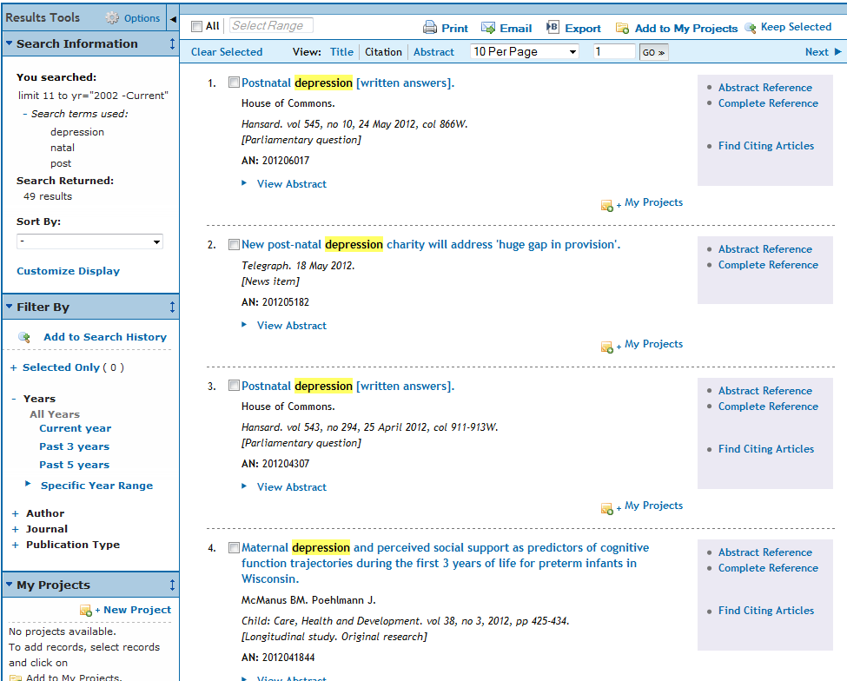

View Abstract

