

Batch Enrolling Participants in Blackboard Organisations

Contents
Introduction 1
Creating a Comma Separated Value (CSV) File 2
Finding Organisation IDs 3
Uploading the CSV File 4

Introduction

Someone with the ‘Administrator’ system role in Blackboard can add large numbers of student to an Organisation, using a CSV file.
This guide gives you the basic information you should need to perform this task. Extra information is available at the Blackboard Help Centre’s ‘Batch File Guidelines for Enrollments’ page.

Creating a Comma Separated Value (CSV) File

To create your own CSV file the following columns are required:

Module ID | Username | Type | Available | Available
ORG_STCE_FAS_032 | 12345678 | S | Y | Y

Where:
- ‘Module code’ is the Organisation ID.
- ‘Username’ refers to the student’s eight-digit number, or staff member’s username.
- ‘Type’ refers the user’s role.
  - S = participant (i.e. student).
  - P = leader (i.e. staff member).
- The fourth and fifth columns relate to whether the user is set as ‘Available’ in the Organisation. Always choose ‘Y’, which stands for yes.

You can create the CSV file using a text editor. This might look like the image below:
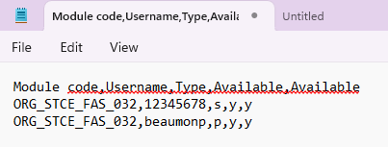

You could use spreadsheet software such as Microsoft Excel, as shown below.
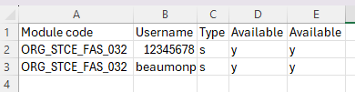

Either way, save the file as a .csv file.

If you have more than 500 people to add, use more than one file.

Finding Organisation IDs

If you are unsure about the ‘Organisation ID’ you can search for it. Click on the ‘Admin’ button from the left menu on the homepage.
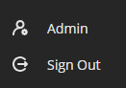
Select the ‘Organisations’ link.
Use the search options to find the Organisation.
You can copy the ID from the Organisation ID column.

Uploading the CSV File

From that same ‘Organisations’ page in Blackboard Admin, select the ‘Enrol Users’ button.
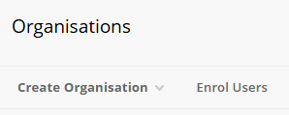
You can use the ‘Browse’ button to select the CSV file that you have created.
The ‘Delimiter Type’ is normally Comma. If you are not sure, select the Automatic option.
Finally press the ‘Submit’ button to perform the upload. You will see the results of the operation. In this example, the title row does not process, the student enrolment failed as the username did not exist, and the staff enrolment was successful.
