

External Examiner Access and Course Navigation

Introduction

Your Account

To access Edge Hill’s Virtual Learning Environment, you’ll need an Edge Hill University account.

These accounts are applied for on an annual basis by the faculty that you are working with. If you have had an account in the past and it is not working now, this might be why.

Edge Hill University uses the Blackboard VLE, which is sometimes referred to as ‘Learning Edge’.

Logging in

You can log in at edgehill.ac.uk/service/learning-edge. Select ‘Log in to Learning Edge’ and log in with your Edge Hill University username and password.

Finding Courses

You will arrive on the Blackboard Courses page. You can browse through courses or use the ‘Search your courses’ search box to find them.
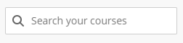

Finding Assessment Activity

An overview of assessed activities can be accessed through Gradebook at the top of the screen.
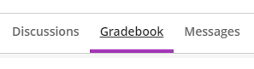

You can use the view button to switch between the list and grid views.
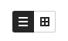

There is also likely to be an assessments area in the ‘Course Content’ area of the ‘Content’ tab. This may contain information about assessments

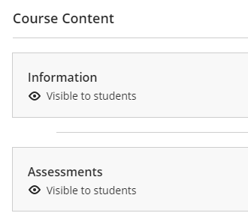

There are several tools that may be used for assessments, but the most used ones are Turnitin, and the Blackboard’s Assignments tool.

Turnitin

If you select a Turnitin assignment you will be taken to a list of students and their submissions.
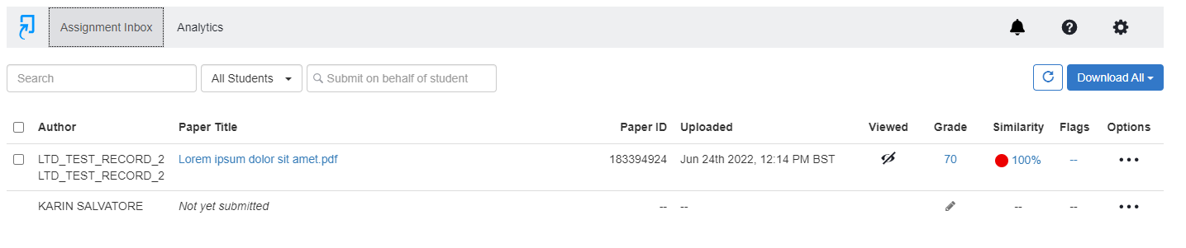

You can select a Paper Title to open Turnitin Feedback Studio where you can see grades and feedback.
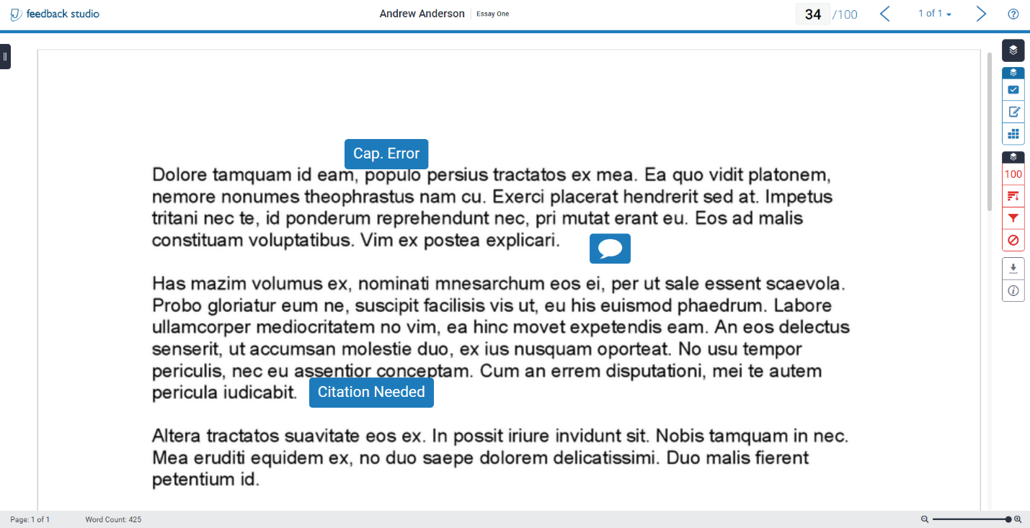

Feedback may be overlaid on the student text in various ways:

- Inline comments around the student paper that are viewable by hovering over the icon with the mouse and scrolling down the submissions.
- General comments accessible by clicking on the ‘Feedback Summary’ icon found on the toolbar, on the right-hand side of the screen.
  - 
- Feedback in relation to Faculty/Department assessment criteria viewable by selecting the ‘Rubric/Form’ icon.
  - 

Blackboard’s Assignment Tool

If you select the title of a Blackboard Assignment from Gradebook you will see a list of students and submissions.
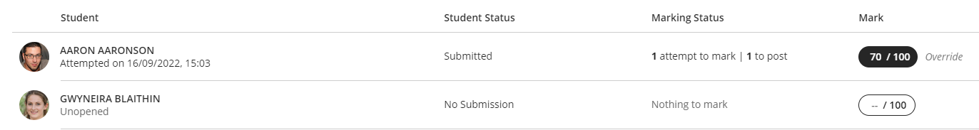

Select a row to see the student’s submission, and feedback.

