

Qwickly Attendance Absence Limits feature

Setup and Advice

Contents
What does the Absence Limits feature do? 1
When would we use this as a department? 2
Two Main Scenarios for Use 2
Behaviours to be aware of 3
Scenario 1 – Normal automated absence emails are turned OFF 4
Scenario 2 – Normal automated absence emails are turned ON 6
Email Templates 8
Reporting and Monitoring 9
Course Report 10
Emails 10
Important reminder on editing an existing absence record or using Scheduled Sessions 11
Student Awareness 12

What does the Absence Limits feature do?

The Absence Limits feature in Qwickly will send out an email notification to a student when they hit one of the limits configured in the course level Qwickly settings. You may customise the text of each Absent Limit email sent out by Qwickly, while reports show at what absence limit point each student’s attendance it at.
This is separate to the default absence email option which sends out an email for every time a student is marked absent.

When would we use this as a department?

A department might employ this feature if they need a mechanism to support or improve an existing process for monitoring attendance. For example, if Qwickly is used for many different types of session in a year of study course on Blackboard. This can prompt more student engagement about their attendance due to the automated notifications sent.
It should be carefully considered and used in a controlled manner, as these emails are sent instantly from Qwickly. This may be an option for departments who do not currently use the default absence emails because of the volume of emails students receive generally.
It is important to prepare students at the start of the year to expect these emails if they are going to be standard process.

Two Main Scenarios for Use
You may or may not currently use the default absence email option which sends out an email for each time a student is marked absent. This guide will show how to use the Absence Limit feature alongside the default absence email, or in isolation without the default absence email turned on.

Behaviours to be aware of
Setting up the feature is straightforward, but the table below shows the behaviours you should be aware of before proceeding:
 | Scenario 1 - Default Absence Email Turned OFF | Scenario 2 - Default Absence Email Turned ON
When are emails sent? | Instantly | Instantly
What triggers emails to be sent | Up to three Absence Limit emails only, triggered when the student attendance reaches the limit. | As soon as the default absence email initial limit is met, and then each time the student is marked absent.  When an Absence Limit is hit, that custom email will be sent.  The default absence email will resume in between limit triggers.
Are repeat emails sent after the final Absence Limit email has triggered | No | Yes, the default absence email will resume for each absence recorded from that point
What impact do amendments to absences recorded in error have on the automation? | If an absence is recorded in error and amended, the reports will update.  Absence Limit emails will not re-send whenever the same limit is met again. It just reinstates the report entry for the first time it was sent  You can manually send an email from Qwickly. | If an absence is recorded in error and amended, the reports will update. Default absence emails will continue as normal.  Absence Limit emails will not re-send whenever the same limit is met again. It just reinstates the report entry for the first time it was sent.  You can manually send an email from Qwickly.
What impact do manual amendments to a record have if the amendment will hit an absence limit? | The Absence limit email does not send automatically. It must be manually sent from the ‘EMAILS’ menu. There will be a warning icon to indicate this. | The Absence limit email does not send automatically. It must be manually sent from the ‘EMAILS’ menu. There will be a warning icon to indicate this.
We have some scheduled sessions in the Qwickly setup – will these be included in Absence Limits? | Scheduled sessions should have their attendance completed in the Attendance menu (not Records), so they are automatically included in calculations.  If edited in the Records screen, then click the column to ‘update’ following any edits, and this will include them in calculations.  Note that the same advice about sending the email applies due to it being a manual amendment. | Scheduled sessions should have their attendance completed in the Attendance menu (not Records), so they are automatically included in calculations.  If edited in the Records screen, then click the column to ‘update’ following any edits, and this will include them in calculations.  Note that the same advice about sending the email applies due to it being a manual amendment.

Scenario 1 – Normal automated absence emails are turned OFF

This is the simplest and least intrusive option in terms of the volume of notifications. However, as shown in the table above, there is a consideration to be made if records are edited later e.g. to correct an error. The reporting options below will help staff monitor and make decisions.

- Lauch Qwickly in the Module/Programme and open the SETTINGS menu.

- The Automatic Emails tab controls the default absence emails sent after each absence. Select ‘Do not send email on absence’

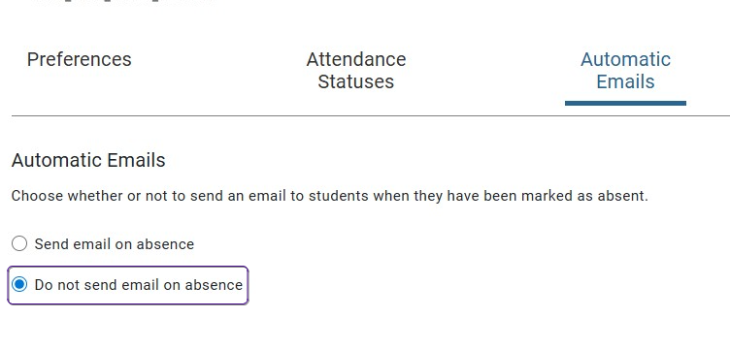

- The Absence Limits tab controls only the settings for the absence limit emails. You may configure up to three Absence Limit triggers and email templates.

You may edit the name of the absence limits; this appears in the email subject when notifications are sent out. Note that the default system name remains on Qwickly reports.

- Enter the number of absences which will trigger each email.
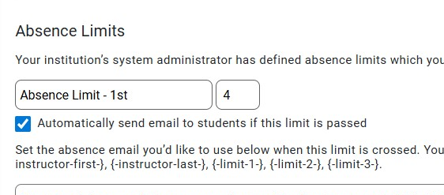

- Setting the trigger to automatically send the email if the limit is reached removes manual triggers being required of staff (unless there has been an edited record)

- Enter your custom text for each email, using the tokens provided. See the section on email templates.

Scenario 2 – Normal automated absence emails are turned ON

This option is more notification intensive, and so it should be considered whether it will be effective or cause confusion. You have the same caveat if records are edited later e.g. to correct an error, as outlined in the table above. The reporting options below will help staff monitor and make decisions.

- Lauch Qwickly in the Module/Programme and open the SETTINGS menu.

- The Automatic Emails tab controls the default absence emails sent after each absence. Select ‘Send email on absence’.

- Enter the number of absences which will first trigger this default email.

This will in effect act as a soft ‘absence limit’. After this is reached, the student will receive a notification for each absence recorded in the module area from this point onwards.

If an Absence Limit is reached, then that email is sent in the place of the default absence email.
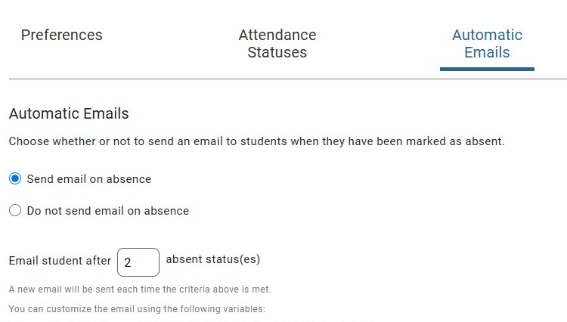
- Enter your custom text for each email, using the tokens provided. See the section on email templates.

- On the Absence Limits tab - you control only the settings for the absence limit emails. You may configure up to three Absence Limit triggers and email templates.

You may edit the name of the absence limits; this appears in the email subject when notifications are sent out. Note that the default system name remains on Qwickly reports.

- Enter the number of absences which will trigger each email.

- Setting the trigger to automatically send the email if the limit is reached removes manual triggers being required of staff (unless there has been an edited record).

- Enter your custom text for each email, using the tokens provided. See the section on email templates.

Email Templates

Depending on which scenario you use, there are email templates to configure:

- Default Absence Email – sent for each absence recorded
- Absence Limit Emails – up to three sent when an Absence Limit is reached

You may use the following tokens in the templates, leaving a space either side when incorporating into the template.

Email token(s) | Default Absence Email | Used in
{-absences-} | Inserts the numerical value of current absences to date e.g. ‘3’ | both
{-date-} | The date of the absence | both
{-course-} | The Course Title | both
{-first-}  {-last-} | Student first and last names | both
{-instructor-first-}  {-instructor-last-} | First and last names of the tutor who recorded the absence | both
{-limit-1-}  {-limit-2-}  {-limit-3-}. | The numeric value of the absence limit e.g. ‘5’ | Absence Limit Emails only

If you add an email address in to the template text, it will appear as a clickable link to launch the default email programme in use.

If you add a web link to the template, then be aware it will not appear in an accessible format – it is in a ‘safelinks’ format:

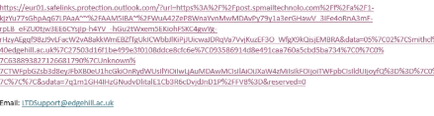

Example Email text:

“Your instructor has marked you absent for {-date-} in your course {-course-}. You have had {-absences-} absences so far.
If you believe this is incorrect please contact dept-email@edgehill.ac.uk”

“You have {-absences-} absences on {-course-} and so have reached the Absence Limit of {-limit-1-}. Please contact your tutor to discuss.”

Reporting and Monitoring

There are two reports which are essential to help you monitor the overall number of absences, the Absence Limits and emails sent.

Note that in reporting the Absence Limit names will be the system default names (even if you have edited these in your settings to give them custom names).

Course Report
This provides an overview of the students’ attendance in the course. This includes a column which lists the Absence Limits which have been reached.

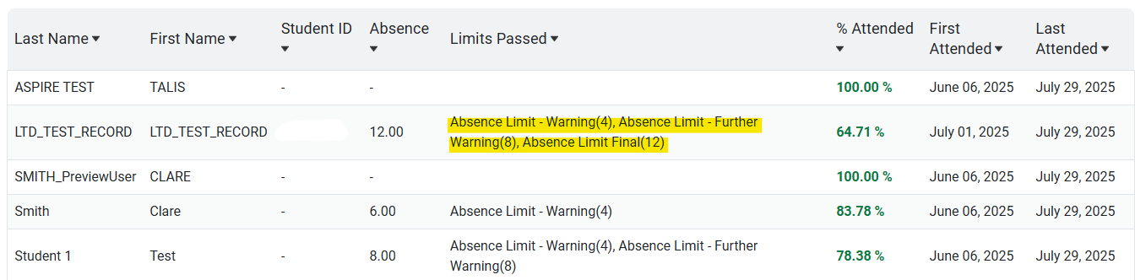

Emails
The report on this menu provides more detail on the emails sent, as well as being more suitable for an instant visual check of Absence Limits.

The green tick indicates that the email was sent (hover to see the date and time).
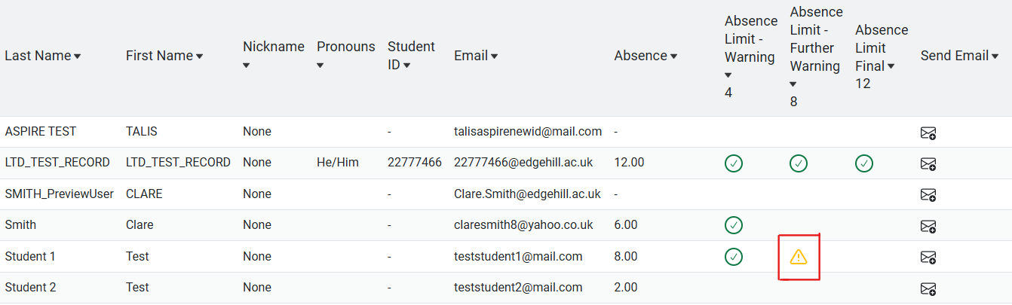

The yellow warning symbol indicates that a manual record change has been made which adds a brand new absence, but the email must be sent manually.

Click the icon, then confirm sending the notification:

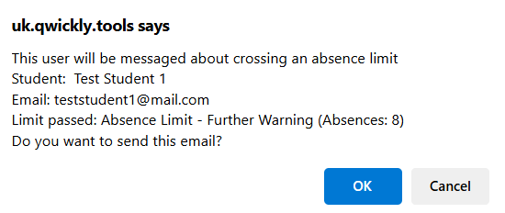

Important reminder on editing an existing absence record or using Scheduled Sessions

As mentioned earlier, there is a small system anomaly in cases where a student hits an absence limit trigger, an email is sent, but then the record is edited after the student has been in touch with the department.

If editing a record reduces their total absence below the threshold, then the automatic email will not be sent again if they pass that same absence limit trigger.

The email tab in Qwickly will revert to ‘sent’ at this point and use the original date this was first emailed out. This should affect a very small number of students as it is a very specific set of circumstances, but if you amend an absent mark to present and it takes a student back below the absence limit, you will need to make a note of this and manually send them the absence email again.

Scheduled sessions should have their attendance completed in the Attendance menu (not Records), so they are automatically included in calculations. If a scheduled session is edited in the Records screen, then click the column to ‘update’ following any edits, and this will include them in calculations.

Note that the same advice about needing to send the email manually from the Emails menu applies - due to it being a manual amendment.

Student Awareness

Please ensure that students are informed of the process clearly, so that they understand the email notifications they may receive from Qwickly as soon as they hit an absence limit (or are marked absent, if that option is also employed). Be clear of the ramifications of hitting certain absence limits, and who they should contact if they believe a mark is incorrect.

