

Learning Edge/Blackboard

Getting Started for Students

Contents
Introduction 2
Video Guides 2
Logging in 3
Your Blackboard Homepage 4
Other Menu Options 6
Institution Page 6
Your Profile 6
Activity Stream 8
Organisations 8
Marks 9
Calendar, Messages and Tools 9
Inside a Course/Module Area 10
Other Sources of Help and support for Students 11

Introduction

Learning Edge is a name used to refer to Edge Hill's online environment for learning and teaching. It consists of the ‘Blackboard’ Virtual Learning Environment (VLE), and a range of other tools such as Turnitin, Panopto and Qwickly Attendance.
This guide covers getting started on Blackboard where you will find Module and Programme areas related to your course, along with links to a range of other useful resources.

Video Guides

We have a set of short video guides to help brand new students get started on the Using Learning Edge web page.

Logging in

We recommend using Blackboard in a modern browser such as Google Chrome, Mozilla Firefox, or the latest version of Microsoft Edge.
You can also use the Blackboard App if you are on a supported mobile device.
If you are using a web browser, go to edgehill.ac.uk and select the ‘Current Students’ link in the top right-hand corner of the page: 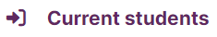
Select the ‘Learning Edge (Blackboard)’ link.
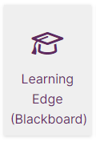
Select the ‘Log into Learning Edge’ link.
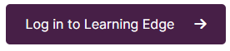
You may be asked to enter your Edge Hill University username and password.

Your Blackboard Homepage

You will see the ‘Courses’ page that shows your course and module areas. All the course areas you have access to will be listed in the Courses list. If your tutor/lecturer says to look for something on Blackboard, this is usually where you should look.
There are filters on the course page, so if you cannot see a module you expect to, check that you are on the ‘Current Courses’ term or that you have not selected another filter.
Select a course’s star icon to favourite it. It will then appear in your ‘Favourites’ section at the top of the page.

If it says ‘Private’ next to a course instead of ‘Open’, this means the course isn’t available yet. Your tutor will release it when required.
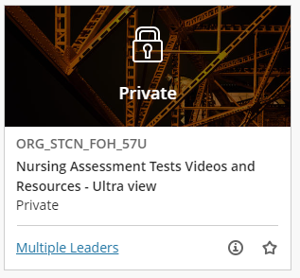

If you do not see the module that you are looking for, please contact your tutor or your departmental administrator. They will be able to check that you are registered for the module or make it visible to students if suitable.

Other Menu Options

After signing in to Learning Edge, you will also see a list of other menu options, in addition to your Courses list.

Institution Page
The first option in the list is the Institution Page:
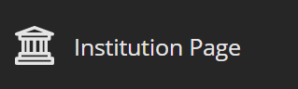
This is where you will find important links and support such as UniSkills and Discover More. You will also see a link to Ask Us where you will find lots of FAQs from Library and Learning Services, Student Services and Careers.
Ask Us is the best place to go if you need help or want to contact Learning Services with a query about Blackboard, or another general query.

Your Profile
The second option is your Profile page. This appears as your own name in capital letters:
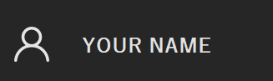
On your Profile page, add a profile image by hovering over the head icon and selecting the little pen icon, and then following the on screen instructions.
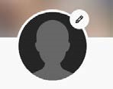
This profile page is also where you can manage the notification settings that you receive:
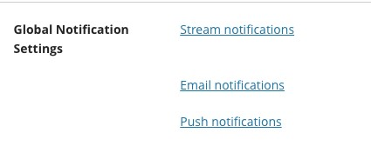
For example, you can set your email notifications to email you a summary each day rather than as the update happens. You should leave the defaults as they are to start with and then work out your preferences as you go.
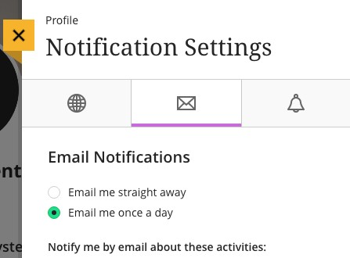

Activity Stream
The third option in the list is the Activity Stream:
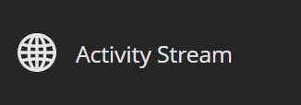
The Activity Stream is where you will find notifications within Blackboard, for example Announcements sent by course tutors. It’s good to check this each time you log in.
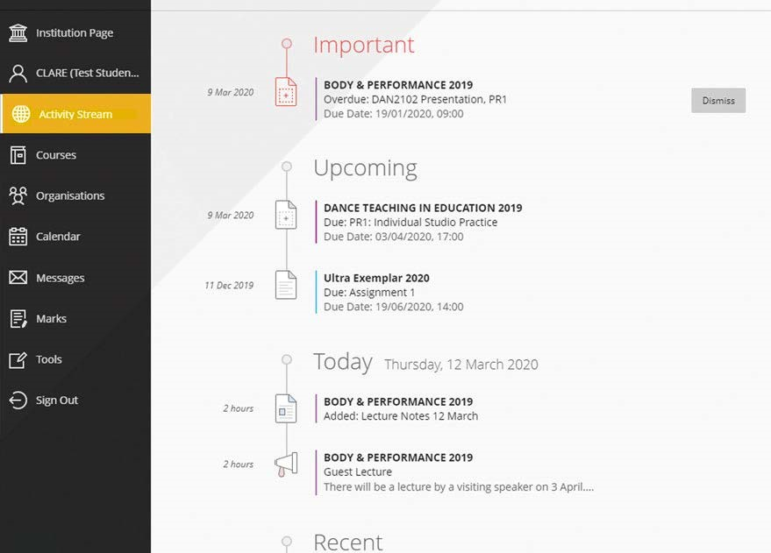

Organisations
The next option, below the default Courses menu, is Organisations:
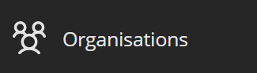
Organisations allows access to Blackboard areas that are not directly linked to a module or programme. They do not have an academic or assessment purpose like Courses do but can be used for information and communication purposes by a department.

Marks
Beneath Organisations, there is the option to labelled ‘Marks’:
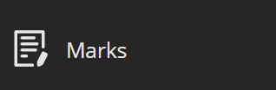
In Marks you can access the grades and feedback for assessments across all your courses.

Calendar, Messages and Tools
Lastly, there are the options for Calendar, Messages and Tools:
You may see events and dues dates on the Calendar if added by your course tutor, while your tutor may also direct you to check Messages or access other Tools.

Inside a Course/Module Area

Every course or module in Blackboard has a unique code which begins with the Academic Year that it is registered to. For example, a course or module code belonging to the 2024/25 Academic Year will begin with ‘2024_’.
A course will look something like:
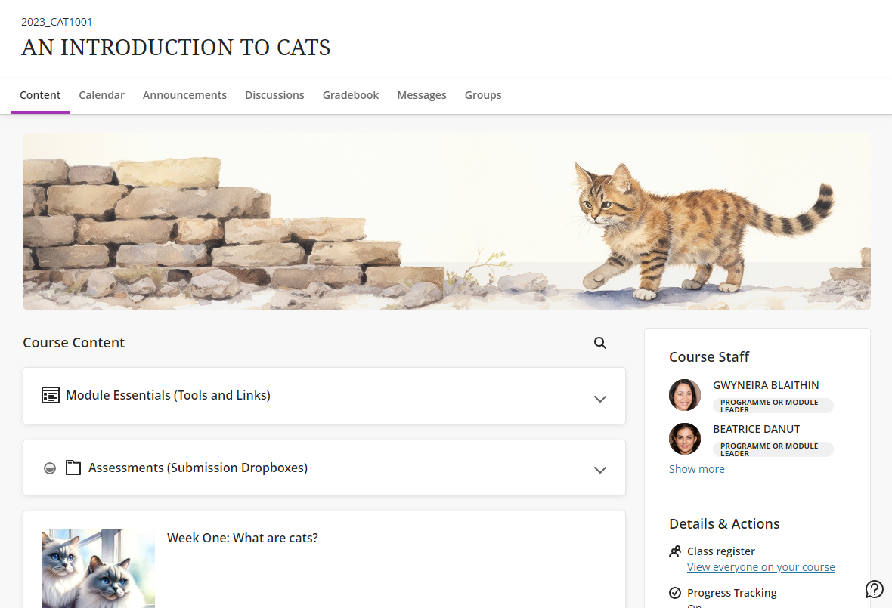
You will primarily navigate through your course content on the right-hand side of the page in Course Content. Your tutor will induct you on your module and make sure you know how it works.
The left-hand menu contains a number of links to various course tools including the Collaborate online classroom. Additional tools, such as Discussions and the Gradebook (where you can view your grades an Ultra course) appear along the top of the page, beneath your course’s code and title.

Other Sources of Help and support for Students

- Search the ‘Ask Us’ online helpdesk - ehu.ac.uk/askus
- Search the Learning Services’ web pages - ehu.ac.uk/ls
- Telephone on - 01695 650800
- Visit the help desk in the Catalyst building on campus.

