Qwickly Attendance for Students

A Guide to Checking In

Contents
Introduction & Key Things to Remember 1
Locating the Attendance Register 2
Checking In 2
Troubleshooting Tips 4
I can’t find the link to Qwickly anywhere in my course. 4
I can’t log my attendance in Qwickly. 4
Qwickly isn’t loading for me. 5
I have received an absence notification, but I was present at my session. 5

Introduction and Key Things to Remember

Qwickly Attendance is a tool that is available in most Blackboard course areas. It is an attendance register which is used to record and monitor student attendance in courses.
To ensure Qwickly Attendance works correctly for you:
- Use a web browser, either on your laptop or mobile device. Performance via the Blackboard Learn mobile app may vary between devices.
- Make sure you are connected to the Eduroam Wi-Fi network or have a strong mobile signal. If you are struggling to connect to Eduroam, visit the Catalyst Help Desk for support.

Locating the Qwickly Attendance

The Qwickly Attendance Register will appear as a link and will may be near the top of the ‘Course Content’ area or in ‘Module Essentials’.
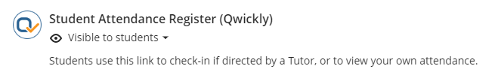
If you’re having difficulty locating Qwickly Attendance then you may find it helpful to use the search ‘magnifying glass’ icon in the top right-hand corner of the course page:
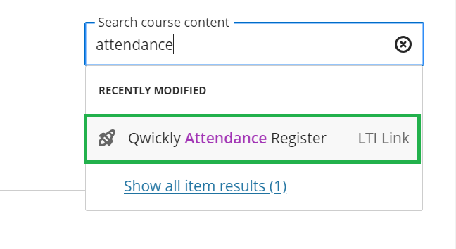

Checking In

In Qwickly Attendance, your tutor will start the check in process, and you are able to log your attendance on your own device during this period.

If they are not requiring a four-digit number to check in, simply click the ‘Check In’ button during the Check In period.

If the tutor does require a four-digit number, it will appear like this on your tutor’s screen, which they are probably displaying on the screen in the classroom:
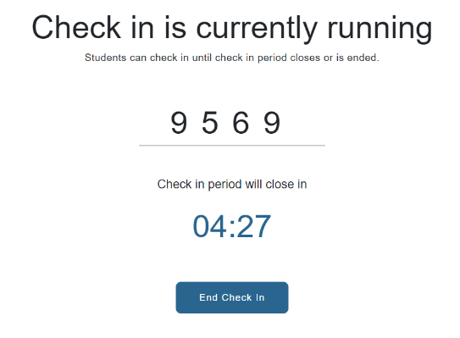
While the Check In is running, select the attendance register link in your course. On your own web browser (either on a desktop, laptop or mobile device), you will see this version of the screen, prompting you to enter the four-digit number:
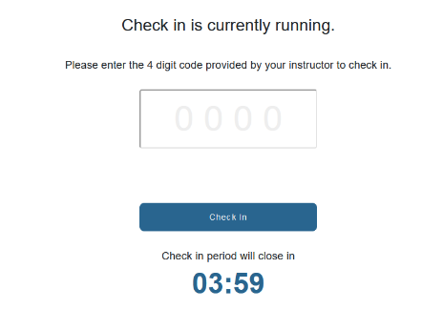
Once you have entered the four-digit number, select ‘Check In’:
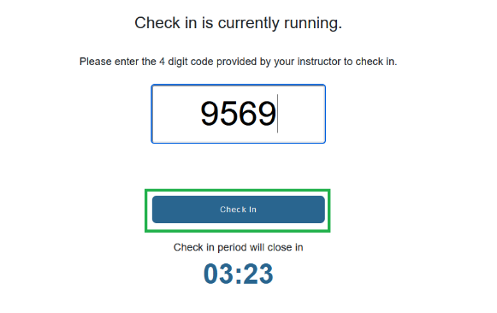

Once ‘Check’ In is clicked, it will redirect you to the Attendance Record page saying Check in successful:
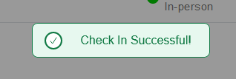

Troubleshooting Tips

I can’t find the link to Qwickly anywhere in my course.
The link to Qwickly is usually labelled as ‘Student Attendance Register (Qwickly)’ in a course area.
As a tip, you can use the search ‘magnifying glass’ icon in the top right-hand corner of your course area and search for a phrase like “Attendance” to prompt the system to search your course for you.
If you’re unable to locate the link at all then please raise this with your tutor.

I can’t log my attendance in Qwickly.
Your attendance in Qwickly can only be logged when your tutor has started the check in. If check in is started and you cannot log your attendance, make sure that you are selecting the correct Blackboard course. The name of the course appears in the top right-hand corner of the Check-In screen.

Qwickly isn’t loading for me.
We strongly recommend making sure that your device is connected to the Eduroam Wi-Fi network on campus in case you are in a location with a weak mobile data signal. Otherwise, Qwickly may load slowly and may prevent you from logging your attendance in time for the Check In.
If you are connected to the Eduroam network and are still experiencing an issue, then please let your tutor know and they can feed this back to the relevant support team to investigate.
If you need assistance connecting to the eduroam Wi-Fi network, please visit the Catalyst Help Desk or email CatalystEnquiries@edgehill.ac.uk.
You may also find useful guidance here: Connect to the Eduroam Wifi Network

I have received an absence notification, but I was present at my session.
Please contact your tutor. The tutor may amend your attendance record if appropriate.

