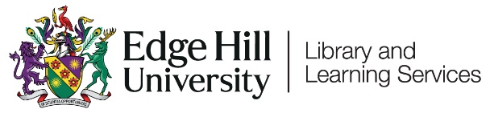

Saving Your LinkedIn Learning Activity Before Leaving Edge Hill University

Contents
Introduction 1
Changing Settings 2

Introduction

When you leave Edge Hill University you will lose access to your Edge Hill University LinkedIn Learning account.
You don’t have to lose the records of your activity and certificates though. There are a couple of things you can do before you leave:
- Download any certificates you want copies of.
- As you may gain access to LinkedIn Learning again in the future, you can ensure that your learning activity is carried over to any new LinkedIn Learning accounts by connecting your LinkedIn and LinkedIn Learning accounts. To do this you need to ensure that your LinkedIn and LinkedIn Learning accounts are connected, and we’d recommend setting the ‘Sync my learning activity from other accounts’ to ‘On’.

Changing Settings

To change your settings, log into LinkedIn Learning, select ‘Me’ and then ‘Settings’ from the drop down menu.
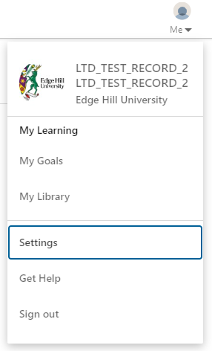

If you see the ‘Connect your LinkedIn account to your LinkedIn Learning account provided by your organization’ option, you’ll need to click on ‘Connect my account’ and input your LinkedIn account details.
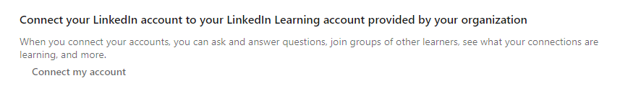
If you see the ‘Disconnect your LinkedIn account from your LinkedIn Learning account provided by your organization’ you have already connected your LinkedIn account.
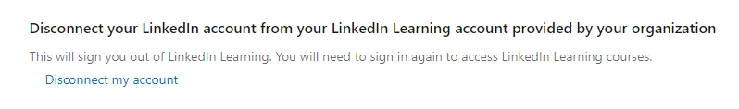
Once your LinkedIn account is connected, we’d recommend checking that the ‘Sync my learning activity from other accounts’ option is set to ‘On’.
