Research Degree

Handbook

2022-23

Contents
Contents
Contents 2
Introduction 6
Research degrees at Edge Hill 9
Your academic experience 9
Additional Tuition: Academic Concepts and communicating your Research 10
Roles and responsibilities 10
Postgraduate Researchers (PGRs) 10
Registration 11
Personal details 12
Researcher Development sessions 12
Supervision 12
Ethics 13
Submission 13
Research Degree Supervisors 14
Supervisory teams 15
The Graduate School Board of Studies 16
Research Degrees Sub-Committee 17
Researcher development 19
Learning and Skills Needs Analysis 19
Researcher Development Programme 21
Core sessions 21
Methodological sessions 21
Additional sessions 22
Programme of related studies 22
Research governance and conduct 24
Research ethics 24
Additional ethics for health-related research 25
Research Ethics Committees 26
Working with human tissue 27
Other important considerations 28
Risk assessment 28
Data protection 29
Examinations 30
Publishing material from the thesis or dissertation 35
Archiving your thesis or dissertation 35
MRes dissertations 35
Doctoral degree theses 35
Intellectual property and copyright 36
Copyright holder permission 36
Research degree regulations 38
Academic appeals 38
Grounds for Appeal 38
Issues, concerns and complaints 39
Monitoring progress and wellbeing support 41
PhD and Professional Doctorate annual appraisals 41
MRes academic review process 41
Progress review 42
Balancing your wellbeing with your research 42
Communication 43
Supervision 43
Support 43
PGR services and opportunities 45
The Wellbeing Team 46
Support services external to the University 47
Inclusion Team 48
SpLD Support Team 49
Research Degree Reasonable Adjustments Panel 49
PGR communication 50
PGR representatives 50
Edge Hill Students’ Union 51
Interruption of studies and extensions 52
Extension 52
Interruption of studies 52
Information and resources 53
E-mails and network access – all research degree PGRs 53
E-mails and network access – PGRs on payroll 53
Printing and wireless network access 54
OneDrive 54
Blackboard (Learning Edge) 54
Research Degree Room and computer access 54
The Catalyst (Library) 55
Your data 55
Financial matters 56
Tuition fees 56
Postgraduate and Postgraduate doctoral loans 56
Financial support 57
Paid work during your research degree 57
PGR Bursaries 57
Appendix 1: PGR Development Programme: Core Sessions 2022-23 59
Aspects of research design 59
Tailoring your research degree experience (LSNA, Programme of Related Studies, role of the supervisor in LSNA) 59
The research proposal and project registration preparation 59
Identifying, evaluating and constructing arguments 60
Research questions 60
Claims to knowledge 60
Combining Disciplines 61
Appendix 2: methodological sessions 2022-23 62
Designing Randomised Control Trials 62
Objectivity and Bias in Experimental Design 62
Data Collection and Sampling Approaches 62
Scientific Communication 62
Communicating in Lay Terms 63
The Funding Landscape in the Sciences 63
What is Theory For? 63
What Do We Mean by ‘Text’? 63
Context Across Disciplines 64
Where Can We Find Evidence? 1: Archives 64
Where Can We Find Evidence? 2: Interviews 64
What is Practice Research? 65
Framing Social Research 66
The Practice of Social Research 66
Empirical Research: Life Story, Ethnography and Autoethnography 67
Using Quantitative Methods in Social Science Research 67
Researching Sensitive Issues 67
Escaping Methodology 68
Appendix 3: additional information spaces 69
Graduate School Blackboard Area 69
Development Programme Blackboard Organisation 69
Research Degree Handbook Addenda 69
Appendix 4: key contacts 70
Graduate School 70
MRes 70
Professional Doctorate (DESM) 71
Professional Doctorate (EdD) 71
PGR Representatives 71
Fees team 71
Research degree administrators 71
Subject area Graduate School research degree contacts 72
Ethics committee secretaries 73
Glossary of terms 74

Introduction
This handbook provides advice and guidance about the processes and procedures that frame your experience as a postgraduate researcher (PGR). It has been designed in consultation with your PGR representatives.
It outlines the roles and responsibilities of PGRs, supervisors and all departments and units within the University that have a significant role in relation to research degrees. In addition, it outlines the research degree enrolment and examination processes, along with the induction and the mandatory element of the postgraduate researcher development programme. This handbook refers to numerous other documents, the links to which can be found in the footer of each page.
While we have tried to be as comprehensive as possible in this handbook, we may update it throughout the year. It is essential that you regularly check your Edge Hill PGR e-mail, the Graduate School webpages and the Postgraduate Research Blackboard space for updates.
If you have any questions about the contents of this handbook, please contact GraduateSchool@edgehill.ac.uk.
We wish you the best of luck in your studies.
The Graduate School

The Graduate School
Research degrees at Edge Hill are organised and run centrally. The Graduate School is the mechanism by which the University does that. The Graduate School is larger than it might at first appear because in addition to the team located on the Stanley corridor of the main building it is also a centrally coordinated network of staff working in the service of the University as a whole on research degree matters. That means that most staff are not solely engaged in Graduate School work but have other responsibilities in faculties and departments. Members of the core Graduate School team have specific dedicated research degree roles and are responsible, under the management of the Dean of the Graduate School, for central coordination and management of the wider Graduate School work conducted by that extended network.
Your research degree registration is in the Graduate School, not the department or faculty in which you are located during your time as a PGR. You will be housed in a department or faculty in order to provide you with convenient access to academic staff working in your discipline, and therefore to a relevant subject-specific research culture. In the case of GTAs, the host department or faculty will provide relevant teaching opportunities. The Graduate School, however, is the University’s means for organising and running all elements of research degrees.
The Graduate School is responsible for ensuring you receive appropriate supervision, and for making any changes to your supervision as necessary. It is also responsible for ensuring the best possible PGR experience and making any alterations to facilitate that. It oversees the development programme for both PGRs and supervisors, and in doing so ensures the sharing of good practice in accordance with relevant regulations, policies, procedures and guidance.
In managing research degrees, the Graduate School:
- Is responsible for the research degree regulations and all procedural and regulatory documentation in relation to research degrees.

- Makes decisions regarding extensions, interruptions of study, composition of supervisory teams and examination teams, project registration, progression and final examination, PGR progress, changes to mode of study, changes of programme.
- Manages all administration in relation to the PGR experience.
- Organises all central development opportunities for PGRs across all years of registration, along with the central PGR induction.
- Provides an annual induction for all new supervisors.
- Is responsible for coordinating the planning and delivery of research degree supervisor development.
- Reviews any, and all, PGR feedback across each academic year from several channels including the PGR representatives.
- Administers PGR Bursary awards.
- Provides support and guidance for the University’s PGR community.
The Graduate School also services the following University committees:
- The Graduate School Board of Studies (GSBoS), which confirms research degree awards.
- The Research Degrees Sub-Committee (RDSC). One of your PGR representatives sits on RDSC.

Research degrees at Edge Hill

Your academic experience
Research degrees at Edge Hill tailor the specific experience of each PGR to his or her individual learning and skills needs in becoming a fully developed researcher, and in completing a specific individual research project.
You will be supported in your research by a Director of Studies (DoS) and, in the case of PhD or professional doctorate, normally one or two additional academics with expertise in the area of investigation or relevant research method(s). You will also receive research training reflecting our commitments and obligations identified in the Concordat to Support the Career Development of Researchers.
To tailor your experience your learning and skills needs are assessed at the beginning of each academic year and reviewed regularly. Your supervisors are central to this. They will help you to develop an understanding of the ways in which the concepts, ideas and problems covered in postgraduate researcher development sessions manifest themselves in your individual research project and specific disciplinary areas.
All Edge Hill research degrees have the following components:
- A research project;
- Non-modular postgraduate researcher development sessions;
- Learning and Skills Needs Analysis – a structured evaluation of your requirements in relation to the development of appropriate knowledge, understanding, and skills. This will be reviewed at regular intervals;
- A programme of related studies to address learning and skills needs;
- Supervision, through which your particular PGR experience will be tailored to your needs.

Information regarding these components can be found in the booklets and on the PGR Blackboard space. Whilst each research degree takes a specific form, they always preserve these five core components. There are, of course, differences in the length of the research proposal required after the first few months of registration, and in the length of the final thesis or dissertation.

Additional Tuition: Academic Concepts and communicating your Research
Tuition is available for researchers to develop and enhance their understanding of core academic concepts relating to the structure, function and role of different aspects of a thesis or dissertation. This is not merely to enhance the communication of your research but to develop sufficient academic rigor in your thought. For those researchers who are close to completion and are interested in publishing their work, peer review of drafts articles is available. If a researcher is returning to study after a long break, refreshers in all the above, are on offer.
For more information please email: GraduateSchool@edgehill.ac.uk

Roles and responsibilities

Postgraduate Researchers (PGRs)
The key to understanding the nature of postgraduate education is recognition of the fact that in such education should take place ‘under your own management’. This significantly alters the nature of responsibilities PGRs have, compared with taught postgraduate students or undergraduates. This is one of the reasons that we go out of our way not to refer to those registered on a research degree as ‘students’. The expressions ‘research student’ and ‘postgraduate research student’ are common enough, although increasingly falling from favour, but they can be misleading as they can bring some people to fail to appreciate the essential role of independence in research degree work.
You have sole responsibility for the production of your own work and, therefore, for ensuring that the work is your own work; correctly referenced and presented. While your supervisors will give advice, it is your responsibility to make decisions about whether to take that advice and precisely how to follow it.
Your supervisors cannot advise you unless you produce work on which they can give advice. Therefore, you, and not your supervisor(s), are responsible for driving the work forward. You are also responsible for the submission of work and the completion of any other documentation, including an annual appraisal report where required. It is your responsibility to ensure that such tasks are completed in accordance with any deadlines.
Unsurprisingly, you have a good many other responsibilities too. Those are outlined below, grouped together under relevant headings.

Registration
- You should ensure that you have sufficient time available to complete your research within the appropriate timescale outlined in the Research Degree Regulations. It is not the responsibility of the University to alter workloads for PGRs who are employed by the University in any capacity. It should be noted, as a rough guide to assist you in planning and managing your time, that completion of a research degree on a full-time basis, including as a Graduate Teaching Assistant (GTA) in three years roughly requires a commitment to 35 hours per week of research. Part-time completion in four-and-a-half years roughly requires a commitment to 23.5 hours per week devoted to the research.
- Ensure that you meet all deadlines related to the successful completion of the thesis or dissertation. If you are a GTA, annual leave is not a reason for missing any deadline. It is important that all GTAs are aware of the fact that annual leave does not apply to your registration as a PGR; it is purely leave from your additional responsibilities as a GTA.
- Ensure that you have suitable facilities and an appropriate room in which to work, whether at home or on campus. While the University provides certain facilities, including those found in the Loft in the Catalyst, you should not rely on access to those facilities. Some departments are able to provide desks for PGRs – you will need to clarify this with the department in which you are housed.

Personal details
- Ensure your personal details are correct on Academic Registry’s student record system so you receive relevant communication. You must check your PGR e-mail inbox on a regular basis – the Graduate School and research degree administrators will only use this address to contact you, regardless of whether you also have a staff account. If you miss key information because you did not check your PGR e-mails, it will not be grounds for an extension to a deadline.

Researcher Development sessions
- Attend all mandatory development sessions. Some will be on campus and others will be delivered digitally.
- Maintain records of development and training undertaken as a result of learning and skills needs assessment and, where possible, recognise when training is required and seek appropriate help.
- Attend any development opportunities identified as useful as a result of the Learning and Skills Needs Analyses.

Supervision
- Prepare adequately for supervisory meetings.
- Ensure that there is monthly written or telephone contact with all members of the supervisory team. You are also jointly responsible with your Director of Studies for ensuring that there is regular face-to-face contact (a minimum of four meetings per year for part-time PGRs, or eight meetings per year for full-time PGRs).
- Ensure that appropriate records are kept of supervisory meetings. Subject areas may have their own documentation for recording supervisory sessions.
- Make supervisors aware of any specific needs or circumstances likely to affect your work.

Ethics
- Ensure that projects are registered on Haplo and undergo appropriate ethical scrutiny prior to the commencement of primary research. No primary research should be conducted until you have written confirmation that you can proceed from the relevant research ethics committee.
- Keep full records in relation to ethical scrutiny and approval. You should be able to produce written evidence of ethical approval by the appropriate committee on request.
- Be familiar with the University’s regulations and policies insofar as they are relevant to PGRs. That includes, but is not limited to, the Research Degree Regulations and policies in relation to health and safety, intellectual property, research governance and ethics, and electronic repositories. Such documents may be updated each year or during the year, so you should ensure you access the current version at the time and not save documents locally.

Submission
- Solely determine when your dissertation or thesis is ready for submission, whether or not this has the approval of your supervisors. You are strongly advised not to submit without the support of your supervisory team but retain the right to do so.
- Ensure that the dissertation/thesis is submitted within the registration period and complies with the required format.
- Confirm that the content of the dissertation/thesis has not been submitted for a comparable academic award (although reference to work already submitted may be made in a dissertation or thesis covering a wider field).
- Ensure that work sent to supervisors is sufficiently well developed and is submitted within agreed deadlines; you should not send every piece of written work that you produce to your supervisory team.
- Upload your thesis to Pure to enable approval by the Graduate School Board of Studies (this only applies to those registered for a doctorate, not those registered for the MRes).

Research Degree Supervisors
Your Director of Studies is responsible for ensuring supervision on a regular and frequent basis and, where appropriate, managing the supervisory team. The Director of Studies will be a permanent member of Edge Hill staff. Guidance on supervisory teams can be found online.

Normally, MRes PGRs will be supervised solely by the Director of Studies but some may have an additional supervisor. Doctoral PGRs (PhD and Professional Doctorate) normally have two or three supervisors in total. Occasionally, there is also an advisor who has specific expertise in one element of the research, but who will not be involved in the supervision of the thesis in its entirety.
The following responsibilities apply for research degree supervisors:
- Ensuring that there is at least monthly written, online, or telephone contact between the PGR and all members of the supervisory team. Normally in the first semester this contact will be more frequent. As noted above, you are also jointly responsible with your supervisor for ensuring that there is regular contact (a minimum of four meetings per year for part-time PGRs, or eight meetings per year for full-time PGRs).
- All supervisors are responsible for reading and commenting on your work in a timely manner - normally within four working weeks. You must recognise, however, that supervisors have many other responsibilities as part of their role as academic staff. As a consequence, there will be occasions when staff are unable to provide feedback quickly. You and your supervisors should plan accordingly.
- Supervisors are responsible for making themselves available for regular supervisory meetings. Again, there will be times in the academic year, or periods when staff are on annual leave or attending conferences, when it will not be possible for meetings to take place. You should discuss this with your Director of Studies, or supervisory team, and plan accordingly. While you may meet with your supervisors individually, in cases where there is a team, you should also meet with them collectively on a regular basis.
- The Director of Studies is responsible for the completion of the learning and skills needs assessment with you, while you are responsible for keeping a record of skills development activities.
- The Director of Studies is responsible for submitting proposals for the progression examination team (if you’re a doctoral PGR) and final examination team proposals (for all PGRs) to the Graduate School at least three months prior to final submission of the thesis/dissertation.
- Supervisors are required to attend research degree supervisor development sessions on a regular basis.
- Where necessary, directing you to support services for advice and assistance, including any appropriate advice or assistance in relation to your wellbeing.

Supervisory teams
PGRs can request a change to their supervisory team by the Graduate School at any point during their research degree. We strongly advise, however, that this only happens in exceptional circumstances, such as a change in the direction of a project where there is a resulting need for a different combination of supervisory expertise.
If you feel that a request for an alteration to a supervisory team is necessary, ideally, your Director of Studies should submit a supervisory team change request form to the Graduate School for approval prior to the implementation of the change. If that is not possible for any reason, please contact the Graduate School for advice. You are entitled to make a request for an alteration to your supervisory team, but the Graduate School is not obliged to approve such an alteration. We will consider the merits of any request and act accordingly. It is important to understand that no changes to supervisory teams have any status until they have been given formal written approval by the Graduate School. All issues relating to supervision should be raised with the Graduate School in the first instance.

The Graduate School Board of Studies
The Graduate School Board of Studies is the progression and award board for research degrees at Edge Hill. It operates with delegated authority from the Academic Board in confirming Progression and Award results for all Edge Hill University Research Awards. Specifically, it is responsible for:
- Confirming examination outcomes for project registration, progression, and final examinations.
- Monitoring and reviewing individual PGR progress, including reviewing the recommendations of the annual appraisal process and taking final decisions on appraisal outcomes.
- Taking final decisions on malpractice outcomes.
- Taking final decisions on fitness to study outcomes.
- Taking final decisions on termination of registration.

The Graduate School Board of Studies meets on a monthly basis. Each meeting deals with matters received by the Graduate School by 15th of each month.
The Graduate School, rather than the Graduate School Board of Studies considers the following:
- interruption of studies requests
- extension requests
- changes to mode of study
- changes to target award sought
- requests for changes to supervisory teams
- Final examination team requests.
Should you or your supervisor need to submit any examination paperwork to the Graduate School (e.g., examination teams for approval), you should do so via GraduateSchoolExaminations@edgehill.ac.uk.

Research Degrees Sub-Committee
The Research Degrees Sub-Committee is responsible for research degree matters relating to the sector, quality, regulations, policies and postgraduate researcher experience. Its terms of reference are:

- To consider proposals for modifications to regulations and policies pertaining to research degrees.
- To make recommendations to Academic Board, through the Research and Innovation Committee, where appropriate, for modification of the Research Degree Regulations and their operation.
- To provide oversight of any research degree developments in the sector, as well as quality & regulatory matters in relation to research degrees and alert the University through the Research and Innovation Committee where appropriate.
- To identify, evaluate, promote and disseminate good practice in postgraduate researcher supervision.
- To consider issues relating to postgraduate researcher experience, making recommendations as appropriate.
- To consider matters as requested by the Graduate School.
- To monitor the effectiveness of the sub-committee on an annual basis.
- To ensure that equality considerations are taken into account in the conduct of the sub-committee’s business.

The Research Degrees Sub-Committee meets three times per year and is chaired by the Dean of the Graduate School.

Researcher development
The UK Quality Code for Higher Education, advice and guidance for research degrees, defines six guiding principles of sound practice in relation to research degrees. Indicator four states:
Providers ensure that research students are provided with appropriate opportunities to regularly reflect on and develop their personal, professional and research skills in consultation with their supervisory team.
By including a Learning and Skills Needs Analysis that informs the development of a programme of related studies, research degrees at Edge Hill not only meet the relevant guidance principle, but also add an additional level of learning experience by tailoring research development opportunities to your needs in tutorial supervision.
Such tailoring means that the core sessions, methodological sessions, known as the postgraduate researcher development programme, and programme of related studies are not discrete components of the programme of research. Rather, these learning experiences are interconnected through classroom sessions and consideration, during tutorial supervision, of the way the various issues raised manifest themselves in your specific research project and the relevant academic discipline in which you are working.

Learning and Skills Needs Analysis
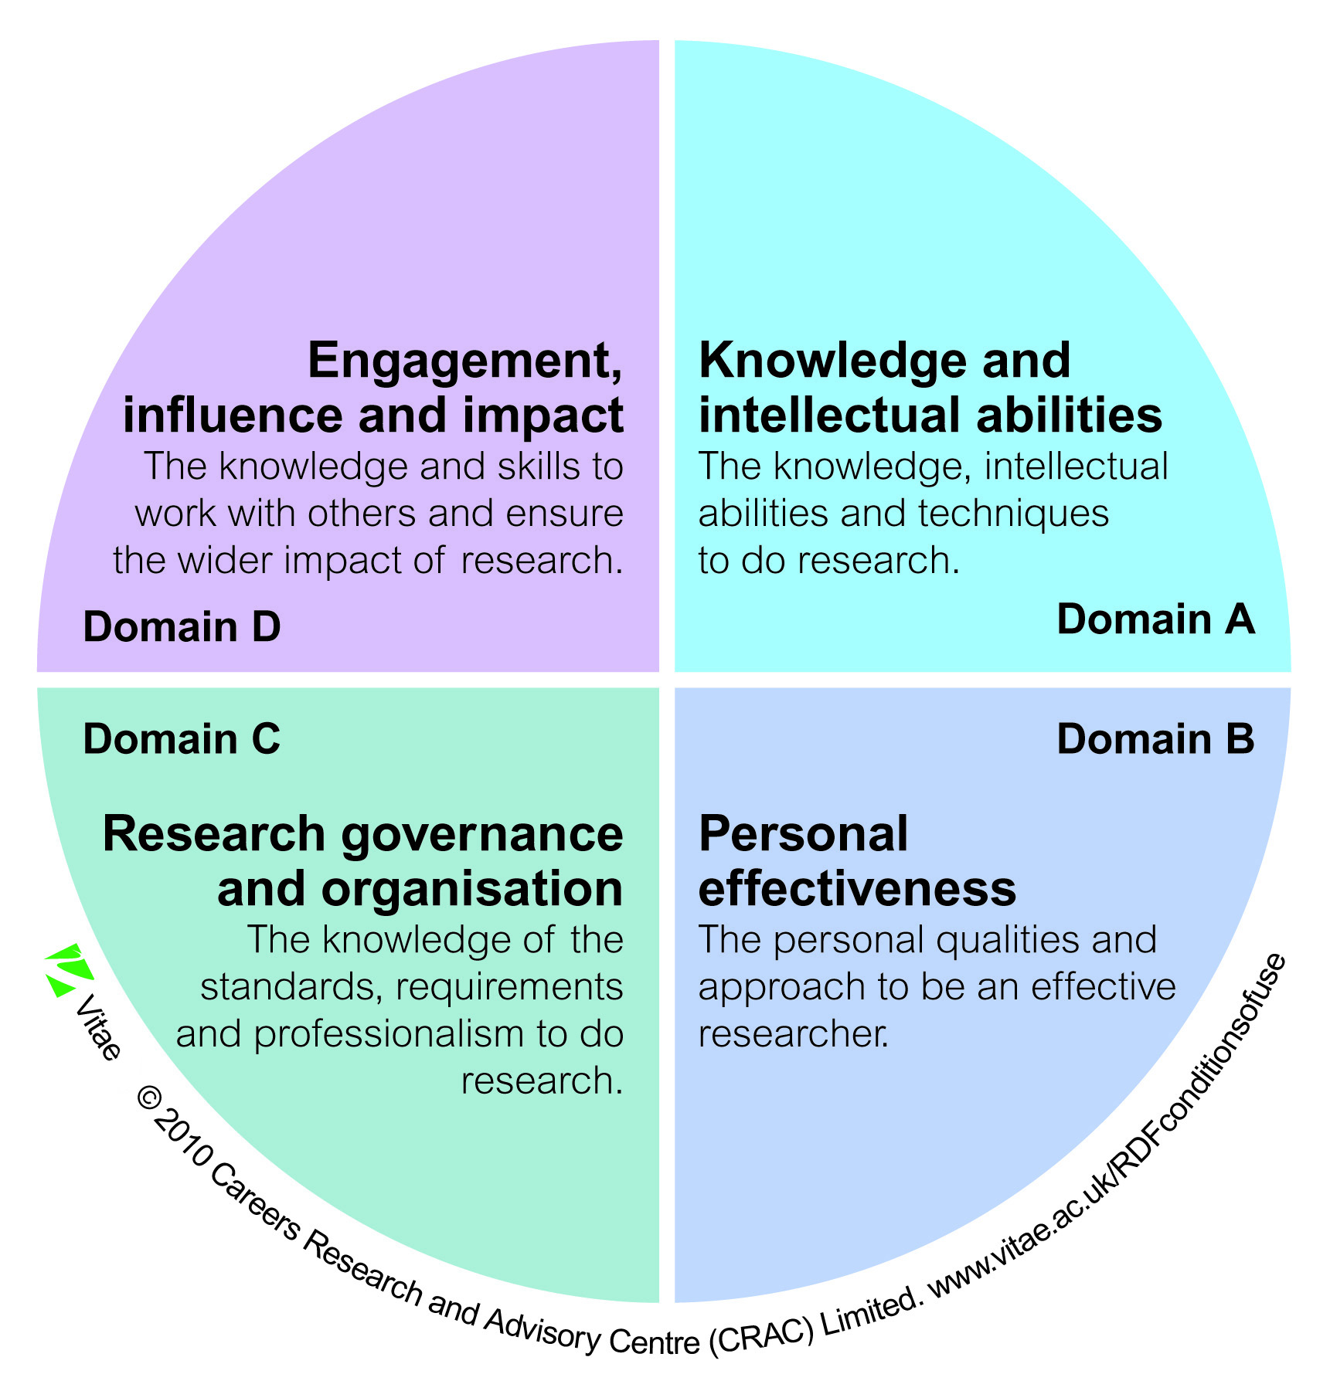
You will need to complete a Learning and Skills Needs Analysis in order to identify your development requirements. Each subject area has its own guidance on needs analysis, paperwork for recording the results of the needs analyses, and details of the resulting programme of related studies. All such guidance will, in some way, be influenced by the Researcher Development Framework (RDF).
Fig A: Researcher Development Framework

In the induction week, you will be introduced to the concept of needs analysis and will then discuss your needs with your Director of Studies and identify concrete targets for development, on the basis of which you will design your programme of related studies. The LSNA and programme of related studies will be submitted at Project Registration.

Researcher Development Programme
The University’s Researcher Development Programme (RDP), from a PGR’s perspective, consists of three separate strands: Core Sessions, Methodological Sessions and Additional Sessions.

If you are an Edge Hill MRes graduate continuing your studies as a PhD PGR, it is not expected that you attend the core or methodological sessions. We do, however, advise you to attend as these do change regularly and provide further insight into your studies. There are considerable benefits of engaging with those sessions a second time as you begin the doctorate and have progressed in your development compared to the early stages of the MRes.
Please note: it is imperative that your attendance is registered for each development session in order to meet the requirements of project registration. If you are unable to attend a session, please contact the Graduate School for advice on a suitable alternative activity.

Core sessions
This portion of the development programme must be attended by all PGRs in their first year, including MRes PGRs.
The material in core sessions covers research design, research project management, research data management, research ethics, and some of the more general conceptual, epistemological and methodological matters in relation to research. The core sessions include a series of short sessions designed to introduce you to some considerations that, while not generic because they apply in different ways in different cases, are of relevance to all research. These sessions are facilitated by a small team of academics from a range of disciplinary backgrounds and will generally take the form of structured discussions.

Methodological sessions
All MRes and Professional Doctorate PGRs must attend a minimum of six methodological sessions (you are free to select which six sessions you attend, but you should seek supervisory advice in making that decision). PhD PGRs should draw on the methodological sessions as necessary as part of their programme of related studies. The LSNA and programme of related studies that you submit as part of your Project Registration must identify the required number of methodology sessions to be completed in your first year.
There are no restrictions as to which sessions any given PGR can attend, nor on the maximum number of sessions you can attend. All PGRs can attend any of the methodological development sessions and should take supervisory advice on which would be most appropriate.
The methodological sessions form a programme of structured discussion activities. Some of the sessions address issues principally of interest to those working in science subjects, some address issues principally of interest to those working in social science subjects, and some address issues most likely to be of interest to those working in arts and humanities subjects. In addition, there are a small number of methodological sessions that are designed to transcend specific disciplinary boundaries.
The full programme of methodological sessions can be found on Blackboard.
Please note: it is imperative that you sign the attendance register for each session that you attend. If you do not sign the register, you have not attended according to our records.

Additional sessions
Additional sessions are provided for PGRs in subsequent years focusing more on professional development and preparing for postdoctoral life. These sessions include understanding the HE environment, including the Research Excellence Framework (REF), preparing for post-doctoral positions, understanding impact, open access and research data management (key developments which affect all researchers and are increasingly prominent). There will also be sessions on topics such as how to publish, interview skills and support in navigating your career options. The full programme of development sessions can be found at http://eshare.edgehill.ac.uk/id/eprint/15860 or via Blackboard.

Programme of related studies
Along with your Director of Studies, you will design a programme of related studies to meet specific learning and skills needs identified through your learning and skills needs analysis.
Your programme of related studies could include attendance at research seminars covering appropriate topics, regardless of which department, faculty or research institute organises them, any other research institute events, research training sessions offered by any department or faculty, sessions that are part of the University’s Researcher Development Programme, individual tutorials that you arrange with members of staff other than those on your supervisory team, and, with the agreement of module leaders, attendance at certain lectures delivered as part of masters or third year undergraduate modules.
In addition, as noted above, PhD PGRs may include some of the methodological sessions as part of their programme of related studies, while MRes and professional doctorate PGRs may include additional methodological sessions, beyond the six that they are required to attend.
It is important to understand that the programme of related studies can include anything that meets the needs identified by the learning and skills needs analysis. There is no stipulated content for the programme of related studies, because, for each individual, it will be tailored to their specific needs, and so unique to them.
External training events are provided by organisations such as Vitae, the National Centre for Research Methods, Cathie Marsh Institute for Social Research, the UK Data service, among others. In addition, there are MOOCs (massive open online courses) across a vast range of subject areas. While many of these external training opportunities are free or low cost, some incur a considerable fee. You need to consult with your supervisory team before committing to external training as there are no specific funds to support this, although you can apply to the PGR Bursary Fund for a contribution to the costs if you can demonstrate that the need is sufficient, could not have been predicted, and cannot be met within the University.

Research governance and conduct
All researchers at Edge Hill University (EHU) must design and conduct their research to the highest standards. The key principles you should follow to achieve this can be found in the Code of Practice for the Conduct of Research. Best practice should be followed for all research matters, including:
- Research design;
- Ethics;
- Research data management;
- Insurance and indemnity.
Information and policies on all of these can be found on the University research governance web pages.

Research ethics
All research projects at Edge Hill, including your PhD, ProfDoc or MRes, must be registered on Haplo, our research ethics system. Once registered, projects undergo ethical review by one of the five subject research ethics committees (SRECs): projects will be assessed to determine whether they require expedited, standard or enhanced review. All research degree PGRs should read the Research Ethics Policy (REP) and the Code of Practice for the conduct of Research26. Full details on the functioning of the SRECs can be found in appendix 1 of the REP.
Research ethics will be discussed in your project registration proposal and those on PhD and professional doctorate routes will be asked about ethics in your registration viva. Ethical approval can only be granted by one of the University’s research ethics committees; you must have received ethical approval before commencing data collection. You should discuss the ethical dimensions of your project with your supervisors. Additionally, you can consult the relevant ethics committee for your particular subject area by contacting the secretary. Names are listed in appendix 4.
An approved registration of the project (an outcome of project registration examination/viva) is still conditional on attaining ethical approval from an appropriate ethics committee – normally required to be within three months of the date of project registration.
No data can be collected, or evidence gathered, before you have received written confirmation that the project has passed appropriate ethical scrutiny/approval.

If you collect any data before ethical approval has been granted, that data cannot be used in the thesis and must be destroyed in compliance with data protection. In addition, this could leave you open to an accusation of research misconduct, so it is vital that you seek advice from your supervisors before engaging in any data collection (or the equivalent for creative projects).You should remember that you could be asked by anyone with an interest in the research to produce proof that ethical review has been undertaken and that you have permission to embark on data collection.

Additional ethics for health-related research

If the research is being carried out within the NHS or within a social care setting you may need to apply for approval from the Health Research Authority (HRA) . EHU will usually be the Sponsor for your research. You will need to apply for sponsorship, it is not automatic. In addition, when you have completed your research it is essential, for any research under HRA approval, that you notify the HRA Research Ethics Committee within 90 days of the end of study. The Graduate School (graduateschool@edgehill.ac.uk) and Research Office (research@edgehill.ac.uk) must also be informed, please copy in both to any messages regarding closing research sites/projects for their records.

Research Ethics Committees
The University Research Ethics Sub-committee (URESC) acts on behalf of its parent committee, the University Research and Innovation Committee (URIC), and is charged with responsibility for overseeing the ethical standards for the conduct of research at Edge Hill.
There are five subject RECs, all reporting to URESC: arts and humanities; social sciences; education; health-related research; and sciences (see figure B). It is the nature of the project, not the department in which the researcher is based, that determines which is the most appropriate committee although the default route will reflect the department in which you are based. All projects undergoing Health Research Authority (HRA) approval must be scrutinised by the Health Research Ethics Committee (HREC) and all projects working under the Human Tissue Authority (HTA) licence must be reviewed by the Science Research Ethics Committee (ScREC). While departments do not grant ethical approval, it is expected that projects will be reviewed and feedback given to researchers before proceeding to the formal process. This is part of a mentoring process and helps to avoid rejection of projects for reasons that could easily be identified by a third person.
Edge Hill research ethics committees can also accept ethical approval from some appropriate research ethics committees outside Edge Hill. In such circumstances the Edge Hill REC must scrutinise the documentation to satisfy itself that the standard of approval meets our own before you begin your data collection – you will be informed of this in writing. Please see the Research Ethics Policy for further details.29
Applications made via ethics system

Fig B: ethics committee structure

Working with human tissue
If your research will involve the collection, use or storage of human tissue it will be subject to the Human Tissue Act 2004. You must seek advice from your supervisor. In addition, if you haven’t undertaken the training for seeking consent, or if it has been more than 3 years since you undertook this training, you must contact the University’s designated individual with responsibility for research involving human tissue (Professor Adrian Midgley, Department of Sport and Physical Activity). You can also contact Professor Midgely, or one of the persons designate, if you have any queries relating to the governance of human tissue at EHU before submission.
Applications for ethical approval for projects involving human tissue can take longer than other ethics applications so you should plan accordingly and ensure that you follow any advice and guidance provided. Further details are available on the University human tissue web pages.34

Other important considerations
While most people work in areas where there are limited risks, or the risks can be well managed and mitigated, there are certain subject areas where particular consideration is needed. If you are working with genetic resources and/or traditional knowledge held by indigenous and local communities that is associated with genetic resources, the Nagoya Protocol may apply: this is an international agreement to promote the fair and equitable sharing of the benefits of research that uses genetic resources. Please consult the guidance and checklist and discuss with your supervisors.
The University also has a separate policy on working with sensitive materials. It is important that you comply with the University’s IT acceptable use policy for accessing high risk materials so we can support you in carrying out legitimate research. We also have a duty of care to our staff and PGRs and viewing material that is excluded from our acceptable use policy may be distressing. Should your work fall into these categories, please consult the University’s Policy on Researching and Handling Sensitive Material and discuss your particular situation with your supervisors.

Risk assessment
All research projects should undergo a risk assessment – for many this will be a simple process that requires the researcher to identify all the different elements of risk associated with the project and then consider the likelihood of them happening and the anticipated impact if they should. Once you have identified the risk, you need to establish how you will mitigate that risk. You should review your risk assessment regularly as circumstances change and therefore the mitigation of risk will also change. There is no Edge Hill risk assessment form for you to complete but the University’s Risk Assessment Guidance is available on the University governance web pages and your risk assessment should be appended to your ethical review application in Haplo28. In addition, your professional association may require you to complete a specific risk assessment. All heads of department must be satisfied that the research in their areas is properly risk assessed and all mitigations in place, and they will be alerted that your ethics application has been completed. Failure to engage with risk assessment could undermine the insurance and indemnity cover for your project and leave you with personal liabilities.

Data protection
Many research projects require that you collect data from a range of sources. All data must be managed carefully (i.e. data storage and data sharing) to ensure its security and integrity in line with General Data Protection Regulation (GDPR) and related data protection legislation. All projects involving data collection will require a data management plan. Data that is based on human subjects has, of course, strict rules and regulations regarding its use and particular care must be given to the management of personal data where individuals have legally enforced rights. It is essential that you provide the right information to your research subjects about how you will process the data collected and what you will do with it in the long term – this information should be clearly stated in the participant information sheet. Poor information at the point of data collection can limit its usefulness and, in the worst cases, will make the data unusable.
In an age of open research, there is an expectation that data will be curated and shared for reuse by you and others where appropriate – indeed, in some subject areas, journals expect researchers to publish the data as an annex to the article or to direct readers to where it is publicly available (at Edge Hill we have Figshare as a data repository). In doing so, you must balance the need for openness with the requirements of data protection. Any data that you publish will be anonymised so will largely be acceptable to share by the rules of the GDPR, but you should ensure that your participants are aware of how you may share it.
More information on data protection is available on the research governance webpages and Edge Hill’s Information Governance wiki.

Examinations
Research degrees are assessed through a combination of written submission and oral examination (the viva), in which you will defend your written work.
The particular process of assessment you undertake depends on the research degree on which you are enrolled:
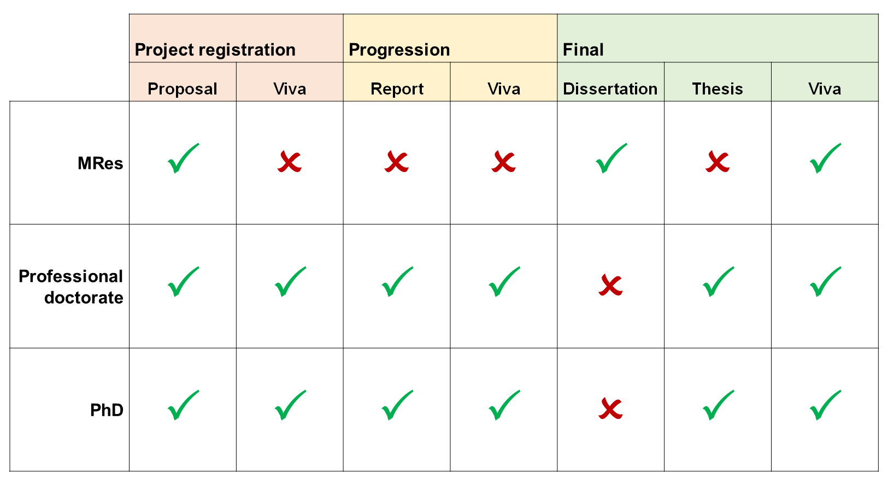
Fig C: Research Degree Examinations

The point at which each of these assessments takes place during your research degree is illustrated by the following timelines (these examples are based on full-time study in the case of the MRes and the PhD, and part-time study in the case of the professional doctorate). Please note: professional proof readers are not permitted.

The underlying processes are largely the same across all three research degrees. The Graduate School has produced a series of addenda (A-D), one for each route of study. These, along with the following guidance on each examination, can be accessed via Blackboard:
- Research project registration guidance
- Progression viva guidance
- Final viva guidance

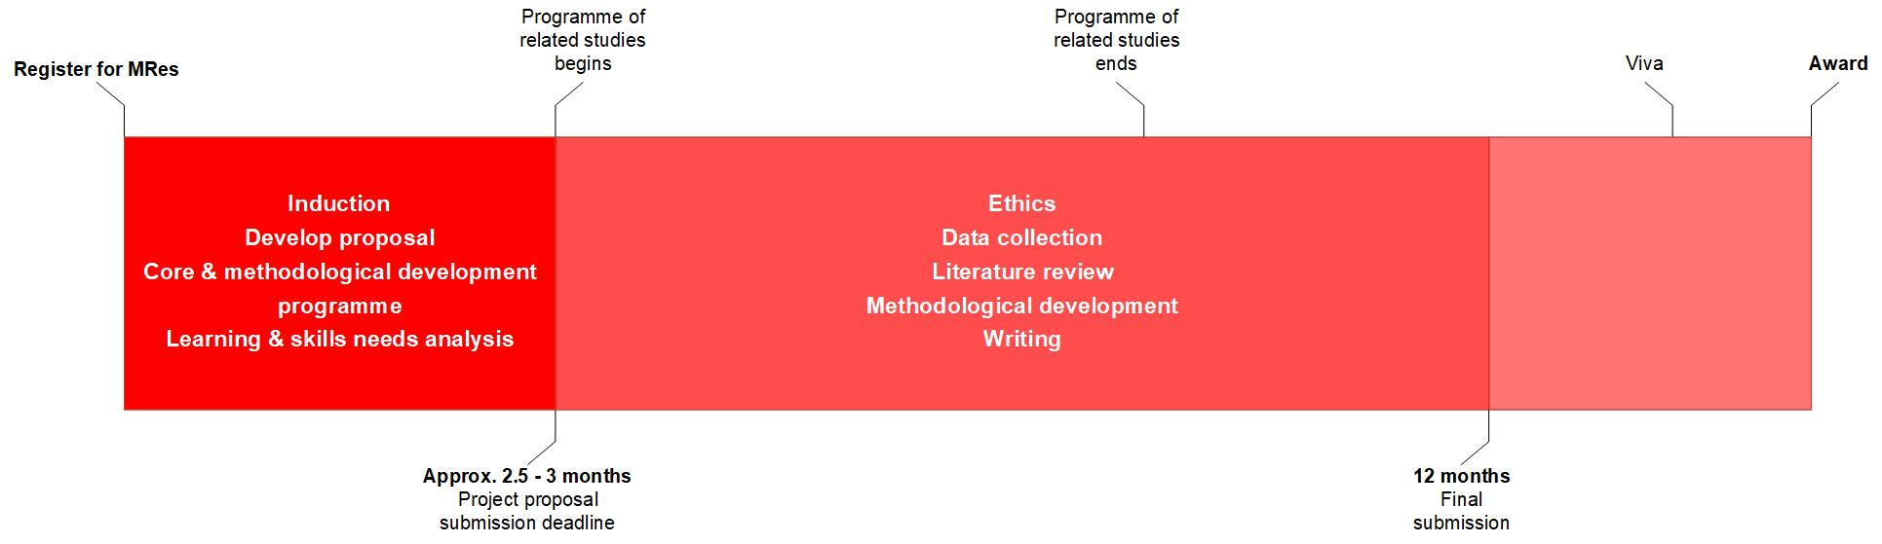
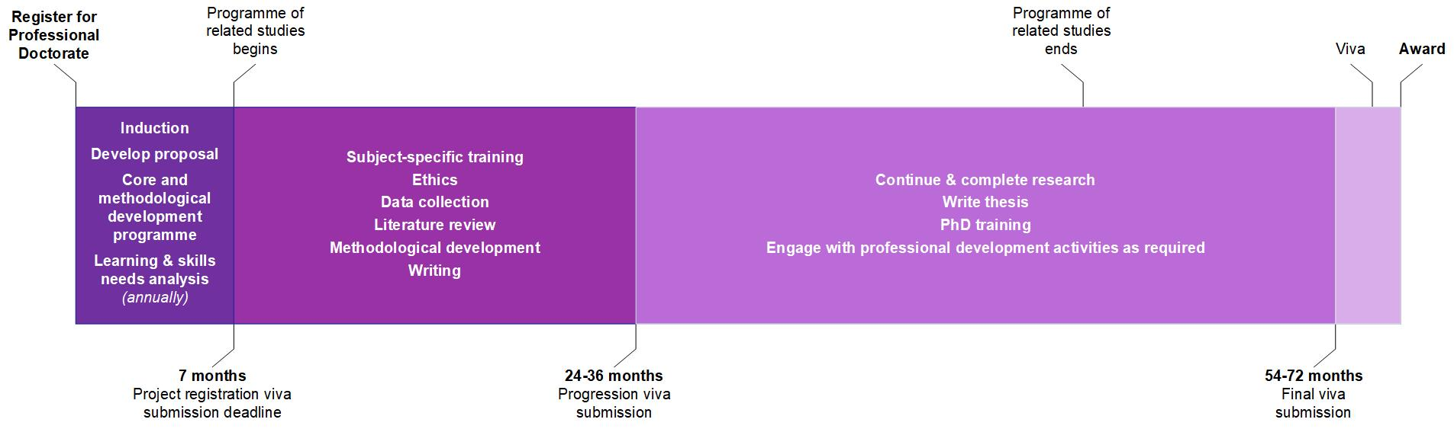
Fig D: MRes Timeline (based on full-time enrolment)
Fig E: Professional Doctorate enrolment (part-time enrolment)
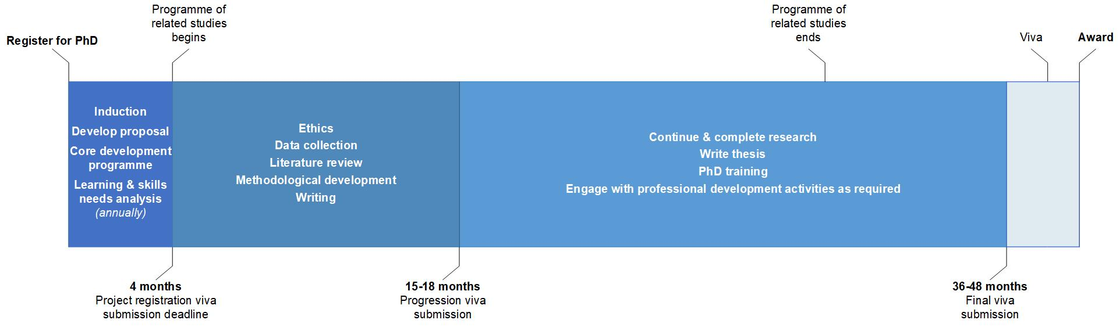
Fig F: PhD timeline (based on full-time enrolment)

Publishing material from the thesis or dissertation
If you publish material from your thesis or dissertation in journals or books you should append the material to the final submission for the examiners to note. While you are not required to publish during the degree, in some disciplines it is increasingly the norm and may be helpful when looking for posts immediately on completing your studies. Publication plans should be discussed with your supervisory team.
Each discipline has its own norms about co-authoring with supervisors and the conventions for the ordering of authors’ names on the publication, so we cannot provide specific guidance here. Generally, we would only recommend that you engage with publication if it does not pose a significant distraction to the completion of the degree itself. It is expected that most PGRs will want to publish their research findings on completion of the thesis, but that will require some alteration of what is presented for examination.

Archiving your thesis or dissertation

MRes dissertations
These are only retained by the University for the academic year of award plus one full academic year, after which we will normally delete the files. You should therefore ensure you keep the final, approved copies of your own work that led to your award – we cannot supply them.

Doctoral degree theses
A condition of award is that the thesis will be uploaded to Pure, the University’s research repository, and harvested by the British Library’s EThOS repository and be publicly available there in perpetuity. This follows principles of open access to research, which means that anyone with an internet connection can read it.
Any restrictions to the thesis being openly accessible must have been approved by the Graduate School Board of Studies prior to submission for final viva when proposing the final exam team. If approved, such restrictions are applied to the thesis for a period of time (an embargo).
Any creative work that constitutes part of a thesis may be exempt from open access if the creative component has been/will be published in exactly the same format as the work submitted for examination, whereas journal articles and other research outputs are very rarely published in the same format as the analytical content of the thesis.
Where an embargo has been approved, you must still submit the thesis electronically to the Graduate School for archiving. For creative works, you will normally be required to divide the thesis into two volumes: the analytical commentary (to be openly accessible) and the creative work (to be embargoed).

Intellectual property and copyright
Any research restrictions for research degree PGR research must be approved by the GSBoS. We recognise you will normally own the intellectual property (IP) and copyright for your original work (unless you have an agreement to the contrary with a third party), including essays, theses, dissertations and independent study projects. There are some exceptions to this, which are detailed in the University’s Intellectual Property Policy.

Copyright holder permission
Your thesis or dissertation may contain material protected by copyright which is held by another individual or body, or you may have created the material but assigned the copyright to a publisher or other entity.
If you do not hold the copyright yourself, you will need to seek permission from the copyright holder if you want to include any protected material such as extracts from books, journals or other publications, or data, or images (including illustrations, maps, photographs, tables, etc.).
Even if you freely downloaded the material from the Internet, you will still need to seek permission: you may have obtained it from someone other than the rights holder.
If the item is available for re-use under a licence applied by its creator (e.g. Creative Commons), you will need to comply with the terms of the licence and cite the licence with your reproduction of the material if appropriate. Re-use may depend on the specific licences attached to the material. If none are stated, you must assume re-use in your thesis requires formal permission.
The rights holder may provide permission that is conditional on specific wording for the acknowledgement, or other conditions. You will have to follow those instructions exactly and keep a copy of any letters of e-mails you receive from rights holders.
You should seek the rights holder’s permission as you go along, rather than waiting until you write your final draft; delays in obtaining such permission will not normally be grounds for an extension so you risk having to omit key material from your thesis.
It is your responsibility to ensure you have permission to use third party material in your thesis or dissertation.

Research degree regulations
The Research Degree Regulations is the single most important document while you are enrolled on a research degree at Edge Hill.
The Research Degree Regulations form part of the University’s general Academic Regulations. Where the Research Degree Regulations are in conflict with the general regulations, the Research Degree Regulations take precedence.
You should read the Research Degree Regulations at the beginning of each academic year. The Regulations are amended annually, while the appendices (schedules A, B, C, etc.) are amended as necessary, so it is best to consult the online documents to ensure you are reading the latest version.

Academic appeals
If you feel you have suitable grounds, you may appeal Graduate School Board of Studies decisions relating to progression and award, or those of malpractice panels, under the terms of the Appeals Procedure set out in the general academic regulations.

Grounds for Appeal
Academic appeals may only be submitted on the following grounds:
- Procedural irregularity in the assessment process
- Bias or perception of bias, or
- Exceptional mitigating circumstances, details which were, for good reason, not previously available to the appropriate assessment board.
The following matters do not, of themselves, form grounds for an appeal:
- Challenges to academic judgements of examiners on an assessment outcome or the level of award recommended or granted.
- Claims that academic performance was adversely affected by factors such as ill-health, where there is no independent, medical or other evidence to substantiate this.
- Complaints against the delivery of supervision and methods of assessment.
- Appeals where no new circumstances are presented or where there is no justification for failing to present the circumstances at the original board/panel.

Issues, concerns and complaints
At Edge Hill University our vision is to provide the best possible PGR experience.
You may have one of several different types of concerns, so different people may be the most appropriate first point of contact:
- Academic issues:
  - Your supervisors in the first instance
  - The relevant Graduate School Research Degree Contact if the problem concerns your supervisors, or if it cannot be resolved by your supervisors
  - The Graduate School if the above options are exhausted or inappropriate
- Administrative issues:
  - Graduate School in the first instance
- Health and personal issues:
  - Graduate School, or
  - Student Services Health and Wellbeing Team
Please also refer to the PGR communication section of this handbook for advice on where to raise issues, concerns or complaints and how they are dealt with. Should you wish to raise a formal complaint, please follow the complaints procedure or contact Student Services for advice. If you think you have grounds for a complaint, you must contact the appropriate area within three months of the incident. Wherever possible, we try to resolve issues without escalating matters to a formal process.

Monitoring progress and wellbeing support
It is a requirement of the UK Quality Code for Higher Education that universities must ensure that they have mechanisms in place to identify and resolve issues relating to the academic progress of PGRs. Edge Hill has a process of annual appraisal that meets that obligation.
Your progress is monitored at various points in your research degree using a variety of methods: through viva and other examinations, progress reviews, and annual appraisals.

PhD and Professional Doctorate annual appraisals
Appraisals provide you with a clear opportunity each year to raise concerns about any aspect of the research process (although you can do this at any point). You will be required to complete an annual appraisal between April and May if selected to do so by the Graduate School Board of Studies – usually, although not only, if your progress has not been formally monitored that calendar year. The appraisal requires you and your supervisors to submit separate online surveys which are then reviewed by two members of academic staff within your subject area who are not in your supervisory team. The appraisal process includes a review of your learning and skills needs analysis.
Depending on the recommendation, your appraisal may then be discussed at the Graduate School Board of Studies. If any questions result from the appraisals, the Board may request more information from you or your supervisor.
Failure to complete the appraisal, or if the Board has concerns about your progress, means that your progress will be placed under review (see ‘Progress review’, below).

MRes academic review process
MRes PGRs do not complete an annual appraisal survey because the period of registration for MRes PGRs is much shorter than that for doctoral PGRs. The progress of each MRes PGR is instead considered at a formal academic review process approximately half-way through the period of registration (six months in the case of full-time PGRs, and nine months in the case of part-time PGRs).
This process requires no input from you, but your supervisor will submit a form assessing your academic progress to the Graduate School. This is then reviewed by the Graduate School Board of Studies. If required, a member of the Graduate School Board of Studies may request more information from your supervisors and meetings will be offered where necessary.

Progress review
There are occasions when research does not progress as planned. If you find yourself in such a situation, the Graduate School may determine that your progress should be placed under review in order to better support you to get back on track. Progress may be placed under review by the Graduate School at any point during your registration. This could be at the request of the supervisory team, the relevant research degree contact, the department or faculty, or it could be a decision made by the Graduate School. Furthermore, your progress will be placed under review automatically upon your return from interruption of studies, as you re-adjust to your work.

Balancing your wellbeing with your research
At times completing a research degree can be an isolating and stressful experience. The Graduate School and your supervisors are committed to doing everything possible to help you avoid problems or to resolve problems as quickly as possible when they arise. The pressure of deadlines and assessment can often lead to PGRs developing a poor balance between their research and other elements of their life.
Should supervisors feel that you require further support to undertake your studies, they will first contact the Graduate School. The Graduate School will endeavour to support PGRs with their studies by tailoring a package of support for them using various support structures including progress review protocols and fitness to study procedures.
On the basis of the idea that to be forewarned is to be forearmed, we asked current, and former, PGRs what advice they would give new research degree PGRs to balance wellbeing and research following reflection on their own experiences. The comments below are the main advice and guidance they would like to give to you as you undertake your research degree:

Communication
- Try to develop a network of people you can talk to during your studies, you can share information, celebrate achievements and provide each other with moral support. Join the PGR Facebook page. (Submitted by a PhD PGR)
- The Graduate School is there to help research degree PGRs, so make sure you keep in touch with them. (Submitted by a PhD PGR)
- You ‘own’ your research. Make sure you are expressing the avenues you want to take to your supervisory team. (Submitted by a PhD PGR)
- Don’t bury your head in the sand. If something goes wrong, which is likely, talk to your team and learn from it. (Submitted by an MRes PGR)

Supervision
- Although supervisors are very busy, don’t get fobbed off by your supervisor, you should be seeing them regularly and getting good quality feedback to stay on track. Contact the Graduate School if you have any concerns and they can help. (Submitted by an MRes PGR)
- Enjoy your project and work with your supervisors. It is your project to lead on but make sure you take their expert advice. (Submitted by a PhD PGR)

Support
- Talk to someone if you are struggling, no one can help if they don’t know you are experiencing challenges. (Submitted by an MRes PGR)
- Remember that this experience can be enjoyable, don’t get caught up in the whole narrative you see on-line about how doing research is isolating and depressing. Many people find it to be the most satisfying thing they have ever done. (Submitted by a PhD PGR)
- The services available at the University are available for research degree PGRs as well – not just undergraduates. Use them. (Submitted by a PhD PGR).

PGR services and opportunities
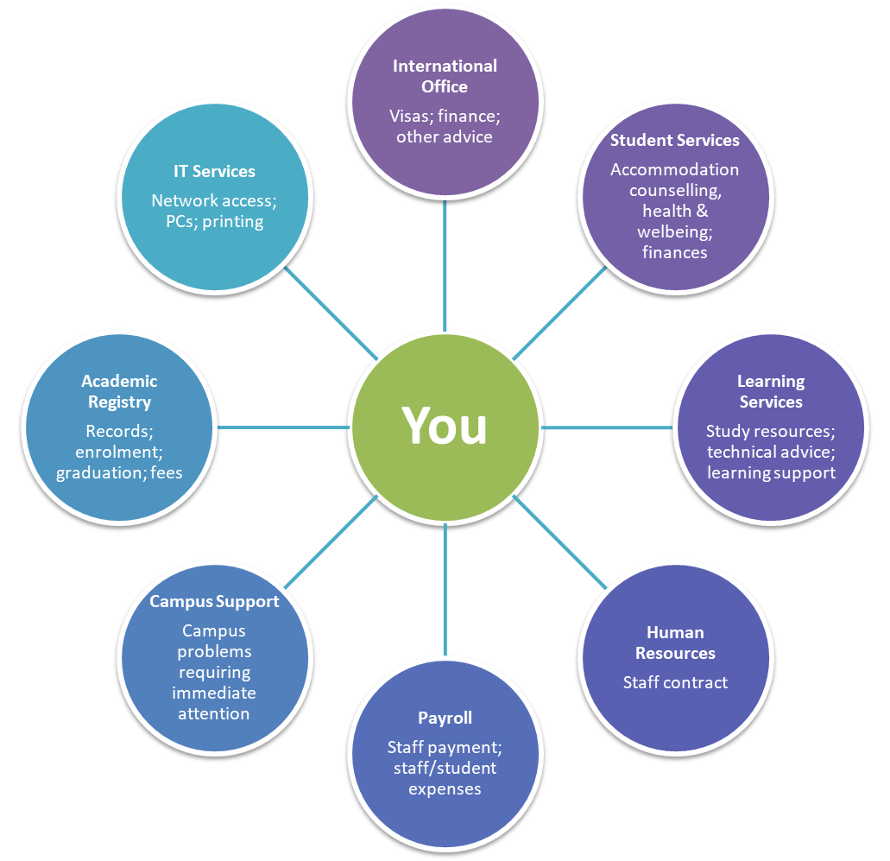
You can access a range of departments at Edge Hill. PGR wellbeing is a priority so if you need support with your campus life; mental health and wellbeing, or would just like some advice, please contact the Wellbeing Team in PGR Services via PGRwellbeing@edgehill.ac.uk or 01695 584554.
Fig G: Services available at Edge Hill
You can find further details about Edge Hill PGRs’ Union, Student Support, the International Office, Careers advice and Learning Services from the links in the footnotes. Each subject area also has a Graduate School Research Degree Contact to support you with any questions. Their details can be found in Appendix 3.

The Wellbeing Team
The Wellbeing team offer many different types of support or advice on any issue that may be impacting your state of health and happiness. This can be anything, regardless of how insignificant you may think the problem is; if it is having a negative impact on your health or mood the Wellbeing team can work with you to resolve any issue, problem, or concern you have.
There are a variety of different issues that can impact every PGR differently. These are a few common examples of things that may be having an impact on your wellbeing:
- Feeling overwhelmed
- Stress
- Anxiety
- Low mood/depression
- Feeling isolated/lonely
- Sexual health
- Diet and exercise
- Drugs and alcohol
- Research issues
Remember these are common and many others will be feeling the same way as you. The Wellbeing team are there to support any PGR regardless of the situation and offer relevant advice and support.
The team also run a number of health promotion events through the year. These events are casual and friendly but also informative and can help you to find other internal and external support services such Counselling, the Campus Life team, drug and alcohol services, GP registration, finding a local dentist, and so on.
If you need help on campus out of hours, Campus Support are available 24/7 and have trained First Aiders in the team. Call 01695 584227.
You can also use our online ‘Let Us Know’ system which is a service that allows you to inform the Wellbeing Team of any concerns you have about yourself and/or other PGRs. This service can also be used anonymously if you wish.
If you feel urgent support is needed please visit our Critical Incident Support page for guidance.

Support services external to the University
- The Samaritans. Need to just talk? The Samaritans are available 24 hours a day, 365 days a year. Get in touch with them for free. Call 116 123 or email jo@samaritans.org . Website: https://www.samaritans.org/
- Liverpool Light Service. If you are near the Liverpool area, you can get in touch with the Liverpool Light Service. This is a preventative out-of-hours mental health crisis service, open from 6.00pm – 12.00am, 7 days a week. It has been set up to provide a safe place for people who are experiencing or at risk of a mental health crisis. Please note that this service is not in place of the 999 emergency service, if an ambulance is required you should call 999 immediately.
- NHS non-emergency number. If you need non-emergency medical advice, you can call 111 for free and speak to the NHS.
- The NHS has a range of self-help guides with practical tips and advice.
- Togetherall. All staff and PGRs at Edge Hill University have free access to Togetherall services through the University. There’s an anonymous community where members can support each other 24 hours a day, 365 days a year. There are trained professionals available 24/7 to keep the community safe, self-assessments and recommended resources, creative tools to help express how you’re feeling and a wide range of self-guided courses to do at your own pace.
For any other departments, please search the Edge Hill website.

Inclusion Team
Based in Catalyst, the Inclusion Team provides information, advice and guidance to PGRs who may need additional support with their studies. If you have a physical or sensory impairment, mental health diagnosis, long-term medical condition, Autism or Asperger’s Syndrome, we can advise on:
- Disclosure and confidentiality
- The support available from the team and other services
- What is meant by “reasonable adjustments” and how you might benefit from them
- Guidance about alternative forms of assessment
- Advice about Disabled PGR Support.
The team’s approach is friendly yet professional and you can discuss your requirements in complete confidence. Contact the team for further information.

SpLD Support Team
Based in Catalyst, the SpLD Support Team provides advice, guidance and support to learners who have or wish to explore any issues related to Specific Learning Difficulties (SpLD) including Dyslexia, Dyspraxia, Dyscalculia and ADHD.
The team can advise on:
- Welcome appointments to explore if you have any indicators of SpLD
- Support for all PGRs from point of contact with the service
- Assessments
- Advice and guidance on applying for Disabled PGRs
If you would like further information about the service, please contact us. Here, you will find detailed information about the assessments and support available through the service.

Research Degree Reasonable Adjustments Panel
The Research Degrees Reasonable Adjustments Panel (RDRAP) oversees reasonable adjustments for research degrees. The Panel reviews PGR support plan to ensure that they comply with the research degrees regulations, are practicable for supervisors and appropriate for PGRs. Reasonable adjustments are those actions or practices which avoid a candidate facing disadvantage because of an additional need.
Learning Services and Student Support will usually submit any PGR Support Plans to RDRAP for scrutiny, before approval. A PGR is also free to submit a request instead of a PGR Support Plan. RDRAP will then make an assessment as to what is reasonable in that case. These assessments, however, must be cognizant of the Research Degree Regulations of the University, based upon an understanding of research degrees, and should maintain the high standards of the University’s research degrees.

PGR communication
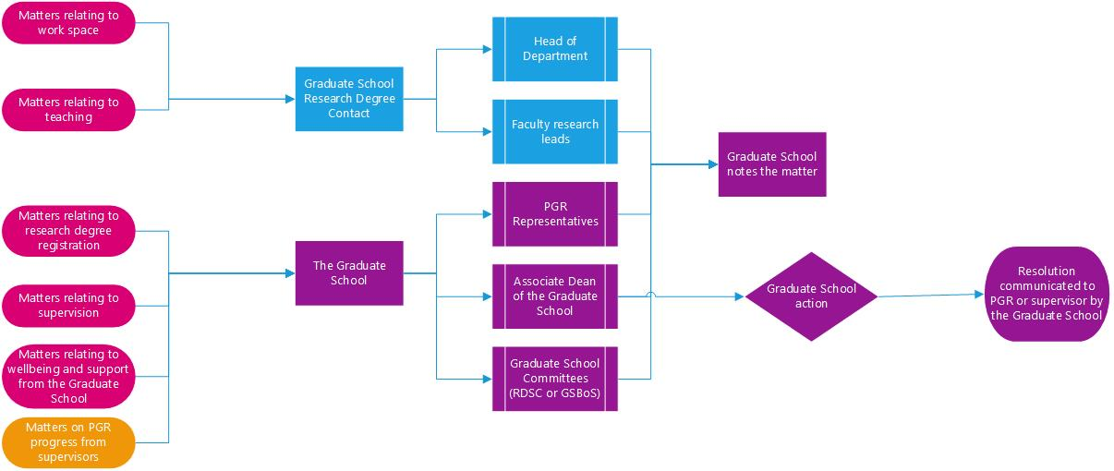
It is important that you know who to contact in relation to various different matters during your research degree. Directing enquiries appropriately will facilitate quick resolution. Figure H represents an overview of where communication should be directed.
Fig H: PGR representation overview

PGR representatives
Each year some of your peers act as PGR representatives to work with the Graduate School to develop research degrees and the PGR experience at Edge Hill. You may even wish to put yourself forward for consideration as a PGR representative at a suitable point in your research.
PGR representatives can raise matters with the University on behalf of PGRs as necessary. They also arrange social events and run the Edge Hill PGR Facebook group.
Your representatives for 2022-23 can be found in the Key Contacts section of this handbook.
Your PGR representatives rotate attendance on the Research Degree Sub-Committee. This group meets three times a year and feeds directly into Research and Innovation Committee and thereby on to Academic Board. The PGR representatives also meet with the Graduate School separately on a regular basis.

Edge Hill Students’ Union
The Edge Hill Students’ Union is independent from the University and provides free, independent advice. If you’re facing an academic issue and find yourself in need of assistance, the SU Advice Team can help. In addition, a EHSU’s Postgraduate Students’ Officer is elected to advocate the best interests of postgraduate students. To contact them, please email suengagement@edgehill.ac.uk.

Interruption of studies and extensions

Extension
You can request extensions to any deadlines that you may have during your studies. Extensions may only be approved by the Graduate School prior to the submission date and evidence as to why the extension is required must be provided along with support from supervisors. The maximum a PGR can request to extend a deadline by is 90 days for doctoral PGRs and 60 days for MRes PGRs.

Interruption of studies
Interruption of studies is an approved period of time during which your PGR registration is paused due to medical reasons or other exceptional circumstances that make it very difficult to continue working on your research. There are two forms of interruption of studies, standard interruption of studies and parental interruption of studies.
Most PGRs will not need to interrupt their studies but, if you feel you do, there is no automatic right to do so, and so you must apply in advance to the Graduate School using the interruption of studies request form and provide evidence that will allow the Board to make an informed decision.
For doctoral PGRs, the minimum duration of any single period of interrupted studies is 90 days with the option to request up to a total of 365 days standard interruption of studies across the entirety of your research degree – this could be four periods of three months across three years of a PhD, or one period of twelve months, or some other permutation. MRes PGRs can request a maximum of three months during their degree. The Graduate School will not consider MRes applications for interruption of studies of anything shorter than one month.
If you request an interruption of studies during before completing the core postgraduate researcher development programme and before gaining registration of your research project, you will be required to restart at the next appropriate formal entry point.
Please refer to the guidance for full details.

Information and resources
It is essential that you also monitor other sources to ensure that you remain up-to-date with developments in the Graduate School and the wider University.

E-mails and network access – all research degree PGRs
All PGRs are provided with access to the University IT network (e-mail, files and storage) following enrolment on a research degree. This access will remain in place until you cease to be registered as a PGR.
Please note: the University does not permit the auto-forwarding to, or permanent storage of, any University business correspondence, email or attachment to non-University managed email systems or services (including, but not limited to, personal email accounts, online file stores, etc.). For further information please see the Acceptable Use Policy.
The Graduate School will only contact you at your PGR e-mail address so you must make sure you check that account regularly. It is your responsibility to manage your email account and any communication that comes through your PGR account.

E-mails and network access – PGRs on payroll
If you are on the payroll at Edge Hill (as a GTA or as a staff member), you will also have network access through a staff account in addition to your PGR account; this means you have a separate staff e-mail account, staff storage, etc. The two accounts are not connected.
The Graduate School will only contact you at your PGR e-mail address so you must make sure you check that account regularly. The reason for this is that, at the end of your staff contract, your staff account will be deactivated and you will no longer have access to e-mails or folders associated with it. Our sending e-mails to your PGR e-mail address means we can be sure they will go to a live account until you complete your research degree.

Printing and wireless network access
In order to print your work from Edge Hill Computers, you will need to add printer credits. This can be done online.

OneDrive
You have access to the University’s OneDrive for Business, which you can access on your PC or other devices. This is ideal for storing your live research data/information securely. It is set up for sharing files within the University, so it can help you share documents with your supervisors or peers, but you will not be able to share documents with external users.
For those on the University payroll, as with your network access, it is advisable to use your PGR account from the beginning or you will lose access to your OneDrive once your employee status ends.

Blackboard (Learning Edge)
The Graduate School has its own Blackboard area. When you log in to Learning Edge, you will see a ‘PGR’ link within the ‘institution’ page.
This ‘PGR area’ is a hub through which you can access the key information you will need during your research degree: regulations; guidance; forms; training calendar and resources; and links to other relevant web pages from around the University.
The Graduate School also has an ‘Organisation’ on Learning Edge called ‘Postgraduate Researcher Development Programme’. All postgraduate researcher development session materials and links to any online sessions will be uploaded onto this space.

Research Degree Room and computer access
While Graduate Teaching Assistants (GTAs) all have access to desk space in their department so they can meet with the undergraduate PGRs they teach, similar resources for non-GTA PGRs cannot be guaranteed.
The Graduate School has therefore arranged the research room in the Catalyst building.

The Catalyst (Library)
The library space is available for all PGRs at Edge Hill. The research room, also known as the Loft, in the Catalyst is on the top floor opposite the silent study room. Entry to this room is for PGRs and staff only through swipe access using your student card.
This room has kitchen facilities with several computers and desk space available for you to use.
Any printing you do on campus will be on one of the many multi-function devices (MFDs), for which you will need to ensure you have enough printing credit.

Your data
At Edge Hill, we are committed to respecting and protecting your personal information. To find ways in which the Graduate School uses your data, please visit the Information Governance webpages.

Financial matters

Tuition fees
You are responsible for payment of your tuition fee unless:
- there are confirmed arrangements in place for an external funding body to pay your fees directly to the University, or
- you are in receipt of an approved fee waiver (for example as part of a Graduate Teaching Assistant studentship).
Regardless of any external funding or sponsorship arrangement you remain personally responsible for your tuition fee and any debt resulting from non-payment.
The University sets out payment dates each academic session and provides information and links on payment methods following enrolment.
If you have any questions about your tuition fee, please contact the Fees, Scholarships and Bursaries Team in Academic Registry.

Postgraduate and Postgraduate doctoral loans
MRes PGRs may be eligible for a Postgraduate Loan. For academic year 2022-23 Student Finance England provide a contribution to costs for eligible students of loans up to £27,892 per student for eligible doctoral degree courses and £11,836 per student for eligible MRes routes. Please see our money matters website for further information and links through to relevant funding information based on your nation and residency.
PG Doctoral Loans are available for PhD PGRs:
- England domiciled PGRs studying in the UK
- Wales domiciled PGRs studying in the UK
- EU PGRs studying in England or Wales.

Financial support
The University offers some financial assistance and advice, including:
- Scholarships
- Student Services can provide advice and administers the University Student Support Fund in case you experience an unforeseen financial emergency during your studies. It is important that you plan your budget well and make use of the advice and guidance available.

Paid work during your research degree
We understand that you may need to maintain employment during your research degree but please remember that work commitments are not a justification for either interruption of studies or extension.
If you are a doctoral PGR and not in receipt of a studentship, the department in which you are based may be able to offer you the chance to do some teaching as and when opportunities arise. These opportunities are managed at the local level, so you will need to speak to your Director of Studies or the head of the department in which you are based about the possibilities. There are specific restrictions in relation to additional work within the University for those on a GTA studentship.
Please note that you must balance the demands of your research with those of any employment.

PGR Bursaries
The bursary is available for activity that is not integral to the applicant's research. For example, attending an academic conference or research-relevant training course. Any funds requested should not have been predictable at the point of the PGR's project registration. Applications should be submitted by an application deadline that is at least 3 months prior to the activity. You will also need to apply to your department or faculty for 50% of the costs – check with your department for this process. The deadline for applications is 4pm on the 15th of each month. The bursary fund will not support daily costs or act as a hardship fund.
Further details can be found in PGR Bursary Fund Guidance.

Appendix 1: PGR Development Programme: Core Sessions 2022-23
These synopses are indicative of the content of the sessions, but as the sessions are based on discussion, the specific content of any iteration of a given session may vary from the general description here. The timetable for these events will be circulated to you separately.

Aspects of research design
This session is an initial introduction to the notion of research design. Through discussion of your existing understanding of research, a number of the most important features of the research process will be identified. You will be gradually introduced to the idea that these are aspects of a whole, not parts in a temporally specific series, and helped to think about the implications of adjustments to any one of those features for the other aspects. The session will also consider the very idea of a ‘research process’, and we will discuss whether the expression ‘research process’ is potentially misleading insofar as it implies that there is a single process that all researchers follow, regardless of the specific nature of their research project.

Tailoring your research degree experience (LSNA, Programme of Related Studies, role of the supervisor in LSNA)
Your learning and skills needs are assessed at the beginning of each academic year through a Learning and Skills Analysis (LSNA) and are reviewed regularly. In this session, you will be introduced to the ways in which you will work with your supervisor(s) to assess your learning and skills needs. Once you have completed your LSNA, you will work with your supervisor(s) to design a programme of related studies. The second part of this session will explain the purposes and scope of a programme of related studies and outline a range of opportunities for PGRs across the University.

The research proposal and project registration preparation
The session will help you to think about the structure of the proposal, your research questions, central concepts and theories, proposed methods of data collection and analysis, proposed contribution to knowledge and central arguments. It would be extremely unwise not to have a method for the production of various different kinds of academic text. This session will introduce you to a range of considerations that are important if you are to develop an appropriate method. The session will give you the opportunity to begin to plan the first draft of your project registration proposal. You will prepare in advance of the session, and so will arrive with material that can be used to assist in the production of a two-page summary of the content of your project registration proposal. On completion of the session, and relevant follow-up work, you will have produced a working document that will have the potential to form the core of your planning in the production of the project registration proposal.

Identifying, evaluating and constructing arguments
This session begins from the thought that it is reason and argumentation, not analysed data, that tells us things and provides the ultimate basis for a claim to knowledge. You will be introduced to the notion of an argument via the concept of inference and the idea of certain things following from other things being the case. The consequences of basing one’s claims to knowledge on certain types of inference will also be introduced.

Research questions
This session will help you to see the importance of specificity in the formulation of research questions and, through consideration of examples, the context-sensitivity of research questions. In addition, the connections between research questions and the other aspects of research design will be explored further by considering the thought that research is question centred or ‘erotetic’ in nature, such that research design can be conceived of in terms of what follows from having specific research questions if one’s goal is to answer those questions. In that way, choices in relation to methods of data collection and analysis, conceptualisation, theory and lines of argumentation can be understood as contributing to the strength of a claim to knowledge by providing a strong basis for the relevant claim.

Claims to knowledge
Making a significant, independent and original contribution to knowledge is the central criterion (although strictly speaking it is three criteria) for the award of a PhD or professional doctorate. While the requirement for originality is not a feature of the criteria for award of the MRes, the need to make a contribution to knowledge is of primary importance for all research degrees. Not just any claim counts as a claim to knowledge in the relevant sense, so you will be introduced to the importance of the relationship between claims to knowledge and making a contribution to knowledge, where what counts as knowledge in such cases is largely framed by the nature of existing work in any given field. In addition, the central importance of a defence of any claims to knowledge in either the dissertation or thesis, and in the viva, will be explored, along with the notion of bases for claims to knowledge. The session should begin to provoke a reflexive awareness of your understanding of the practices you undertake in claiming knowledge and the scope and limits to such claims.

Combining Disciplines
In recent years increasing emphasis has been placed, particularly by funding bodies, on research that combines two or more disciplines in addressing a research topic. Generally, that development has gone unquestioned, with advocates of such research pointing to the popularity and alleged success of areas of inquiry such as cognitive science, which includes a range of disciplines, including, inter alia, cognitive neuroscience, cognitive psychology, psycholinguistics, philosophy and computer science to study the mind and cognition. Such areas of inquiry are often claimed to be ‘inter-disciplinary’, which is frequently contrasted with ‘multi-disciplinary’ research, which combines disciplines in an importantly different way. This session will raise critical questions about the nature of inter-disciplinary research with a view to sharpening our understanding of central issues of research design that emerge when one attempts to combine disciplines. Consideration will also be given to the related, and frequently misunderstood, topics of triangulation and multi-methods approaches to research.

Appendix 2: methodological sessions 2022-23
These synopses are indicative of the content of the sessions, but as the sessions are based on discussion, the specific content of any iteration of a given session may vary from the general description here.
Science

Designing Randomised Control Trials
RCT’s are widely regarded as the gold standard design for establishing the efficacy of interventions in healthcare. This session will offer an introduction to the basic principles of randomised controlled trials, the importance of their key features and how their design provides a robust basis for establishing a link between cause and effect. Students will gain an understanding of the main features of bias control that are the hallmark of these designs, why they are generally designed and delivered by teams of people and often expensive. As a general rule, they cannot and should not be delivered by individuals.

Objectivity and Bias in Experimental Design
This session will build upon the broad themes addressed in the session on the scientific method, exploring ways to achieve objectivity, identify potential sources of bias and subjectivity when formulating and testing hypotheses and research questions, designing experiments, and selecting sampling approaches.

Data Collection and Sampling Approaches
Fundamental to the design of a robust experiment is an understanding of the range of data that can be collected in the discipline and the type of data that should be collected to address the question being addressed. This session will explore various types of data (qualitative, semi-quantitative, quantitative), handling of this data and the influence of data type on analytical approaches, interpretation and conclusions.

Scientific Communication
Effectively communicating the importance of your research and its findings within your field, to a broader scientific audience or to non-scientists, is key to your success as a researcher. This session will explore techniques to achieve a concise scientific style in various forms of communication, including proposal writing, publication, and presentation. It will also discuss how to identify the appropriate outlets for science communication and discuss the publication and peer review processes.

Communicating in Lay Terms
Building on the themes discussed in the previous session, this session will explore the important skill of writing and communicating to non-scientists as well as mechanisms of outreach and promoting research to the public and the scientific community.

The Funding Landscape in the Sciences
Funding opportunities in the Sciences exist for all career stages, from small grants to support graduate conference attendance to large scale grants supporting postdoctoral research. It is essential to gain an early understanding of the relevant funding opportunities available in your field in the short term but also those open to you in your next career stage. This session will explore the funding landscape for Science in the UK and internationally, the various mechanisms for finding funding opportunities, and how to plan small grant proposals.

Arts and Humanities

What is Theory For?
Researchers working in the humanities will engage a range of philosophical, theoretical and historical approaches, and explore the work of cultural criticism, reception and production through a range of critical perspectives, interdisciplinary insights and applications. These theoretical and historical perspectives allow scholars to tease out the critical charge embedded in the notion of culture itself, and the transformative potential of creative and critical work in the arts and humanities. But, as Szeman, Blacker and Sully have pointed out, ‘[w]hat makes critical theory, “critical” is its ceaseless interrogation of the process by which knowledge gets transformed into doxa [commonly-held belief]’ (xvii-xvii: 2017). This session will discuss the importance, uses and applications of critical and cultural theory within the humanities.

What Do We Mean by ‘Text’?
Analysis of text/s will be important to the work of most researchers within the humanities, but that text may come in a variety of forms, and approaches to it will be broad and diverse. Within cultural and historical studies, the centrality of text is debated and contested, and how you identify and approach text in your own work will be a fundamental consideration. Uncovering meaning and interpreting a text, understanding why and how a text was produced, investigating the authenticity or validity of a text, exploring what people do with texts, defining what relationship one text bears to others, and engaging in the discourses that surround a text are just some of the methods you might employ. This session will discuss and question the uses of text/s within the humanities.

Context Across Disciplines
Following on from the discussion of text, it is important to consider context. Any text or artefact comes from a specific time and place, but to state that your approach is ‘contextual’ is too broad and has little precise meaning. Text, meaning and context are multifaceted and multi-layered in their relationships and are perspective-dependent. Recognition of these complex associations is necessary in understanding the nature of history and culture. This session will consider what is meant by context and the implications of a range of contexts, including social, historical, and political, that may have an impact upon your study.

Where Can We Find Evidence? 1: Archives
This session will focus on how you will develop and support your research as your project progresses. We will discuss a range of resources and facilities available to you in print and in various electronic formats through Edge Hill Learning Services and beyond. Importantly, we will reflect critically upon the processes by which sources and evidence are selected, presented and employed. We will also explore the potential benefits of archival research. Finally, and this will be followed up in your supervision sessions, you will be encouraged to consider how the issues discussed relate to your own research.

Where Can We Find Evidence? 2: Interviews
Stuart Hall explained 'identity' as referring ‘to the meeting point, the point of suture, between on the one hand the discourses and practices which attempt to 'interpellate' [give identity to and individual, group or category], speak to us or hail us into place as the social subjects of particular discourses, and on the other hand, the processes which produce subjectivities, which construct us as subjects which can be 'spoken'. Identities are thus points of temporary attachment to the subject positions which discursive practices construct for us’ (1996: 5-6). Identity and subjectivity underpins many of the projects you are undertaking. Many of you will be considering how identities are constructed or recorded, how they shift and how they are impacted upon by contexts. Who we are, how we describe ourselves to others, and how our own identity and perception influences and shapes our scholarship is perhaps less regularly considered. Today’s session will ask you to address your identity as an academic and researcher.

What is Practice Research?
The Research Excellence Framework (REF) exercise acknowledged that practice is firmly embedded as an accepted mode of research. However, it also noted that there were inconsistencies in the understanding of practice as research. The term ‘practice as research’ has been employed to establish a space for arts practice in academic environments, and it therefore refers to a broad range of research activity. It can refer to a research process that leads to an arts-related output, an arts project as one element of a research process drawing on a range of methods, or a research process entirely framed as artistic practice. Practice as research is therefore not a ‘method’ in itself, as it draws upon a variety of methodologies that might be incorporated into interdisciplinary research projects. This session will address questions circulating practice as research and associated discussions by drawing on the experience of practitioners working within the university.

Social Sciences

Framing Social Research
Social science research does not happen in a vacuum and the subjects of social scientific research need to be understood within wider social, cultural, political, economic, spatial and temporal (and other) arenas. These contexts and frames are important to understand the trends, developments and phenomena that social scientists study. It is reflected in both the particular literature of the field of study and the intellectual ideas that have built our understanding of that field. This session will involve a discussion about the importance of context and the way in which we frame our approach to our research by developing our particular question and including or excluding different perspectives and fields of study. It also looks at the intellectual issues around framing your questions and the importance of knowing the wider field and making decisions about focus and framing in writing a thesis. It raises a number of interesting questions: How do we make decisions around how much and how little context we need to include in our research in order to produce digestible and effective research? How do we both understand, and take a critical approach to, our field of research? Can we make universal statements or are all social phenomena only to be understood in particular context?

The Practice of Social Research
The researcher trains to develop their question, make decisions about the methods they use and the sources of information from which they draw their data, and develop their research design to yield meaningful data from which to develop findings. Data is collected, collated, and then analysis takes place.
This is the practice of social research, and the central activities that constitute the research process in many disciplines. It is important that researchers understand both the sequence of practices and how they develop a coherent design that can then be operationalised by the researcher. The extent to which this design and operationalisation is done effectively will often determine the value and effectiveness of the research. This session will explore issues around the practice of social research, mapping the process and exploring the key components.

Empirical Research: Life Story, Ethnography and Autoethnography
This session will explore some of the theoretical, methodological, and epistemological aspects of life story research. Life story writing can be positioned distinctively or through a myriad of multiple intersecting ways, which may include those taking an ethnographic, autoethnographic, autobiographic, and/or philosophical stance. Rich sources of life story data can be found in oral stories, interview transcripts and diary entries to name but a few. Essentially, life story research sparks reflective moments, which illuminate and/or critique wider social, cultural, and political matters. Practical insights of how this kind of research can be done will also be a feature of this session.

Using Quantitative Methods in Social Science Research
This session introduces PGRs to the options available for secondary quantitative data analysis. All UK university researchers have access to a wide range of high-quality secondary datasets, yet these are often an under-used resource. In this session, PGRs will be introduced to the range of datasets available to them, including - but not limited to - the British Social Attitudes series, Understanding Society and the Family Resources Survey. PGRs will be shown how to download these datasets, prepare them for analysis and some basic but useful ways in which these datasets can start to be analysed.

Researching Sensitive Issues
Undertaking qualitative research on sensitive topics often raises a variety of ethical problems that arise in the planning of a project, or in the conduct of the research activity. This session complements the ethics approval process sessions, with a focus on the how to manage sensitive issues in research. This session will focus on sensitivity from the point of view of the individual researchers themself, research participants, individuals, groups, communities connected either with the research participants and/or the research topic/focus. The session offers practical advice to consider and take away.

Escaping Methodology
This session will explore the quest for creative and non-standard methodologies. It problematises methodology, and then builds on theories of rupture in order to explore bespoke, original, and personal methods in the design and implementation of research projects. As such, it offers brief overviews of visual and sensory methods; narrative methods; participatory methods; practice-as-research; autoethnography.

.

Appendix 3: additional information spaces
The following list links to a few areas used by the Graduate School to house key information. These have been referred to throughout this document, however, they have also been listed in a separate appendix below for you to navigate to these spaces easily.

Graduate School Blackboard Area
This space houses all core examinations and registration paperwork for PGRs. (https://learningedge.edgehill.ac.uk/webapps/blackboard/content/listContentEditable.jsp?content_id=_3502079_1&course_id=_270202_1)

Development Programme Blackboard Organisation
This space houses information related to the development programme, including development programme materials and links to any sessions that are held online. (https://learningedge.edgehill.ac.uk/ultra/organizations/_236673_1/cl/outline)

Research Degree Handbook Addenda
Each route of study (MRes, PhD and Professional Doctorate) has an addendum specifically for their degrees. These can be found as a separate upload via the Research Degree Handbook link.
(http://eshare.edgehill.ac.uk/15194/)

Appendix 4: key contacts

Graduate School
Dr Leon Culbertson, Dean of the Graduate School. (GraduateSchool@edgehill.ac.uk)
Prof Fiona Hallett, Associate Dean of the Graduate School. (GraduateSchool@edgehill.ac.uk)
Lydia Richardson, Graduate School Manager. (GraduateSchool@edgehill.ac.uk)
Dr Craig Collinson, Researcher Development Fellow. (GraduateSchool@edgehill.ac.uk)
Dr Chris Hughes, Researcher Development Fellow and Research Degree Academic Coordinator (Doctoral Training)
Dr Christopher Greenough, Researcher Development Fellow and Research Degree Academic Coordinator (Social Sciences)
Dr Peter Wright, Researcher Development Fellow and Research Degree Academic Coordinator (Arts & Humanities)
TBC - Researcher Development Fellow and Research Degree Academic Coordinator (Sciences)
Louise Nightingale, Research Degree Administration Coordinator. (GraduateSchool@edgehill.ac.uk)
Marylene D’Ingeo, Research Degree Administration Coordinator. (GraduateSchool@edgehill.ac.uk)
Holly White, Research Degree Administrator. (GraduateSchool@edgehill.ac.uk)
TBC, Research Degree Administrator. (GraduateSchool@edgehill.ac.uk)

MRes
Dr Christopher Hughes, MRes Leader

Professional Doctorate (DESM)
Professor Paresh Wankhade, Business School, Professional Doctorate in Emergency Services Management Lead (Paresh.Wankhade@edgehill.ac.uk)

Professional Doctorate (EdD)
Professor Carol Robinson, Faculty of Education, Professional Doctorate in Education Lead
(Carol.Robinson@edgehill.ac.uk)

PGR Representatives
Please contact your reps through the Edge Hill Research Student Facebook page.

Fees team
Fees team (tuitionfees@edgehill.ac.uk)

Research degree administrators
(GraduateSchoolExaminations@edgehill.ac.uk)

Subject area Graduate School research degree contacts

Subject area | Name
Biological Sciences | Jayne Charnock  Claire Harper
Business and Management Research | Paresh Wankhade
Computer Science and Informatics | Ella Pereira
Education Research | Christine Lewis (Recruitment)  Francis Farrell (PGR experience)
English Language and Literature | Peter Wright
Historical Research | Alyson Brown
Geographical and Geological Research | Joaquin Cortes
Health Research | Lucy Bray
Legal and Criminological Research | Andrew Millie
Media and Performing Arts (Creative Arts) | Helen Newall
Psychological Research | Dorothy Tse
Social Science Research | Alyson Brown
Sport, Exercise and Physical Activity | Matthew Greig

Ethics committee secretaries
CTRL + Click the contact name to open an email to them.
SREC | Secretaries
Arts & Humanities | Gemma Hardy
Social Sciences | Joanne Blood
Science | Emma Keane
Education | Megan Burns
Health Related Research | Elizabeth Long

Glossary of terms
- Researcher Development Programme (RDP)- A programme of 1-2 hour training or discussion sessions covering research methodology, research skills, research governance and personal development. Based on Vitae’s Researcher Development Framework.
- Director of Studies (DoS) - Your DoS is a member of your supervisory team. The role of DoS is purely administrative but the individual holding that role does also have full supervisory duties. Further information about supervisory teams can be found in this handbook.
- Extension - An extension relates to a specific examination submission deadline, allowing additional time to meet the requirements of the submission. It does not change any of your later deadlines, including your maximum registration date. Please refer to the guidance on seeking interruption or an extension for research degrees document for further information.
- Graduate School - Research degrees at Edge Hill are organised and run centrally. The Graduate School is the mechanism by which the University does that. Further information about the Graduate School can be found on page 5 of the handbook.
- Graduate Teaching Assistant (GTA) - GTAs are fully funded PGRs who teach as part of their funding agreement.
- Interruption of studies - Allows the PGR (you) to request between three and twelve months away from the project without losing that time from your registration period. If you make an application for an interruption of studies, and it is successful, it effectively moves the remaining deadlines by the same amount of time as the approved interruption of studies. The period of interruption you can request during your studies depends on your research degree route (MRes/doctoral). Please refer to the guidance on seeking interruption or an extension for research degrees document for further information.
- Learning and Skills Needs Analysis (LSNA) - Your learning and skills needs are assessed at the beginning of each academic year and are reviewed regularly. This review is done through an LSNA. Paperwork varies depending on your subject area and can be accessed through your subject area Graduate School Research Degree Contact or DoS. Further information can be found in this handbook.
- Methodological development sessions - The methodological sessions comprises a programme of structured discussion sessions. Some of the sessions address issues principally of interest to those working in science subjects, some address issues principally of interest to those working in social science subjects, and some address issues most likely to be of interest to those working in arts and humanities subjects. In addition, there are a small number of methodological sessions that are designed to transcend specific disciplinary boundaries. Further information can be found in this handbook.
- PGR Bursary - PGR Bursaries are intended to support you with unforeseen research expenses. The bursary is usually match funded by the relevant department/faculty. The PGR Bursary scheme will not support daily costs or act as a hardship fund.
- Programme of Related Studies - You will design a programme of related studies which could include attendance at research seminars covering appropriate topics, regardless of which department, faculty or research institute organises them, any other research institute events, research development sessions offered by any department or faculty, sessions that are part of the University’s Researcher Development Programme, individual tutorials that you arrange with members of staff other than those on your supervisory team, and, with the agreement of module leaders, attendance at certain lectures delivered as part of masters or third year undergraduate modules. Further information can be found in this handbook.
- Research Degree Routes - Edge Hill offers three awards: Masters by Research (MRes), Doctor of Philosophy (PhD) and Professional Doctorate (DESM or EdD). MPhil is no longer a target award for PGRs to attain.
- Research Excellence Framework (REF) - The REF is the UK’s system for assessing the quality of research in UK higher education institutions. Further information about the REF can be found here.
- Subject area Graduate School research degree contact - Each of the subject areas under which research degree activity is organised has an assigned Graduate School research degree contact to support PGRs within that subject area.
- Viva (Project Registration) - All doctoral PGRs undertake a project registration viva. This is an oral examination with an examination panel comprising an examiner from your supervisory team and an examiner who has relevant subject expertise and has not been involved in your supervision. MRes PGRs submit for project registration but that is a paper-based assessment without a viva.
- Viva (Progression) - All doctoral PGRs undertake a progression viva. This is an oral examination with an examination panel comprising an internal examiner and an external examiner. MRes PGRs do not undertake a progression viva.
- Viva (Final) - All research degree PGRs undertake a final viva at the end of their studies. This is an oral examination with an examination panel comprising of a panel chair, an internal examiner and an external examiner.

Updated: 28 September 2022
Graduate School
Edge Hill University
St Helens Road
Ormskirk L39 4QP
Tel: 01695 657763 (internal: 6763)
GraduateSchool@edgehill.ac.uk
edgehill.ac.uk/graduateschool

https://www.edgehill.ac.uk/graduateschool/
Generally, those registered on the MRes are supervised solely by the Director of Studies, but occasionally and additional supervisor will be added to an MRes team.
https://www.vitae.ac.uk/policy/concordat
Paperwork for Learning and Skills Needs Analysis can be accessed through your Director of Studies (DoS).
Click here for further guidance.
Phillips, E. M. and Pugh, D. S. (2015, p.2) How to Get a PhD: A Handbook for Students and Their Supervisors, sixth edition, Maidenhead: Open University Press.
https://www.edgehill.ac.uk/documents/research-degree-regulations/
The GTA handbook can be found on the PGR Blackboard area.
https://www.edgehill.ac.uk/service/student-record/
https://www.edgehill.ac.uk/service/haplo/
https://www.edgehill.ac.uk/documents/research-degree-regulations/
https://www.edgehill.ac.uk/documents/health-safety-and-environmental-policy/
https://www.edgehill.ac.uk/documents/intellectual-property-policy/
https://www.edgehill.ac.uk/document/research-ethics-policy/
Submission for final examination earlier than the expected time to completion does, however, require the approval of all members of the supervisory team.
Schedule A of the Research Degree Regulations specifies your final submission format - https://www.edgehill.ac.uk/documents/research-degree-regulations/
http://eshare.edgehill.ac.uk/14165/
http://eshare.edgehill.ac.uk/9105/
https://www.qaa.ac.uk/en/quality-code/advice-and-guidance/research-degrees. The full UK Quality Code for Higher Education has been replaced by the short Revised UK Quality Code for Higher Education. Full guidance information can be found here. https://www.qaa.ac.uk/quality-code
This paperwork can be accessed via your subject area research degree contact.
www.vitae.ac.uk/rdf. Diagram taken from the Vitae Researcher Development Statement.
https://www.vitae.ac.uk/events
http://www.ncrm.ac.uk/
http://www.cmist.manchester.ac.uk/about/
https://ukdataservice.ac.uk/training-events/
https://www.edgehill.ac.uk/document/code-of-practice-for-the-conduct-of-research/
https://www.edgehill.ac.uk/research/things-to-consider/
https://www.edgehill.ac.uk/service/haplo/
https://www.edgehill.ac.uk/document/research-ethics-policy/
https://www.hra.nhs.uk/approvals-amendments/what-approvals-do-i-need/
https://www.hra.nhs.uk/planning-and-improving-research/research-planning/student-research/
http://eshare.edgehill.ac.uk/id/document/47602
https://www.hra.nhs.uk/approvals-amendments/managing-your-approval/ending-your-project/
Edge Hill has a research licence issued by the Human Tissue Authority (licensing number 12632). Please see Edge Hill’s HTA pages for further information https://www.edgehill.ac.uk/document/human-tissue-quality-manual/
Nagoya-Protocol-Guidance Accessible.docx (live.com) Nagoya-Protocol-Checklist-for-Researchers Accessible.docx (live.com)
https://www.edgehill.ac.uk/document/policy-on-researching-and-handling-sensitive-material/
Risk Assessment Guidance link
https://www.edgehill.ac.uk/departments/support/ls/research/managing-data/
https://www.edgehill.ac.uk/services/figshare/
https://www.edgehill.ac.uk/research/things-to-consider/
https://go.edgehill.ac.uk/display/compliance
https://www.edgehill.ac.uk/document/research-data-management-policy/
http://eshare.edgehill.ac.uk/15194/
http://eshare.edgehill.ac.uk/11640/
http://eshare.edgehill.ac.uk/12121/
http://eshare.edgehill.ac.uk/12120/
https://repository.edgehill.ac.uk/
https://www.edgehill.ac.uk/documents/intellectual-property-policy/
https://www.edgehill.ac.uk/documents/research-degree-regulations/
https://www.edgehill.ac.uk/document/academic-regulations-2022-23/
It is expected that the procedural irregularity would be on behalf of the University, not on behalf of the PGR; e.g. material administrative error, or an irregularity in the conduct of an assessment or panel in contravention of the relevant regulations or structures.
In some cases, not necessarily all, it may be beneficial to also inform your supervisors of any health or personal issues.
https://www.edgehill.ac.uk/departments/support/studentservices/wellbeing/
https://www.edgehill.ac.uk/documents/complaints-procedure/
https://www.qaa.ac.uk/quality-code
http://eshare.edgehill.ac.uk/9099/
https://www.edgehill.ac.uk/document/academic-regulations-2022-23//
https://www.facebook.com/groups/edgehillpgrgroup/
https://www.edgehillsu.org.uk/
https://www.edgehill.ac.uk/departments/support/studentservices/
https://www.edgehill.ac.uk/international/
https://www.edgehill.ac.uk/careers/
https://www.edgehill.ac.uk/departments/support/ls//
https://www.edgehill.ac.uk/departments/support/studentservices/wellbeing/
https://www.edgehill.ac.uk/departments/support/studentservices/let-us-know/referral-form/
https://www.edgehill.ac.uk/departments/support/studentservices/critical-incident-support//
https://liverpool-light.org.uk/
https://web.ntw.nhs.uk/selfhelp/
https://togetherall.com/en-gb/
inclusionteam@edgehill.ac.uk 01695 657568 or https://www.edgehill.ac.uk/departments/support/studentservices/inclusive/
spld@edgehill.ac.uk 01695 657526 or www.ehu.ac.uk/spld
https://www.facebook.com/groups/edgehillpgrgroup/
http://www.edgehillsu.org.uk/
Applications submitted shortly after the requested interruption of studies start date may be approved in exceptional circumstances but must be accompanied by a suitable explanation, and appropriate evidence, for the late request.
http://eshare.edgehill.ac.uk/14627/
http://eshare.edgehill.ac.uk/14627/
Acceptable Use Policy
https://www.edgehill.ac.uk/services/printing/
https://edgehill.cloud.panopto.eu/Panopto/Pages/Viewer.aspx?id=45bd64c1-b742-4ff0-83a8-ac2b009de9a7
https://www.edgehill.ac.uk/departments/support/ig/
https://www.edgehill.ac.uk/study/fees-and-funding/
https://www.gov.uk/postgraduate-loan
https://www.edgehill.ac.uk/study/fees-and-funding/postgraduate-students-2022; https://www.findaphd.com/funding/guides/uk-phd-loans-scheme.aspx
https://www.edgehill.ac.uk/scholarships/
https://www.edgehill.ac.uk/departments/support/studentservices/moneyadvice/student-support-fund/
Further information can be found in The GTA Handbook on the PGR Blackboard area
http://eshare.edgehill.ac.uk/id/eprint/14650

