Blackboard Collaborate

Participant Guide

Introduction

This quick guide shows how to join a Collaborate Ultra webinar and use the participant tools. We’d recommend that you use a supported browser.

Accessing a Session

You can access a session via a Blackboard area or using a link that has been shared with you.

Blackboard Area Access
From the Details & Actions menu, select ‘Join Session’ then the appropriate room.
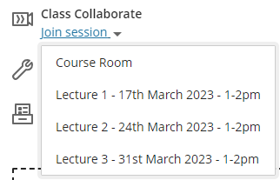

Shared Web Link
- Click on the link provided by your instructor.
- You will be prompted to enter your Display Name.
- Click ‘Submit’ to join session.

Getting set up in the Collaborate room

When you first enter the room, you will be prompted to follow a tutorial. This will introduce you to the different controls in the room.

When you click on the microphone or video icons you will be prompted to run a test and select which camera or microphone to use.
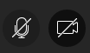

You may also be prompted to allow the browser to access to your microphone and webcam. Click ‘Allow’.
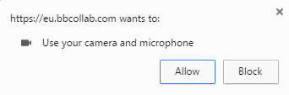

User Interface

The tutorial will have introduced you to the different controls in Collaborate.

The Blackboard help pages for Collaborate are also available to remind you how the system works, and also talk you through things like adding a profile picture.

All the tools and icons are described on the ‘Use the Tools’ page.

Communicating in a session

If you are given the chance to ask questions you can either use text or audio if you have a microphone.

Text Option

Click the Open Collaborate panel icon on the lower right of the screen.
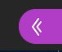
Click the Chat icon.
Select ‘Everyone’ from the panel and type in the ‘Say something’ box. Press Enter to send the message. You can also click the smiley face to choose emoticons.

Audio Option

Click on the ‘Share audio’ icon, then speak your question.
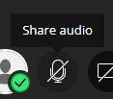

Click again on the ‘Audio’ icon when you have finished to close the microphone. Always remember to mute yourself when not speaking.

Leaving a session

When the session is over, and you are ready to leave click on the browser’s Close button or the ‘Leave Session’ icon from the bottom of the left hand menu.

Troubleshooting

- If you have technical problems:
  - Close and re-enter the session.
  - Close other browser tabs that might be using the microphone or audio.
  - Blackboard have a Troubleshooting guide.
  - Often accessing the session using a mobile device will solve issues with sound.
- If you need to adjust the volume or change the microphone or webcam:
  - Click the Open Collaborate panel icon on the lower right of the screen.
  - Click the My Settings icon.
  - Open Audio and Video Settings to adjust volume.
  - If you need to change the microphone or webcam you are using, click ‘Set up your camera and microphone’ to restart the setup wizard.
- On a desktop or laptop computer, you may need to check you have the default audio output on your computer set correctly. If you have headphones and speakers connected, you may need to set the default playback device to your headphones.
  - Windows: Right click the speaker icon near the clock at the bottom right of the screen, choose Playback devices, select the appropriate output device and then click Set Default.
  - Mac: OS X guide.

