Addendum B: Masters by Research (MRes)

Booklet

2022-23

MRes postgraduate researcher details
Name:
Contact number:
Edge Hill email address:

Submission information:
Project registration
submission deadline
Final submission deadline
Final viva date

Introduction
This booklet provides advice and guidance about the processes and procedures that frame your experience as a postgraduate researcher completing the MRes at Edge Hill University. Whilst the main handbook outlines all aspects of research degrees, this document provides a short digest of information particular to the MRes. It also refers to numerous other documents, the links to which are embedded where relevant.
It is important that this addendum is read in conjunction with the Research Degree Handbook. While we have tried to be as comprehensive as possible in this booklet, and the handbook, we may update them throughout the year. It is essential, therefore, that you regularly check your PGR e-mail, the Graduate School webpages, and the Postgraduate Research Blackboard space for updates.

The structure of the MRes

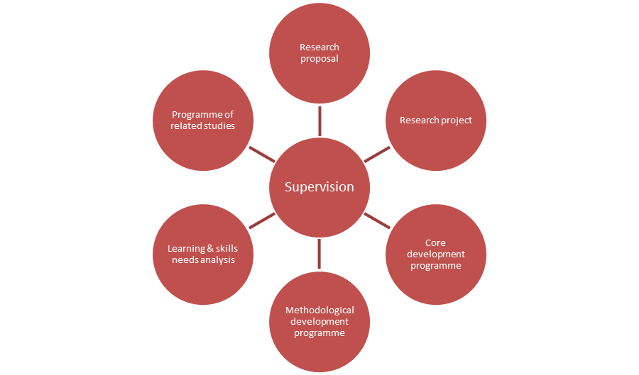
Masters by Research (MRes/LLM)

- Research proposal (5,000 words, no viva);
- Research project (dissertation or approved equivalent up to 30,000 words and viva);
- Core researcher development programme (classroom and online sessions which are then tailored to the needs of individual PGRs in supervisory tutorials);
- Methodological development programme (online sessions which are then tailored to the needs of individual PGRs in supervisory tutorials);
- Learning and Skills Needs Analysis conducted throughout the programme of research;
- A programme of related studies designed to address identified needs.

Core sessions
Core researcher development sessions must be attended by all PGRs in their first year. The material in core sessions covers research design, research project management, research data management, research ethics, and some of the more general conceptual, epistemological, and methodological matters in relation to research. They are designed to introduce you to some considerations that apply in different ways in different cases and are of relevance to all researchers.
These sessions are facilitated by a small team of academics from a range of disciplinary backgrounds and will take the form of structured discussions. The programme of core sessions can be found in Appendix 1 of the main handbook.
Please note: it is imperative that your attendance is registered for each development session in order to meet the requirements of project registration. If you are unable to attend a session, please contact the Graduate School for advice on a suitable alternative activity.

Methodological sessions
All MRes PGRs must attend a minimum of six methodological sessions (you are free to select which six sessions you attend, but you should seek supervisory advice in making that decision). Six of these are designed by staff working in the Social Sciences, six by staff working in the Sciences and six by staff working in the Arts and Humanities. You should make your selection based on the results of your Learning and Skills Needs Analysis. You can, however, attend as many methodological sessions as you wish and we advise PGRs to consider sessions beyond their discipline in order to develop their understanding of research. The programme of methodological sessions can be found in Appendix 2 of the main handbook.
Please note: it is imperative that your attendance is registered for at least six methodological sessions in order to meet the requirements of project registration. If you are unable to attend a session, please contact the Graduate School for advice on a suitable alternative activity.

Programme of related studies
Along with your Director of Studies, you will design a programme of related studies to meet specific learning and skills needs identified through your Learning and Skills Needs Analysis. Your programme of related studies could include attendance at research seminars covering appropriate topics. You can attend research seminars, and events, regardless of which department, faculty or research institute organises them. Likewise, you can attend sessions that are part of the University’s Researcher Development Programme, individual tutorials that you arrange with members of staff other than those on your supervisory team, and, with the agreement of module leaders, certain lectures delivered as part of masters or third year undergraduate modules. Any additional methodological sessions you attend beyond the required six sessions may form part of your programme of related studies.
There will also be sessions on topics such as preparing CVs, responding to peer review, how to publish, and support in navigating your career options.

Timeline
All MRes PGRs will submit a proposal for project registration which will be examined by your supervisor and another member of staff with suitable expertise who has not been involved with your supervision. This is a paper-based exercise that does not involve a viva. All research projects must be registered on Haplo, our research ethics system.
Academic review takes place part way through the MRes programme. As an MRes PGR you do not have to do anything, this is simply an opportunity for supervisors to register your progress with the Graduate School.
At the end of your programme of study you will submit a dissertation that will be examined at viva.
 | Project registration | Academic review | Final
MRes PGR responsibility | Submission of proposal (with associated documentation). There is no viva. | NA - this is completed by your supervisory team. | Dissertation submission (with associated documentation) and viva.
Supervisor responsibility | Propose second examiner and jointly examine the project registration proposal. | Complete required paperwork. | Propose examination team, one member of which will be external to the university.

The following guidance on each examination can be accessed via Blackboard:
- Research project registration guidance
- Final viva guidance
The following diagram indicates the timeline of studies for a full-time and part-time PhD PGR. A further breakdown of key milestones has also been provided:
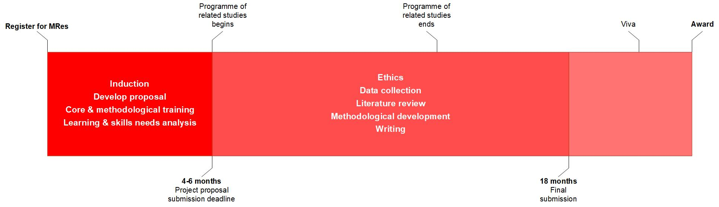
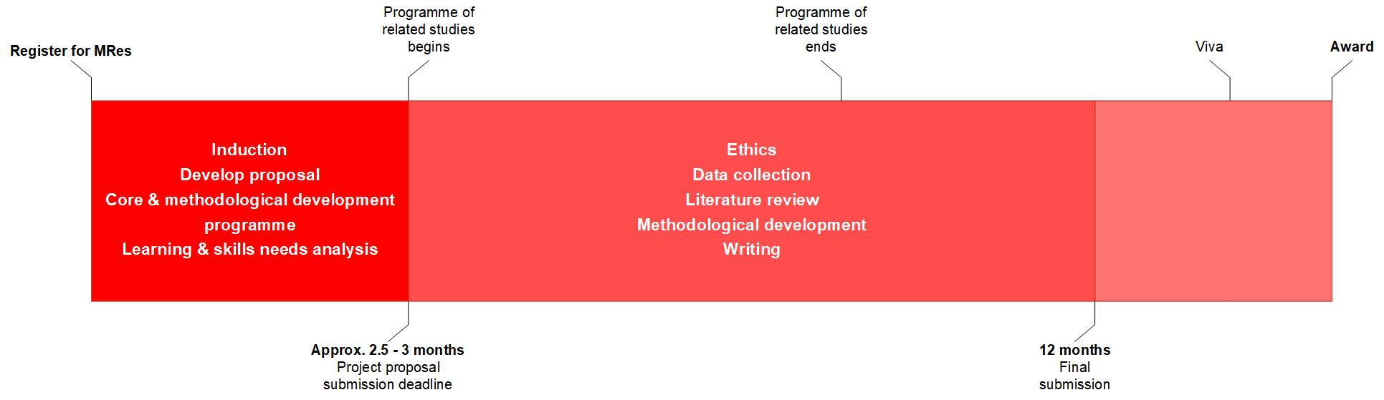
MRes Timeline (based on full-time enrolment)
MRes Timeline (based on part-time enrolment)
Milestone | Full-time | Part-time
MRes registration start date | Your Graduate School induction date
Learning skills and needs analysis (LSNA) | Conducted annually between the PGR and their supervisory team.  The first LSNA should happen within the first 6 weeks of MRes registration and be reviewed annually.
Programme of related studies | Conducted annually with a mid-year review with the PGR and their supervisory team.  Design of the programme should happen within the first 6 weeks of MRes registration and be reviewed mid-year.
Project registration submission deadline | 2.5-3 months from your MRes registration start date | 4-6 months from your MRes registration start date
Project registration submission outcome | Within 6 weeks of your project registration submission.
Ethics submission | Made as soon as possible after your project registration.  A deadline to submit your ethics applications is given to MRes PGRs following their project registration approval. This is normally 10 working days.
Academic review | Coordinated by the Graduate School on an annual basis.  All MRes are involved in this process, with the necessary paperwork completed by their DoS.
Final examination team proposal | Submitted to the Graduate School 3 months prior to your final submission.
Maximum Final submission deadline | 12 months into MRes registration | 18 months into MRes registration
Final viva examination | Within 6 weeks of your final submission
Graduation | Edge Hill conducts July and December Graduation ceremonies. Details are sent to relevant PGRs annually to ensure registration for the most appropriate ceremony.

Support from the Graduate School
The Research Degree Handbook complements this addendum. Please ensure you read this alongside this booklet.
If you have any questions about the contents of this document, please contact GraduateSchool@edgehill.ac.uk.
Updated: 22 September 2022

http://eshare.edgehill.ac.uk/15194/
http://eshare.edgehill.ac.uk/15194/
http://eshare.edgehill.ac.uk/15194/
https://learningedge.edgehill.ac.uk/webapps/blackboard/content/listContentEditable.jsp?content_id=_3502079_1&course_id=_270202_1
http://eshare.edgehill.ac.uk/15194/

