Addendum D: Professional Doctorate in Education (EdD)

Booklet

2022-23

EdD postgraduate researcher details
Name:
Contact number:
Edge Hill email address:

Submission information:
Project registration submission deadline
Project registration viva date
Progression submission deadline
Progression viva date
Expected final submission deadline
Absolute max final submission deadline
Final viva date

Introduction
This booklet provides advice and guidance about the processes and procedures that frame your experience as a postgraduate researcher completing an EdD at Edge Hill University. Whilst the main handbook outlines all aspects of research degrees, this document provides a short digest of information particular to the EdD. It also refers to numerous other documents, the links to which are embedded where relevant.
It is important that this addendum is read in conjunction with the Research Degree Handbook. While we have tried to be as comprehensive as possible in this booklet, and the handbook, we may update them throughout the year. It is essential, therefore, that you regularly check your PGR e-mail, the Graduate School webpages, and the Postgraduate Research Blackboard space for updates.

The structure of the EdD
Research proposal

Research project
Programme of related studies

Supervision

Core development programme
Learning & Skills Needs Analysis

Methodological development programme
Ed.D. research development and support programme

Professional Doctorate in Education content (EdD)

- Research proposal (up to 15,000 words and viva);
- Research project (thesis or approved equivalent up to 60,000 words and viva);
- Core researcher development programme (classroom and online sessions which are tailored to the needs of individual PGRs in supervisory tutorials);
- Methodological development programme (online sessions which are tailored to the needs of individual PGRs in supervisory tutorials);
- EdD postgraduate researcher development and support programme (classroom and online sessions which are tailored to the needs of individual PGRs in supervisory tutorials);
- Learning and Skills Needs Analysis conducted throughout the programme of research;
- A programme of related studies designed to address identified needs.

Core sessions
Core researcher development sessions must be attended by all PGRs in their first year of study. The material in core sessions covers research design, research project management, research data management, research ethics, and some of the more general conceptual, epistemological, and methodological matters in relation to research. They are designed to introduce you to some considerations that apply in different ways in different cases and are of relevance to all researchers.
These sessions are facilitated by a small team of academics from a range of disciplinary backgrounds and will take the form of structured discussions. The programme of core sessions can be found in Appendix 1 of the main handbook.
Please note: it is imperative that your attendance is registered for each development session in order to meet the requirements of project registration. If you are unable to attend a session, please contact the Graduate School for advice on a suitable alternative activity.
Additional sessions are provided for doctoral PGRs in subsequent years focusing more on professional development and preparing for post-doctoral life. These sessions include understanding the HE environment, including the Research Excellence Framework (REF), preparing for post-doctoral positions, critical discussions, understanding impact, open access and research data management (key developments which affect all researchers and are increasingly prominent).
There will also be sessions on topics such as preparing CVs, responding to peer review, how to publish, and support in navigating your career options.

Methodological sessions
Doctoral PGRs should draw on the methodological sessions, as necessary, as part of your programme of related studies. There are no restrictions as to which sessions, nor on the maximum number of sessions, you can attend. All PGRs can attend any of the methodological development sessions and should take supervisory advice on which would be most appropriate. The programme of methodological sessions can be found in Appendix 2 of the main handbook.

Programme of related studies
Along with your Director of Studies, you will design a programme of related studies to meet specific learning and skills needs identified through your Learning and Skills Needs Analysis. Your programme of related studies could include attendance at research seminars covering appropriate topics. You can attend research seminars, and events, regardless of which department, faculty or research institute organises them. Likewise, you can attend sessions that are part of the University’s Researcher Development Programme, individual tutorials that you arrange with members of staff other than those on your supervisory team, and, with the agreement of module leaders, attendance at certain lectures delivered as part of masters or third year undergraduate modules.

EdD researcher development sessions
EdD research development sessions must be attended by all EdD PGRs in their first two years of study; these sessions will be classroom-based and digital. They will focus on developing methodological and theoretical understandings relating to your doctoral study and will support the completion of the two written assessments within Stage 1 of the EdD. The sessions will mainly be facilitated by academics with a range of expertise within the Faculty of Education. There will also be opportunities for PGRs to present and discuss their work-in-progress.

Timeline
All PGRs will submit a proposal for project registration which will be examined by viva. All research projects must be registered on Haplo, our research ethics system. You will discuss relevant research ethics matters in your project registration proposal and you will be asked about ethics in your registration viva.
You will submit your progression documentation part way through the Doctoral programme. If at a suitable standard, this work will be examined at a viva.
At the end of your programme of study you will submit a thesis that, if at a suitable standard, will be examined at viva.

 | Project registration | Progression | Final
PGR responsibility | Proposal submission (with associated documentation) and viva | Progression submission (with associated documentation) and viva | Thesis submission (with associated documentation) and viva
Supervisor responsibility | Propose second examiner and examine proposal at viva (or nominate another member of the supervisory team to do so). | Propose examination team, one member of which will be external to the university.  The supervisor will also act as internal examiner. | Propose examination team, one member of which will be external to the university.

The following guidance on each examination can be accessed via Blackboard:

- Research project registration guidance
- Progression viva guidance
- Final viva guidance

The following diagram indicates the timeline of studies for a part-time Professional Doctorate PGR. A further breakdown of key milestones has also been provided:

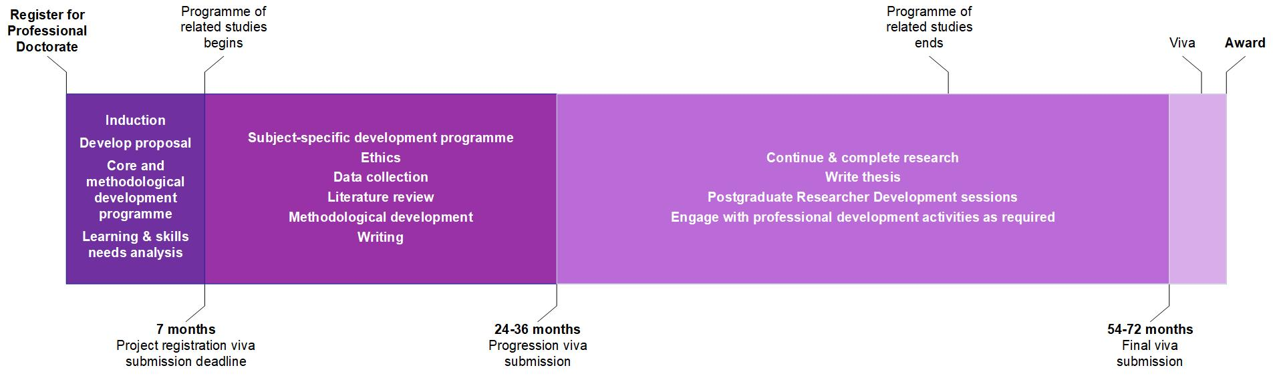
Professional Doctorate enrolment (part-time enrolment)
Milestone | Part-time
Professional doctorate registration start date | Your Graduate School induction date
Learning skills and needs analysis (LSNA) | Conducted annually with a mid-year review by the PGR and their supervisory team.  The first LSNA should happen within the first 6 weeks of Professional Doctorate registration and be reviewed mid-year.
Programme of related studies | Designed by the PGR and their supervisory team following each LSNA or LSNA mid-year review.  Design of the programme should happen within the first 6 weeks of Professional Doctorate registration and be reviewed regularly.
Project registration submission deadline | 7 months from your Professional Doctorate registration start date
Project registration viva date | Within 6 weeks of your project registration submission
Ethics submission | Made as soon as possible after your project registration examination
Annual appraisal | Coordinated by the Graduate School on an annual basis.  All doctoral PGRs are required to engage with this process.
Progression examination team proposal | Submitted to the Graduate School 3 months prior to your progression submission.
Progression submission deadline | 24 – 36 months into Professional Doctorate registration.
Progression viva date | Within 6 weeks of your progression submission.
Final examination team proposal | Submitted to the Graduate School 3 months prior to your final submission.
Expected final submission deadline | 54 months into Professional Doctorate registration
Maximum Final submission deadline | 72 months into Professional Doctorate registration
Final viva examination | Within 6 weeks of your final submission.
Graduation | Edge Hill conducts July and December Graduation ceremonies. Details are sent to the relevant PGRs annually to ensure registration for the most appropriate ceremony.

Support from the Graduate School
The Research Degree Handbook complements this addendum. Please ensure you read this alongside this booklet.
If you have any questions about the contents of this document, please contact GraduateSchool@edgehill.ac.uk.
Updated: 20 September 2022

http://eshare.edgehill.ac.uk/15194/
http://eshare.edgehill.ac.uk/15194/
http://eshare.edgehill.ac.uk/15194/
https://learningedge.edgehill.ac.uk/webapps/blackboard/content/listContentEditable.jsp?content_id=_3502079_1&course_id=_270202_1

