Digital & Innovation Skills Helix in Health

Introduction
Welcome to this ORCHA and DISH reflective learning package. It aims to introduce you to the ORCHA platform and to ways in which it can be used and aims to provide an opportunity to reflect on issues related to its use such as professional accountability, barriers to implementation and person-centred planning.
The structured reflection embedded in this portfolio can be submitted for feedback, and, as such, can subsequently be utilised towards periodic professional revalidation for nurses, midwives, doctors, and allied professions such as physiotherapists, dieticians, occupational therapists and speech and language therapists.
Nurses and midwives, for example, are required to undergo 35 hours of continuing professional development every three years, and to write reflective accounts related practice and CPD. The structure of the reflective exercises in this portfolio are based on the prescribed requirements of organisations such as the Nursing and Midwifery Council. Once you have completed the exercises in this document, please email sherratc@edgehill.ac.uk or clinicaleducation@edgehill.ac.uk for feedback.
More information can be found here:
http://revalidation.nmc.org.uk/

https://www.hcpc-uk.org/standards/standards-of-proficiency/

https://www.gmc-uk.org/registration-and-licensing/managing-your-registration/revalidation

Learning outcomes

By the end of this learning experience, you will be able to:
1) Demonstrate an understanding of how ORCHA and apps can be used to promote health and well-being, and to promote independence and self-care in clients with long term conditions

2) Reflect upon the scope of apps within health and social care settings

3) Identify the potential benefits, limitations and barriers, in the use of apps in
relation to person centred care.

4) Identify potential risks to service users in relation to apps

5) Reflect on the role of the health care worker in supporting the service
user/carer in engaging with apps.

6) Demonstrate an understanding of person-centred care and assessment in
relation to the use of apps.

ORCHA
All health professionals will be aware of the high prevalence of long-term conditions including physical and mental health. Moreover, there is an awareness that much of this is preventable, and, when established, many aspects of care can be self-managed. There is strong potential for using Apps to support people when they are aiming to prevent and manage long-term conditions.

Apps provide us with a very real opportunity to affect culture change in our healthcare system – contributing to moving the emphasis from ‘treatment’ to ‘prevention’ and harnessing the public’s own ability and enthusiasm [in most cases] to self-care and managing their own health.

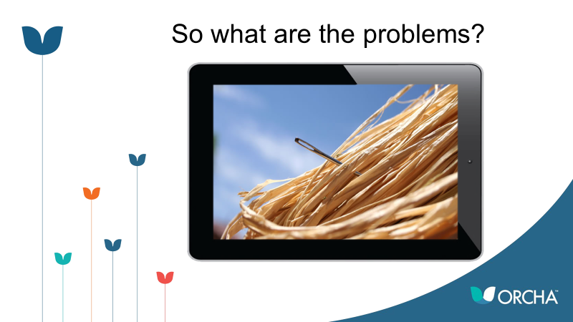

A brief internet search will reveal that there are many excellent Apps that are either freely available, available at a cost, or are accessible on subscription (or via some other method of ‘in app purchase’ such as access to premium content). However, it is difficult to establish which Apps are safe to use (e.g. they won’t sell on data to third parties) and if they comply with appropriate legislation.

Moreover, a health professional will need to be assured that the advice found within an App is evidence based, safe, and that it reflects national guidelines and health infrastructure including available resources.

ORCHA have established that there are three main questions on people’s lips…

1) How can you find the great Apps in such a crowded space?

2) How do you know if an App is safe to use, won’t mistreat your data and is likely to work for you?

3) How can Apps work along other services you use?

If people, the public and health and care professionals alike, had confidence in apps – and were proactively using them – we could reduce pressure on the healthcare system with fewer people becoming ill in the first place, and people being able to manage their own existing conditions better.

ORCHA is here to help; providing a platform on which both patients and health professionals can access health and care apps that have been rated on their merits.

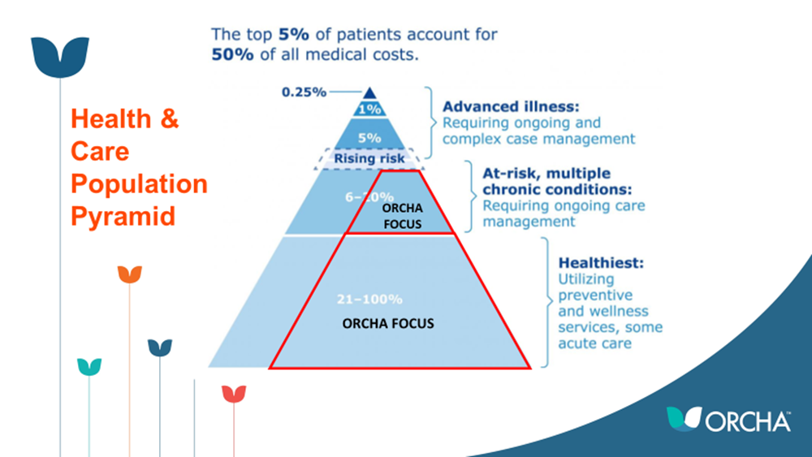

It’s free for you to use – and is not only a resource for you to encourage your patients to use, but you can also recommend specific apps to specific patients using the system’s text/email facility.

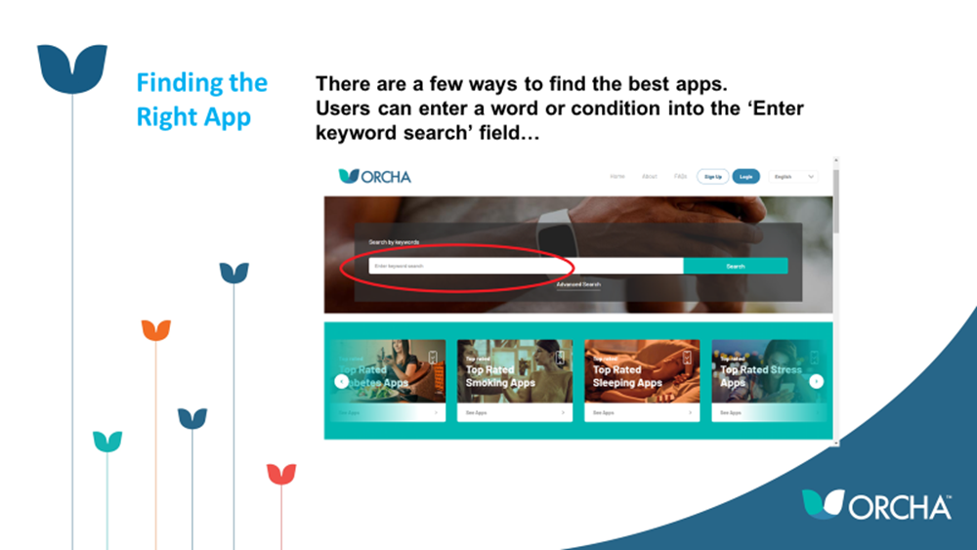

What’s more, professionals can recommend specific apps to individual patients, according to their needs and requirements – using ORCHA to send texts or emails in a triage or consultation setting, be that face-to-face or remote.

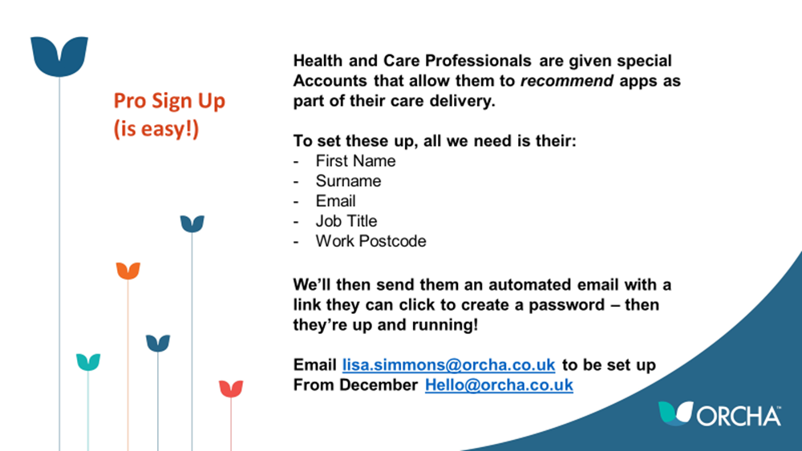

There are many positives related to using Apps to promote independence and well-being.

However, it is important to understand potential barriers. This includes personal barriers identified by the individual and or family member, such as:- fear of new technologies, lack of access to these new technologies (such as smart phones), lack of confidence in their use, reluctance to accepting that support or change is required, and/or concerns that using the Apps may result in a reduction of support given by health and social care workers.

Activity
Identify an App that could be used to meet a specific need, e.g. communication, safety, and/or the ability to recognise when action is needed. Now:
- Identify the benefits of the App for this specific group in terms of health, well-being and the promotion of independence.
- Consider the limitations of the App and the advice that may need to accompany its use.

App

Health and social care needs of group that might be supported by the App

Potential benefits of the App for this specific group

Limitations of the App

Are there any members of that group that the App might not be suitable for?

Barriers to effective use

Support and advice that a typical member of that group may need

Health and social care providers may also identify barriers to the use of Apps including service integration, risk assessments, staff training, monitoring, maintaining and updating, and for some health and social care staff the fear of changes to job
role.

Please reflect on the barriers to App use in your specific workplace, and, if appropriate, consider ways in which these may be addressed:

Barriers to use

Strategies to address barriers to appropriate uptake

Barriers that cannot be circumnavigated and that prevent full uptake

It is important to acknowledge that not every patient will want to, or be able to, embrace apps. Moreover, a specific App may appeal to a health professional, but a patient may have different preferences and priorities. Patient centred care is, therefore, something that will be considered in this reflective portfolio.

ORCHA can help facilitate patient centred care because it has the facility to match the best app to the individual. By using the Advanced Search options available, a filter can be applied to enable people to find the App they want, with the right features – and matching to their needs (such as cost, age, etc). This may increase the probability that a user will have a positive experience with an App – first time!

Personal Reflection Activity
Consider your role in supporting a service user to select and use an App

Which other members of the multi professional team may be involved?

How could you support a service user to express their choices and concerns in relation to an App?
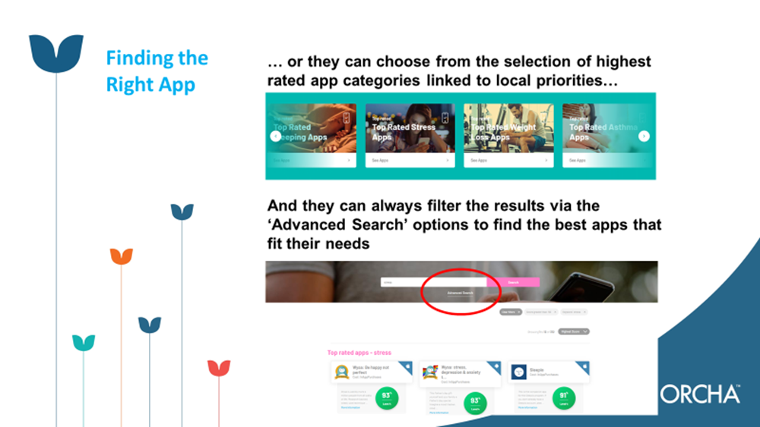

It’s far more likely that someone will ‘stick’ with an app and see the benefits of it if it comes on the back of a recommendation from a health or care professional, so ORCHA have built the functionality within the site that means you can recommend apps to your patients as part of your care delivery.

Across Liverpool, the CCG have funded ORCHA Pro Licenses which provide the facility for you to make these recommendations. If you do not yet have one, but would like one to support your learning and professional practice, please contact hello@orcha.co.uk with your name, where you work, your job title, and your email address.

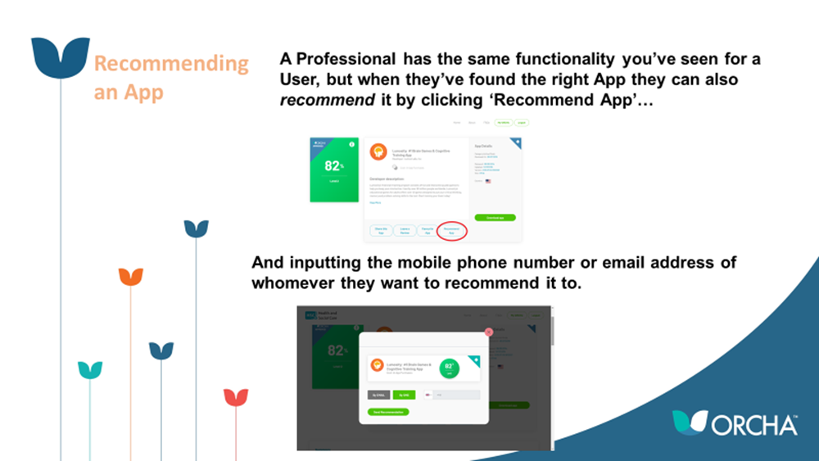

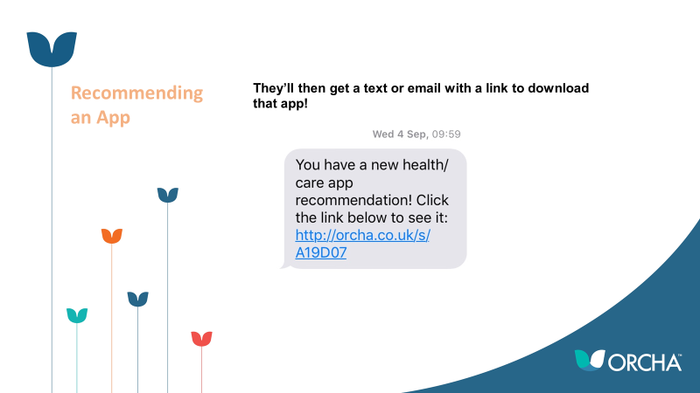
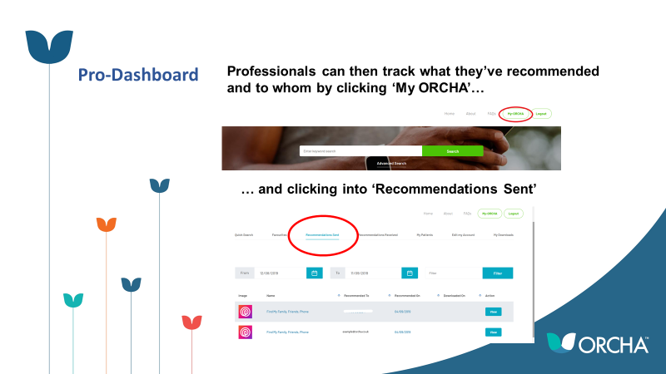

By providing high quality apps to those either on waiting lists, in active treatment, or who have been discharged from the care pathway, we can potentially support users to achieve better outcomes than they might otherwise have done.

Activity: ‘Person Centred Thinking’ Tools
A variety of person-centred thinking tools are available from:
http://helensandersonassociates.co.uk/person-centred-practice/personcentred-thinking-tools/sorting-important-tofor/ . Click on the link and explore the tools that you might find useful in your working practice. Watch the video “sorting important TO /FOR.” Now answer these questions:

What are the benefits to the service user of a person-centred approach to care?
What are the benefits to the health and social care worker?

What is your role in promoting a
person-centred care?

There are some limitations to ORCHA, and the Apps do not take the place of essential health education or review of the management of long term conditions – rather they can be used as a tool to support such interventions, especially where there is pressure on services.

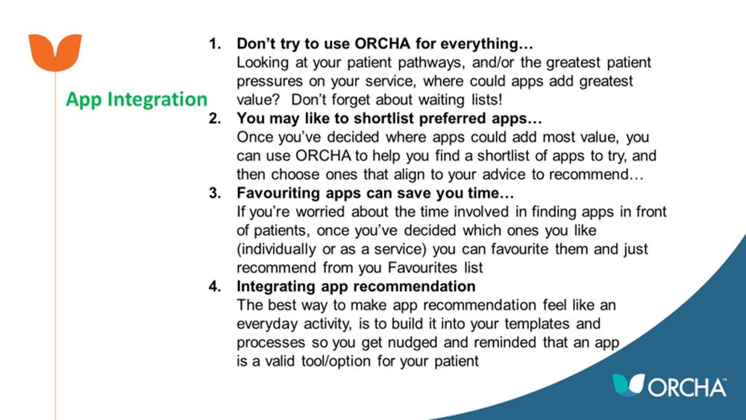

Crucially, all Apps found on the ORCHA platform have been reviewed, and details of the reviewing process can be found here: https://liverpool.orcha.co.uk/about

You will see that each App is scored, the higher the score the more confidence that a health professional can have in it. ORCHA explain that ‘any score below 65% would indicate that an App has some issues that users should investigate further prior to using this App. Scores below 45% indicate that an App has considerable issues or challenges and in its current form is potentially unhelpful or unsafe’. As a health professional, it is important to be aware that patients may not understand the risks of accessing low-scoring Apps.

ORCHA are also keen to explain that a high scoring App is not guaranteed to be effective or safe, although it does mean that the App developer has taken more care over the App's compliance with key Standards than other similar Apps.

So, there is no guarantee that the App is clinically safe. Indeed, when ORCHA assess for ‘clinical assurance’ it looks for evidence that there is a qualified professional or organisation behind the App or that it has been endorsed, accredited or underwritten by such an individual or organisation. This does not mean that ORCHA has assessed the app to ensure that it is evidence based, or that it complies to national guidelines. Many Apps are international, and it may be that an App was designed to be used in a different context to that which you intend applying it.

It is important, therefore, that you are confident that the clinical content of Apps that you are recommending are evidence based, that they can operate within the context of local systems and resources.

Risk management
Risk management is concerned with the assessment, analysis and management of
risks. It is simply recognising which events (hazards) may lead to harm in the future
and minimising their likelihood (National Patient Safety Agency 2017)
http://www.nrls.npsa.nhs.uk/resources/?entryid45=59825&q=0¬risk¬&p=3

Clinical risk management is concerned with improving quality and safety within health and social care practice. The success of any risk management is to raise awareness of any potential hazards or risk of harm and then acting to prevent or reduce those risks.

Five Steps to Easy Risk Assessment (National Patient Safety Agency, 2007)

Activity.
Select an App related to your specific speciality. Now answer these questions:

Are there any risks associated with the use of the App?

Is there anything that could be done to reduce those risks e.g. patient education?

Can the App be ‘dovetailed’ into existing care to ensure that risks are minimised?

Reflection.
Finally, remember that you are encouraged to reflect on your learning, and also on significant events that support your professional development, such as the implementation process for ORCHA and associated Apps.

Remember that you can learn equally by reflecting on things that go well (so you can do it again in future) and also on things that did not go well, or where barriers were experienced (so you can change what you do next time).

Please find an example of structured reflection that can be used for professional revalidation, (overleaf). This example is adapted from the Nursing and Midwifery Council. NMC Registrants are advised to use this form. Registrants from other professional bodies can choose to use this form, or can substitute forms from their own professions. Everyone should also complete the Submission Template.
You must use this form to record five written reflective accounts on your CPD and/or practice-related feedback and/or an event or experience in your practice and how this relates to the Code. Please fill in a page for each of your reflective accounts, making sure you do not include any information that might identify a specific patient, service user, colleague or other individuals.
Please refer to our guidance on preserving anonymity in the section on non-identifiable information in How to revalidate with the NMC.
Reflective account:
What was the nature of the CPD activity and/or practice-related feedback and/or event or experience in your practice?
What did you learn from the CPD activity and/or feedback and/or event or experience in your practice?
How did you change or improve your practice as a result?
How is this relevant to your Professional Standards (‘The Code’)?
Select one or more themes: Prioritise people – Practise effectively – Preserve safety – Promote professionalism and trust

Digital & Innovation Skills Helix in Health

SUBMISSION OF REFLECTIVE PORTFOLIO
FOR FEEDBACK
FULL NAME

WHICH PROFESSIONAL BODY ARE YOU REGISTERED WITH?
EMAIL ADDRESS

Once you have completed the exercises and reflective statement in this document, please send by email to sherratc@edgehill.ac.uk or clinicaleducation@edgehill.ac.uk for feedback.

