Activities
This guide is for personal users
Guide updated 29/04/2022
Contents
What can I record as an activity in Pure? 2
Existing activity records 2
Selecting a type 2
Activity types & sub-types 2
Creating your activity 3
Activity information 4
Description 4
Period 5
Degree of recognition 5
Person/organisations 5
Person role 5
Activity managed by 6
Documents and links 7
Keywords 7
Public engagement types 7
Relations 8
Record visibility 8
Things to note about… 8
…the external examination type 8
…membership types 9
…Fellowships 9
…the research degree supervision sub-type 9

What can I record as an activity in Pure?
- Think of these as ‘esteem’ records that you want to showcase on your profile and in CVs.
- You can relate an activity to other records in Pure, allowing them to complement each other and show different aspects of the same work.
- You are best placed to decide whether you would like to tell the world about an activity, but you should consider the benefit of adding the record. For example:
  - Is adding it a good use of your profile’s ‘real estate’? Or would it dilute your profile/confuse the audience?
  - Is membership of an internal committee/group of interest to the reader?
  - Was your participation in an event significant enough to justify an activity record or should it just be mentioned elsewhere in your profile?
If your activity record contains no description or files, it merely tells the reader where you were on the given dates. You should consider whether that is of interest or use to the public; if it is for internal use only, you can change the record’s visibility.

Existing activity records
- Once you have located your existing activities, you can sort or filter them as required.

Selecting a type
Always click or or where you see them before you close a window or section, or your changes will not be saved.
- to open the submission guide window.
- Choose

Activity types & sub-types
- You first need to select an activity type (middle column) then a sub-type within that (right-hand column).
- The form you need to complete will be different between each parent type. But the form you need to complete for the sub-types within your chosen parent type will be the same as each other.
  - e.g. Membership of a council and Membership of a network use the same form as each other because they are both sub-types within Membership types; but they use a different form to (e.g.) any activity under Talk or presentation types.
- Hover over the type or sub-type in the submission guide window for a brief description of its intended use.
- Click on a sub-type to open the activity editor screen.
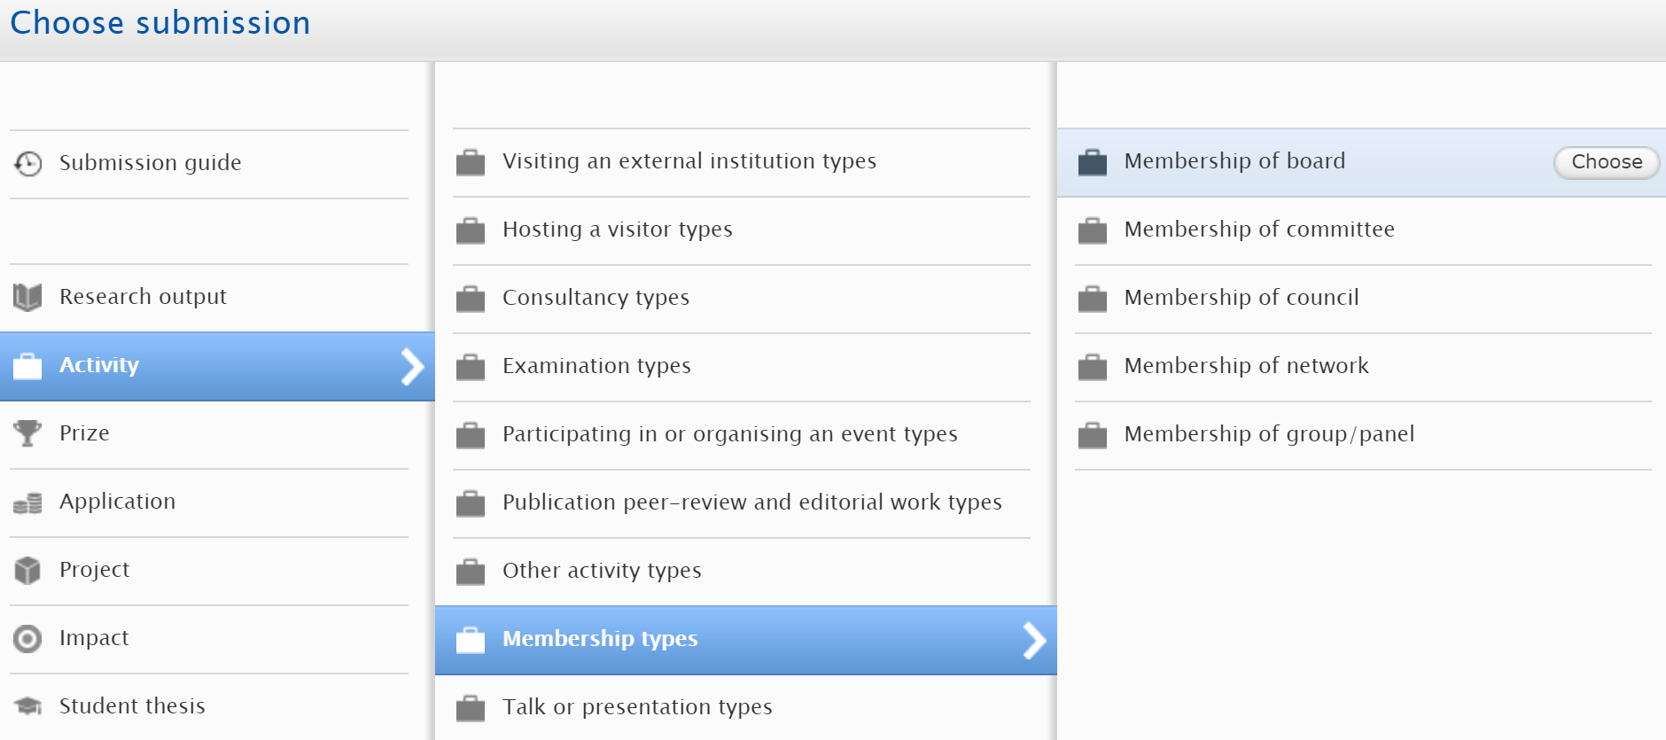

Creating your activity
- When you have selected your sub-type, add as much metadata as you reasonably can to explain the activity and your role in it to the reader.
- Some fields are common to all activity types, but other fields are specific to the type you select.
  - There are also some important things you need to keep in mind for certain activity types and how Edge Hill uses them, explained at the end of the guide.
- Check how the activity looks on the portal when you are done – you may want to edit, add or remove some metadata.
- Your department or faculty may also have certain requirements of its own that you should be aware of in terms of information to record or a consistent style to follow. If so, you will need to ask someone appropriate in your area for details.

Activity information
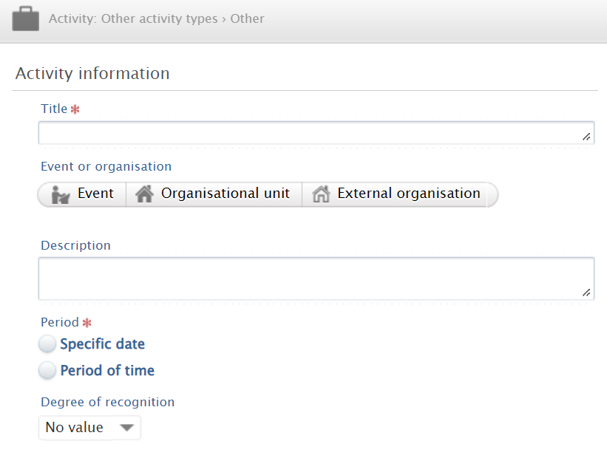
- Give your activity a clear title; something that allows you and others to understand what it is at-a-glance, and to differentiate it from other similar activities if possible.
- Depending on the activity type selected, this section near the top of the window gives you the option to link the activity to a:
  - Journal
  - Publisher
  - Event
  - Internal organisational unit where the activity took place.
    - Do not select one just because it is your home department if the activity did not take place there; your department is automatically added as managing organisational unit.
  - External organisation where the activity took place, or the parent organisation for activities such as memberships.
- You can only add one of these to a single record so choose the most appropriate/informative one for your activity.

Description
It is important to include some details about the activity for the reader, so they know what they are looking at.
- You can use this field to expand on your role, the nature of the activity, etc.
- If the activity is a membership of an external sub-group or committee, you can state which one here.
  - You would have added the parent organisation of the group as the external organisation at the top of the window, as per the previous section.

Period
- Choose either:
  - Specific date (e.g. the date on which you delivered a speech), or
  - Period of time (e.g. the start and end date of your membership of a group or other body).
- You need to provide the year as a minimum, but the more precise you can be, the better.
- Period of time can contain just the start date (or year); leaving the end date blank leaves the activity open-ended so don’t forget to add it at some point!

Degree of recognition
- Give the reader an idea of whether this activity was local, regional, national or international.
- You can skip this if not appropriate for the activity type.

Person/organisations
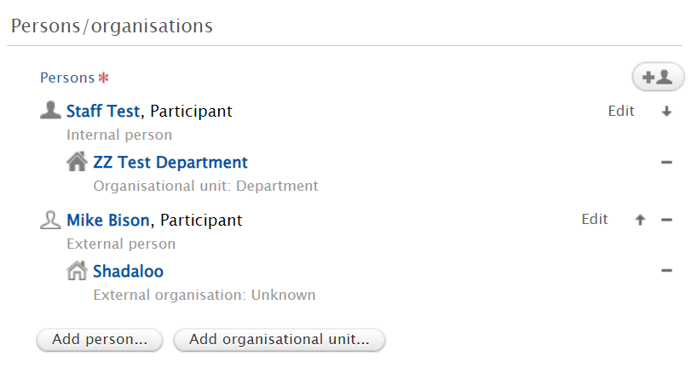
- You will usually automatically appear in this section, with your internal organisational unit affiliations (e.g. department).
- You can edit your departmental affiliations (for this activity record only); it will not change the affiliations on your person profile.
- You can add other internal or external people or even external organisations to the activity as collaborators, if appropriate.
- Adding an internal person will add the activity to their Pure profile as well, and they will be able to edit it.

Person role
- Each person added to the activity record is automatically assigned a default role on the activity.
- The default role varies according to the chosen activity type.
- The default role may not be appropriate for your/your collaborator’s involvement in the activity, for example you may have delivered a keynote speech so you should change your role from Speaker to Keynote speaker.
- Change the role by clicking Edit next to the person’s name and selecting a different role as necessary.
- You can provide more information about your role in the activity Description field (above), if needed.
- If you feel a role should be added to the available list, let us know.
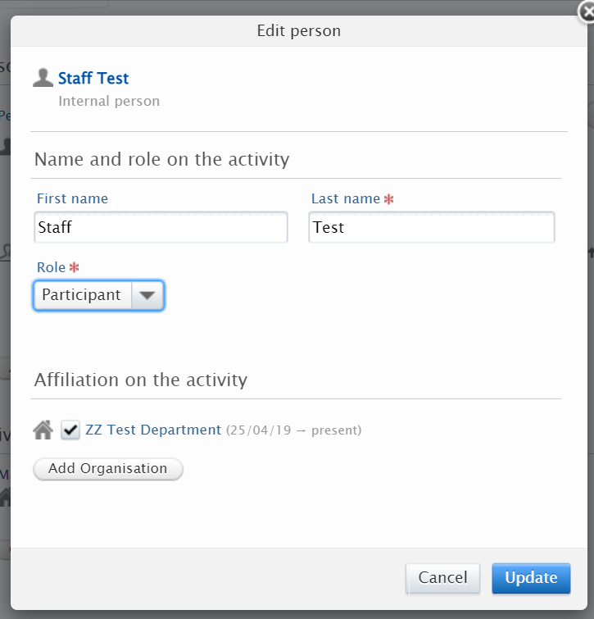

Activity managed by
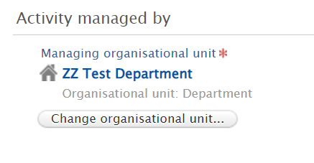
- The managing organisational unit will always be your home unit. You cannot change it to a unit you are not based in, according to the staff record.
- This determines which department can report the activity.
- If the activity is research degree supervision, with supervisors from multiple departments named in the person section, the managing organisation should be that of the DoS.

Documents and links
- You can add relevant documents and links to the record.
- Consider whether they are necessary for the purpose of the activity record.
- You can restrict visibility of individual documents if you want the overall activity to be publicly visible but not a particular file, but always check that the restriction has taken effect by looking at the activity on the portal (you may need to refresh the activity’s portal page in your browser a few times if other public changes have not taken immediate effect.
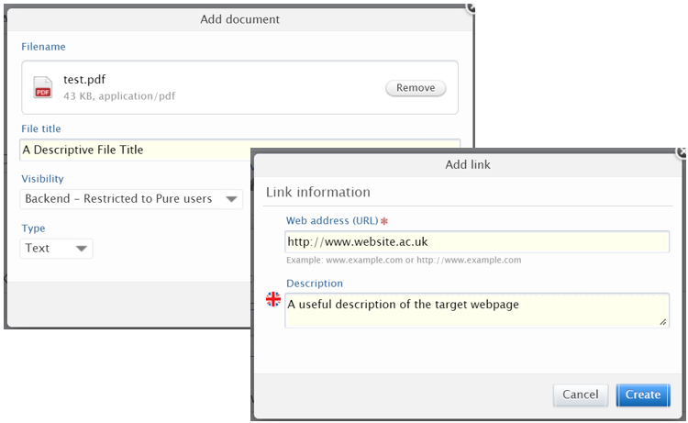

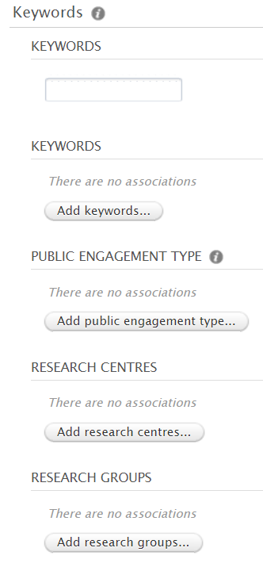
Keywords
- In addition to entering free text keywords, you can select pre-defined keywords by using the various buttons in this section.
- See the Keywords user guide for how keywords operate across Pure.
- The public engagement type keyword section is specific to activities.

Public engagement types
- Optional but recommended where appropriate for the activity
  - e.g. the activity involved engaging with non-academic groups or organisations for public benefit.
- Click and a list of labels will pop up.

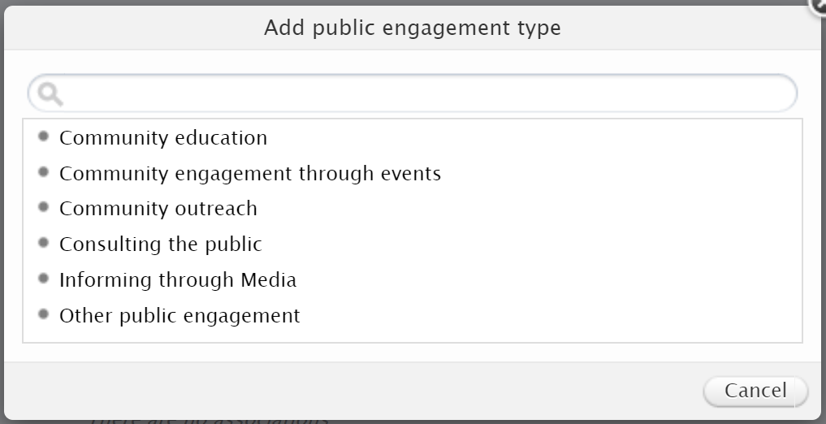
- Select an appropriate label and the list will close. You will see the label has been added to the activity editor window.
- Click the button again to add more labels as appropriate for this activity.
This field is visible on the activity record on the public portal so visitors can see that your activity involved public engagement. They can also filter Activities searches on any of these public engagement types to discover all activities that contain them.

Relations
- You can relate the activity to other content in Pure where appropriate. See the standalone user guide on relating content in Pure.

Record visibility
- You can control the visibility of the overall activity record.
- The default is Public i.e. visible on the portal.
- If you restrict visibility to the record, the visibility of all files attached to it is restricted regardless of each file’s own visibility settings.

Things to note about…

…the external examination type
- Do not include:
  - The name of the student you examined. This is the student’s personal information and is neither essential for you to save the record, nor relevant for the reader to understand the significance of the activity.
  - Acting as an ‘external’ examiner within Edge Hill while you were employed here e.g. as someone external to another department or faculty.
- Do:
  - Include the broad subject and university in the activity title, if it does not identify the examinee e.g. PhD examination: Cognitive Psychology, Empire State University.
  - Add the external university using 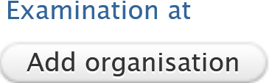 to create the connection between your activity and that university e.g. on your network map, in reports.

…membership types
- Membership of network
  - A network/group that disseminates research across institutions e.g. special interest group, research network, professional bodies, etc. Its aims may not be as tightly defined or measurable as those of a group or panel.
- Membership of group/panel
  - A group or panel with more specific, measurable aims than a network e.g. working groups, standing groups, expert panels.

…Fellowships
- If the fellowship is related to other content (e.g. funding recorded in Pure) you can relate the activity to the relevant record (e.g. a project record that the activity and funding award records have in common).
- If you wish to prioritise any fellowships on your public profile, you can set them as highlighted content.

…the research degree supervision sub-type
- Create one activity per student supervised.
- Title. It may be appropriate to name the student in the activity title, to help distinguish between activities in your activity list e.g. PhD supervision: Gwen Stacy.
  - Generally, you should be okay to name an internal doctoral research degree student because they likely have/had a public profile in Pure and you could relate the activity to the student’s own Pure content (see below).
    - Do not name any other type of internal student because they will not have had a Pure presence of any kind.
  - You might be okay to name external students.
There could be personal/data protection reasons that mean you should not identify the student in your activity, even if they are on an internal doctoral research degree, so it is good practice to agree with the student whether you can name them, whether internal or external. If in doubt, find another way to differentiate between supervision activity records.
- Add the (internal) organisation or external organisation (another university) of the student in the Activity Information section at the top of the window (see above).
  - This will create the connection between your activity and that internal department/faculty or the external university e.g. on your network map, in reports.
- Description. Enter the thesis/project title.
- Person section:
  - Add your co-supervisors (internal and external). Select the appropriate role for each.
    - By saving this record with internal supervisors added here, it is automatically linked to all your Pure profiles, and you can all edit it.
  - Do not add the supervised student to the Person section.
- Relations: if the internal student has created a doctoral project record in Pure, you can relate this activity to that project to show the supervisory relationship. That project can act as a stepping stone for the reader to discover other related records (e.g. the thesis, outputs).
Pure is a showcase, it is not the system of record for PhD information, so changing details in Pure (e.g. supervisory teams) will not change the information approved by the University. Follow Graduate School procedures instead.

