RefWorks User Guide

Library & Learning Services

**Table of contents**

About RefWorks 3

Create an account. 3

Adding References 3

Manual Creation 4

Exporting references from Discover More 5

Exporting references from an online database 5

Exporting references from the British Library 8

Exporting references from Google Scholar 9

Editing references in RefWorks 11

Folders 12

Using Folders to organise references. 12

To Permanently delete an item from RefWorks, g 12

Reading a document 12

Annotating a document 14

Highlighting: 14

Creating a Bibliography 15

Quick cite. 16

Advanced features of RefWorks 17

Bulk editing 17

Sharing Documents and Collaborating 18

Custom style editor 19

Using Refworks in Microsoft Word: RefWorks Citation Manager 20

# About RefWorks

RefWorks is designed to help organise your research and store bibliographic information all in one place. This information can then be used to generate reference lists and citations in the appropriate format.

# Create an account.

This is the link to [RefWorks](https://refworks.proquest.com/)

There are links to RefWorks on the Referencing section of the Uniskills webpages, at <https://www.edgehill.ac.uk/ls/uni-skills/referencing/>, or the Referencing tools page on the Research Support webpages at [Referencing tools - Learning Services (edgehill.ac.uk)](https://www.edgehill.ac.uk/ls/research/refworks/)

Once in RefWorks select the **Create account** link.

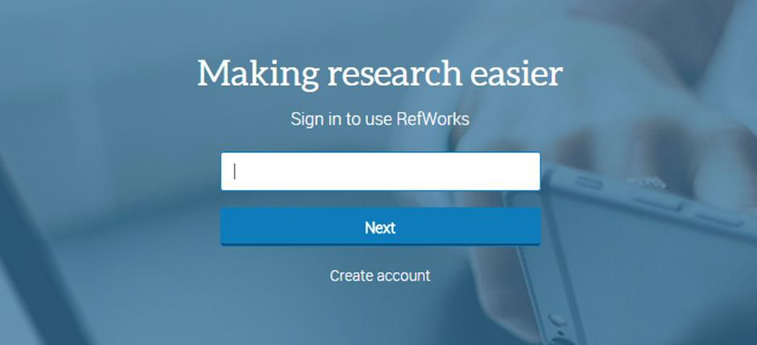

Sign up ensuring you use your Edge Hill University email address. Your RefWorks password is personal to you and Library & Learning Services cannot keep a record of this data.

Once signed in, RefWorks training, YouTube tutorials and more support are available via the help icon at the top right of the screen. The image shows the blue and white question mark icon that appears at the top right hand corner of the RefWorks screen.

# Adding References

## Manual Creation

|  |  |
| --- | --- |
| Manual creation of a record isn’t something you need to do very often, but if you have a tricky reference or a physical copy of a printed item, you can add it yourself. Simply click on the + Add button and select **Create new reference.**  From the drop-down menu, select the type of reference you wish to add. RefWorks will display the fields you need to fill in and will try to identify your reference and autocomplete the fields. | A Screenshot of the menu that appears when you click on the +Add option. The Create new reference option is highlighted. |
|  |  |

The new reference will go into your **Last Imported** folder (unless you specify otherwise).

## Exporting references from Discover More

To export the details of a book or a journal article to RefWorks, first perform a search of Discover More.

There is a **Cite** link in the record of the book or article. Clicking on this brings up a pop-up box. On the left-hand side, you can **Export to** **RefWorks.**

RefWorks confirms that your reference has been added and it will go into your **Last Imported** folder.

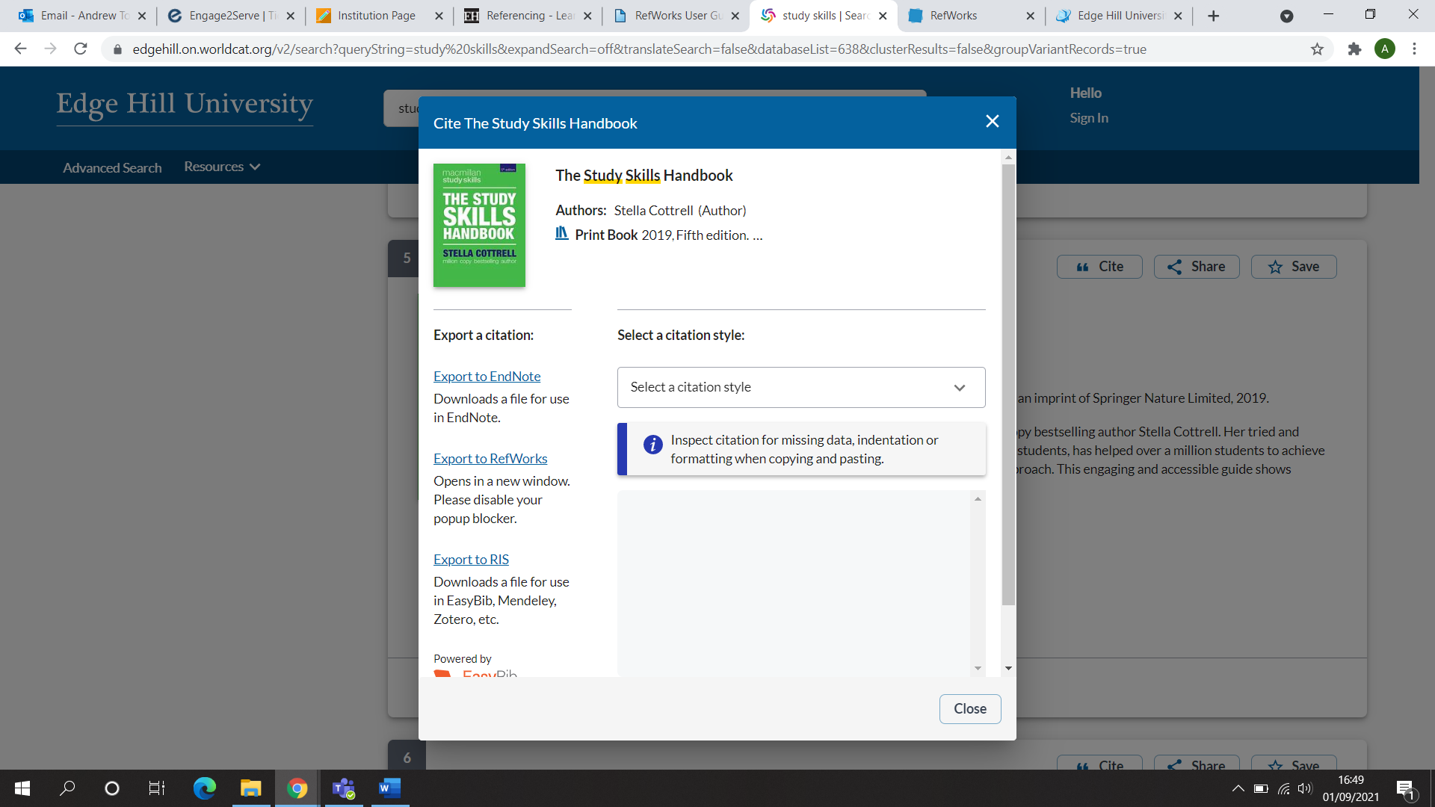

## Exporting references from an online database

If you are sending references from an online database to RefWorks, you need to be logged in to your RefWorks account and have the database open in the same browser.

Please note that every database will have a different way of saving articles to RefWorks. Some databases directly link to RefWorks, but some require you to download your references and import them into RefWorks. It is usually straight forward, but if not, the help function of the database will give you instructions.

Scopus is an example of a database where you need to export the references Select the articles you wish to send to RefWorks and, click **Export.**

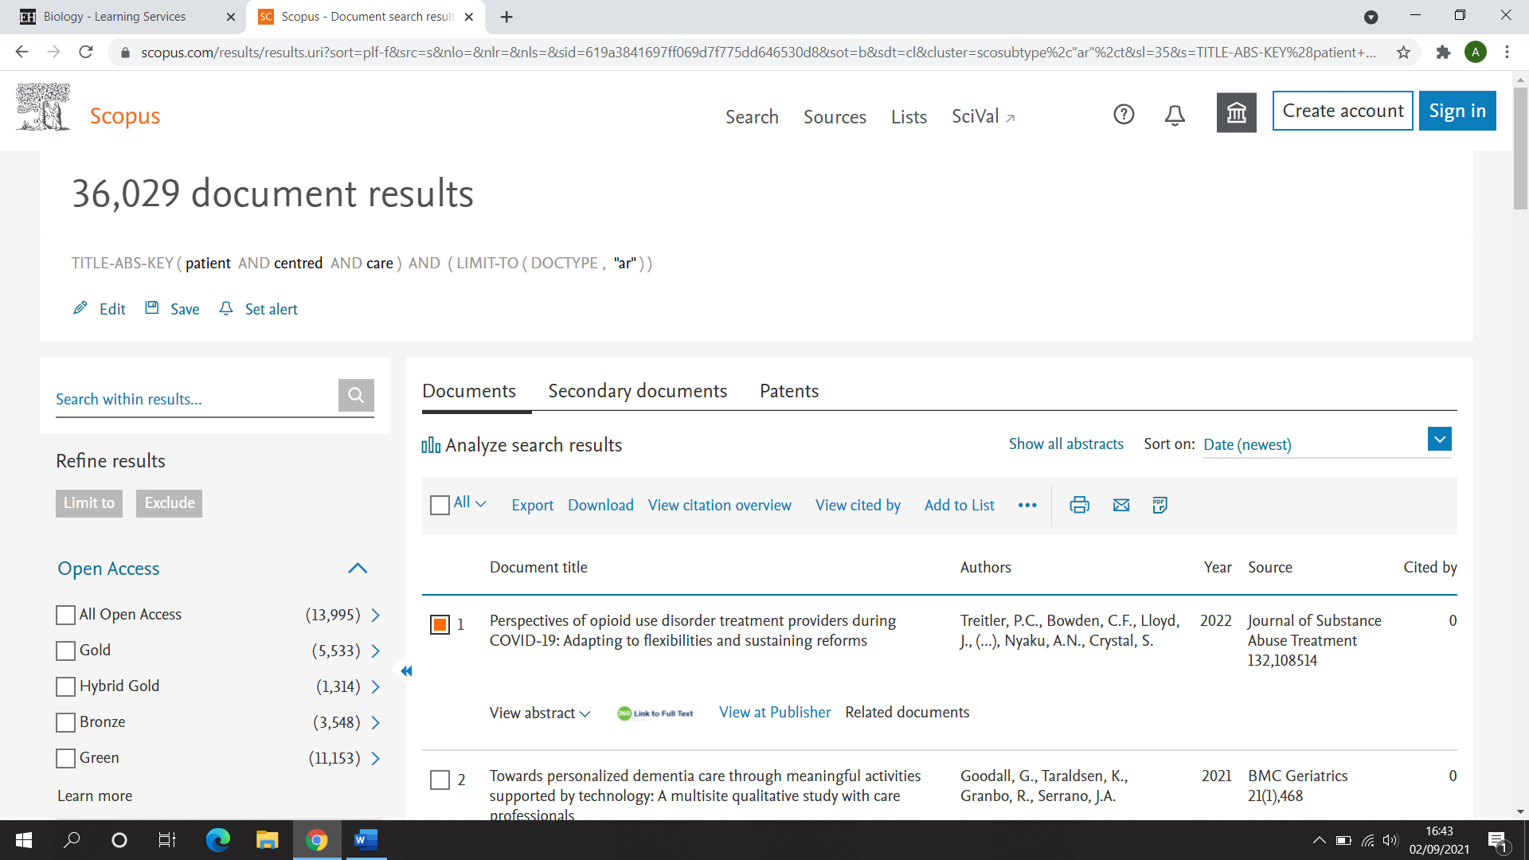

A list of File Type and Reference Manager options will appear, select RefWorks (RIS).

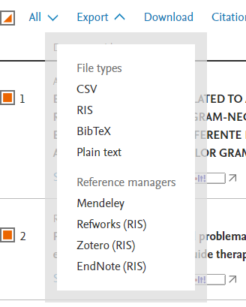

When you have chosen to send your references to RefWorks, you need to press **Export**.

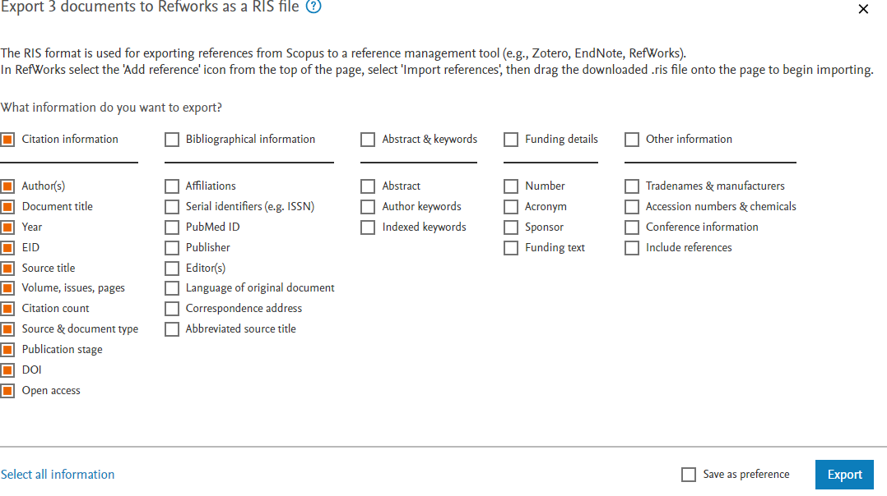

Your Scopus references will be sent to your **Downloads** folder. From there you can import them into RefWorks.

Log into RefWorks and select **+Add** then **Import References**.

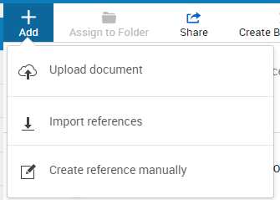

From here, you have the option to **Select File from your Computer**. Navigate to your Downloads folder and choose the file with the format RIS formatted file. You will be given a list of possible RIS file types, you can select RIS Scopus. This will help RefWorks import your references with the most accurate information possible.

Finally click on **Import.**

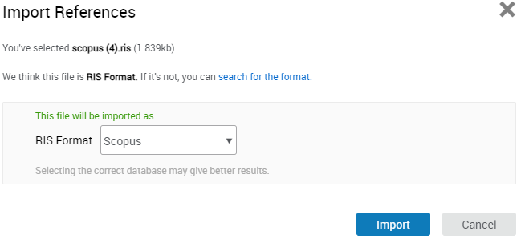

RefWorks confirms that your references have been added to your **Last Imported** folder.

## Exporting references from the British Library

During your research you may have borrowed books on inter-library loan from the British Library or have used books that are not in the EHU library. By using the British Library export function, you can use the information to create records in your RefWorks account.

Visit <https://www.bl.uk/> and select their main catalogue search.



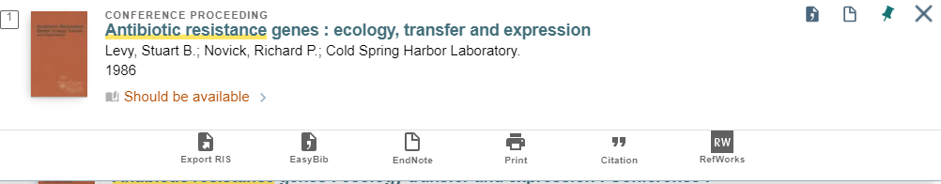

Identify the item that you require and then click on the details of this item.

Select the item you require and choose **RW RefWorks** below the item record.

Please note that you may need to edit this reference in RefWorks, it is easiest if you do this when you export the records, so you still have the original source record open to check the details.

## Exporting references from Google Scholar

If you use Google Scholar to locate references, you can export the individual references to RefWorks. In Google Scholar, go to the 3 horizontal bar menu icon and select settings.

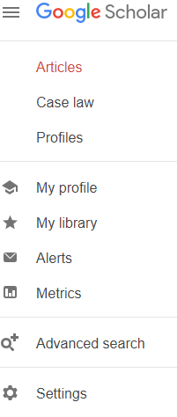

Then in the bibliography manager use the drop-down to select RefWorks and save.

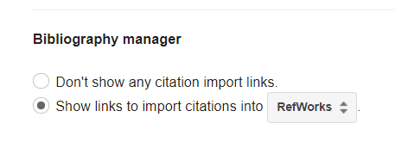

In the item records you will then see an option to export to RefWorks.



# Editing references in RefWorks

It is worth checking your references as you import them into RefWorks to ensure that all the metadata has been imported correctly. You can edit them to add in any additional data you may want to include. You can also use the edit function to add a note to your references (e.g. the date you imported them)

To edit a reference, select the one you want, then when it opens on the right-hand side of the screen, click on the pencil icon.

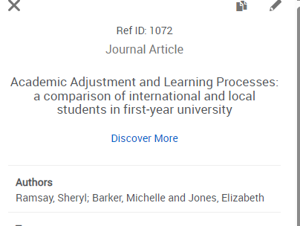

If you reference doesn’t have all the fields you would expect to see completed, you can use the **Find and complete a reference** function to fill in more fields.

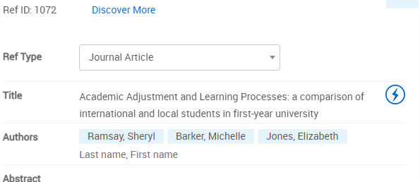

If you want to revisit the full text of an article, you can manually add in the pdf or you can use the **Discover More** link at the top of your reference to take you back to the article.

## Adding a PDF to an article in RefWorks

When your article’s details are imported into RefWorks, you can download the full text of the article into your RefWorks library. Select the citation in your **Last Imported** folder and click on the The pencil icon  icon. You can then drag and drop the pdf file or upload it from your computer if you wish to store it in RefWorks.

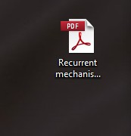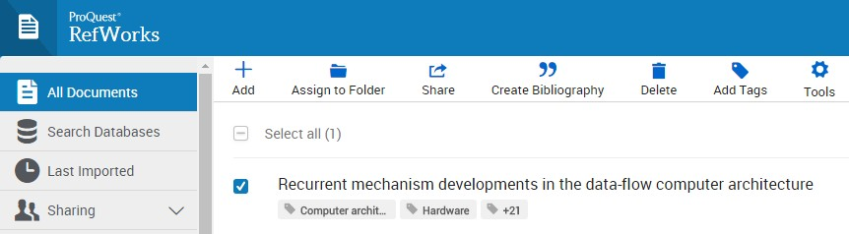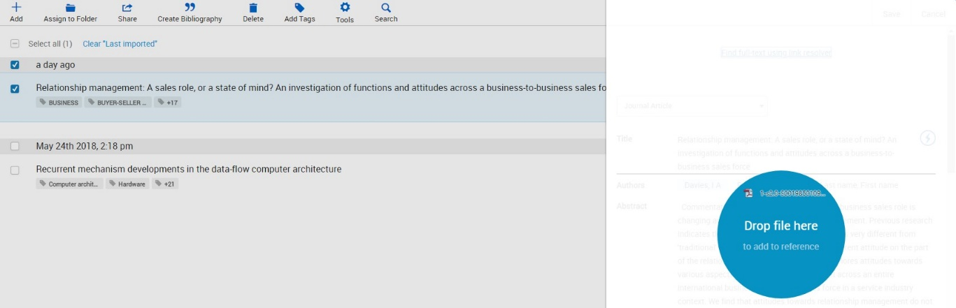

This is an optional step you can take to include the full text of your references; you can also use the link to return to the original reference.

# Folders

|  |  |
| --- | --- |
| RefWorks allows you to organise references into folders.  To create a folder, simply click **My Folders** on the left-hand side of the page, then **+ Add a folder**.  Name your folder and click **Save**. Your new folder will appear on the left-hand side of the page under **My Folders**. References can be added to more than one folder.  To add a subfolder, select a folder and click on the menu button to the right of the folder name. Select **Add subfolder** and give the new subfolder a name. |  |

## Using Folders to organise references.

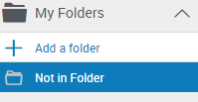

Once you have created a folder, you can organise your items.

From the **All References** or **Last Imported** view, click on an item and drag it into the folder of your choice, or select the items you want using the checkboxes and use the **assign to folder** option at the top of the screen.

You can drag items from one folder to another (the item will remain in the original folder as well). Click the folder name to view all the items within that folder.

To remove an item from a folder, go to the folder and select the item(s) you wish to remove. Click the delete button. When you remove items from folders, they remain in RefWorks in the All Documents area.

To Permanently delete an item from RefWorks, goto the **All References** folder, select the item(s) you wish to delete and click the **delete** icon. You will be asked to confirm that you want to do this as deleting items from the **All References** folder is a permanent deletion.

You can add tags to references to organise your items further and you can use those tags to search for references in the RefWorks search box.

# Reading a document

RefWorks has a built-in document reader. You can read supported documents using a web browser.

To read documents, you must first bring the citation details and the full text into RefWorks (see above).

Click on the listed link to read the full text. If the item does not contain a document, the bibliographic data of the reference only will be displayed.



When reading a document, you have several options, which can be found on the tool bar on the top of the page.



On the left-hand side, you will find options to zoom in and out; print; download document; highlight and add comments on the selected text.

On the right-hand side, you will find the option to make document notes and to edit the references.

## Annotating a document



You can annotate any of your own documents saved in RefWorks. You may be able to annotate documents shared with you if you have been given permission to annotate and/or modify the document.

To annotate a document, click on the name of the item to open it in RefWorks. Click the letter A comment icon at the top of the page.

Image of the icons within ythe RefWorks PDF reader. Select the icon with a capital A inside it to add a comment.

Select the text area you wish to comment on. Your comment will appear to the far right of the selected area. You have the option to change the colour of your comment by clicking on the colour of your choice in the comment itself.

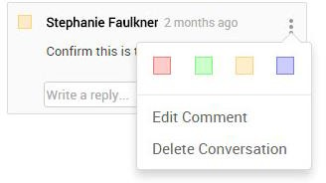

If you change the colour of your comment, the associated highlighted text annotation will be the same colour.

Comments can be edited or deleted at any time. To edit a comment, just click on the comment and make your changes. To delete a comment, click on the comment and click the “x” in the right-hand corner of the comment. Once you type a comment, it is automatically saved.

Highlighting: You can also highlight text within the document. Click the highlight icon and drag your mouse across the text you wish to highlight. To remove highlighting, click on the highlighted area and select Delete Conversation.



# Creating a Bibliography

You can easily create a bibliography from your **All References** area or any RefWorks folder.

Go to the folder you want and click the **Create Bibliography** button and select **Create bibliography**.

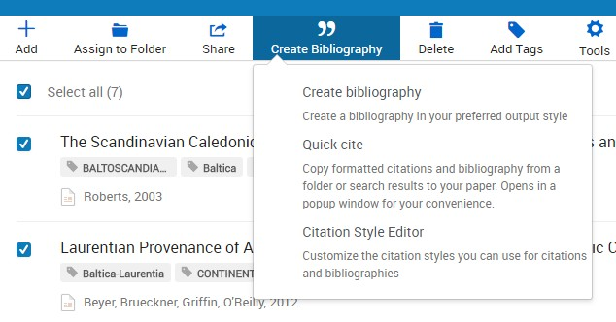

You can choose to create a bibliography for selected references or for all references in the folder.

The Edge Hill Harvard referencing style is used by most departments and is based on Harvard British Standard. You can however also choose from the list of referencing styles in RefWorks.

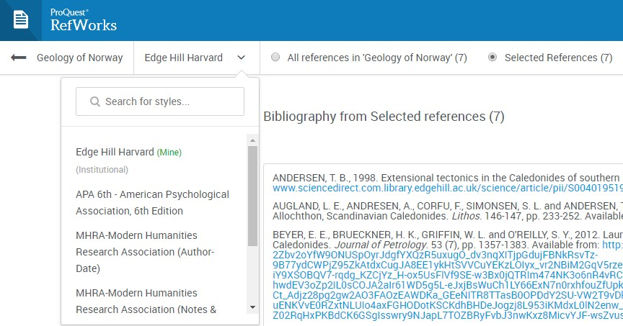

Your formatted bibliography will then be displayed for you to copy and paste into any word processing software. You should always double-check the bibliography with your department’s referencing style to ensure that it matches and for any incorrect formatting or missing information.

# Quick cite.

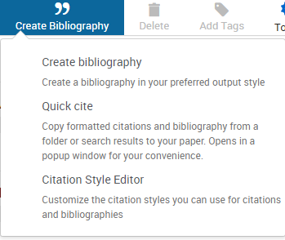

Quick cite enables you to quickly create a reference list. It can be found in the Create Bibliography menu.

When you have selected the folder containing the papers you want to cite, you will be asked to choose your preferred reference style, then the references you want to reference. A bibliography is generated which you can paste into your document.

# Advanced features of RefWorks

## Bulk editing

You may want to annotate multiple items with the same message, for example that you imported them on a specific date for a specific search. Using bulk editing ensures that the same message is repeated on all the selected records.

Select the batch of references or folder that you wish to annotate.

From the toolbar select tools

The blue and white tools icon in RefWorks in the shape of a cog, and also labelled tools.

and then bulk edit

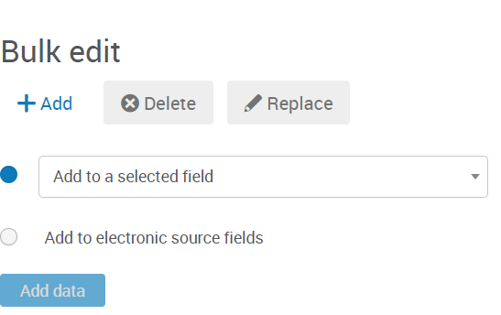

In the add to selected field drop-down, select the notes field and type the information that you require into the free text box. Ensure that you retain **leave existing data alone** as you may already have added text to the notes field previously.

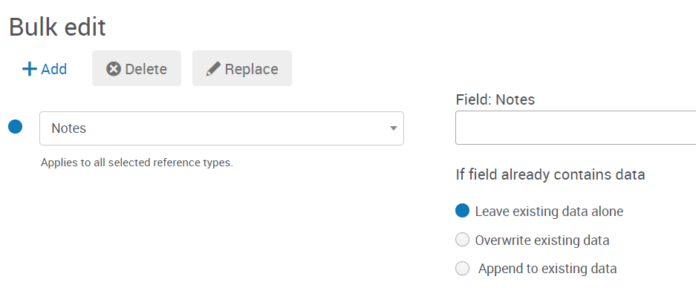

Then **add**. It will come up with a verification message, select **Yes** to add the notes to your references.

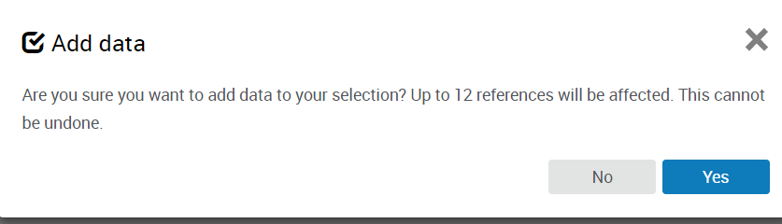

# Sharing Documents and Collaborating

With RefWorks you can give your colleagues access to any of your folders, to allow you to collaborate on projects. Please note that you should not share RefWorks folders or content with colleagues outside Edge Hill, as this could breach copyright and our licences.

To do this, simply click on the folder you wish to share, click the **Share** button and choose **Share folder**.

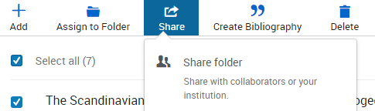

Input your colleague’s email address and assign rights to that person. They can either read, annotate or modify the folder. Your colleague will get an email, with a link included, which allows them to access your folder. They have the option to accept or reject this link.

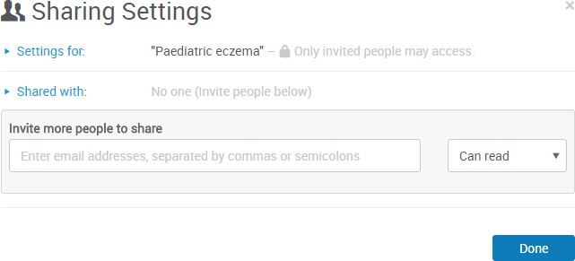

If you want to check who you've shared a folder with, hover over the folder you want to check. Then go to the **Share** option and click **Share folder.** You can change the rights at any time.

You can also change the sharing from **private** to **institution**, which gives everyone in your institution access to your folder.

# Custom style editor



If your preferred referencing style is not in RefWorks, you can use the Custom Style Editor to customise your citation style.

You can find information to help you do this in the help section of RefWorks (found via the question mark icon).

# Using Refworks in Microsoft Word: RefWorks Citation Manager

If you are using an Edge Hill PC or laptop, you can use RefWorks Citation Manager to create your reference lists in Microsoft Word. If you are on campus, you can get RefWorks Citation Manager from within Word, by clicking on File Get Add-ins. A dialogue box will appear, and you should click on Admin Managed. You should then click on the option for RefWorks Citation Manager.

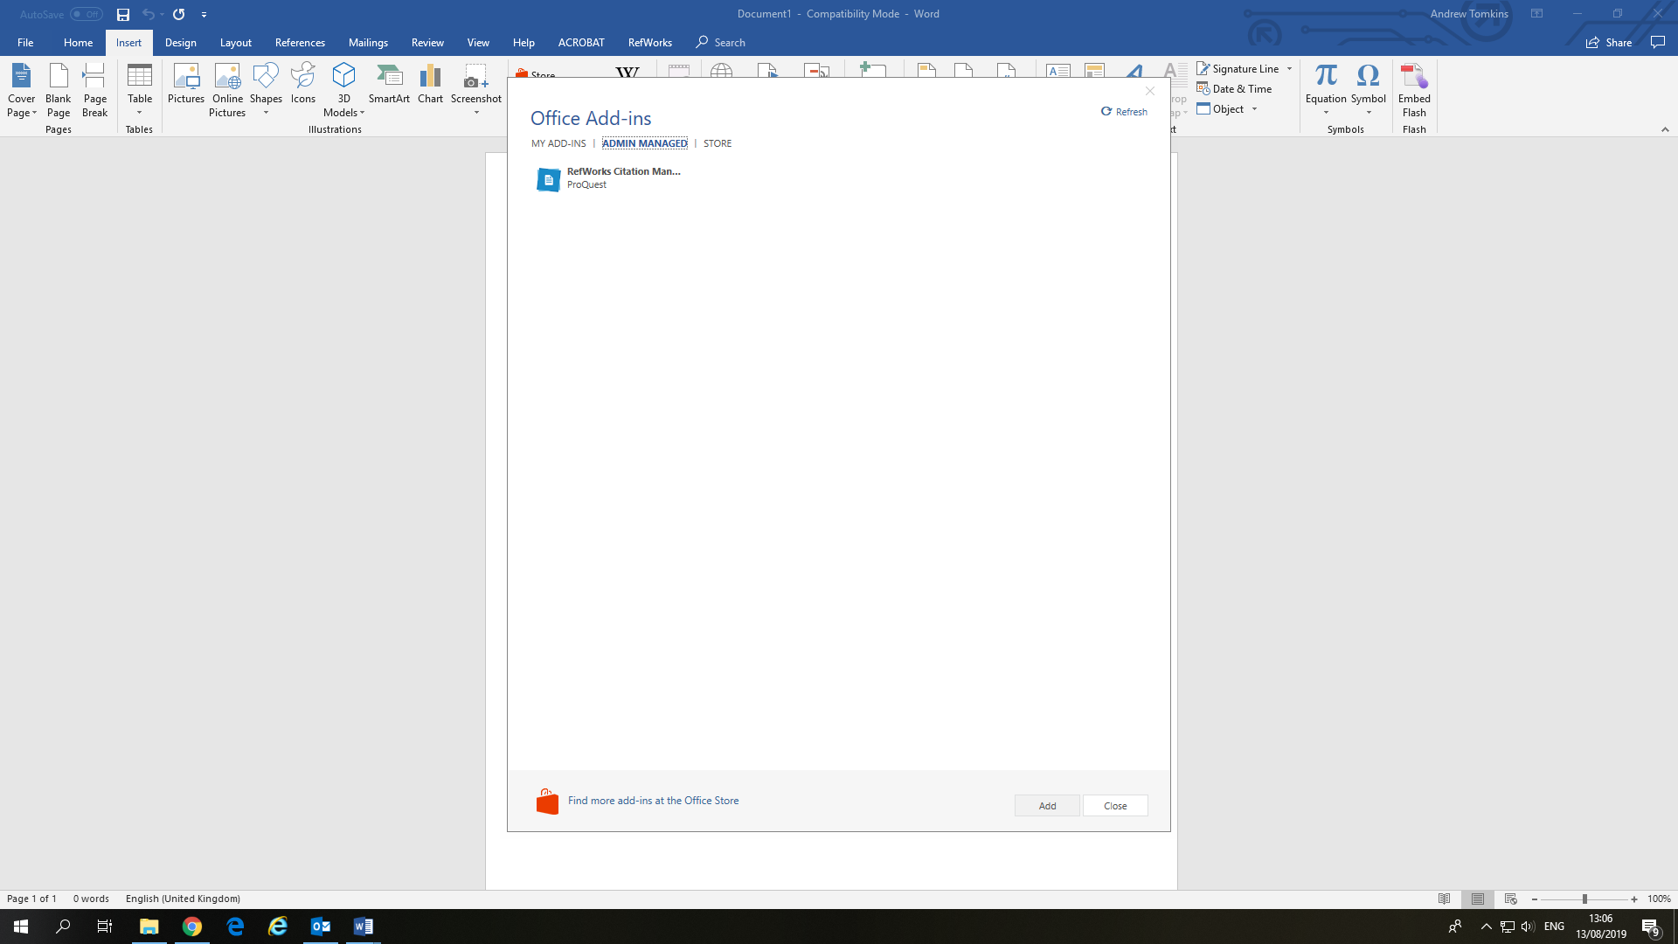

If you are off campus, from within Word you should click on File then Get Add-ins. You will then need to search for RefWorks Citation Manager in the Microsoft Office Store and follow the necessary steps to download it.

Once you have downloaded RefWorks Citation Manager Log in boxes appear on the right-hand side. You should log in with your RefWorks login details.

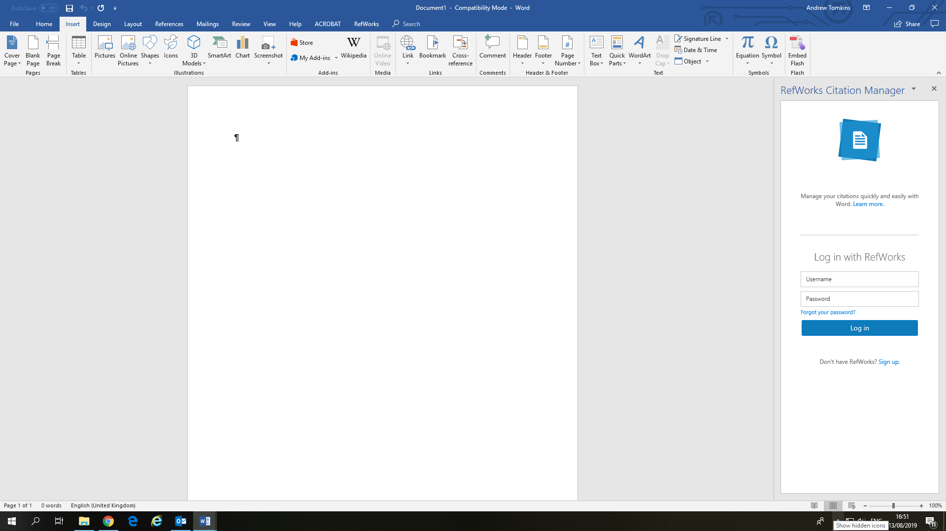

If you have divided your references into different projects, then select the relevant project from the drop-down list that appears when you click on the arrow next to Untitled Project. You then click on Update. If you have not divided your collection of references into different projects, you just need to click on Update and leave the selection as Untitled Project.

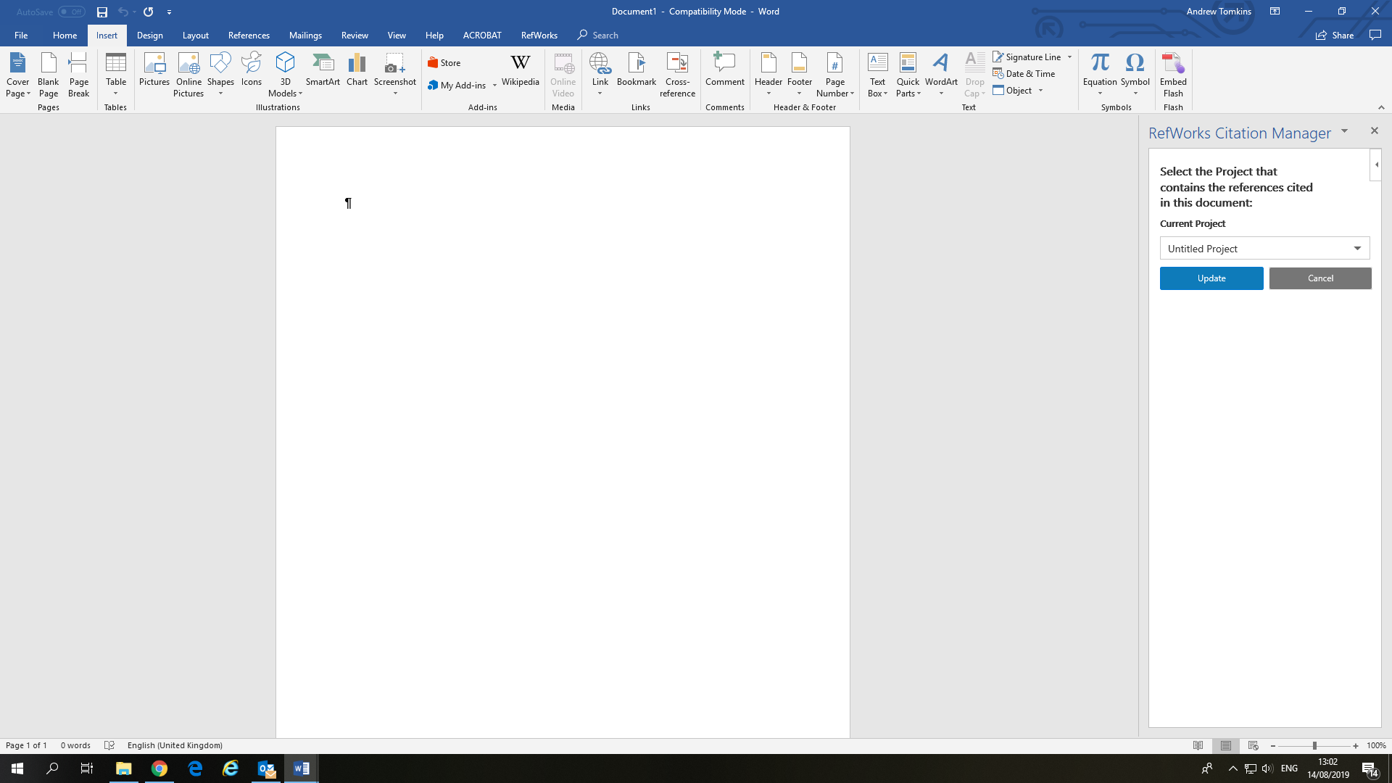

To add a citation, you can either select it from your list of references or click on the drop-down arrow next to All References and select the relevant folder. Once you are in the correct folder, select the required reference and click on Insert Citation. The citation will be added to your document. RefWorks Citation Manager will create the full reference for your reference list and will place this immediately after the citation. You can then cut and paste the full reference into your reference list or at the end of your document.

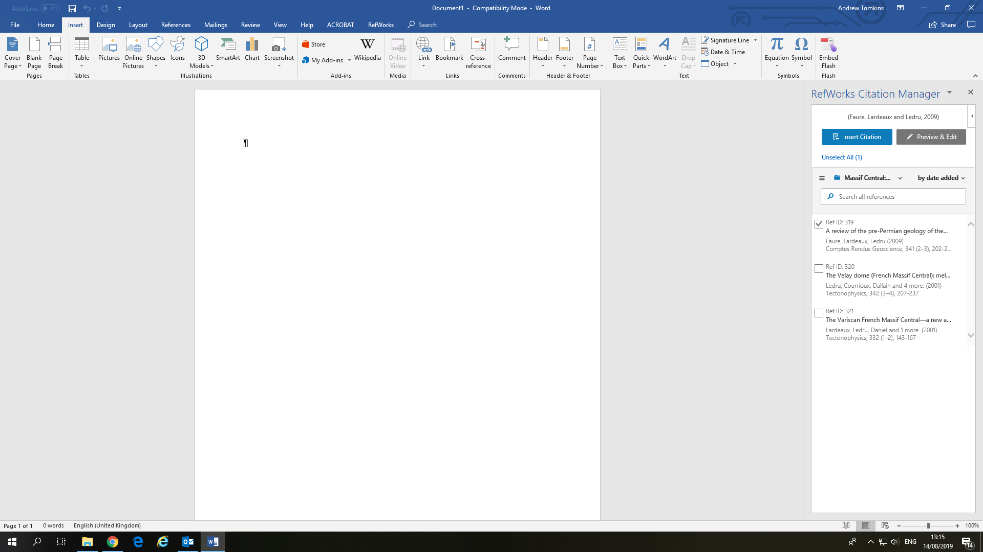

If you are inserting a direct quotation into your document and need to add a page number to the citation when you select the reference, or if you are adding a secondary citation, click on Preview & Edit.

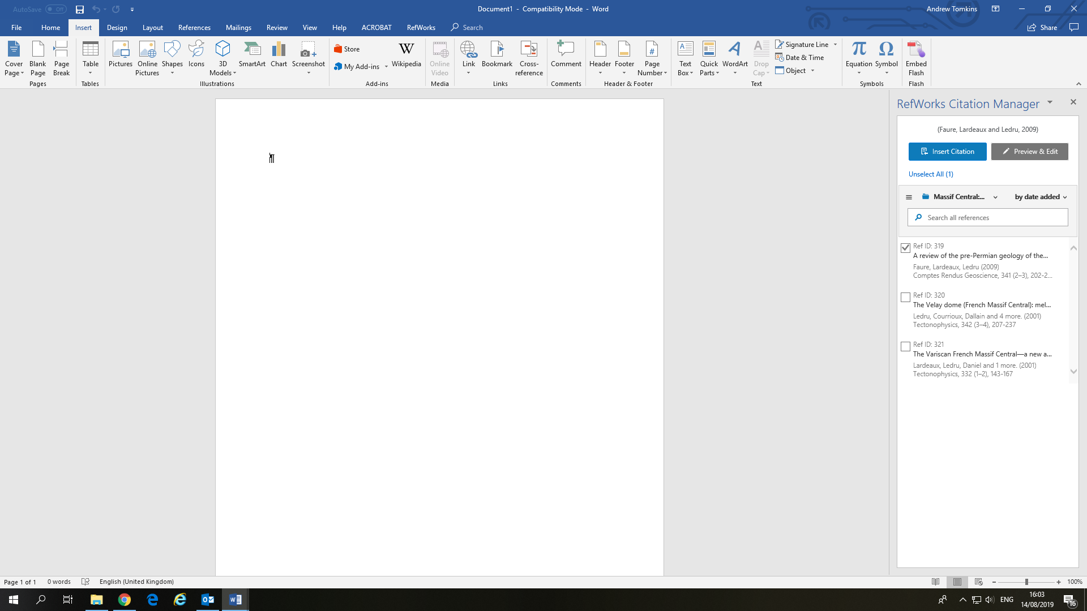

The following screen has an area called Add prefix/suffix. You can add the primary citation information in the prefix box (if you are secondary citing) and the page number(s) in the suffix box. Once you have added this information, click on Insert Citation.

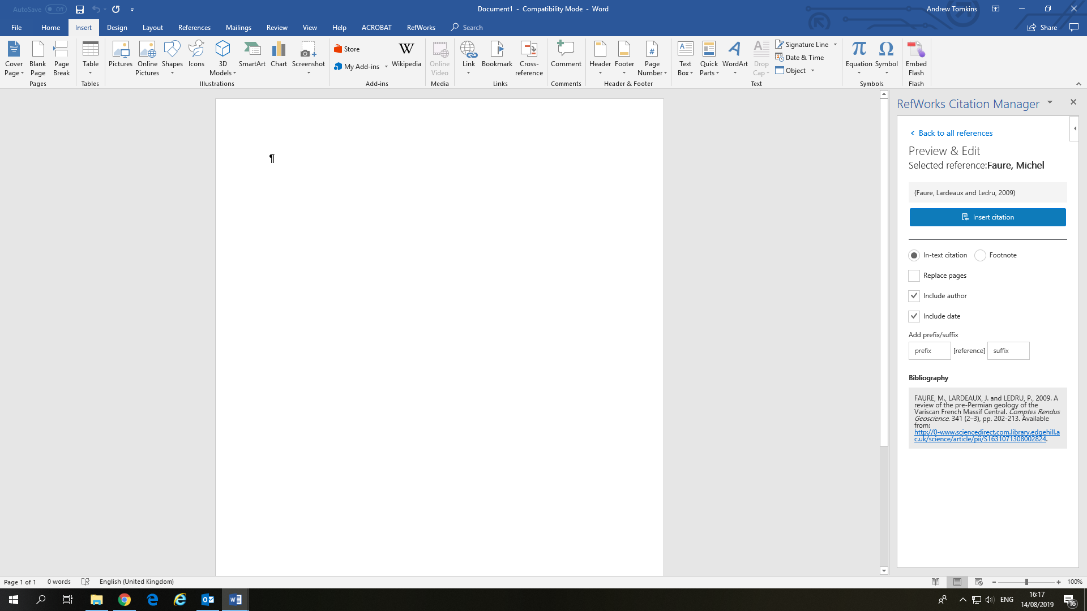

If you click on the three horizontal lines in the left-hand corner, you can change your referencing style or log out.

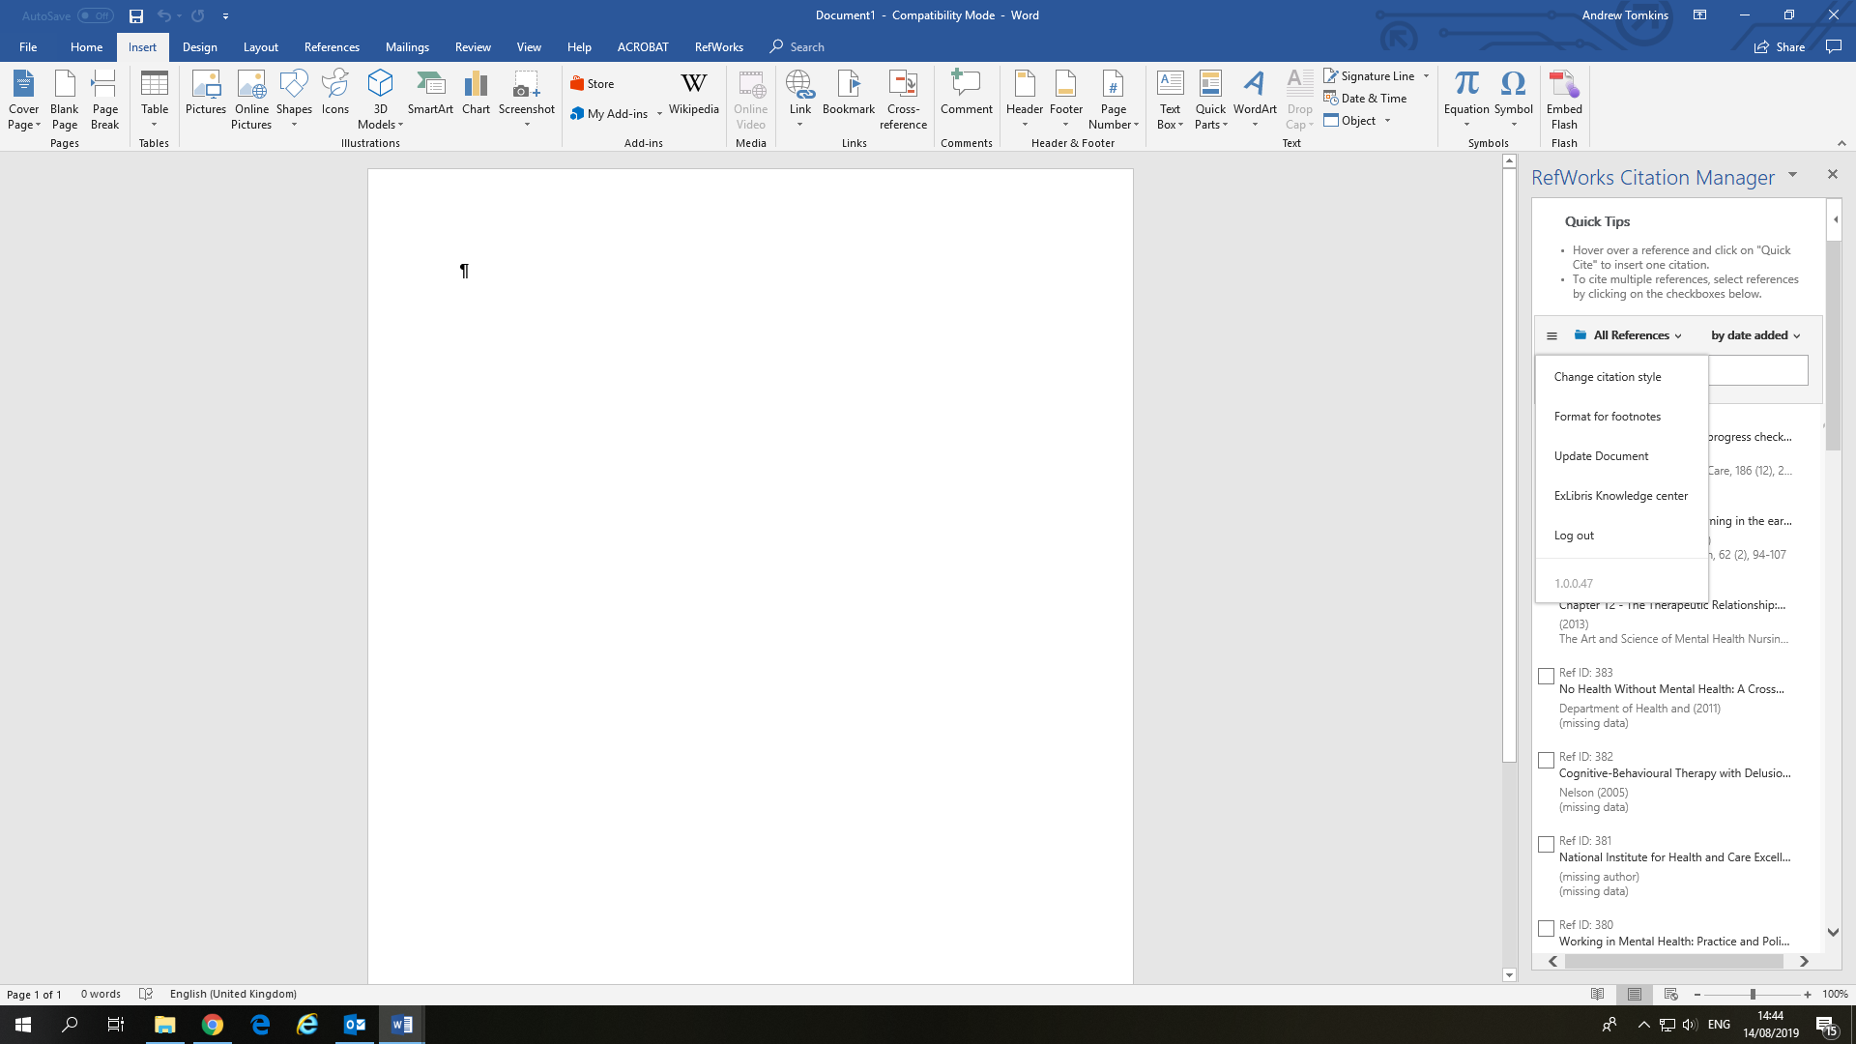

Please remember to check your citations and reference list against your style guide to ensure they are correct.