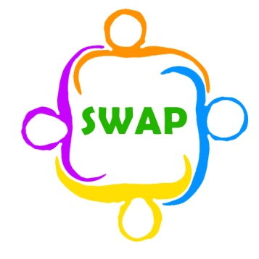
Support for Wigan Arrivals Project
Volunteer Role Description
(Women’s Group)

Location of position | Penson Street
Responsible to | Emma Atherton
Purpose of role | To organise activities and liaise with Emma Atherton regularly about the progress and development of the group.
Description of tasks | At the Women’s Group we aim to make a safe and welcoming space for our female clients. You will be responsible for taking a register of the participants. You will create activities for the Women’s Group based on conversations and sub-group meetings with Emma and your fellow Women’s Group volunteers. You will ensure that the group runs smoothly and encourage the women to come to English classes and that the women feel welcome to use the services provided by SWAP.
Time commitment | Every Wednesday from 10-12:15pm
Skills & Qualities | Good grasp of English, reading, writing and speaking  Good communication skills.  Ability to interact with people from different backgrounds and people who don’t speak English.  Patience.  Compassion.  Diplomatic.  Good teamwork skills.  Flexible working style.  Creativity and innovation are good qualities to bring to the Women’s Group.
Training and support | Induction done with Emma.  Volunteer’s meetings are held to give a space to discuss the volunteer experience at SWAP.
Expenses | Any travel expenses and 50p per hour for food reimbursement
Benefits to volunteer | Access to any in house training opportunities for free  Work with people from around the world in a role where no one day is the same. Working at SWAP is always a rollercoaster ride, you will meet people, learn things, and experience things you never thought you could do in Wigan.
Application procedure | Please email Emma for an application form and state which role you are interested in applying for
Contact information | Emma Atherton  E: emma@swapwigan.org  T: 01942 516572

