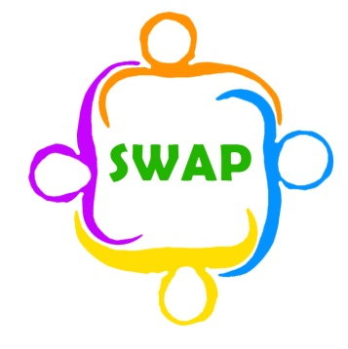
Support for Wigan Arrivals Project
Volunteer Role Description
(Advocacy/Casework)

Location of position | Penson Street
Responsible to | Emma Atherton and Shelagh Linde
Purpose of role | Offer valuable support and advice to refugees and asylum seekers to help them settle in to a new environment.
Description of tasks | Help vulnerable asylum seekers and refugees to access suitable support services, the NHS, social services and legal representatives. Help them access healthcare, clothing and local amenities. You will find that there is no such thing as a typical day. We will try to prepare you for the role to the best of our ability, having said that, we are regularly confronted with new issues or the same issues that must be resolved in new ways. This is the nature of the role and you will have to adapt to new situations and problems as they present themselves. We will always be available to give advice and support to you in your role.
Time commitment | 1-4 day a week, depending on your availability
Skills & Qualities | Good grasp of English, reading, writing and speaking  Good communication skills.  Ability to interact with people from different backgrounds and people who don’t speak English.  Patience.  Compassion.  Diplomacy.  Good teamwork skills.  A flexible working style
Training and support | Induction done with Emma.  You will be required to spend 2 half days shadowing Shelagh (our Advocacy Case Worker) or a fellow advocacy casework volunteer.  We will also provide half a day’s training on ‘The Keys to Casework’, this will cover the jargon you will need to be successful in the role and be an opportunity for you to have some of your questions answered.  Regular informal volunteer’s meetings are held to give a space to discuss the volunteer experience at SWAP.
Expenses | Any travel expenses and 50p per hour for food reimbursement (these are made available on request)
Benefits to volunteer | Access to any in house training opportunities for free  Work with people from around the world in a role where no one day is the same. Working at SWAP is always a rollercoaster ride, you will meet people, learn things, and experience things you never thought you could do in Wigan.
Application procedure | Please email Emma for an application form and state which role you are interested in applying for
Contact information | Emma Atherton  E: emma@swapwigan.org  T: 01942 516572

