Research Questions

1. The role of research questions

1.1 What is the point of asking research questions? To get answers.

1.2 What is the point in seeking answers to research questions? Answering them results in propositions – declarative statements or claims that say that something is the case – which constitute claims to knowledge, and so are the kind of thing that could constitute a contribution to knowledge (original or otherwise).

1.3 Could one make a[n] (original) contribution to knowledge by having research aims or objectives instead of questions? No.

1.4 Could one make a[n] (original) contribution to knowledge by having hypotheses instead of questions? The testing of a hypothesis is, implicitly, the posing of a question. It’s usually best to also explicitly pose the question.

1.5 What if it is necessary to sharpen the question by doing research? That’s not sharpening the question; it is asking different questions. One can still start with a question and ask subsequent questions as prior questions are answered.

1.6 Research is ‘erotetic’ (question-centred) in nature.

2. The occasion-sensitivity of questions

2.1 Not only can the same question can be asked in different ways, but questions are occasion-sensitive, so the same question, phrased in the same way, can mean different things (and so ask a different question) depending on the context in which it is asked.

‘Thus, the question “Why are you drunk?”, asked by my wife, requires a different kind of answer than that provided by, say, my doctor: he notes my having X milligrams of alcohol per millilitre of blood – that explains my being drunk. But the kinds of answer appropriate for my wife would include, “I have been celebrating my promotion”, “I have been drowning my sorrows at getting fired”, or some such …. That a question in the same form of words when asked by her requires a different kind of answer is another way of saying, in that context, the question amounts to something different.’ McFee (2010: 32)

2.2 The question ‘What is this table made of (i.e. composed of)?’ asked of a physicist not only requires a different answer than the same form of words asked of a carpenter, but it asks a different question.

2.3 If research subjects are persons, then it makes a considerable difference to how we understand research questions, because it makes a difference to the context in which the questions are asked – compared to situations in which the subjects of the research are, say, animals, or parts of bodies. The fact that research subjects are persons marks them as both moral subjects (protected by the Helsinki Declaration, Nuremburg Code etc.), and moral agents, capable of expressing opinions, taking action and adopting positions that can be morally evaluated and praised or criticised.

3. Identifying logically prior commitments in one’s questions

3.1 Consider the conceptual, theoretical, epistemological and methodological commitments in each research question.

3.2 An example:

Consider the question ‘How does the brain make unconscious conjectures about the assumptions it makes in interpreting visual data?’

3.3 This is derived from the claim by Kandel et al. (1991: 433) that ‘illusions illustrate that perception is a creative construction based on unconscious conjectures about many of the assumptions the brain makes in interpreting visual data.’

3.4 This entails (at least) the following commitments:

- The brain makes conjectures.
- Conjectures can be unconscious.
- The brain can make assumptions.
- It is the brain (not the human being) that interprets visual data.
- That perception should be explained in terms of the idea that ‘physical stimuli to the retina are transmitted to the brain, where they become sensations, which are conceived to be raw material from which perceptions are synthesized by the unconscious mind.’ (Bennett and Hacker, 2008: 9)

3.5 All of these commitments/assumptions can, as Bennett and Hacker (2008) stress, be rather easily brought into doubt.

3.6 Anyone posing the question based on the claim by Kandel et al. (1991) must recognise the conceptual, theoretical, epistemological and methodological commitments implicit in the question, and should have arguments (and in certain cases also evidence) to support each of those commitments.

4. The connection between research questions and arguments

4.1 Arguments contain premises, which, strictly speaking, are phrased as conditional statements (if …, then …). If there is a research question corresponding to each of the premises of an argument, then the logic (if it is a valid inference) will show the conclusion to be true without it being necessary to directly measure or otherwise research the thing claimed in the conclusion.

4.2 As a consequence, research can establish more than can be directly measured or otherwise directly addressed.

5. The need for a symmetry of potential outcomes

5.1 Good research questions have a ‘symmetry of potential outcomes.’ This means that you should make sure, in forming the research questions, that the research will be of value regardless of what the results are.

5.2 Don’t ask questions such as ‘is there …?’ or ‘do/does …?’ etc. if the answer being ‘No’ will mean that your research will be of little interest and can go no further.
5.3 Equally, don’t ask questions such as ‘is there …?’ or ‘do/does …?’ etc. when you really know the answer already; such questions aren’t research questions.

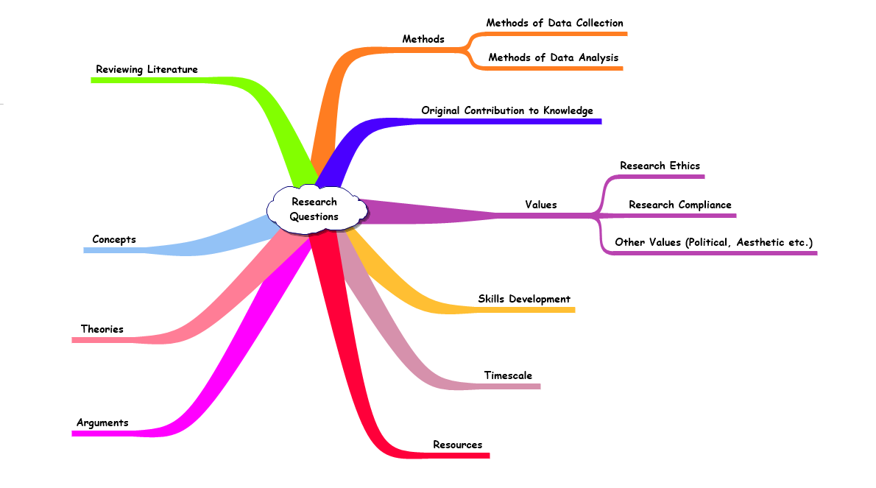

References
Bennett, M. R. and Hacker, P. M. S. (2008) History of Cognitive Neuroscience, Oxford: Wiley-Blackwell.
Kandel, E. R., Spencer, W. A. and Brindley, F. J., (1991) ‘Electrophysiology of hippocampal neurons. I. Sequential invasion and synaptic organization, J. Neurophysiol. 24, 225-42.
McFee, G. (2010) Ethics, Knowledge and Truth in Sports Research: An Epistemology of Sport, London: Routledge.

