Blackboard Administration Guide for

Faculty Administrators

Contents
Background 1
Merging Courses 2
Part 1a: Merging one area into another 3
Part 1b: Creating a new ‘Parent’ area to merge modules into 7
Part 2: Staff Access to Courses 10
Adding Programme or Module Leads 10
Extra Note: Secondary roles 11
Part 3: The ‘Unused Courses’ Term 14
Part 4: Troubleshooting Common Student Issues 16

Background

Blackboard Course areas are automatically created for every Module and Programme based on information in the Student Information Database (SID). These Course areas are initially empty apart from the basic template. All students registered for the Programme or Module in SID will be automatically enrolled in the Blackboard area and will be able to access it once the academic in charge of the Course area has opened the course to students.

Merging Courses

These automatically generated Blackboard sections do not necessarily match the taught curriculum. Some programme teams use a programme area, some don’t. Some departments provide students with a separate module area for each module, and some join several modules together in one Blackboard Course area.
This guide will help you ensure that the way the Course areas are set up in Blackboard fits with the way the curriculum is taught.
The examples used in this guide may not be the same as modules and programmes that you will be working with. However, the technical process involved will be the same, whether you are merging a Child Course into a Parent Course, creating a new area with the ‘_MRG’ suffix to merge several courses into, or giving staff access to the section.
In Part 1a we look at merging some Child Courses into a Master Course. In Part 1b we’ll look at creating a new Course area for several Child Courses to be merged into. Each option could be used depending on requirements.
This guide will help you ensure that the way the Course areas are set up in Blackboard fits with the way the curriculum is taught.
The examples used in this guide may not be the same as modules and programmes that you will be working with. However, the technical process involved will be the same, whether you are merging a Child Course into a Parent Course, creating a new area with the ‘_MRG’ suffix to merge several courses into, or giving staff access to the section.

In Part 1a we look at merging some Child Courses into a Master Course. In Part 1b we’ll look at creating a new Course area for several Child Courses to be merged into. Each option could be used depending on requirements.

Course merging is performed using the Admin Panel in Blackboard. Click on the Admin menu to access this panel.

N.B. When you need to close the Admin Panel use the link on the top right of the screen:
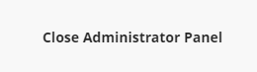

To search for courses to merge you need to access the ‘Courses’ page.
Click on the ‘Courses’ link to open it.
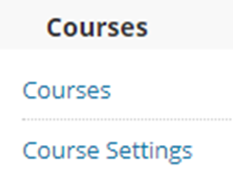

Part 1a: Merging one area into another

We will use a module with the code LIT1000 in this example. You can search for this in the ‘Search’ section, using ‘Course ID’ ‘Contains’ ‘LIT1000’.

In the returned results, we see a range of modules from different years.
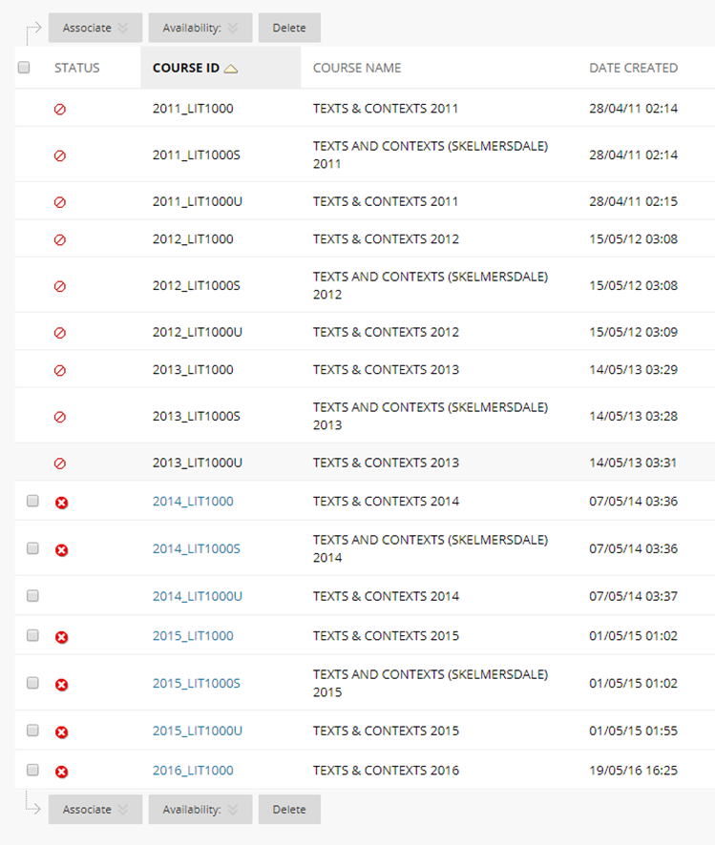

Let’s say that we are interested in the 2016-17 years modules. We can see that there are three prefixed with 2016:
- ‘2016_LIT1000’ which is the main area that most student have access to.
- ‘2016_LIT1000S’ which is a version of the module taught off campus in Skelmersdale.
- ‘2016_LIT1000U’ which is a version that Study Abroad students are given access to.

The Skelmersdale students are taught separately from the main group of students taught at Ormskirk, so the section with the prefix S does not need merging into the main area. However the Study Abroad student will be part of the group taught at Ormskirk, and they will need access to the same Blackboard course as those students. We therefore need to merge the Study Abroad student area (the Child area), in with the main area (the Master area).

Hover over the Course ID for the main area which is going to be the Master course and a grey circle will appear.
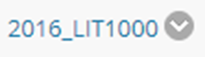

Click on the grey arrow to open a menu. Select the Edit option and the ‘Course Settings’ page opens. Within the section ‘General Information’ you will see a check box labelled ‘Select Courses to Merge’.

If you click on the box a Child Courses section appears below it. This allows you to select ‘Child’ courses to merge into the ‘Master’ course (i.e. ‘2016_LIT1000’).

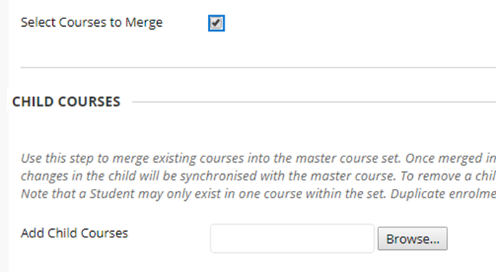

Click on the ‘Browse’ button and a window will open containing search options. You can use this to search for a child course to add. In this case we want to add ‘2016_LIT1000U’, so we’ll search for that.

Click on the check box on the left to select the Course area, then click the ‘Submit’ button. The Course ID for the Child Course will be added to the text box.

You can then click on the ‘Submit’ button to save your changes.

If you search for either the Child or Master Courses now you will see an arrow next to the Child Course, and its Course ID indented. This visual indication of the relationship between the two Course areas will make it easier to track.
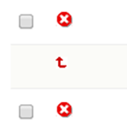

Part 1b: Creating a new ‘Parent’ area to merge modules into

We have seen how to merge one area into another. However, there are cases where separate modules or instances of courses are taught together. For example, two programmes might share the teaching on a Research Methods module but register the students separately on their own modules.

In this case you would create a new area that will be used as a ‘Parent’ course, and merge in both modules.

Click on ‘Create Course’ and select ‘New’ from the menu.

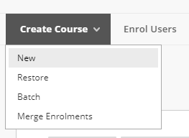

Add information to the ‘Create Course’ page.

- Course Name: Should be the title of the course which students will see. If the module names are the same, you can use the same title. If they are different you might want to decide on a title which both groups of students will understand. For consistency, we’d recommend writing this in capitals.
- Course ID: Should be in the format YEAR_[distinguishing information such as programme of module code]_MRG. For example, 2017_ FOHSC_BSCN_MAR17_MRG, where 2017 represents the 2017-18 academic year and MRG shows that it is a merged course.
- Term: Select the academic year that this area relates to, to allow staff to organise their list of courses by academic year.
- Availability: Leave the ‘Available’ setting set to ‘No’ to prevent students being able to view the section. The module/programme leader will release the section when it is time.

When you have added the information click the ‘Submit’ button.

The new area will need the Course or Module template applying. These can be downloaded from the Module and Programme Blackboard Templates page on eShare.

They can be uploaded to the new Blackboard area through the ‘More options for Course Content’ menu. Select ‘Import Content’.
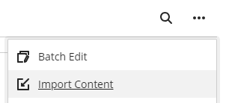
Then select ‘Import Course Content’ and select the zip file for the template that you downloaded.
To merge the ‘Child’ course(s) into this new ‘Parent’ course, repeat the process in Part 1a of this guide.

Part 2: Staff Access to Courses

Adding Programme or Module Leads

Once the first ‘Programme or Module Leader’ is enrolled, they can then enrol other staff themselves through the course area.

You can do this via the Administrator Panel.

Locate the course in the Courses section, as before.

Click on the round grey ‘action link’ that appears next to the course name and select ‘Enrolments’ from the menu that appears.
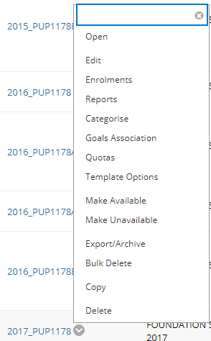

On the following page click on the ‘Enrol Users’ button.

This opens the Add Enrolments page.
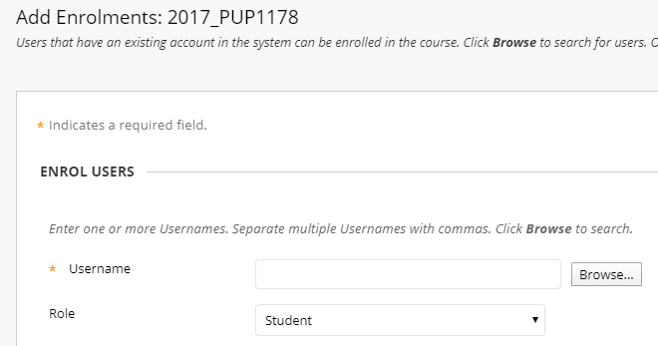

You need to add a username, and select a role, before clicking the ‘Submit’ button.
If you do not know their username, click on ‘Browse’, and use the search options to find a user and their username.

The module or programme leader should be added with the ‘Programme or Module Leader’ role, which can be selected from the drop-down menu.

Click the ‘Submit’ button to finish adding the user.

Extra Note: Secondary roles

Secondary Institution Roles are used to customize what users see on the Institution Page in Ultra Base Navigation. From the ‘Admin’ menu select ‘Users’ and search for the username.
Select ‘Edit’ from the dropdown menu against the username, you can edit their institution roles.

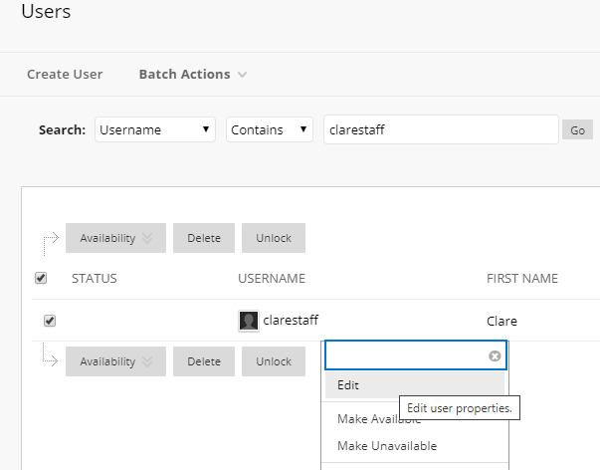

Select the name of the faculty from the list of ‘Available Roles’ and click on the arrow that points to the right to move it to the list of ‘Secondary Institution Roles’. Click the ‘Submit’ button.

This will allow the user to see the faculty specific panel on the Institution Page of Blackboard.

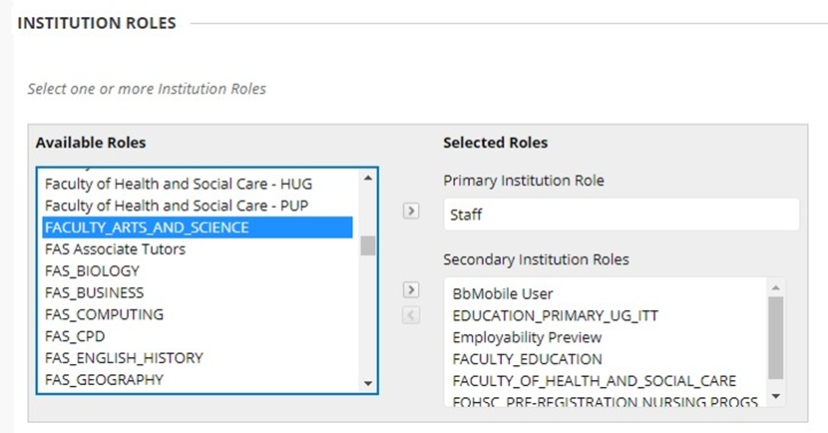

Part 3: The ‘Unused Courses’ Term

In Ultra Base Navigation, the Course page will list all courses a student is attached to even if that course is not being used.

To avoid confusion for students, departments have the option to move courses into a Term called ‘Unused Course Areas’. You would only move courses into this Term if they were never going to be used. Courses that are simply unavailable but will be made available later, should remain in their originally assigned Academic Year Term.

You can do this via the Administrator Panel.

Click on the ‘Courses’ link to open it.

Search for the course(s) as before, in this example, the search is based on the course name and the date of creation.

Select the courses for which you want to change the Term. Click Associate - Terms
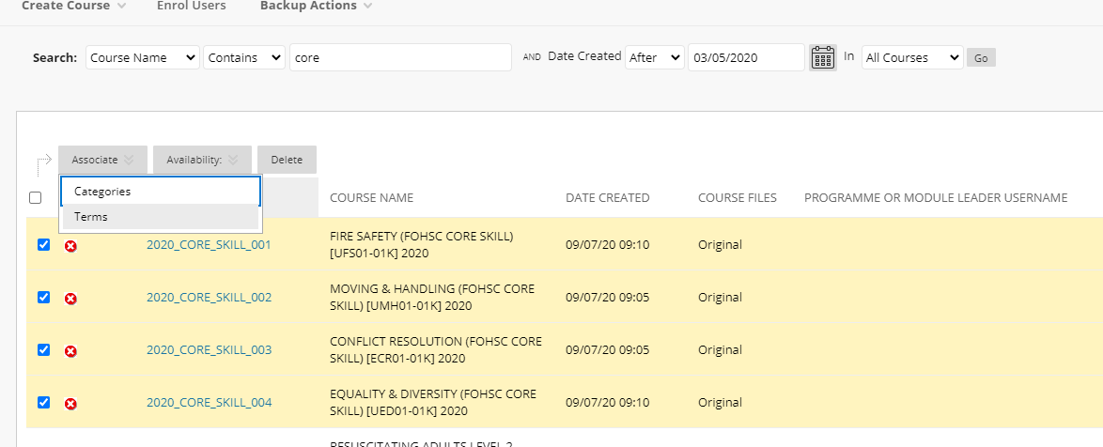
Select the Term ‘Unused Courses’ and Click Submit.
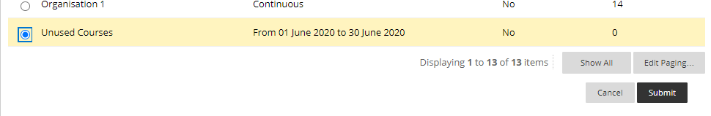

In practice, what this does is move the courses into a Term which may be a filter option on the home Courses page for users. Users will only see ‘Unused Courses’ in the filter if they are attached to courses which are in that Term.
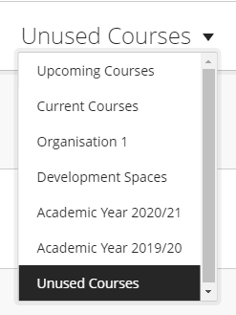

Part 4: Troubleshooting Common Student Issues

You might get queries from students if they cannot access Blackboard courses that they expect to. If so, it is worth considering the following things.

- Is the area released to students? The academic member of staff in charge of the section might not have made it available yet.
- Students may have changed one of the filters on the Courses page of Ultra Base Navigation, from the default settings.
- For the week at the start of term when students are registering, student course registrations feed through to Blackboard overnight, and during the rest of the year the process runs once per hour. Close to the start of term, if it looks like a student should have access but doesn’t, it is worth asking the student to wait until the next day.
- If students cannot see an area that they expect to see, you can check on SID to see if they are registered on the module or programme in question.
Be aware that with merged areas, students see the name of the area that they are enrolled in, rather than the name of the parent area that this might have been merged into. This can cause confusion as staff see the name of the parent area and may tell them to look for that. This is not a common issue as the names of child and parent courses are usually similar.

