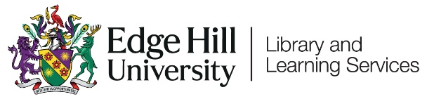

Learning Edge/Blackboard

Getting Started for Students

Contents
Introduction 2
Video Guides 2
Logging in 2
Your Blackboard Homepage 3
Other Menu Options 5
Institution Page 5
Your Profile 6
Activity Stream 7
Organisations 7
Marks 8
Calendar, Messages and Tools 8
Inside a Course/Module Area 10
Ultra Course View 10
Original Course View 11
Other Sources of Help and support for Students 13

Introduction

Learning Edge is a name used to refer to Edge Hill's online environment for learning and teaching. It consists of the Blackboard Virtual Learning Environment (VLE), and a range of other tools such as Turnitin, Panopto and Qwickly.
This guide covers getting started on Blackboard where you will find Module and Programme areas related to your course, along with links to a range of other useful resources.

Video Guides

We have a set of short video guides aimed at new students.
- What is Learning Edge and how do I log in?
- How do I find Course areas and Organisations?
- Where Can I Find Content and Tools in a Module Area?
- How Do I Control My Notifications?
- Can I Access Blackboard On My Mobile Device?

Logging in

We recommend using Blackboard in a modern browser such as Google Chrome, Mozilla Firefox, or the latest version of Microsoft Edge.
You can also use the Blackboard App if you are on a supported mobile device.
If you are using a web browser, go to edgehill.ac.uk and select the ‘Current Students’ link in the top right-hand corner of the page: 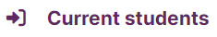
Select the ‘Learning Edge’ link.
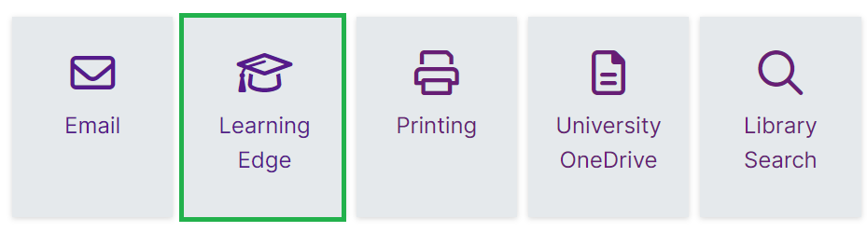
Select the ‘Log into Learning Edge’ link.
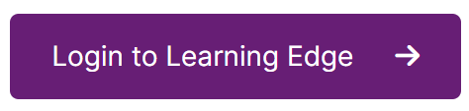
Finally, enter and submit your Edge Hill University username and password, and you will arrive on your Learning Edge homepage.

Your Blackboard Homepage

When you have logged in, the Courses page is the default homepage. Here you will see your course and module areas. All the course areas you have access to will be listed in the Courses list. If your tutor/lecturer says to look for something on Blackboard, this is usually where you should look.
The Courses list will appear in the same way, regardless of whether you are on an Original or Ultra Course.
- There are filters on the course page, so if you cannot see a module you expect to, check that you are on Current Courses or have not selected another filter.
- Click the star against a course to keep it at the top of the page, this will be useful to do as you work through different modules.
- Private means the course isn’t available yet. Your tutor will release it when required.

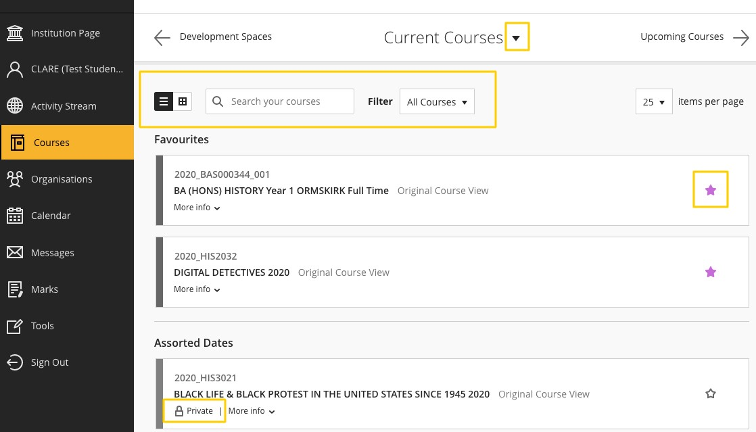
If you do not see the module that you are looking for, please contact your tutor or your departmental administrator. They will be able to check that you are registered for the module or make it visible to students if suitable.

Other Menu Options

After signing in to Learning Edge, you will also see a list of other menu options, in addition to your Courses list.

Institution Page
The first option in the list is the Institution Page:
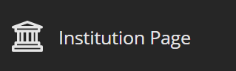
This is where you will find important links and support such as UniSkills, the Library Catalogue and Subject Webpages. You will also see a link to Ask Us where you will find lots of FAQs from Library and Learning Services, Student Services and Careers.
This is the best place to go if you need help or want to contact Learning Services with a query about Blackboard, or a general query:
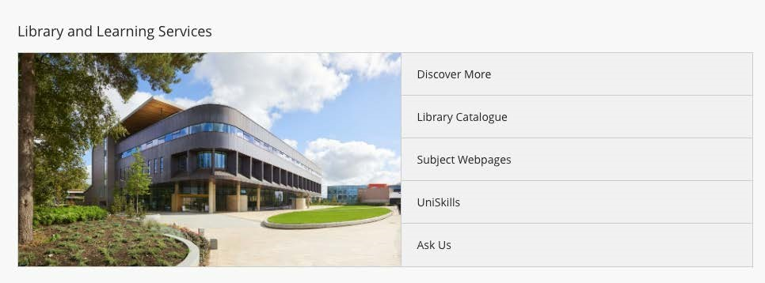

Your Profile
The second option is your Profile page. This appears as your own name in capital letters:
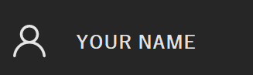
On your Profile page, add a profile image by clicking on the little pen icon, then follow instructions.
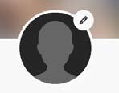
This page is also where you can manage the notification settings that you receive:
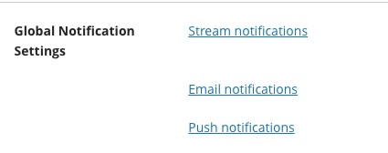
For example, you can set your email notifications to email you a summary each day rather than as the update happens. You should leave the defaults as they are to start with and then work out your preferences as you go.

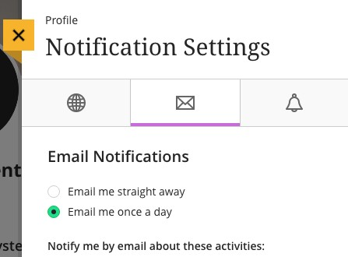

Activity Stream
The third option in the list is the Activity Stream:
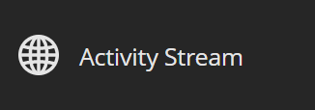
The Activity Stream is where you will find notifications within Blackboard, for example Announcements sent by course tutors. It’s good to check this each time you log in.
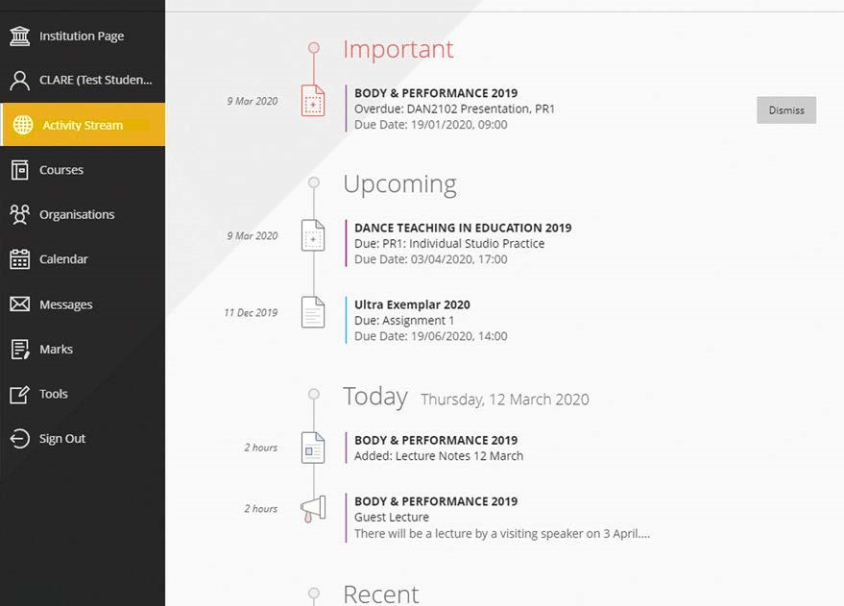

Organisations
The next option, below the default Courses menu, is Organisations:
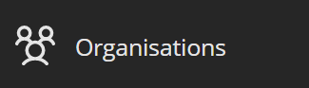
Organisations allows access to Blackboard areas that are not directly linked to a module or programme. They do not have an academic or assessment purpose like Courses do but can be used for information and communication purposes by a department.

Marks
Beneath Organisations, there is the option to labelled ‘Marks’:
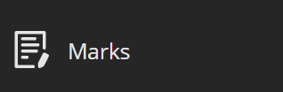
In Marks you can access the grades and feedback for assessments across all your courses.

Calendar, Messages and Tools
Lastly, there are the options for Calendar, Messages and Tools:
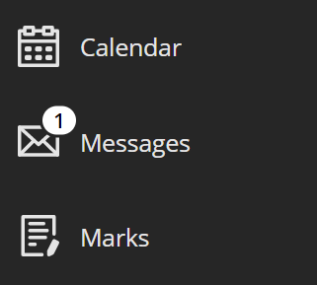
You may see events and dues dates on the Calendar if added by your course tutor, while your tutor may also direct you to check Messages or access other Tools.

Inside a Course/Module Area

If you started studying with us for the 2022/23 Academic Year, you will most likely see your course and module areas in the Ultra course view. The majority of returning students will remain on Original course view until next year.
Every course or module in Blackboard has a unique code which begins with the Academic Year that it is registered to. For example, a course or module code belonging to the 2022/23 Academic Year will begin with ‘2022_’.

Ultra Course View
A course that is in Ultra view will look like this:
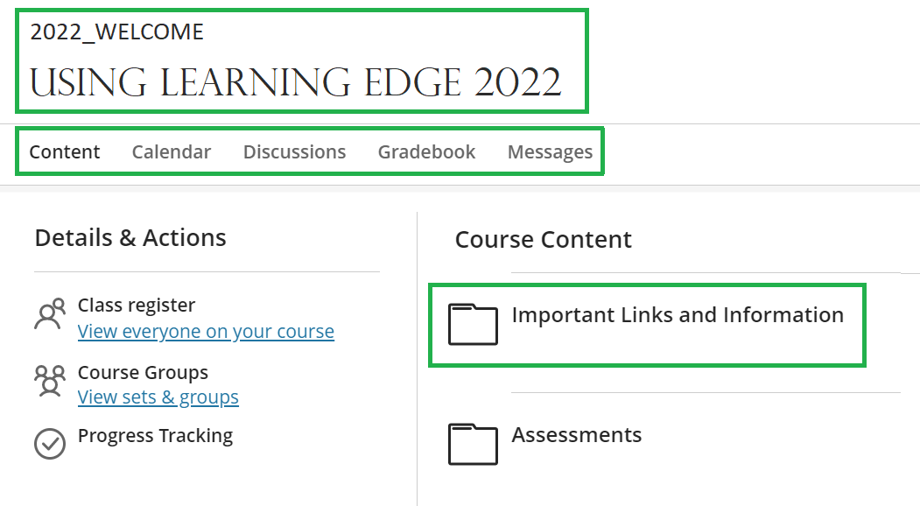
Inside an Ultra course or module area, the course is formatted on a white background and you primarily navigate through your course content on the right-hand side of the page. Your tutor will induct you on your module and make sure you know how it works.
The left-hand menu contains a number of links to various course tools including Collaborate, Groups and Announcements. Additional tools, such as Discussions and the Gradebook (where you can view your grades an Ultra course) appear along the top of the page, beneath your course’s code and title.
An Original course looks a little bit different to the main menu page when logging in to Learning Edge. This is completely normal.

Original Course View
A course that is running in Original view will look like this:
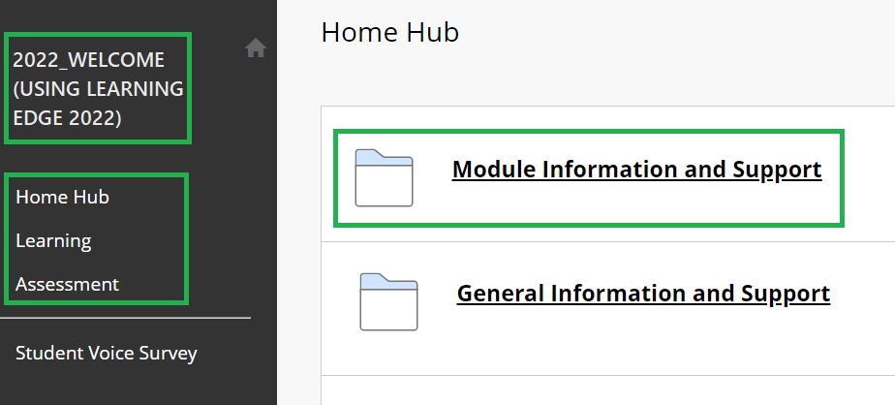
Inside an Original course or module area, you will have links to resources and tools on the left-hand menu - Use this to navigate the course. Your tutor will induct you on your module and make sure you know how it works.
The left-hand menu has a dark grey background and will have a number of different links, including ‘Home Hub’, ‘Learning’ and ‘Assessment’, as well as a link to the Student Voice Survey. Depending on your department there may be additional links that you can see in this left-hand menu. Your course code and title, appear in the top of the menu, and the course content and links will appear on the right-hand side.
An Original course looks a little bit different to the main menu page when logging in to Learning Edge. This is completely normal.

Other Sources of Help and support for Students

- Search the ‘Ask Us’ online helpdesk - ehu.ac.uk/askus
- Search the Learning Services’ web pages - ehu.ac.uk/ls
- Telephone on - 01695 650800
- Visit the help desk in the Catalyst building on campus.

