

Uploading Items to eShare

Contents
Accessing eShare 1
Preparing Items 1
Uploading New Items 2
eShare Abstract Pages 3

Accessing eShare

eShare can be accessed at: https://eshare.edgehill.ac.uk/. Log in with your Edge Hill University username and password.

Preparing Items

- Note the eShare Terms and Conditions.
- Ensure that items are accessible and conform to The Public Sector Bodies Accessibility Regulations 2018. There is guidance on the Digital Accessibility SharePoint page.

Uploading New Items

- Select ‘My Resources’, and then ‘New Resource’.
- Under ‘Files & Links’ select ‘Choose File’ to upload a file. You can upload multiple files.
  - When a file is uploaded you can select ‘Show options’ and select the type of document, and you could select a Creative Commons license for it.
  - If you have multiple files you can use the blue arrows to reorder them.
- Under ‘Resource Information’ add a title. You can also add a description, names of the authors, and advice for reuse.
- Under ‘Tags’ you can add tags to help people find your resource. Try to think of the terms a user may search that are not in the title or description.
- Under ‘Viewing permissions’ you can choose who can view the item.
  - If you want to choose individuals under ‘Selected users’ they will only show up in the list if they have logged into eShare previously.
- Under ‘Editing permissions’ you can give other individuals permission to edit the item.
- Finally select ‘Save and Return’ to save the item.

eShare Abstract Pages

The item can be accessed via an abstract page.
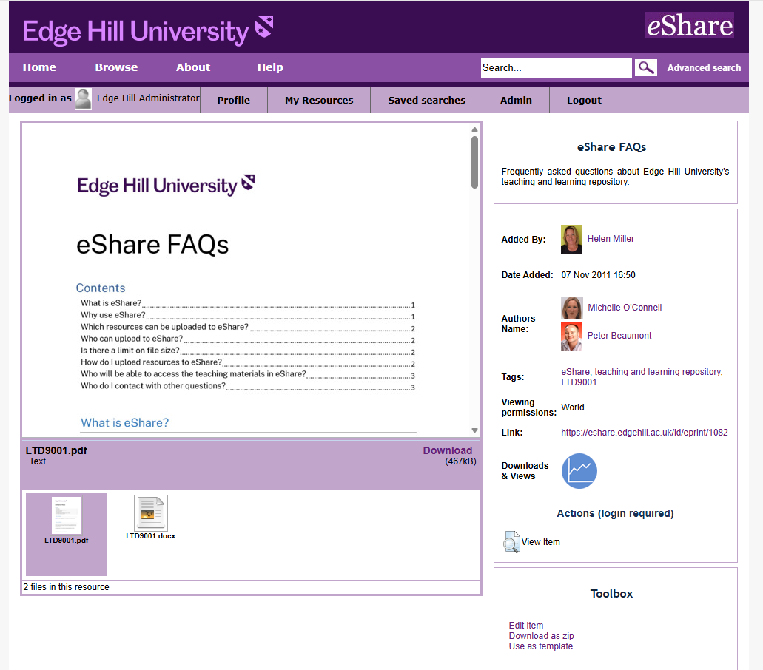
- You can edit the item by selecting ‘Edit Item’. Only those with editing permissions for the item will see this.
- We recommend linking and sharing links to the abstract page using the ‘Link:’ shown on the abstract page. If you link directly to the document, later updates to the document can break the link.

