Box of Broadcasts

Recording and Sharing TV and Radio Programmes Online

Contents

Contents 1
Introduction 2
How to Access BoB 2
Using BoB 2
Video Sharing Options 3
Using BoB Videos with PowerPoint 4
Getting Notifications of Upcoming Broadcasts 6
Getting MP4 and MP3 Versions of Broadcasts 7

Introduction

Box of Broadcasts (BoB) is an online service which makes it easy for you and your students to access and share recordings from TV & Radio.

How to Access BoB

You can access BoB by going directly to the BoB website. Select ‘Sign In’ and start typing ‘Edge Hill University’ into the ‘Where Are You From?’ box. Select ‘Edge Hill University’ from the list that appears. Finally select the ‘Go button.
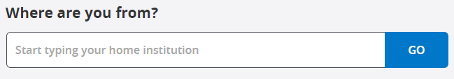
You will then be prompted to type in your Edge Hill username and password.

Using BoB

Learning on Screen have a collection of videos that show you how to use BoB. The videos cover most things that you will need to know.

Video Sharing Options

BoB provides options for you to share the video, and these can be used to share the video within Blackboard.

Under each video there is ‘Share’ button. Clicking on this gives you three options for sharing – Link, WAYFless Link, and Embed.
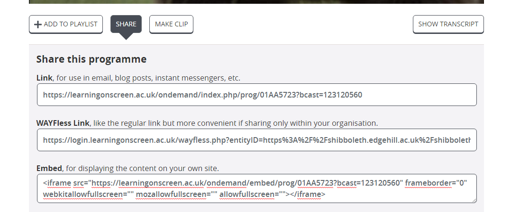

The WAYFless link will be the easiest for students to use to access the video, while the Link and Embed options will require students to go through a process of navigating to log in pages, and so are not recommended.

Using BoB Videos with PowerPoint

Because BoB is not a publicly available resource like YouTube, for example, it is more difficult to include in your presentations. Rather than embedding a BoB video in PowerPoint, you will need to link to the video from a slide.

You could create a link on some text or you can use an image, such as the image from the title page for the video.

On Windows you can copy part of your screen by holding down the ‘Shift’ + ‘Windows’ keys and pressing ‘S’. When an opaque overlay appears over your screen, click the left mouse button and drag to select part of the screen.

Paste the screen shot on to your PowerPoint slide.
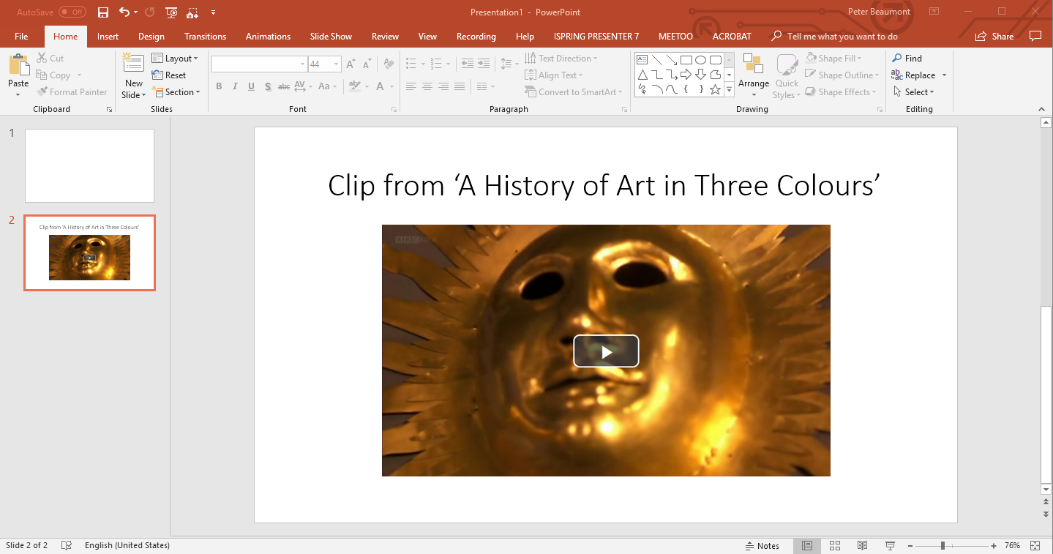

Copy the link from BoB. Use the Link, not the WAYFless link, in this case.
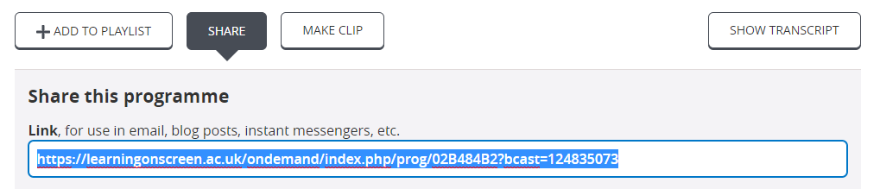

Right click on the image in PowerPoint and select ‘Link’ from the dropdown menu.
Paste the video link into the ‘Address’ box and then select ‘OK’.

You will need to log into BoB in a web browser before you start your presentation.

When PowerPoint is in Slide Show mode, you will be able to click on the image to open the link in the default web browser.

Getting Notifications of Upcoming Broadcasts

Television and Radio Index for Learning and Teaching (TRILT) allows you to request email alerts for forthcoming programmes up to 10 days in advance of their broadcast. This helps ensure that you don’t miss the chance to record useful programmes.

To set an alert up, go to TRILT, click on ‘Sign in’ at the top right of the screen, and start typing ‘Edge Hill University’ into the ‘Where Are You From?’ box. Select ‘Edge Hill University’ from the list that appears. Select the ‘Go button. You will then be prompted to type in your Edge Hill username and password.

Choose ‘Auto Alerts’ from the menu on the left-hand side.
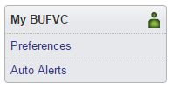

On the Auto Alerts page, you can use the ‘set up your email address’ to set your preferences for when you access the site on the computer you are on now. You can then save Auto Alerts which will be emailed to you on a selected day of the week.

If the programme is broadcast on one of the channels that BoB records, you can then make a note to log in to BoB to search for it and request that it is saved.

Getting MP4 and MP3 Versions of Broadcasts

It is possible to get MP4 versions of TV broadcasts or MP3 versions of radio programmes, although Edge Hill University can only request 24 individual broadcasts per year.

Our video ‘Ordering Off-Air Recordings as MP4s or MP3s’ goes through the process.

