Swetswise Journals
What are Swetswise Journals?

Swetswise is a journal collection database that offers over 6,000 multidisciplinary journals from a variety of publishers which can be accessed via the Swetswise interface
How do I access Swetswise Journals?

- Like all our electronic resources, Swetswise Journals are accessible via the Library Catalogue.
- Enter Swetswise Journals in the search box, choose ‘Electronic Library’ from the right drop-down menu and click ‘submit’.
- Connect to the database by clicking on the link in the centre of the screen.
How do I search Swetswise Journals?

To browse the Journal Collection for Journal Articles, take the following steps:

2.
1.
Click on the Content Search tab and select Article Search
Click on basic search or advanced search if you have a comprehensive search strategy

3.
Enter your search terms

4
Limit your search results by selecting a specific Subject Category or Publication Date

Evaluating the Search Results

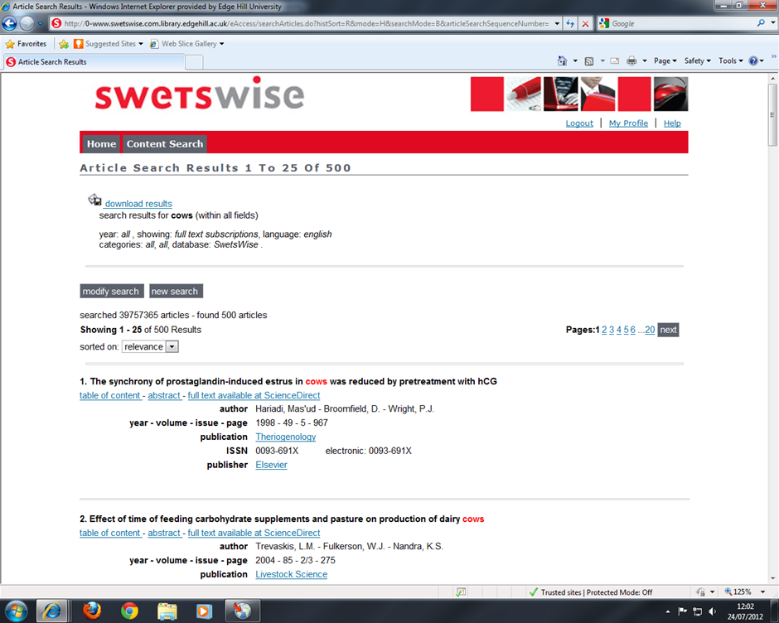
Click to view article abstract or full text

Saving and Printing an article

Print & Save Article

