Academic Search Premier
What is Academic Search Premier?

Academic Search Premier is a multi-disciplinary database which offers full text for more than 4,050 scholarly journals. Covering virtually every area of academic study, Academic Search Premier is a good source of information whatever your subject.
How do I access Academic Search Premier?

Like all our electronic resources, Academic Search Premier can be accessed via the Library Catalogue.
Enter ‘Academic Search Premier’ in the search box, choose ‘Electronic Library’ from the right drop-down menu and click ‘Submit’.
Choose the second record down and then connect to the database by clicking on the link in the centre of the screen.
How do I search Academic Search Premier?

Enter your key words
in the search box.

Use the Search modes options to tailor your search. Academic Search Premier will automatically find all the search terms you enter, but if you want to search for a phrase, e.g. “climate change”, choose ‘Exact Phrase’.

Limit results to articles published within a certain date range.

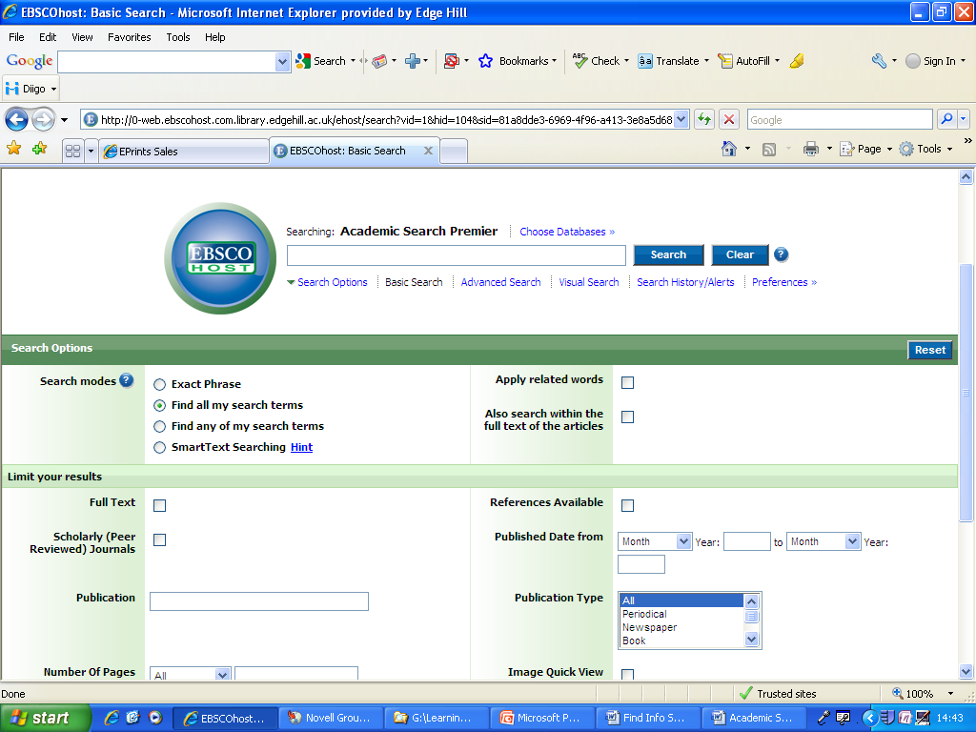
Tick this box to search only for articles that are available in full text.

Tick this box to select peer reviewed articles – this will give you the best quality information.

Evaluating the Search Results

Click on article title to view abstract
Number of search results

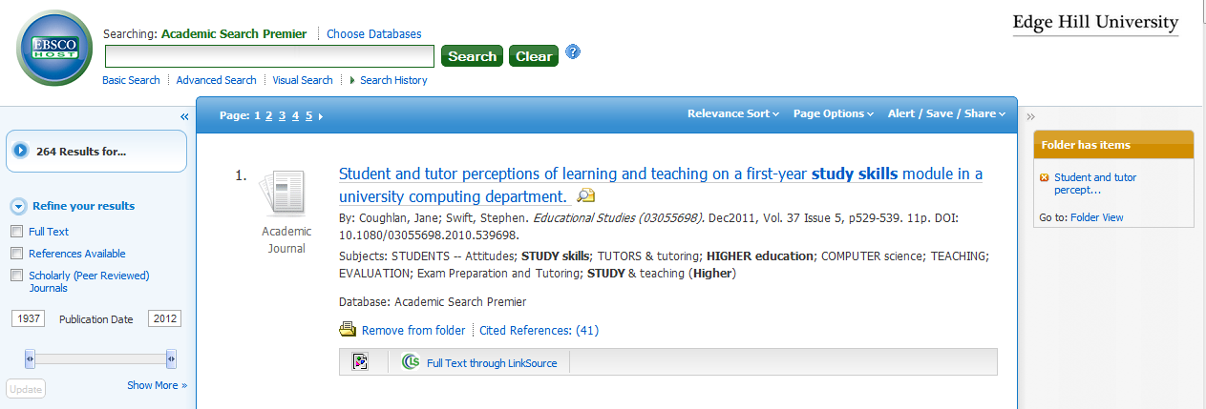
Add this result to your folder
Change the publication date of your results by moving the date slider
Click on PDF to view article in Full Text

_____________________________________________________________
E-mail or save a copy
Saving , printing and emailing your results

Print
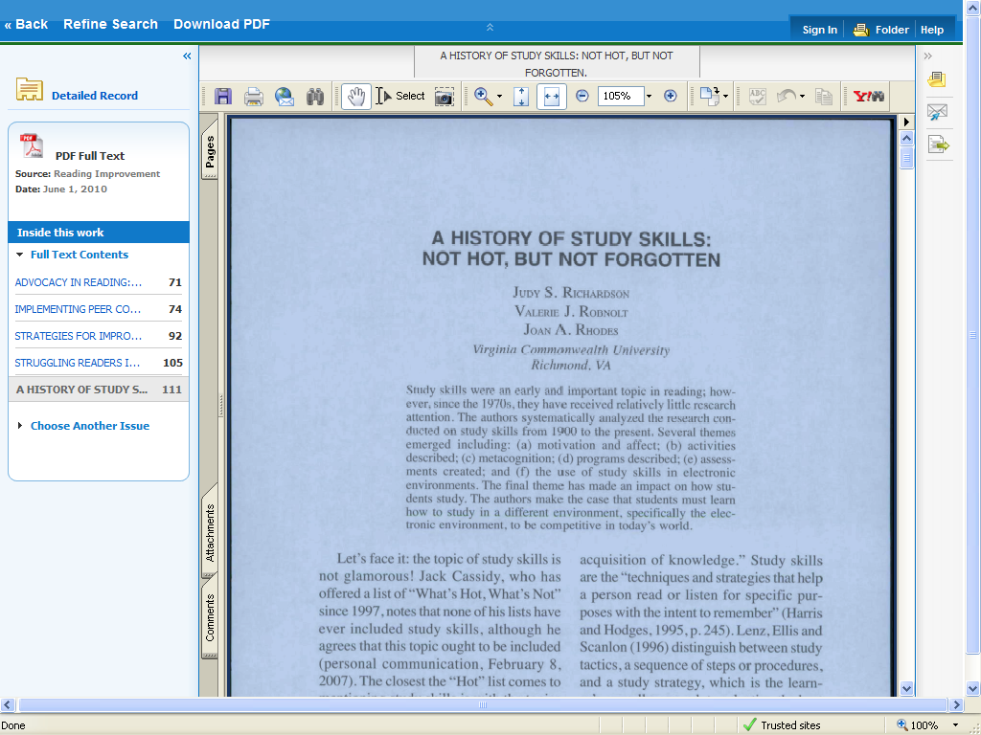
Table of contents

