Setting up Qwickly Attendance Registers

Contents
Introduction 2
Setting Up the Attendance Register 2
Preferences 3
Additional Settings Information 4
Recording Attendance 5
Recording Attendance Manually 5
Record Attendance via Check In 7
Instructor View of the Check In 7
Student View of the Check In 8
Managing and Amending Attendance Records 10
Amending Individual Records 11
Deleting Incorrect Register Columns 12
Download Attendance Data 14
(Optional) Session Scheduler 14

Introduction

Qwickly Attendance is an integration in Learning Edge (Blackboard) which enables the recording of student attendance throughout the duration of the course.
Attendance Registers can be managed manually by staff or may be set to allow students to log their own attendance on a personal device using the Check In feature.
For the 2024/25 academic year, is included in the Baseline Template and needs to be set up prior to use:
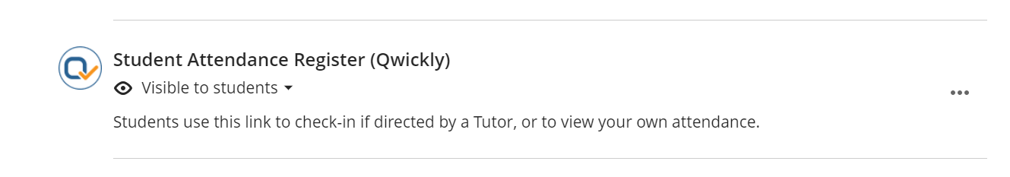

Setting Up the Attendance Register

A register can be set up using the following process:

- Click on the Qwickly Attendance Register link in the course. This will prompt for the Qwickly Attendance tool to load.

- On the screen that follows, select the ‘Begin Setup’ icon in the center of the screen:
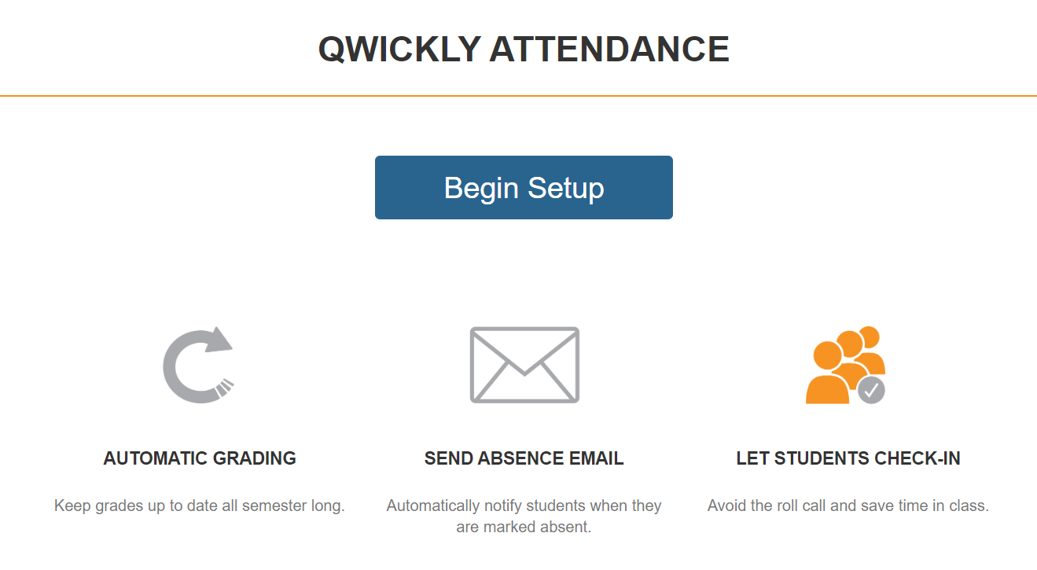

This will take you to this course register’s Settings page which is divided in to four sections: Preferences, Attendance Statuses, Automatic Emails and Grading.

Preferences
The majority of your register’s options are configured in the Preferences panel. The main settings in order of appearance are:

- Semester – For 2024/25, there is a single option to use for the register. Select this option when setting the register up for use.
- User Sorting – Set to your preference, based on First Name, Last Name or Username.
- Student Grouping – This can be set to ‘Single List’ to simply list all students who are enroled in the course, or can be set to ‘By Course Groups’ if your Blackboard course uses Groups for attendance purposes.
- Check In – This option enables students to check in on their own device. The Check In Timer can be set in minutes and the register can be set to require a PIN when checking attendance.

Click ‘Save Settings’ to confirm:

Once the settings have been confirmed, your course’s register will be set up for use.

The Preferences page also contains an optional ‘Schedule Sessions’ function which is covered towards the end of this guide.

Additional Settings Information

In addition to the Preferences tab, the following tabs are also located in the Settings page:

- Attendance Status: Illustrates the status that are applied to attendance records (Present; Absent; Excused). These cannot be changed.
- Automatic Emails: This can be used to configure the register to send an absence email after an absence threshold has been met.
- Grading: Allows the awarding of points based on attendance.

Recording Attendance

There are two approaches to recording attendance in Qwickly; either manually or via students checking in themselves.

To view all available register options, click on the ‘Attendance’ link in the left-hand menu:

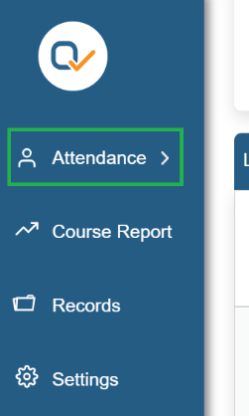

Recording Attendance Manually
Recording attendance manually as an Instructor or Administrator can be conducted either through the ‘List’ mode, or through the ‘One-By-One’ mode:

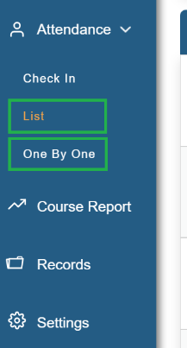

‘List’ mode will display all of the students in your Class within a single list and can be filtered by Group, whereas ‘One-By-One’ mode will progress through your Class sequentially, displaying a single student profile on-screen at a time.

Record Attendance via Check In
‘Check In’ mode enables your students to record their own attendance on their device whilst a Check In is running.

Note: You can change your Check In session settings at any time by navigating back to the ‘Settings’ window.

To begin a Check In session, click on the ‘Check In’ option, enter a clear Title for your session and then click the ‘Start Check In’ icon:

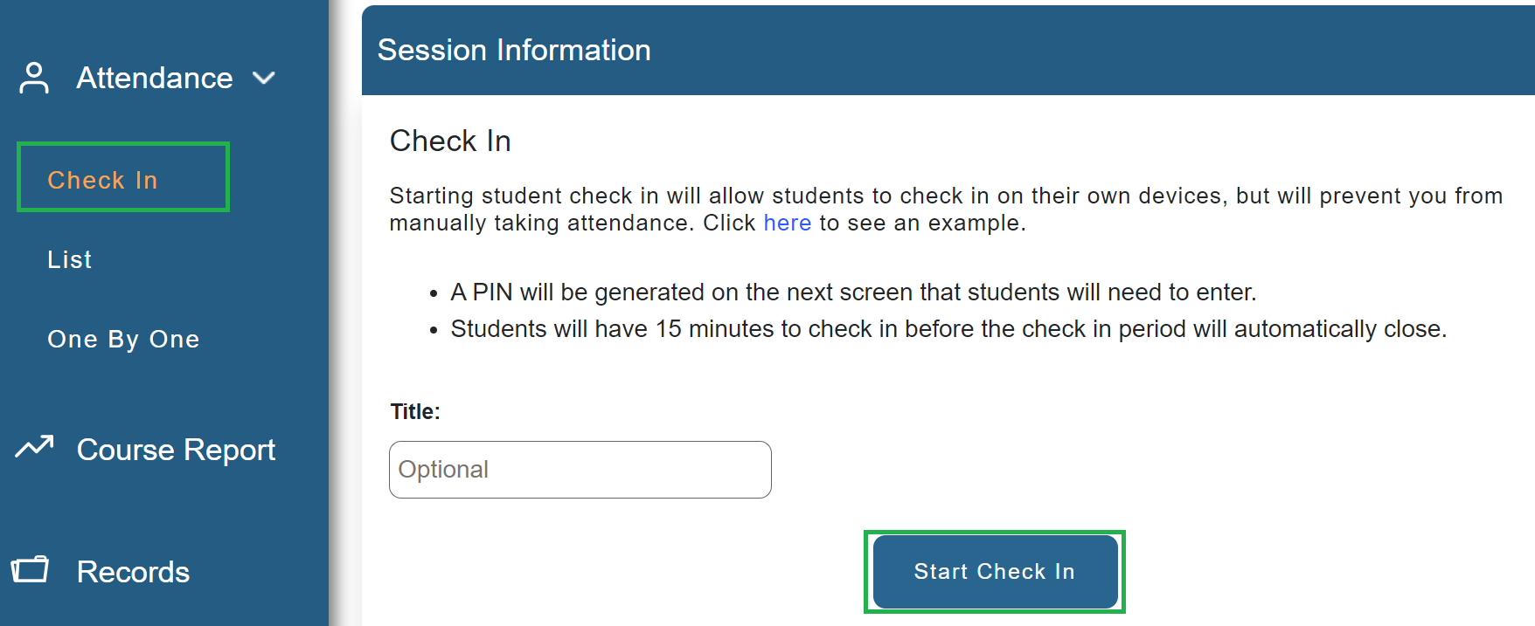

This will begin the Check In session based on your settings.

Instructor View of the Check In
When the Check In begins, this will allow the students to log their own attendance and the Check In screen will appear on the Instructor’s own screen.

If you have set a Timer, this will begin counting down and will automatically close the Check In when the duration reaches 0. If you have not set a Timer, the Check In will run indefinitely until it is closed manually.

If you have set your register to require a PIN, the 4-Digit PIN will display on screen during the Check In period:
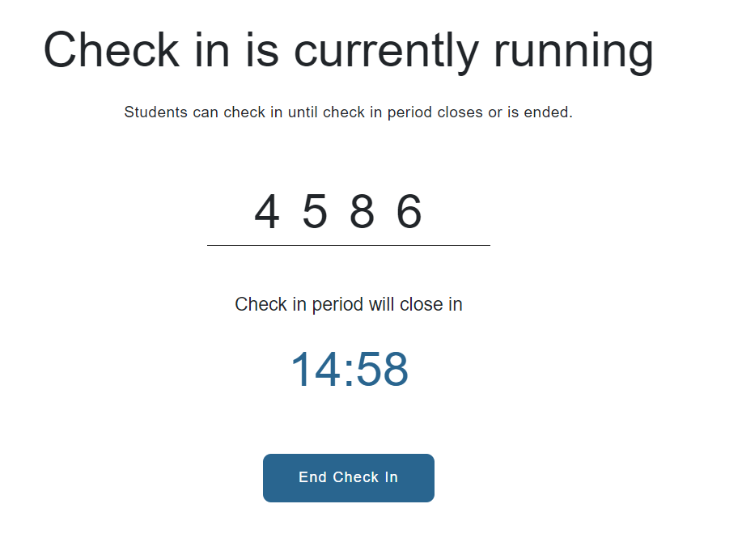

Note: If a PIN is required, ensure that it is on clear display, or is easily identifiable, for all students in attendance.

Student View of the Check In
Depending on the preference of the student, they may check in either on a Desktop, Laptop or Mobile device.

The process and interface between either device is mostly the same and illustrated in the below table:

Desktop / Laptop Device | Mobile / Tablet Device
The below screenshot illustrates the first screen of the Check In Process on a laptop or desktop device: | The below screenshot illustrates the first screen of the Check In Process on a Mobile/Tablet Device:
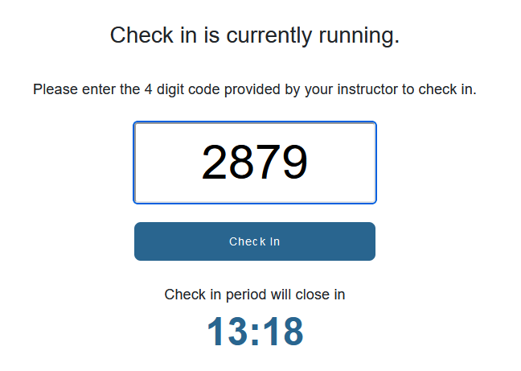 | 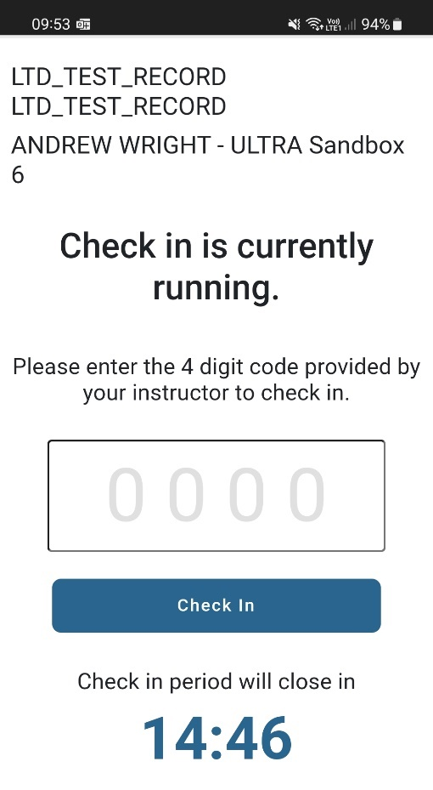
The below screenshot illustrates when the student has successfully checked in: | The below screenshot illustrates when the student has successfully Checked-In:
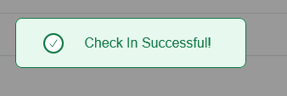 | 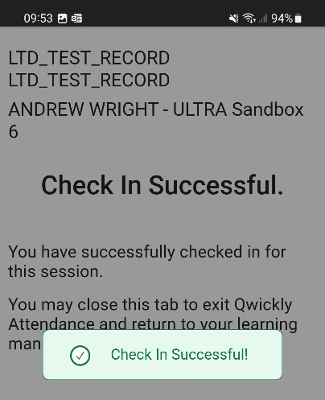

Managing and Amending Attendance Records

It is imperative that attendance records are accurate in your registers. Occasionally, you may encounter a scenario which has caused attendance data to be incorrect which can be rectified by an Instructor or Administrator.

Some examples of when such scenarios may occur include:

- A student is in attendance, but fail to Check In within the Check In duration; possibly due to a difficulty with their own device or login.
- A tutor begins a Check In session in error and ends the Check In after a few seconds. The tutor then begins a second Check In session for the students to log their attendance.

- A tutor begins the Check In session for the wrong Group in their register, preventing some students from being able to log their attendance.

The below methods can be used to rectify incorrect attendance records either for individuals or for entire sessions.

Amending Individual Records

An Instructor or Administrator can amend an individual attendance record by navigating to the ‘Records’ option in the left-hand menu:

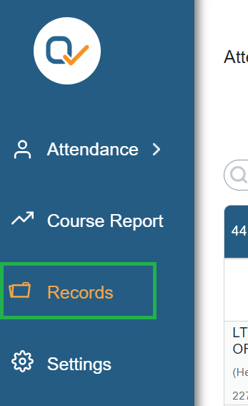

In the ‘Records’ page, select the cell of the record that you would like to amend. In the below example, the student record needs to be changed from ‘Absent’ to ‘Attended’:

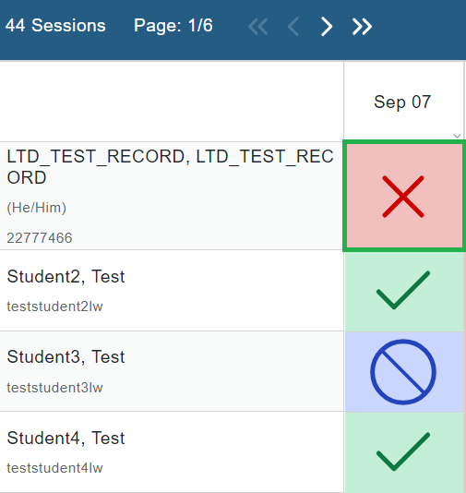

After selecting the cell, you will be prompted to amend the record and can include an optional comment:

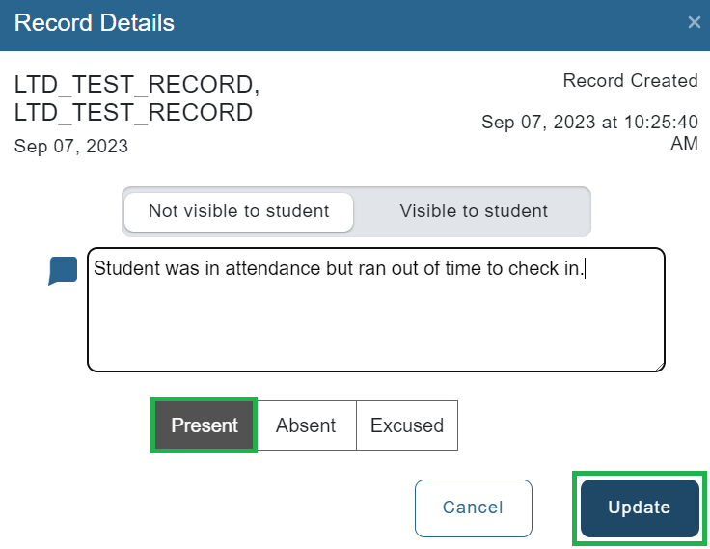

The record will then be amended to ‘Present’ and is therefore corrected for this student.

Deleting Incorrect Register Columns

An Instructor or Administrator is able to remove erroneous columns from their attendance register to rectify sessions that were started by mistake.

To delete the column, select the column title in the ‘Records’ page:
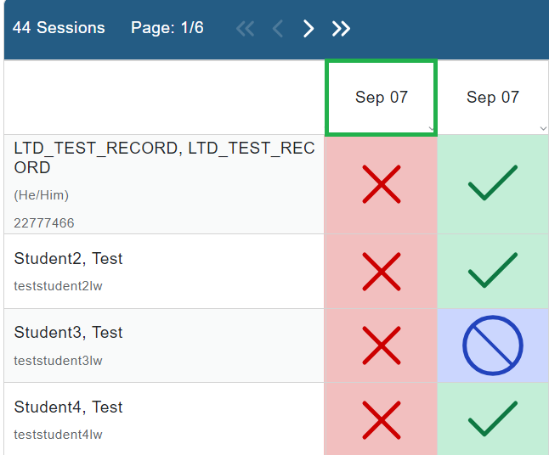

In the window that appears, select ‘Delete Session’ in the bottom left-hand corner:

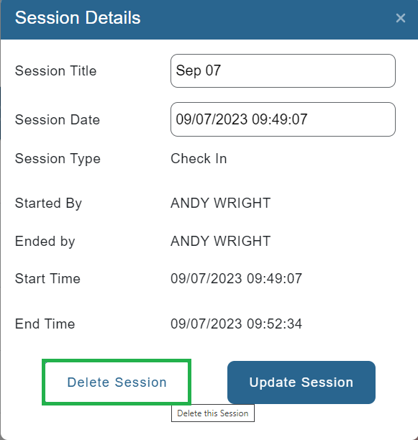

Download Attendance Data

Attendance data can be downloaded from the ‘Records’ window by clicking on the ‘Download’ icon on the top right-hand corner of the records table:

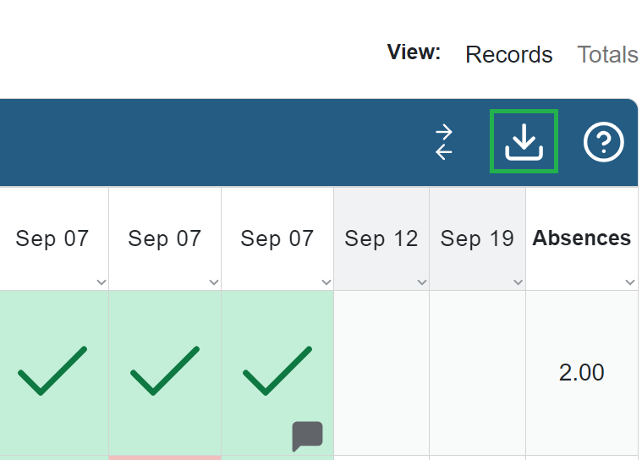

In the pop-out window that appears, you can select any additional information that you would like to include in your downloaded report, in addition to the mandatory Student Name and Attendance Status options.

Confirming the download will produce a Comma Separate Value (.csv) spreadsheet.

(Optional) Session Scheduler

Once you have saved the settings for your register, you may find it beneficial to schedule your sessions ahead of time. This is optional and not a requirement for your registers to run correctly.

The Schedule Sessions function can be used to create a register column which repeats on any set day of the week. To create your schedule:

- One the Preferences page, click on ‘Add Sessions’ in the bottom left-hand corner:
- On the pop-out window, set the days that you would like the register sessions to repeat and the range of dates that you would this to apply to:
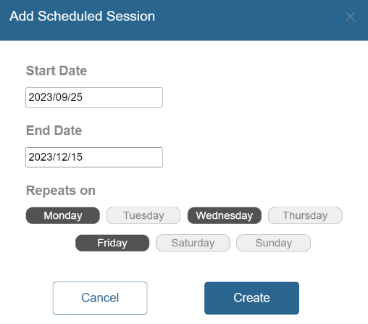
- Click ‘Create’ to confirm.
- In the left-hand column of the register, select ‘Records’.
- The ‘Records’ page will now display with the scheduled sessions:
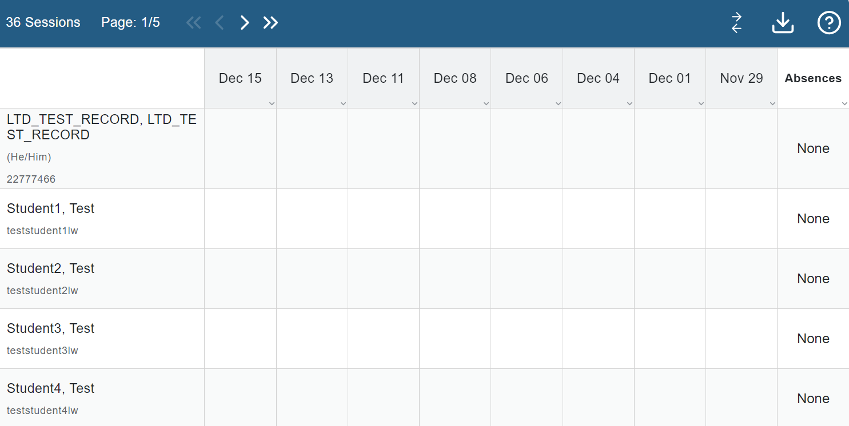
Note: If you would like to reverse the order of register columns from left-to-right then you can select the dual-arrow icon in the top right-hand corner:

- If the date that you start the register corresponds with a pre-scheduled session then it will appear as a selectable option:
