Setting Up Time-Limited Assessments for Nursing

Introduction 1
Setting up a TLA 2
Adding Questions 3
Creating Groups 3
Key Settings 4
Optional Settings 10

Introduction
Nursing have chosen a specific method of running ‘Time-Limited Assessments’ (TLAs) through the Test tool in Blackboard UItra. The method uses a standard time limit within a wider window method, but rather than using Accommodations for students with time-modifications, an extra version of the Test is created for each type of time-modification.
This document covers how to set up this specific type of TLA. We won’t cover everything that you could do with the Test tool in Blackboard but will focus on the key settings that you need to use to make this specific type of TLA work.

Setting up a TLA
On the Course Content section, navigate to the location that the students will look for the TLA. It will be a location such as an Online Time-Limited Assessment folder within an Assessment folder.
Select the purple plus button that appears, and then select Create from the drop-down menu that appears.
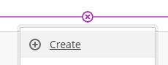
On Create Item panel select ‘Test’ under the Assessment area.
Give the Test a name. To do this select the default title at the top-left of the ‘Content and Settings’ page to edit it.
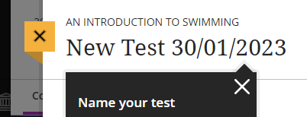
It is important to be consistent with labelling across the year(s) of study so that students become familiar with naming and location. Consistency includes the wording use, the order of the words and formatting (such as capitals). We recommend the following style:
ONLINE TIME-LIMITED ASSESSMENT 1 [23rd JANUARY 2023 – 10am-1pm]
You may want to clarify if this is a TLA for students with no time modifications, 25% extra time, or 25% extra time and 5 minutes extra per hour, to help ensure that you give the correct students access.

Adding Questions
Create or add questions, and associated information. Blackboard’s ‘Create Tests’ page provides details.

Creating Groups
The ‘Group Sets for Time-Limited Assessments’ video shows how to set up groups for students with different time modifications.

Key Settings

Introduction
This section covers the key settings for this kind of LTA. It might help if you understand that:
- Start time is controlled by ‘Release Conditions’.
- The ‘Time-limit’ prevents a student from having any more than the allocated time (e.g. 90 minutes or 120 minutes).
- At the ‘Due date’ any student submissions that are still in progress will be submitted. This prevents any submissions from being late. If a student reaches this time, it means they’ve started later than recommended and will not have had their full time.

Due Date
This is the date and time that the TLA ends. It is found within Test Settings.
You can open the Test Settings by clicking on the cog icon on the right.
The Due date setting is found under ‘Details & Information’.
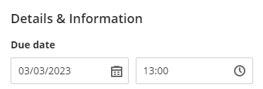

Preventing Late Submissions
You should prevent students submitting late by checking the ‘Prohibit late submissions’ checkbox. Tests will be automatically submitted at the due date and time.

Release of Marks
‘Post assessment marks automatically’ should be unchecked so you can post all student marks at the same time.

Description
The description appears below the Test title on the Course Content area. There is a 750-character limit and there are no options for formatting. You could use this to give details of what the students can expect in the TLA, for example:
“You have 90 minutes maximum to complete this exam. The exam will be released by 10:00am. You must have started by [11:30am/11:07am/10:58am] to ensure you receive your full time allocation. The exam will finish at 1pm. At 1pm, any open attempts will be automatically submitted. You will have 1 attempt to complete the exam. If you have any problems during the exam, please contact the team on 2022NUR1000@edgehill.ac.uk. Please ensure you have a good internet connection and power on the device you are using before starting. The exam takes the form of several multiple-choice questions (MCQs) and two essay style questions. Please include details of references used at the end.”

Time-limit
The ‘Time limit’ setting controls how long students have to complete their TLA within the wider window. Once they start the TLA the timer counts down, even if they leave the Test environment.
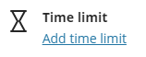
If we have a 120-minute TLA :
- For the Test for students with no time modifications the ‘Time limit’ should be 120 minutes.
- For the Test for students with 25% extra time modification the ‘Time limit’ should be 150 minutes.
- For the Test for students with 25% extra time plus 5 minutes per hour modification the ‘Time limit’ should be 163 minutes.
If we have a 90-minute TLA :
- For the Test for students with no time modifications the ‘Time limit’ should be 90 minutes.
- For the Test for students with 25% extra time modification the ‘Time limit’ should be 113 minutes.
- For the Test for students with 25% extra time plus 5 minutes per hour modification the ‘Time limit’ should be 122 minutes.

Note that if the TLA has a Time-Limit of 122 minutes, students must start the exam at least 122 minutes before the ‘Due-Date’ to ensure they get their full time. This information needs communicating to the students. For example for a 90-minute TLA that runs is released at 10am (technically 9.59am) and has a due date of 1pm:
- Students with no time-modification need to start by 11:30am at the latest to get their full time allocation.
- Students with a 25% time-modification, need to start by 11:07am at the latest to get their full time allocation.
- Students with 25% extra time plus 5 minutes per hour modification, need to start by 10:58 at the latest to get their full time allocation.

Release Conditions
Release conditions control when students can select the link to enter the exam. They are accessed outside of the Test Settings menu, at the top right of the screen.
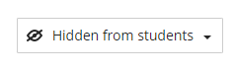
By default it reads ‘Hidden from students’. Never set it to ‘Visible to Students’ or students will see the exam and the questions. Select ‘Release conditions’ from the drop-down menu.
To control the times that the TLA is available select ‘Date/Time and add ‘Show on’ and ‘Hide after’ dates and times. Then select ‘Save’.
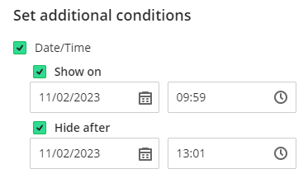
We’d recommend setting the ‘Show on’ date to one minute before the official start time. This is because it can take up to a minute for the Test to become available to students.
Release conditions can also be used to give only individuals or groups access to a Test. As you are using a different copy of the test for students with different types of time-modifications, or no time modification, this is relevant.
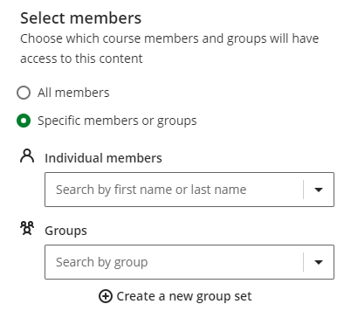
Open the Groups drop-down menu and under the TLA Group Set we created earlier, select the appropriate group.
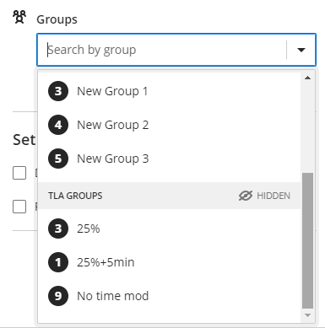

Optional Settings
There are more settings that may be relevant for an assessment in particular cases. The Blackboard Help Centre pages may help you decide.

Presentation Options
These will be visible if you more than one question or page.

Marking & Submissions
These will generally be left as default except ‘Post assessment marks automatically’ which we noted in the General Settings section.

Assessment results
These settings can usually be left as the default settings.

Assessment security
The access code option is rarely used.

