Setting Up Time-Limited Assessments

Introduction 1
Setting up a TLA 2
Adding Questions 3
General Settings 5
Optional Settings 8
Other Key Settings for ‘Standard TLAs’ 9
Other Key Settings for ‘TLAs with Windows’ 11
Copying Tests from Original to Ultra 14
Appendix One: Notes on Test Settings 16

Introduction

This document covers how to set up ‘Time-Limited Assessments’ (TLAs) using the Blackboard Ultra Test tool. The Test tool allows the use of a range of question types and feeds the grades into the Gradebook. The Blackboard Help Centre pages go into more detail than this guide, so may help answer other questions that you have.
Timing for these TLAs is commonly set up in two ways. It is important to identify the type of TLA you are running. Standard TLAs have a set start and end time (e.g. 10am to 11:30am), while TLAs with Windows consist of a time limit within a wider exam window (e.g. 90 minutes between 10am and 1pm). Both methods of timing will need setting up in a very specific way.

Setting up a TLA

On the Course Content page select the plus sign to add a Test. It is recommended that this is done from within an appropriate folder – most likely an Assessments > Online Time-Limited Assessment folder. In the menu, select Create to open the Create Item panel and scroll down to select Test under the Assessment area.
Give the Test a name. Select the default title at the top-left of the ‘Content and Settings’ page to edit it.
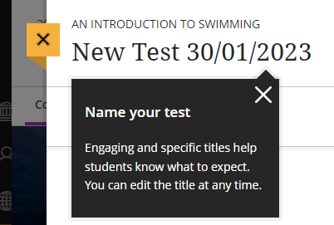
It is important to be consistent with labelling across the year(s) of study so that students become familiar with naming and location. Consistency includes the wording use, the order of the words and formatting (such as capitals). We recommend the following style:
ONLINE TIME-LIMITED ASSESSMENT 1 [23rd JANUARY 2023]

Adding Questions

There are four main things that you can add when constructing your Test.

Text
You can add text anywhere within a Test. This allows you to create Tests that are split into Sections (disables randomisation of questions though), add information or scenario setting before questions or simply to give some content.

Files
In a similar way to adding text, you can add files. This may be to deliver additional reference content or supporting materials within the test which wouldn't be accessible before beginning the test. In a similar way you can also add multimedia such as diagrams, images, or graphics. If you need to link to a video, we recommend uploading the video to Panopto and then link to the video by using the Content Market > Panopto Course Video option so that it can be streamed.

Questions
There are a variety of different question types in Tests in Ultra:
• True/False
• Multiple Choice
• Matching
• Fill in the Blank
• Calculated Formula
• Essay

Feedback
You can add automated feedback that can be shown when questions are automatically marked. Additional settings when this is used include when to display the feedback, display of question scores and whether to display the correct answers. Automated feedback can save you time afterwards giving individual feedback yet still has the benefit of offering the student further resources to aid and enhance their learning based on a specific question.

General Settings

These are settings that will always be required.

Due Date
This is the date and time that the TLA ends. It is found within Test Settings.
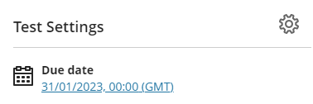
You can open the Test Settings by clicking on the cog icon on the right.

Preventing Late Submissions
Reduce the chance of students submitting late by checking the ‘Prohibit late submissions’ checkbox. Tests will be automatically submitted at the due date and time, except for students with time modifications on ‘Tests with Windows’. We will discuss how to avoid issues related to this later.

Release of Marks
‘Post assessment marks automatically’ should be unchecked so you can post all student marks at the same time.
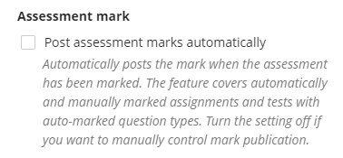

Description
The description appears with the Test title on the Course Content area. There is a 250-character limit and no options for formatting. You could use this to give details of what the students can expect in the TLA. For a Standard TLA this might read.
“You have 90 minutes maximum to complete this exam, plus any time-modifications relevant to you. It will start at 10am. At 11:30pm (or later if you have time-modifications) any open attempts will be automatically submitted. You will have 1 attempt to complete the exam. If you have any problems during the exam, please contact the team on 2022NUR1000@edgehill.ac.uk. Please ensure you have a good internet connection and power on the device you are using before starting. The exam takes the form of several multiple-choice questions (MCQs) and 2 Essay style questions. Please include details of references used at the end.”

Release Conditions
Release conditions control when students can select the link to enter the exam.
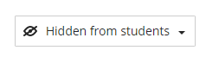
Release conditions are accessed outside of the Test Settings menu, at the top right of the screen.

By default it reads ‘Hidden from students’. Never set it to ‘Visible to Students’ or students will see the exam and the questions. Select ‘Release conditions’ from the drop-down menu.
Release conditions could be used to give only individuals or groups access to a Test. However you will be using it to release and hide the Test at certain times.
To do this select ‘Date/Time and add ‘Show on’ and ‘Hide after’ dates and times. Then select ‘Save’.
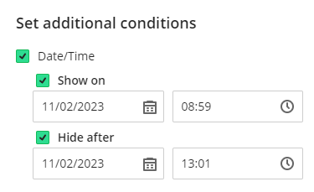
We’d recommend setting the ‘Show on’ date to one minute before the official start time. This is because it can take up to a minute for the Test to become available to students.

Optional Settings

These settings may be relevant for an assessment in particular cases. The Blackboard Help Centre pages, or the ‘Appendix One: Filling in the ‘Test Settings’ section at the end of this document may help you decide.

Presentation Options
These will be visible if you more than one question or page.

Marking & Submissions
These will generally be left as default except ‘Post assessment marks automatically’ which we noted in the General Settings section.

Assessment results
These settings can usually be left as the default settings.

Assessment security
The access code option is rarely used.

Other Key Settings for ‘Standard TLAs’

Standard Tests start and end at specific times for everyone.
The only settings specific to only this type of TLA relate to students with time-modifications. These students will receive due-date Exceptions.
To add an Exception for a student:
- Go to Gradebook and select the assessment a student needs an exception in.
- Locate the student and select the three dots at the end of their row. Select ‘Add or edit exceptions’.
- On the Exceptions panel, adjust the due date for the student.
  - I’ve spoken to the Inclusion Team, and they say in terms of time modifications we’ll come across ‘25% extra time’, and ‘25% extra time + 5 minutes per hour’ modifications. Note that the 5 minute per hour includes both the original time and the 25% extra time.
  - Students needing 25% extra time doing a 90-minute exam need the due date to be 113 minutes after the start date.
  - Students needing 25% extra time doing a 120-minute exam need the due date to be 150 minutes after the start date.
  - Students needing 25% extra time + 5 minutes per hour, doing a 90-minute exam need the dues date to be 122 minutes after the start date.
  - Students needing 25% extra time + 5 minutes per hour, doing a 120-minute exam need the dues date to be 163 minutes after the start date.
- Select ‘Save’.

Other Key Settings for ‘TLAs with Windows’

‘TLAs with Windows’ allow a time-limit within a wider TLA Window. This might be a 90-minute time limit within a 4-hour window.
In the past some TLAs have allowed a short window (e.g. 10 minutes longer than the time limit) however this can cause problems if there are students with time-modifications, so we recommend that this is avoided.
All students must be aware that to get their full time for the test they need to start early enough. If the window is 10am-2pm and they get 90 minutes, then they won’t get their full time if they start after 12:30pm, and students with time modifications need to start even earlier. We’d recommend long windows with a recommended time that everyone should have started by.
There are two settings that need to be added for this type of TLA.

Time Limit
Within ‘Test Settings’ under ‘Additional Tools’ you need to set the ‘Time limit’. This is how long the students gets to complete their tests. The ‘Work is automatically saved and submitted when the time expires’ option should be selected.
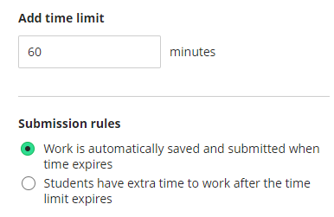

Accommodations
Students with time-modifications on this type of Test require ‘Time-limit accommodations’.
This applies to any assessments in this Blackboard area where the ‘Time-limit’ setting is used, so keep that in mind.
Also keep in mind that if a student has a ‘Time-limit accommodation’ the ‘Prohibit late submissions’ setting will not apply to them so that they receive their full extra time. The downside is that if they start the Test too late their submission may be marked as late. Students with ‘Time limit accommodations’ need to be informed that they must start early enough to allow then to use their full time, and if they start later than this they need to manually submit before the ‘Due date’.
To add an Accommodation for a student:
- Go to ‘Class register’.
- Locate the student and select the three dots at the end of their row. Select ‘Accommodations’.
- Select ‘Time limit accommodation’ and add the correct extra time percentage in the ‘Custom percentage’ box.
  - I’ve spoken to the Inclusion Team, and they say in terms of time modifications we’ll come across 25%, and 25% + 5 minutes per hour modifications. Note that the 5 minute per hour includes both the original time and the 25% extra time.
  - Students needing 25% extra time have 25% added to the time limit accommodations box
  - Students needing 25% + 5 minutes per hour have 36% added to the time limit accommodations box
- Select ‘Save’.

Copying Tests from Original to Ultra

To copy a test from an original course to an Ultra follow the below instructions:
- Navigate to the Ultra course where you want the test to be.
- Click into the Assessment folder where you want the test to appear.
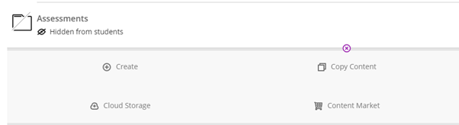
- Select Copy Content (or click the plus (+) and then Copy Content).
- Search for the course you want to copy from and click on the course title.
- Navigate to the folder that contains the Test you want to copy by click on the titles of the folder.
- You don’t have to copy entire contents of a folder – you can select individual items. This avoids copying Turnitin dropboxes (for example)
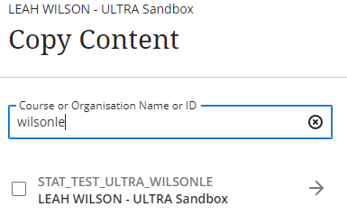
- Select the test you want to copy and click Copy selected content.
- You will be notified of any options/questions that haven't copied over correctly.

Appendix One: Notes on Test Settings

It is important to carefully review the Test settings as they not only affect the student experience and interaction with the assessment but also the integrity of the process. For each test that you create, you have the following options.

Details and Information
Due Date - This is the date/time an assessment must be submitted by. Items submitted after the due date will be marked as late. The due date also appears on student’s calendars. Note: If an assessment is hidden, it will not appear on a student’s calendar.
Prohibit late submissions - Disallows a late submission. In-progress and saved attempts will auto-submit at the due date. Students will receive a submission receipt via email. Specified accommodations are still honoured. Note: If students have submitted attempts, you cannot change the due date to a date in the past. If the due date has passed, you can't select the Prohibit late submission setting.
Prohibit new attempts after due date - This option prevents students from beginning a new attempt after the due date. Note: Selecting ‘prohibit late submissions’ auto-enables ‘prohibit new attempts after due date.’ However, staff can enable the ‘prohibit new attempts after due date’ option on its own.
Allow class conversations - If you allow class conversations, students can discuss the test with you and their classmates while the test is available. Students can contribute to the conversation before, during, and after the test. As the conversation develops, it appears only with the relevant test.
Display one question at a time - If the assessment has questions such as MCQs or True/False, this setting displays them one page at a time rather than all at once.
Randomise questions - You can randomize questions and their answers. Questions appear in order to you but are randomized for students. To prevent confusion, don't add numbers to reference other questions within the test. You can't randomize questions in a test with text blocks (free text) or attachments (files).
Randomise answers - You can use one or both settings, so tests appear differently for each student. You can only randomize answers for Matching and Multiple-Choice questions. If you want to randomize answers for True/False questions, use the Multiple-Choice question type with True and False answer choices.
Collect submissions offline - This setting is used for assessments that do not require online submissions, such as oral presentations or observations. If this setting is enabled, students cannot make submissions to the assessment.

Marking and Submissions
Mark category - This should be Test
Attempts allowed - You can let your students submit more than one attempt at a Test
Mark using - Points, Percentage or Letter. We generally use Points
Maximum Points - Specify Maximum Points
Anonymous marking - We don’t support Anonymous marking at the moment
Assessment mark - This feature auto-posts grades without it having to be done manually

Assessment Results
Submission view - Allows control over whether students are able to have access to what they submitted after they complete an assessment.
Automated Question Feedback - Provide students with feedback that automatically releases based on chosen settings.
Question Scores - Allows students to see the Test questions and their scores for each question.
Correct Answers - Allows students to see the correct answers for each question.

Assessment Security
Access code - You can add an access code to control when students and groups take a test. At this time, the access code is generated at random by the system. This would be used if the Test was being taken in a room at the same time by the students and the code would be shared at the point that they start (via a screen or projector).

Additional Tools
Time limit - You can set a time limit for the Test. If no time limit is issued, students can view a test and they don’t have to submit it. They will be able to save and close their test and return to it later.
Use marking rubric - You can add a rubric to help you evaluate student submissions based on key criteria that you define. You can create a new rubric or associate a rubric that you’ve already created. Note: At this time, you can only add a rubric to a Test without questions – it is mainly use in Assignments, not Tests.
Goals & standards - We currently do not use this function.
Assigned groups - You can create a test for groups of students. By default, you assign a grade to each group, but you can change a group member’s individual grade.
Originality Report - You can use SafeAssign to check for plagiarism. It is like Turnitin in it will produce a similarity report. SafeAssign should be enabled prior to submissions.
Description - Add an optional description: The description appears with the Test title on the Course Content area. There is a 250-character limit. Use this to give details of what the students can expect in the Test – for example:
“You have 90 minutes maximum to complete this exam, plus any time-modifications relevant to you. It will start at 10am. At 11:30pm (or later if you have time-modifications) any open attempts will be automatically submitted. You will have 1 attempt to complete the exam. If you have any problems during the exam, please contact the team on 2022NUR1000@edgehill.ac.uk. Please ensure you have a good internet connection and power on the device you are using before starting. The exam takes the form of several multiple-choice questions (MCQs) and 2 Essay style questions. Please include details of references used at the end.”

