Submitting Assignments to Turnitin

Contents
Introduction 1
Submitting to Turnitin 2
Re-Submitting to Turnitin 5
Viewing Grades and Feedback 6

Introduction
Turnitin is an assignment submission tool, used within Blackboard. Most assignments are submitted through Turnitin.
It is recommended that you use Google Chrome or Mozilla Firefox when submitting assignments.

Submitting to Turnitin

You would normally find Turnitin assignment dropboxes under a section or folder named ‘Assessments’ or ‘Assignments’.
A link to the dropbox will look something like the image below:
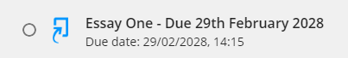
Click on the link and select Launch.
On the submission page selecting the arrow next to the assignment name will reveal important information about the conditions, such as the due date and time, whether ‘resubmissions’ up to the due date are permitted, and the feedback release date when grades are released:
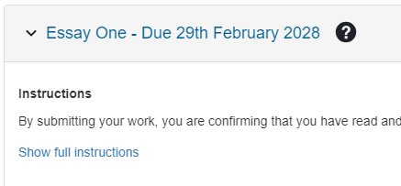

When you are ready to submit, click the ‘Upload Submission’ button, and a pop-up box will appear.
Hover your cursor over the question mark icon next to ‘Submission File’ to see which file types are permitted. The maximum file size for submission is 100MB.

Most people upload their assignment using the first option, using the ‘Choose File’ button select their file Enter a meaningful Submission Title.

Before you start this process, make sure the file that you are submitting is closed. If you have the file open in Microsoft Word, for example, it may affect the submission.

When ready, click ‘Upload and Review’, and you will see the file uploading.

The Review screen shows a preview of the file, so that you can check everything is ok. Click ‘Submit to Turnitin’.

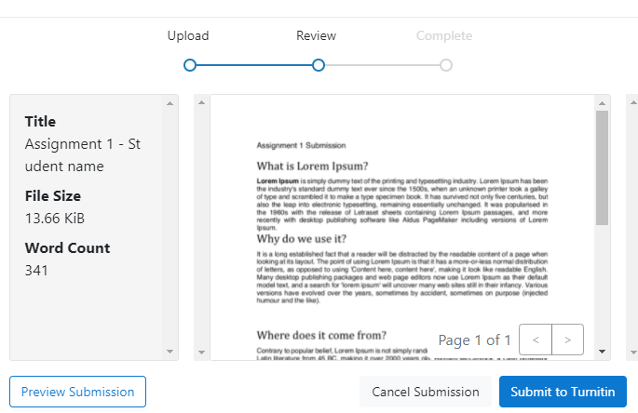
Once the file has submitted, you will see a message saying it has been successful. 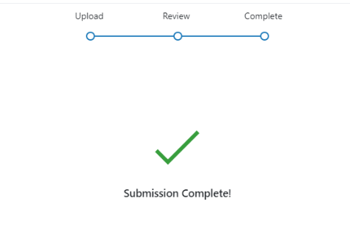

The pop-up box will then disappear, and you will see your submission in the assignment dashboard:

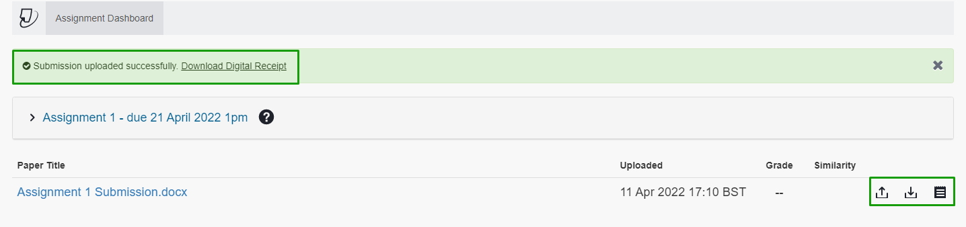

You will not receive an emailed digital submission receipt, but you can download one here, straight after submitting, or later, by clicking the paper icon to the right of the submission.

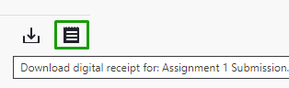

Re-Submitting to Turnitin

If you wish to re-submit to Turnitin, and if the settings permit it, click back onto the assignment to load the same ‘Assignment Dashboard’ page, and click the ‘Resubmit Paper’ icon which looks like an up arrow.

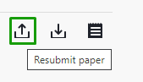

You will see a pop-up explaining that after 3 re-submissions, a new similarity report will take 24hrs to appear.

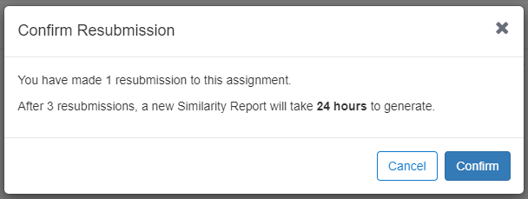

Viewing Grades and Feedback

To view your grade after the feedback release date, access the same assignment dropbox, your grade will be entered by the tutor against your submission:

When you click on the assignment, it will open up, and you will be able to view any feedback entered by the tutor:

You can download a pdf copy of your assignment with the feedback included, by clicking the download icon, and selecting ‘current view’:

