Ethics application approval workflow
This guide is for applicants
Guide updated 01/02/2022
Contents
Supervisor (student applications only) 1
Head of Department 2
If you add a reviewer as co-applicant 3
Subject Research Ethics Committee (SREC) 3
If the system will let you submit 4
If the system will not let you submit 5
Unsuitable reviewer selected (student applications only) 5
Department not associated with a SREC 5

- This guide focusses on an ethics application’s route through the approval workflow in the Ethics Monitor system.
- An application must pass through up to four review/approval steps in Ethics Monitor:
  - Supervisor (only student applications)
  - Head of Department (all applications)
  - Subject Research Ethics Committee (SREC; all applications)
  - University Research Ethics Committee (URESC; only certain activity/SREC referrals)
- Your application can be returned to you at any stage if the reviewer needs you to make changes. When you resubmit the updated application to the workflow, it goes straight back to the step that asked for the changes.

Supervisor (student applications only)
Do not add your supervisor as a co-applicant – they cannot approve their own applications so the system will not send it to them, and approval will be delayed.
- If you are a student, you need to specify at least one supervisor.
- Simply type your supervisor’s name in the Supervisor field and select them from the list that pops up.
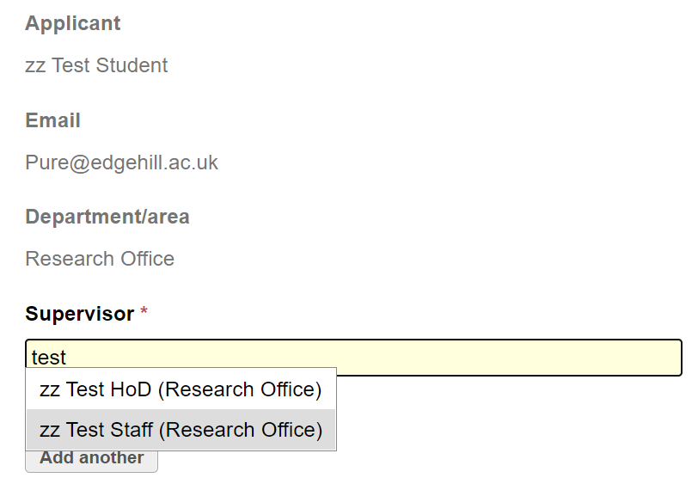
- They will be added to the field. You can then add additional supervisors in the same way, as necessary.
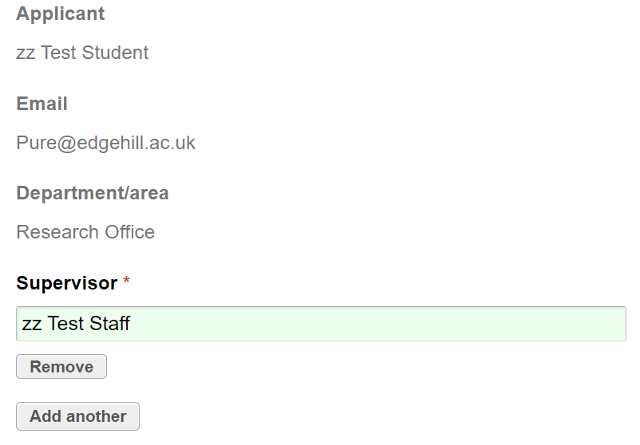

Head of Department
Do not add your head of department as a co-applicant – they cannot approve their own applications so the system will not send it to them, and approval will be delayed.
- Simply type your head of department’s name in the Head of Department field and select them from the list that pops up.
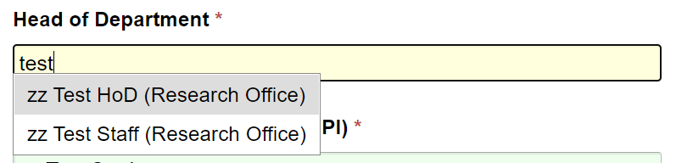
- They will be added to the field.
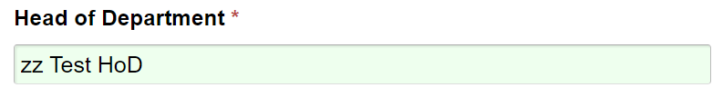
- You should normally select your actual head of department in this field. If your department/faculty has internal processes that mean a staff member other than your head of department should approve ethics applications instead, you can select any staff member.
- Students: if you select someone other than your actual head of department here, the person you select must have head of department permissions in the Ethics Monitor or you will not be able to submit the application.
  - Your department/faculty should advise you if it deviates from the standard process, but they need to have arranged for a change in their proxy head of department’s system permissions with the Research Office.

If you add a reviewer as co-applicant
- When you select a supervisor and head of department on your application, they will be set as reviewers in the approval workflow.
- Users cannot approve their own applications; if you have also added any of those named reviewers to the Internal co-investigators (CI) section, the application will be redirected to the URESC secretary instead of that reviewer.
The system will allow you to submit the application but the URESC secretary is not a reviewer and does not get alerted to these cases, so your application will be delayed. Check your application before you submit to avoid this.
- The Reviewers section of the application summary page will show you if this problem affects your application.
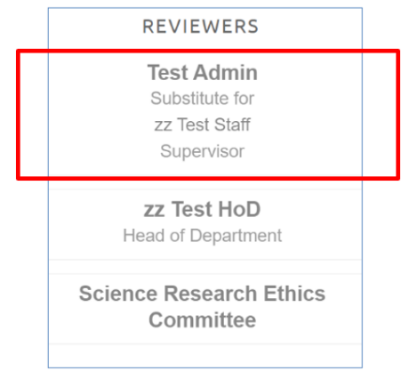
  - Where you would normally see the reviewer’s name, you will instead see the URESC secretary’s name listed as ‘…Substitute for…’ the expected reviewer’s name and role in the workflow (supervisor; head of department).
- To correct this, you need to either remove the reviewer from the Internal co-investigators (CI) section or replace them as supervisor/head of department (as applicable) with another suitable staff member.
  - The course of action you take may depend on several factors outside the scope of the Ethics Monitor, including the processes of your department/faculty/SREC/Graduate School/other appropriate area.

Subject Research Ethics Committee (SREC)
- If you are staff, the SREC for your application is normally based on your own department according to your Ethics Monitor account.
  - This information comes from your staff record so cannot be edited in Ethics Monitor, but there can be a delay in the system receiving updates.
- If you are a student, your student record is not linked to a department so the SREC is normally based on the department of the person in the Head of Department field.
- Some applications will be routed to specific SRECs if they involve work with human tissue or require Health Research Authority approval, regardless of the departments involved.
- If the abovementioned department details are correct but you think the SREC shown on the application summary screen in Ethics Monitor is not appropriate, submit the application to that SREC and it will decide whether the application should be referred to another SREC.

If the system will let you submit
- If Ethics Monitor can identify a SREC from the details supplied, the application summary screen will show:
  - A ‘green light’ against the Submit application button, and
  - A complete approval route under Reviewers, from supervisor (if you are a student) to a specified SREC (and URESC if applicable)
- This screen does not tell you if your application form is incomplete. Click Submit application to see which sections, if any, have incomplete mandatory fields.
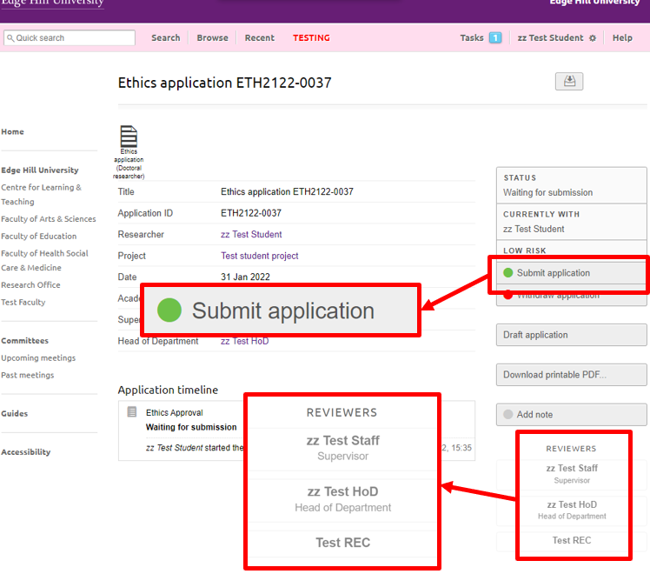

If the system will not let you submit
- If Ethics Monitor cannot identify a SREC from the details supplied, the application summary screen will show:
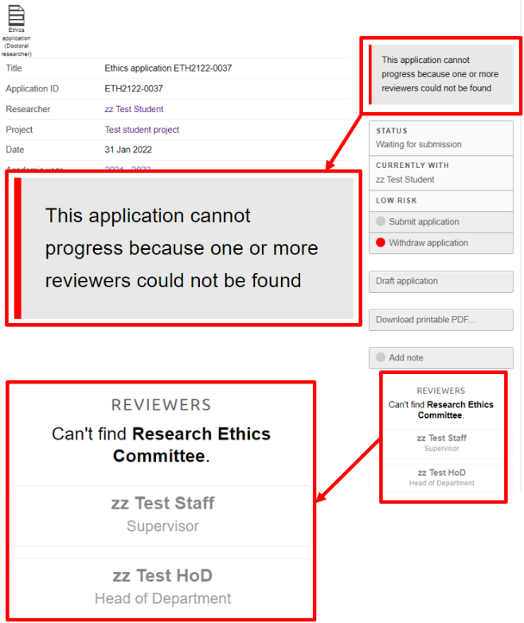
  - No ‘green light’ against the Submit application button, and
  - An on-screen error message e.g. ‘The application cannot progress because one or more reviewers could not be found’, and
  - No SREC listed under Reviewers, as well as on-screen text e.g. ‘Can’t find Research Ethics Committee’.
- This screen does not tell you if your application form is incomplete. Click Submit application to see which sections, if any, have incomplete mandatory fields.
- In terms of the workflow, one of two things usually causes the error text mentioned above, and prevents submission.

Unsuitable reviewer selected (student applications only)
- This is the most common reason you will not be able to submit.
- The Head of Department you have selected on your application does not have the necessary permissions in the system for that role.
- You need to select an appropriate person as Head of Department, as outlined above.

Department not associated with a SREC
- This is a less common reason you will not be able to submit.
- Staff: occurs if your department is not linked to a SREC.
- Students: occurs if the person selected as Head of Department has the necessary permissions in the system but their department is not linked to a SREC.
- Let us know; we can usually fix this quickly.

