The PowerPoint Record Tab

Contents

Introduction 1
Getting access to the Record tab 2
Example Process: Creating a Screencast Video 3
Example Process: Creating an Online Presentation using Commentary and Annotations 8

Introduction

The PowerPoint Record tab is useful when you want to create audio and video recordings that can be added to your presentation slides or exported as a video. The Record tab is available with a Microsoft 365 subscription.

Getting access to the Record tab

The tab will look something like this.
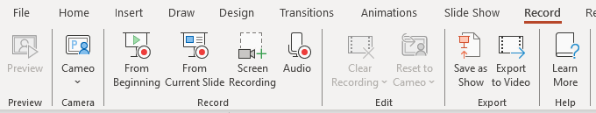
In some cases, you might need to manually make the tab visible. Right click on the ribbon and select ‘Customise the Ribbon…’.

Under ‘Customise the Ribbon’ > Main Tabs, make sure the ‘Recording’ option is checked.
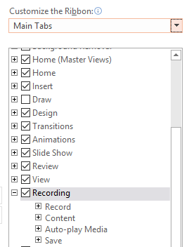

Example Process: Creating a Screencast Video

A common use of the Record tab will be to create screencasts. When you create a screencast, you record your screen and the audio from a headset or stand-alone microphone.

The Screen Recording option allows you to make one or more of these recordings.
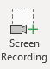

There are several processes you could go through to create a screencast, but in this example, we will create two recordings with title slides, and export them as an MP4 video which could be hosted on YouTube or Panopto.

Start by creating the required slides. Leave blank slides where you are going to record videos and put title slides between these.
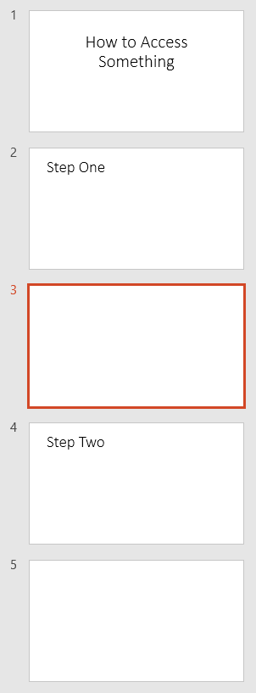

Select the slide that you want to place the recording on and click ‘Screen Recording’. PowerPoint will be minimised, and the controls dock will appear.

Your cursor will change to a cross, and you can select a section of, or all the screen, to record. Press ‘Windows logo key + Shift + F’ to easily select the whole screen.

The ‘Select Area’ button enables you to reselect the area to be recorded. You can deselect the Audio and Record Pointer options to prevent the recording of these.

Click ‘Record to start the recording or use the keyboard shortcuts.
- Press Windows Logo Key + Shift + R to start and pause the recording
- Press Windows Logo Key + Shift + Q to stop the recording

If the control dock is appearing on the recorded video:
- Ensure it is not pinned by clicking the dock’s pin icon until it sits sideways.
- Ensure that your cursor is not hovering over the dock, and it should disappear before the recording countdown is complete.
- Note that pressing ‘Windows Logo Key + Shift + I’ collapses the controls dock. If you are having trouble, you might be able to use this.

When you stop the recording, it will appear on the slide that you selected beforehand. You can select and delete the video if you want to record it again.
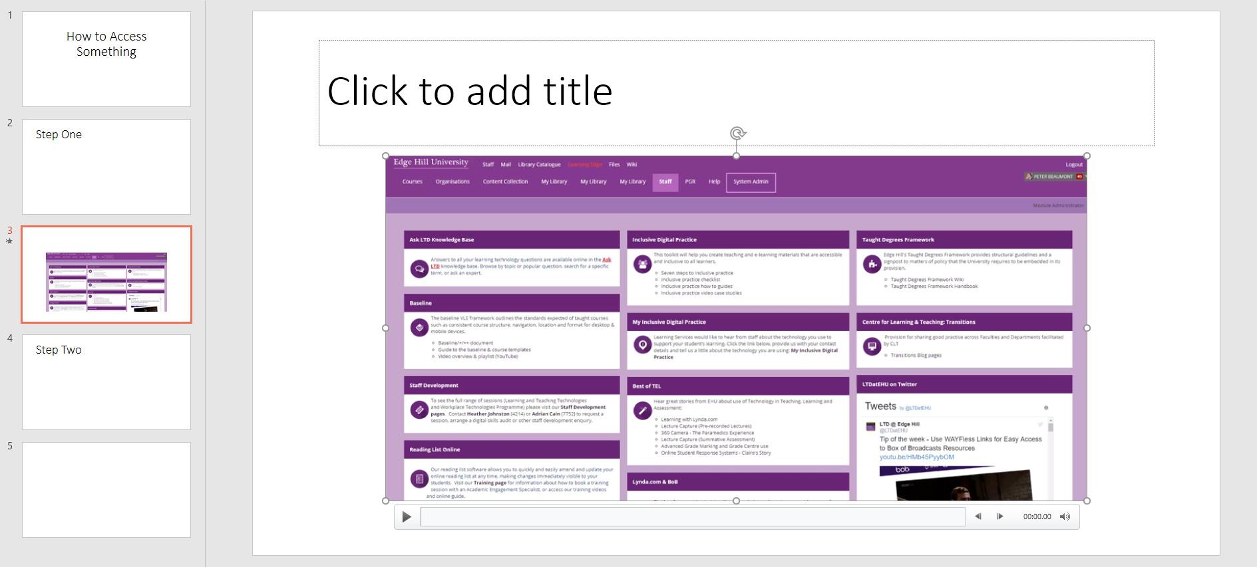

Click on the round handles on the sides and corners of the video to resize it as required.

Once you have created the second video and are happy with your creation, you can export the whole presentation as a video. Click on the Export to Video button.
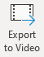

On the ‘Export to video’ screen you can add a title and export with default settings using the ‘Export Video’ button or choose ‘Customize Export’ to change the settings such as the video quality.
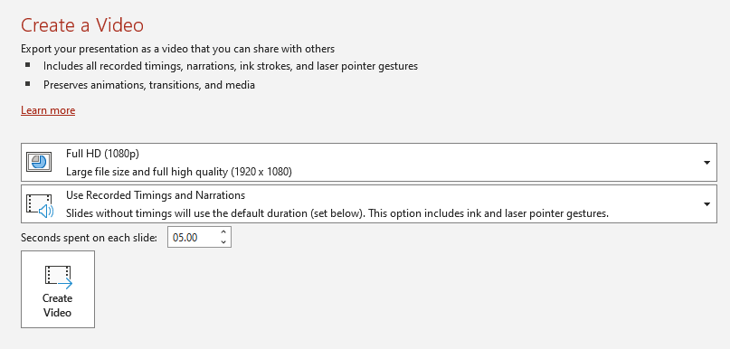

Choose the required file quality, along with the other settings. Note that ‘Seconds spent on each slide’ refers to the slides without video on, so unless you have already manually set a timing for these, they will stay on screen for the length of time selected here.

Finally, you can select the file type to export from the drop-down menu
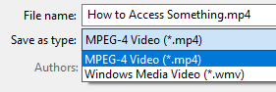

A video will be exported, which can be hosted on YouTube or Panopto, for example.

Example Process: Creating an Online Presentation using Commentary and Annotations

Another activity that the Recording tab enables is creating a narrated or annotated version of an existing presentation.

Open a new copy of your existing presentation slides as the recording process will alter them. Select ‘From Beginning’.
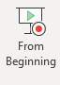
This opens a recording screen. Recording is done slide by slide. You can start, stop, and control cameras, mics, and the teleprompter, using the controls at the top of the screen.

Annotation options can be seen at the bottom of the screen. These could be used to highlight a section of text.

When you have finished the recording for a slide, you can move to other slides using the arrow buttons at the bottom of the screen.

