

Qwickly Attendance for Students

A Guide to Checking In

Contents
Introduction 2
Locating Qwickly Attendance 2
Checking In 3
Troubleshooting Tips 5
I can’t find the link to Qwickly anywhere in my course. 5
I can’t log my attendance in Qwickly. 5
Qwickly isn’t loading for me. 6
I have received an absence notification, but I was present at my session. 6

Introduction

Qwickly Attendance is an attendance register tool that is accessed thought Blackboard areas.

The ‘Qwickly Attendance in Blackboard’ page gives you information on connecting to the eduroam WiFi and recommended browsers.

Locating Qwickly Attendance

A link to the Qwickly Attendance Register may appear near the top of the ‘Course Content’ area or in ‘Module Resources and Support’.
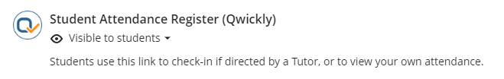
If you’re having difficulty locating Qwickly Attendance then you may find it helpful to use the search ‘magnifying glass’ icon in the top right-hand corner of the course page:
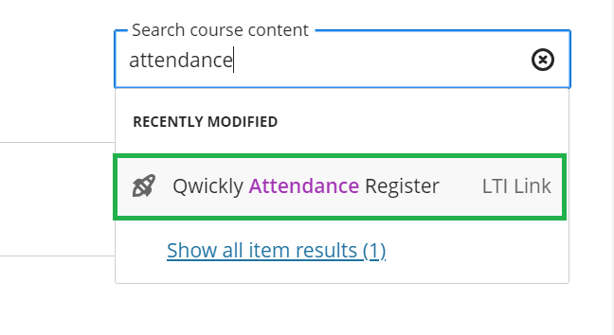

Checking In

In Qwickly Attendance, your tutor will start the check in process, and you are able to log your attendance on your own device during this period.

If they are not requiring a four-digit number to check in, simply click the ‘Check In’ button during the Check In period.

If the tutor does require a four-digit number, it will appear like this on your tutor’s screen, which they are probably displaying on the screen in the classroom:
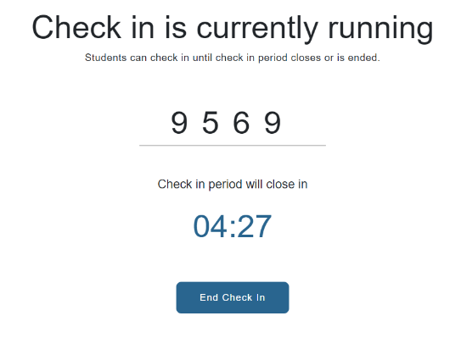
While the check in is running, select the attendance register link in your course. On your own web browser (either on a desktop, laptop or mobile device), you will see this version of the screen, prompting you to enter the four-digit number:
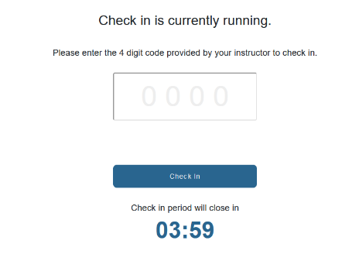
Once you have entered the four-digit number, select ‘Check In’:
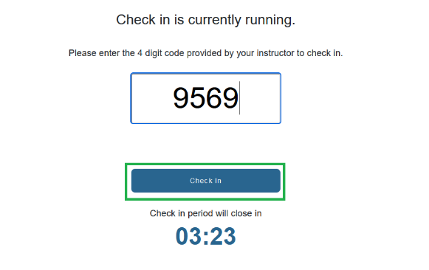
Once you select 'Check In' it will redirect you to the Attendance Record page and display the message “Check in Successful”.
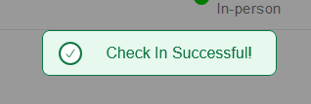

Troubleshooting Tips

I can’t find the link to Qwickly anywhere in my course.
The link to Qwickly is usually labelled as ‘Student Attendance Register (Qwickly)’ in a course area.
As a tip, you can use the search ‘magnifying glass’ icon in the top right-hand corner of your course area and search for a phrase like “Attendance” to prompt the system to search your course for you.
If you’re unable to locate the link at all then please raise this with your tutor.

I can’t log my attendance in Qwickly.
Your attendance in Qwickly can only be logged when your tutor has started the check in. If check in has started and you cannot log your attendance, make sure that you are selecting the correct Blackboard course. The name of the course appears in the top right-hand corner of the Check-In screen.

Qwickly isn’t loading for me.
Make sure that your device is connected to the Eduroam Wi-Fi network on campus in case you are in a location with a weak mobile data signal.
If you are connected to the Eduroam network and are still experiencing an issue, then please let your tutor know and they can feed this back to the relevant support team to investigate.

I have received an absence notification, but I was present at my session.
Please contact your tutor. The tutor may amend your attendance record if appropriate.

