Qwickly Attendance for Students

Guide to Checking In

Contents
Introduction & Key Things to Remember 1
Locating the Attendance Register 2
Checking In 2
Troubleshooting Tips 4
I can’t find the link to Qwickly anywhere in my course. 4
I can’t log my attendance in Qwickly. 4
Qwickly isn’t loading for me. 4
I have received an absence notification, but I was present at my session. 5

Introduction & Key Things to Remember

Qwickly is a software tool that appears in most course areas of Learning Edge. It is an attendance register which is used to record and monitor student attendance in courses.
So that Qwickly works correctly for you, please note the following:
- Use a web browser, either on your laptop or mobile device. Performance via the Blackboard Learn App may vary between devices.
- Make sure you are connected to the Eduroam Wi-Fi network or have a strong mobile signal. If you are struggling to connect to Eduroam, visit the Catalyst Help Desk for support.

This guide will go through the process for checking in as a student in both an Ultra and Original course.

Locating the Attendance Register

In an Ultra Course, the Qwickly Attendance Register will appear as a link and will usually be in the ‘Module Introduction and Essential Links’ folder:
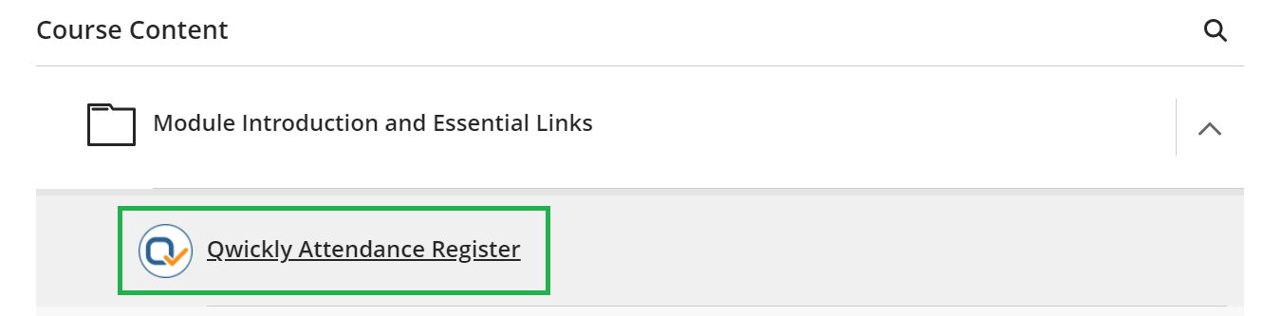
If you’re having difficulty locating the Attendance Register in your course then you may find it helpful to use the search ‘magnifying glass’ icon in the top right-hand corner of the course page:
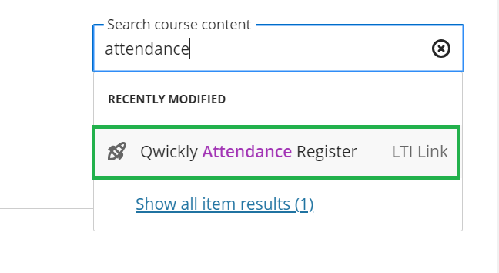

Checking In

In Qwickly, your tutor can start the Check In using their own account and you’re able to log your attendance on your own device during this period.
If there is no PIN required to check in, simply click the ‘Check In’ button during the Check In period.
If the tutor has set it so that a PIN is required, it will appear like this on your tutor’s screen:
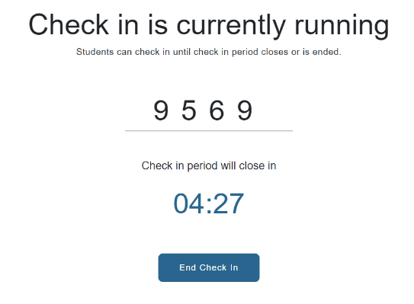
While the Check In is running, select the attendance register link in your course. On your own web browser (Either on a desktop, laptop or mobile device), you will see this version of the screen, prompting you to enter the PIN:
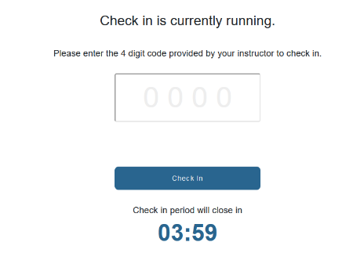
Once you have entered the PIN, select ‘Check In’:
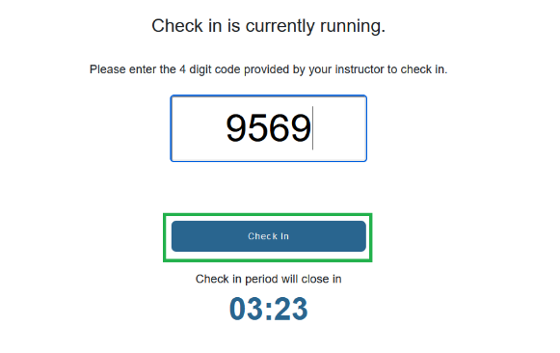

Once Check In is clicked, it will redirect you to the Attendance Record page saying Check in successful:
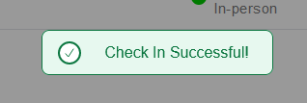

Troubleshooting Tips

I can’t find the link to Qwickly anywhere in my course.
The link to Qwickly is usually labelled as ‘Qwickly Attendance Register’ in a course area.
As a tip, you can use the search ‘magnifying glass’ icon in the top right-hand corner of your course area and search for a phrase like “Attendance” to prompt the system to search your course for you.
If you’re unable to locate the link at all then please raise this with your tutor.

I can’t log my attendance in Qwickly.
Your attendance in Qwickly can only be logged when your tutor has started the Check In. If Check In is running and you cannot log your attendance, make sure that you are selecting the correct Blackboard course. The name of the course appears in the top right-hand corner of the Check-In screen.

Qwickly isn’t loading for me.
We strongly recommend making sure that your device is connected to the Eduroam Wi-Fi network on campus in case you are in a location with a weak mobile data signal. Otherwise, Qwickly may load slowly and may prevent you from logging your attendance in time for the Check In.
If you are connected to the Eduroam network and are still experiencing an issue, then please let your tutor know and they can feed this back to the relevant support team to investigate.
If you need assistance connecting to the eduroam Wi-Fi network, please visit the Catalyst Help Desk or email CatalystEnquiries@edgehill.ac.uk.
You may also find useful guidance here: Connect to the Eduroam Wifi Network

I have received an absence notification, but I was present at my session.
Please contact your tutor. The tutor may amend your attendance record if appropriate.

