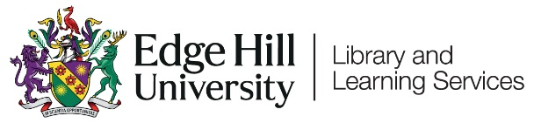

Course and Organisation Roles in Blackboard

Introduction

Different users in Blackboard Courses and Organisations are given different roles. These roles controls what permissions the users have within Blackboard.

For example:
- A module leader is given the ‘Programme or Module LEADER’ role and can do anything within a course.
- Staff working on a module area when they are not a module leader might be given ‘Programme or Module TUTOR’ role, which has some limits to what they can change in a course.
- Students are automatically given the ‘Student’ role which gives fewer permissions for adding and creating content.

It is usual practice for administrators to give the programme or module leader access and for the leader to give access to other staff.

Please contact Learning Technology Development for specific details of what each role allows.

