Turnitin Submission Dropboxes

Basic Setup

Contents
Introduction 2
Creating a Submission Dropbox 2
Applying Settings 4
Basic Settings 4
Optional/Additional Settings 5
Editing Settings 10
Blackboard Settings 10
Turnitin Settings 11
Managing Grade Release 12

Introduction

Turnitin is a third-party integration used in Learning Edge (Blackboard) to enable Electronic Marking of Assessment (EMA) and to support the development of the academic writing practices of students.
This short guide demonstrates the process of setting up a submission point – Known as a Turnitin Submission Dropbox – within a Blackboard Ultra course.

Creating a Submission Dropbox

In most courses, an Assessment folder is usually used for Turnitin Submission Dropboxes, as well as other forms of assessment. Selecting the Assessment folder will expand the box in the course interface and display a purple ‘+’ icon when hovering the cursor over any of the grey divider lines within the folder:
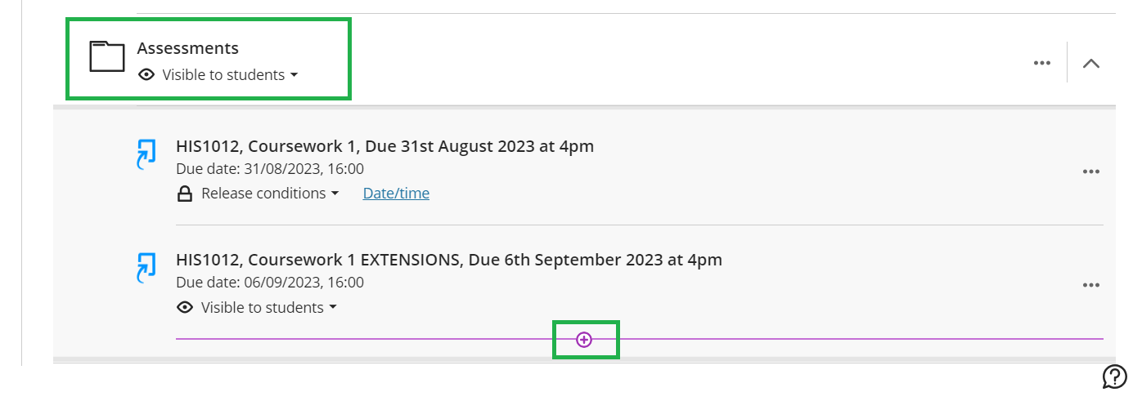
Select the ‘+’ icon at the point that you would like to place the Submission Dropbox, followed by ‘Content Market’:
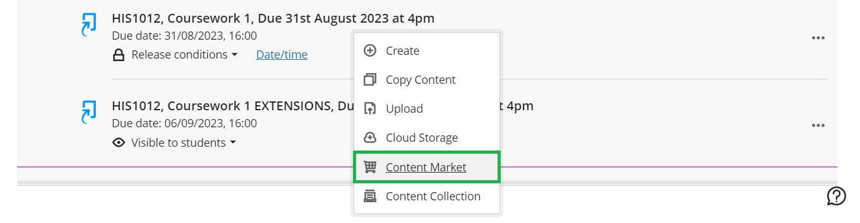
In the ‘Content Market’ page that appears, select the tile labelled ‘Turnitin Assignment LTI’:
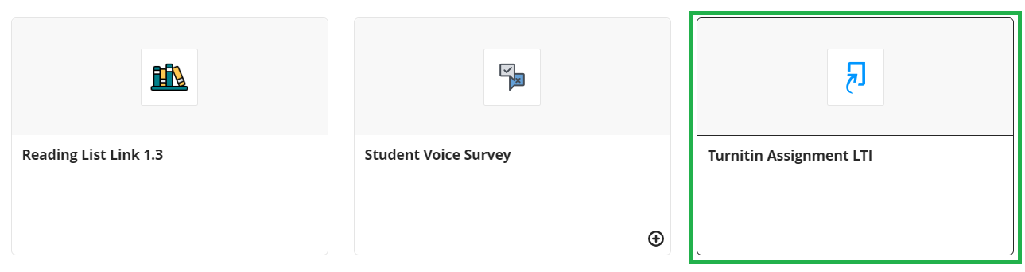
This will then prompt the Turnitin Assignment LTI tool to load:
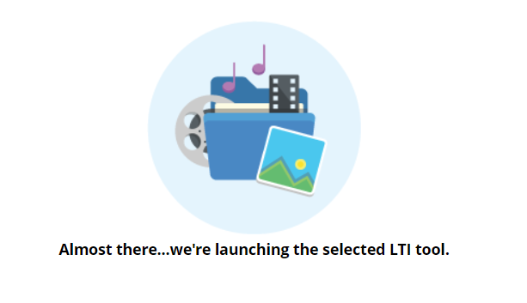

Applying Settings
Once loaded, the Turnitin Submission Dropbox’s Settings page will appear where you will be able to set how assignment will run. This settings page is divided in two sections: Basic Settings and Optional/Additional Settings.

Basic Settings

- Set the Title for your assignment. We recommend labeling this clearly for you and your students by using the following format:
[Course Code], [Assignment Purpose], [Due Date and Time]
For example:
HIS1012, Coursework Submission 1, Due 8th September 2023 at 4pm
You may wish to also include in the title whether the Submission Dropbox is for extensions or Exceptional Mitigating Circumstances (EMC).
- Include any additional information that you would like to leave for your assignment in the ‘Instructions’ field.
- Set the Maximum Grade for the assignment. We recommend setting this to 100.
Note: If your Submission Dropbox is not intended for awarding a mark - Such as for providing feedback only - a Maximum Grade of 100 is still recommended to prevent grade sync errors between Turnitin and Blackboard.
- Set the Start Date, Due Date and Feedback Release Date for your assignment, ensuring that the Due Date setting matches the date and time advised in the Title.
Note: US-Formatted dates are used in the Turnitin Settings page, i.e., Month-Day. For example, “08-04” would denote August 4th.
The below screenshot illustrates an example:

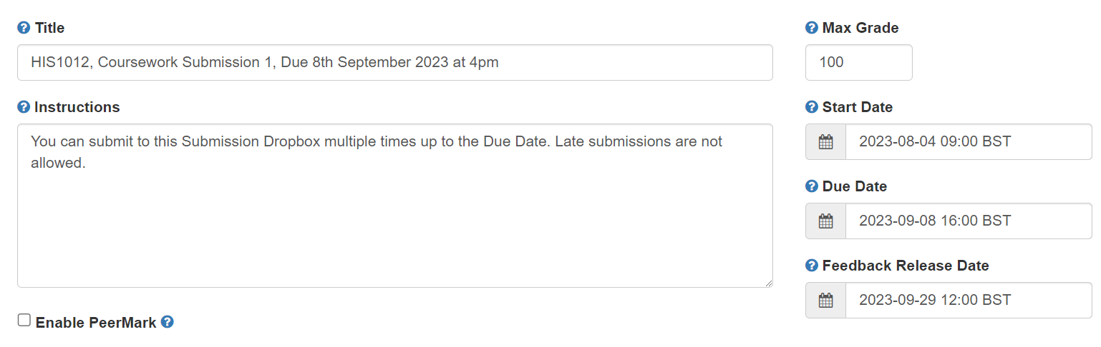

Optional/Additional Settings

The Optional Settings page provides further settings that can be applied to the Turnitin Submission Dropbox, including whether you would like to allow students to resubmit their work up to the Due Date and whether you would like to allow submissions after this date and time.

The below settings are listed in order of appearance and follow our standardised advice – Your department or assessment lead may use a variation on below.

- Beneath the ‘Submission settings’ section, we recommend the following settings:
  - Set ‘Submit papers to’ to Standard paper repository for live assessments.
Setting to Do not store the submitted papers would be advised for Submission Dropboxes created for draft or testing purposes.
  - Untick ‘Allow submission of any file type’ to ensure that only file types that can produce a Similarity Score may be submitted.
  - Untick ‘Allow late submissions’ if you do not wish for students to submit after the Due Date has passed.
  - Untick ‘Enable grammar checking using ETS® e-rater® technology’.
  - Tick ‘Attach a rubric’ if your department marks using a rubric; otherwise, untick this setting.

The below screenshot illustrates an example:

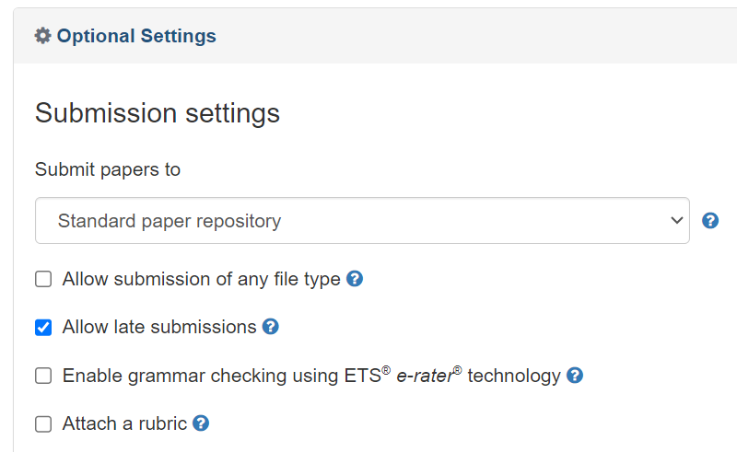
- Beneath the ‘Compare against’ section, we recommend the following settings:
  - Tick ‘Student paper repository’
  - Tick ‘Current and archived web site content’
  - Tick ‘Periodicals, journals and publications’

The below screenshot illustrates an example:

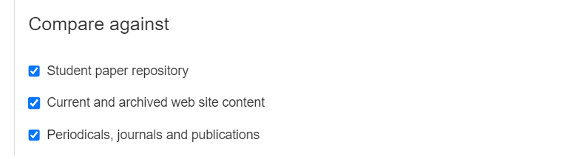

- Beneath the ‘Similarity Report’ section, we recommend the following settings:
  - Set ‘Generate Similarity Reports for student submission’ to either:
Generate reports immediately (students can resubmit until due date) if you would like to allow resubmissions before the deadline
or Generate reports immediately (students cannot resubmit) if you would like students to submit only once.
Note: We advise using either of these settings so that students can view their Similarity Report at the point that they submit. We do not advise using the Generate reports on due date option.
  - Tick ‘Allow students to view Similarity Reports’
  - Untick ‘Exclude bibliographic materials’
  - Untick ‘Exclude quoted materials’
  - Tick ‘Exclude small sources’ and set ‘Small match exclusion type’ to Words. Set the ‘Source Exclusion Threshold’ to 10 Words.

The below screenshot illustrates an example:

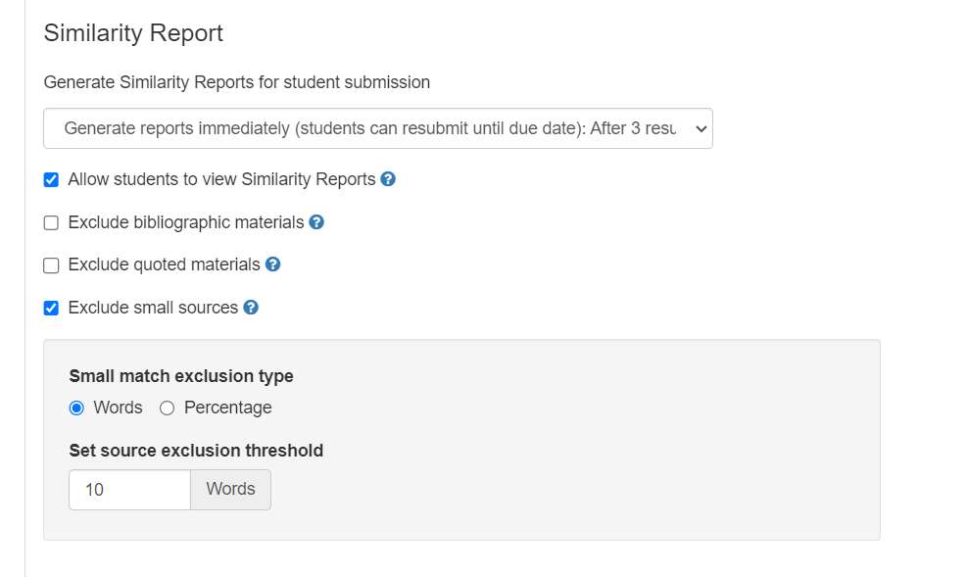

Lastly, it is best practice to review your settings before confirming to create the Submission Dropbox by clicking ‘Submit’.
The following message will then be displayed, confirming that your Submission Dropbox has been created successfully:

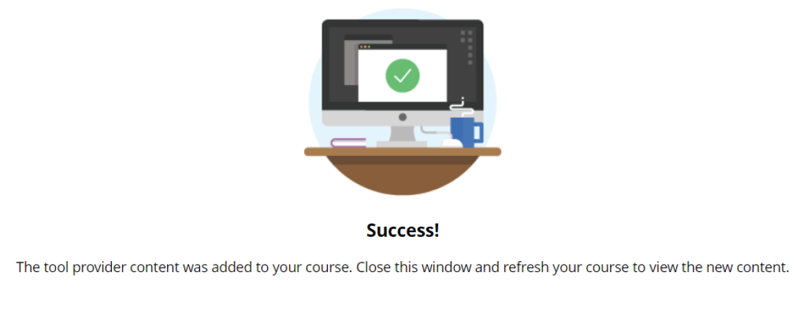

Editing Settings

You can amend your Submission Dropbox settings at any time after creation.
Title, Instructions, Start Date and Due Date are amended in Blackboard whereas Feedback Release Date and any Additional Options are amended in Turnitin.
Important: Never delete a Submission Dropbox. If the Submission Dropbox needs to be removed from student view, set it to unavailable instead.

Blackboard Settings
The Title and Due Date of your Submission Dropbox can be amended by clicking on the ‘…’ icon in the course content area, followed by ‘Edit’:
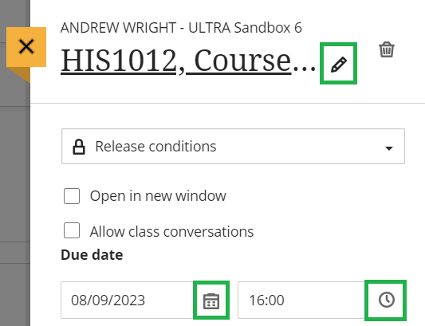

The Start Date can be amended by firstly clicking on the Release Condition for the Submission Dropbox:
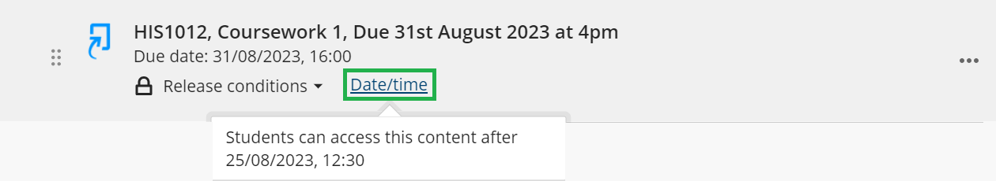
And then by amending the Show On parameter:
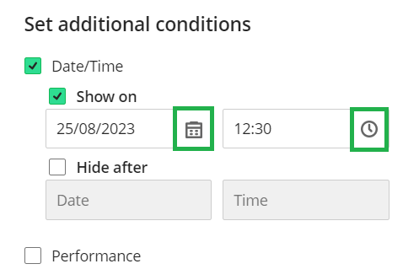
Upon submitting the change, Blackboard will update the Turnitin Submission Dropbox accordingly.

Turnitin Settings
The Feedback Release Date or any Additional/Optional Setting can be amended in Turnitin. To access the Turnitin Settings menu, click on the Turnitin Submission Dropbox link in the course area to load the Turnitin Class List for the assignment:
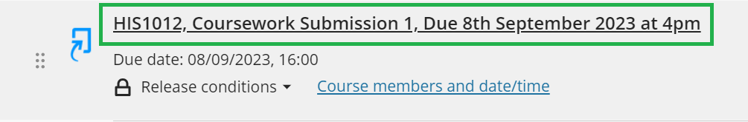
In the Turnitin Class List, click on the Settings ‘Cog’ in the top right-hand corner:

Managing Grade Release
In Ultra Course View, marks and feedback are released by Turnitin and Blackboard on the defined Feedback Release Date.
When student submissions are marked through the Feedback Studio, the mark value is passed through to Gradebook in a Not Posted state. Marks that are in this state are not visible to students.
You can view which assignments are in a Not Posted state by the presence of the ‘Post Marks’ icon next to the assignment title in Gradebook:
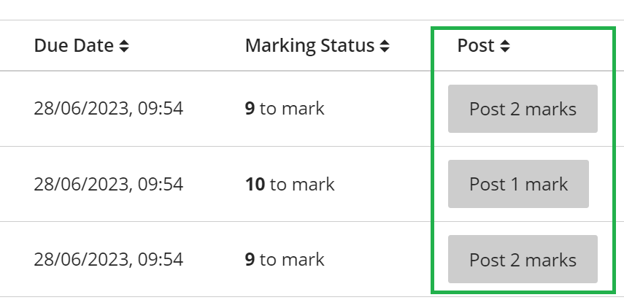

Once the defined Feedback Release Date is reached, Blackboard posts the marks automatically, enabling the students to view their marks and feedback.

