

The PowerPoint Recording Tab

# Introduction

The PowerPoint Recording tab is useful when you want to create audio and video recordings to either add to your presentation slides, or to export them as a video.

The Recording tab replaces the old Office Mix tool. It is available with an Office 365 subscription and will be developed over time, notably with the connection of Forms for quizzes and Stream for hosting. This means that you might see extra options to those shown in this guide.

Contents

Introduction 1

Getting access to the Recording tab 2

Example Process: Creating a Screencast Video 4

Example Process: Creating an Online Presentation using Commentary and Annotations 9

Help: Choosing to Record your PC audio 11

# Getting access to the Recording tab

If you have upgraded to Office 365 it will tell you on the start-up window for the desktop version of PowerPoint. The Recording tab is only available if you have been upgraded.

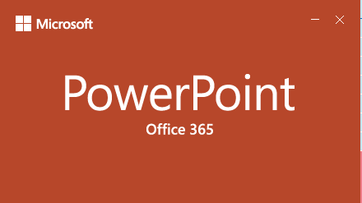

The tab will look something like this.

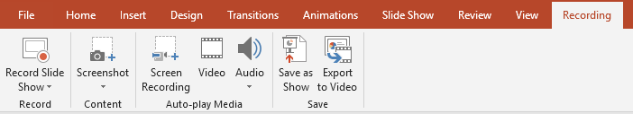

In some cases, you might need to manually make the tab visible. Right click on the ribbon and select ‘Customise the Ribbon…’.

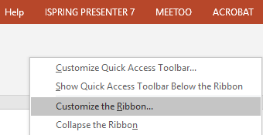

Under Customize the Ribbon > Main Tabs, make sure the ‘Recording’ option is checked.

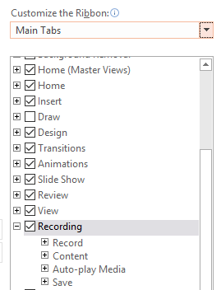

# Example Process: Creating a Screencast Video

A common use of the Recording tab will be to create screencasts. When you create a screencast, you record your screen and the audio from a headset or stand-alone microphone.

The Screen Recording option allows you to make one or more of these recordings.

Screen Recording icon

There are several processes you could go through to create a screencast, but in this example, we will create two recordings with title slides, and export them as an MP4 video which could be hosted on YouTube or Panopto.

Start by creating the required slides. Leave blank slides where you are going to record videos and put title slides between these.

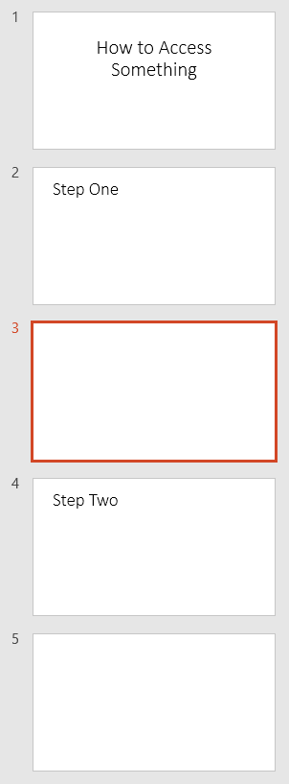

Select the slide that you want to place the recording on and click ‘Screen Recording’. PowerPoint will be minimised and the controls dock will appear.



Your cursor will change to a cross, and you can select a section of, or all the screen, to record. Press ‘Windows logo key + Shift + F’ to easily select the whole screen.

The ‘Select Area’ button enables you to reselect the area to be recorded. You can deselect the Audio and Record Pointer options to prevent the recording of these.

Click ‘Record to start the recording or use the keyboard shortcuts.

* Press Windows Logo Key + Shift + R to start and pause the recording
* Press Windows Logo Key + Shift + Q to stop the recording

The trickiest thing that I’ve come across with using Screen Recording, is getting the control dock to disappear before the recording starts.

* If you have two monitors, just record the screen that the dock is not showing on
* If you have one monitor the dock should appear at the top of the screen. Ensure it is not pinned by clicking the dock’s pin icon until it sits sideways.

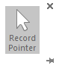

Ensure that your cursor is not over the dock, and it should disappear before the recording count down screen is finished.

* Note that pressing ‘Windows Logo Key + Shift + I’ collapses the controls dock. If you are having trouble, you might be able to play with this.

When you stop the recording, it will appear on the slide that you selected beforehand. You can select and delete the video, if you want to record it again.

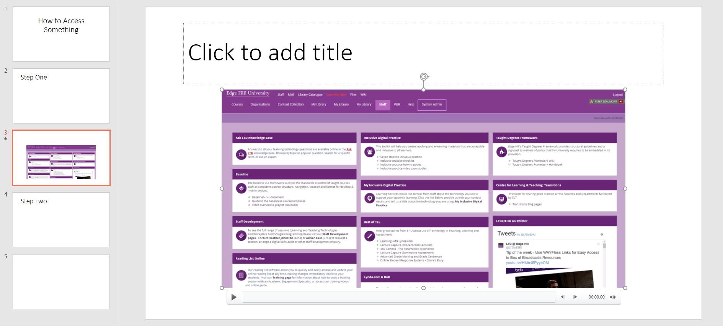

Click on the round handles on the sides and corners of the video to resize it as required.

Once you have created the second video and are happy with your creation, you can export the whole presentation as a video. Click on the Export to Video button.

Export to Video icon

On the Export screen select ‘Create a Video’

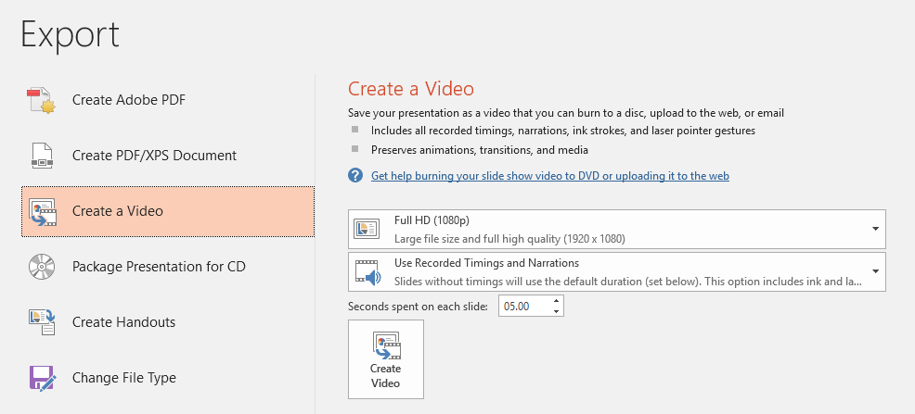

Choose the required file quality, along with the other settings. Note that ‘Seconds spent on each slide’ refers to the slides without video on, so unless you have already manually set a timing for these, they will stay on screen for the length of time selected here.

Finally, you can select the file type to export from the drop-down menu

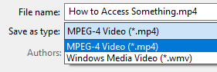

A video will be exported, which can be hosted on YouTube or Panopto, for example.

# Example Process: Creating an Online Presentation using Commentary and Annotations

Another activity that the Recording tab enables is creating a narrated or annotated version of an existing presentation.

Open a new copy of your existing presentation slides as the recording process will alter them. Select ‘Record Slide Show’ > ‘Record from Beginning’.

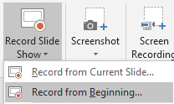

This opens a recording screen. Recording is done slide by slide.



You can start and stop using the controls at the top left of the screen.



You can choose whether to record attached microphones and cameras at the bottom right.

Microphone and video icons

Annotation options can be seen at the bottom of the screen. These could be used to highlight a section of text.

Annotation options

When you have finished the recording for a slide, you can move to other slides using the arrow buttons at the side of the screen.



# Help: Choosing to Record your PC audio

If you want to switch between recording your microphone, and recording the sound on the computer, there is no specific option in PowerPoint to control this. You’ll need to look at the Sound options in Control Panel

To access this type ‘Sound’ into the Windows search box and select the ‘Sound: Control Panel’ option that appears near the top of the list.

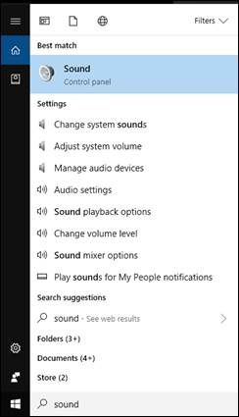

In the Sound options that appear, select the Recording tab.

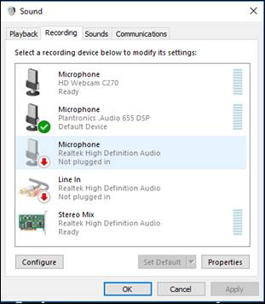

Start a video with sound (e.g. from YouTube).

We want the sound to appear in the sound bar to the right of Stereo Mix.

First, try unplugging your USB microphone, and any other microphones that are attached to your PC. This might cause the audio to come through Stereo Mix.

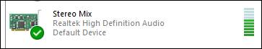

If this doesn’t work, make sure Stereo Mix is enabled, by right clicking on it and selecting ‘Enable’.

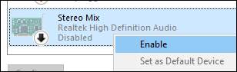

You then right click and select ‘Set as Default Device’.

Once the sound is coming through Stereo Mix, PowerPoint should save that.