Digital *Viva Voce* Examinations

Guidance

**Contents**

1. General 1

2. Format 3

3. Appeals 3

4. Appendix 1: Zoom set up - step by step guide……………………………………………………………….4

5. Appendix 2: Skype set up - step by step guide………………………………………………………………9

6. Appendix 3: Teams set up - step by step guide……………………………………………………………12

7. Appendix 4: chair guidance for video conferencing examinations………………………………….……14

1. General
   1. These arrangements address the specific requirements when conducting a digital viva. The Research Degree Regulations[1] should be referred to for all aspects of the examinations process outside of processes in place specifically for digital vivas.
   2. It is the normal expectation that the *viva voce* examination for research degrees be conducted in person with all parties present (candidate, examiners and chair) with progression vivas being the exception. Progression vivas should be conducted online with all parties present (candidate, examiners and chair). Requests for video conference project registration and final vivas will be considered by the Graduate School. The guidelines below lay out what arrangements need to be made to ensure that an examination by video conferencing runs smoothly and fairly. Under no circumstances should a *viva voce* examination take place by audio conference alone.
   3. These guidelines do not replace the requirements of the Research Degrees Regulations[2] in relation to the *viva voce* examination, but they do provide adjustment in relation to the form of the oral examination. They should be made available to candidates and all examiners where it is proposed that a *viva voce* examination be conducted by video conferencing.
   4. Video conference *viva voce* examinations can only be undertaken once all parties involved have read and agreed to the requirements of these guidelines.
   5. The candidate must not feel any pressure to agree to being examined using video conferencing.
   6. Candidates that agree to a *viva voce* examination by video conferencing must understand that:
      1. It is their responsibility to ensure their internet connection works in advance of the examination.
      2. Should the connection fail mid-way, the viva will not end, but rather the chair will call the candidate again as soon as possible. If the chair cannot resume the call, the candidate and examiners should utilise the messaging function on the system.
      3. The examination must be held within normal working hours (BST/GMT between 09:00 and 17:00).
      4. Video conference examinations can make it difficult to interpret social cues which, in turn, may disrupt the flow of conversation.
      5. The *viva voce* examination must not be recorded by any party.
      6. The candidate is expected to use their own hardware for the *viva voce* examination.
      7. The candidate is expected to ensure their examination environment is appropriate for the examinations period, devoid of any distraction which may disrupt the examination process.
      8. Physical copies of the submission are required *unless* told otherwise by the Graduate School.
      9. Candidates are unable to appeal the outcome on the grounds of examination format.
   7. Where the examiners, or the chair, feel that the aims of the examination have not been successfully achieved, because of the format, that should form the basis of the recommendation to the Graduate School Board of Studies. Under such circumstances, a new examination (which will *not* constitute a re-examination) may be arranged.
   8. The examiners, chair and candidate will have access to this guidance document and a step by step guide to use the Graduate School’s favoured video conferencing platform.
   9. All members of the examination, including the chair, must run a test of the platform at least 24 hours before the examination.
   10. The chair and the candidate must have their EHU email accounts open during the examination in the event the video conferencing connection fails.
   11. Should any members of the examination require support in relation to closed captioning or other access requirements, they should bring this to the attention of the Graduate School in the first instance using the reasonable adjustment process outlined on the submission cover sheet, well in advance of the viva date.

2. Format

* 1. Given the likely pressure on electronic infrastructure, it may not be wise to mandate a video conferencing platform for use in examinations. The Graduate School will, therefore, initially aim to use Zoom for video conferencing vivas but all participants should be prepared to use at least one other agreed platform (e.g. Teams). A Graduate School Research Degree Administrator will open the digital room and pass over ‘host’ responsibilities to the chair. The chair will ‘host’ the examination using their Edge Hill University Zoom log in details. Guidance for chairs in relation to video conferencing using Zoom can be found in Appendix 2 of this document.
  2. An independent chair, who has undertaken the Graduate School chair training within the last 3 years must chair examinations unless stated otherwise in the research degree regulations (e.g. MRes final vivas).
  3. All individuals taking part in the examination must make sure that the examination is undertaken privately and ensure they are not disturbed (e.g. mute mobile phones, put a sign on the room door to ensure a quiet environment). It is recommended that attendees use headphones with a microphone where possible, to ensure strong communication during the examination as, sometimes, built-in microphones on computers do not pick up speech clearly.
  4. Observers approved by the Graduate School must attend with their camera off and microphone muted.
  5. After the examination, once the candidate has left the *viva voce* call, the examiners should discuss and agree the content of their final examination report and feedback specification so that their recommendations can then be conveyed to the candidate by inviting them back to the call. The final examination paperwork must be written up and submitted in the usual way.

3. Appeals

* 1. The examination panel should consider the fact that the extraordinary nature of an examination under these conditions can affect even the most confident candidate. When convening an examination by video conferencing, the examiners are advised to reflect on that, whilst nevertheless upholding the appropriate standards, when making an academic judgement about the recommendation to the Graduate School Board of Studies.
  2. The grounds for appeal against a decision resulting from an examination using this method are no different from those under normal circumstances and cannot include the format of the examination.

*Document updated: 31 March 2022*

Appendix 1: Zoom set up - step by step guide



Sign up to zoom using your work email

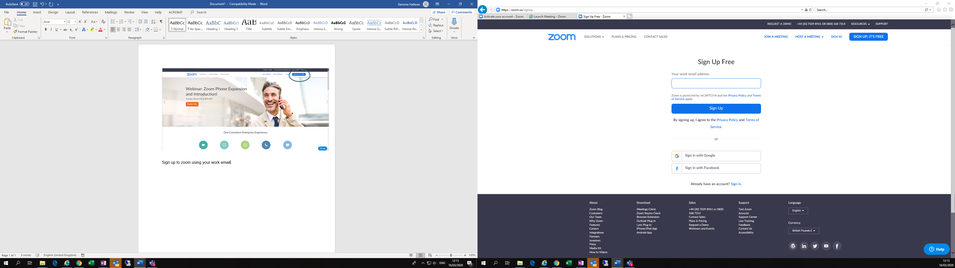

You will receive an email to activate your account. Click sign in

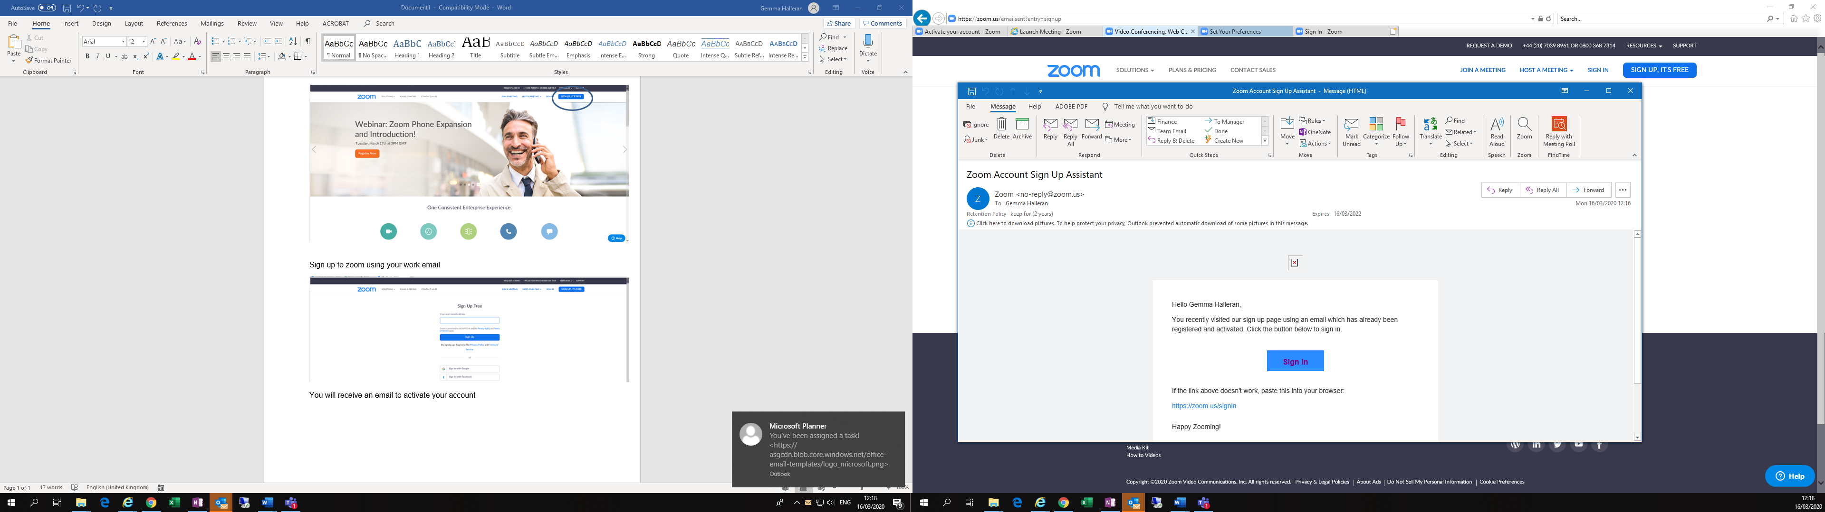

You will be asked to enter your email address and a password. Then you will receive an email with your personal meeting id.

At the top right-hand bar is the option to launch a meeting. Follow the instruction to download and run the software. Another window should pop up, you can pin this to your taskbar for easier access. If you hover at the bottom you can see icons, the green one allows you to share your screen with other in the meeting

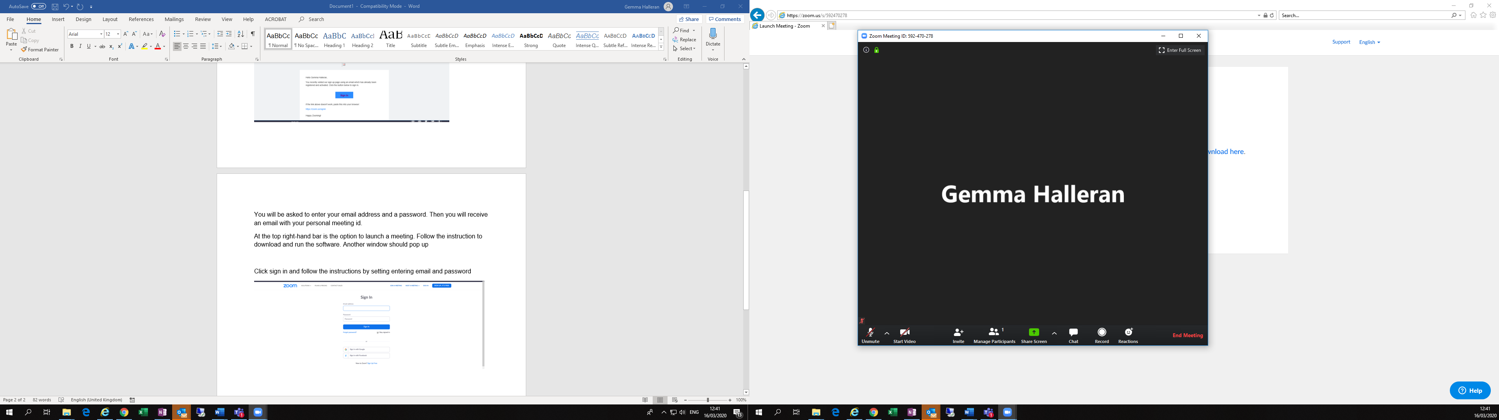

You can invite people using this icon, which creates an email containing a link.  
Also, you can copy and paste a link found in the **i** icon at the top left-hand corner and share this with guests

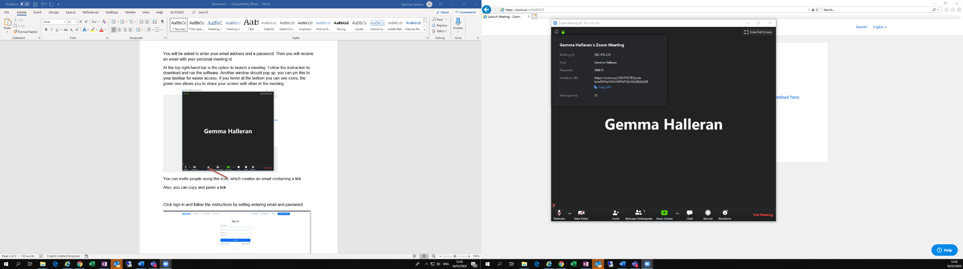

To finish meeting, click End meeting found in the bottom right hand corner

The Chair should ‘lock’ the Zoom call once all attendees are in the meeting by clicking ‘security’ and then ‘lock meeting’. This means no other participants can enter. To unlock the meeting, and allow a candidate to enter, simply toggle the lock meeting button and relock it once entered.

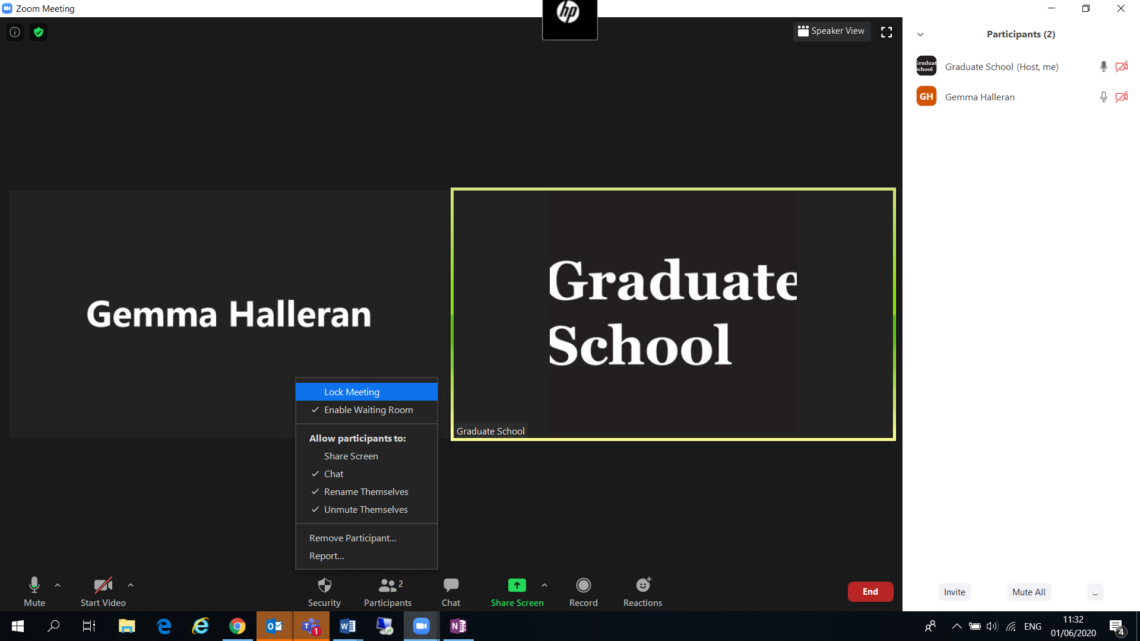

Please ensure your microphone and camera are functioning.

Please note that you can be part of meeting with just audio.

You can change the view of a meeting by clicking the ‘9 dots’ for gallery view, found in the top righthand corner

Once you have registered you can go back into zoom using the sign in screen shown.

**Using the Graduate School Zoom pro account – administrator guide**

Log into the Graduate School Zoom account and wait until the Chair and panel members have arrived for the pre-meeting.

To allocate the Chair ‘host’ status, the administrator must click ‘end’ on the bottom right to leave the meeting.

Zoom will prompt the administrator to click ‘leave meeting’

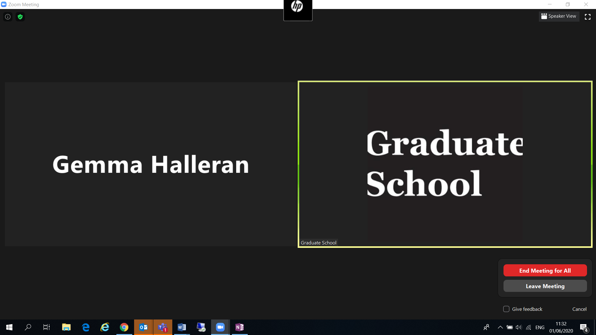

Once this has been selected, the administrator will need to select from the list of current attendees who will be the new host

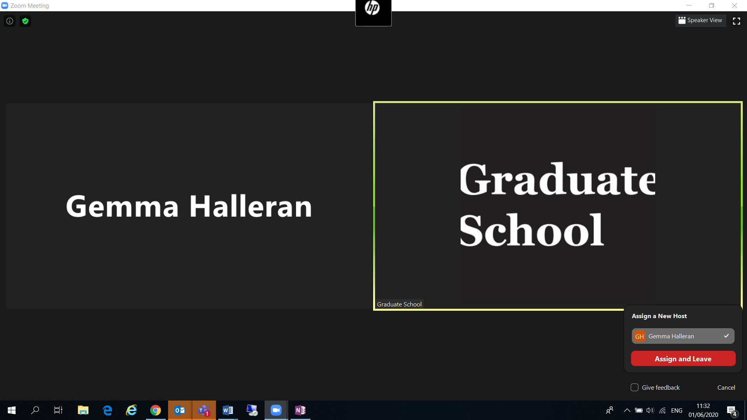

Once a new host has been selected, the administrator must click ‘assign and leave’ for the changes to take place.

The administrator should not need to enter the meeting once they have left however, if they do, the Chair will still have host rights of the meeting until they reallocate them to the administrator.

FAQ support for Zoom can be found in this document.[3]

Appendix 2: Skype set up - step by step guide

Download skype and create an account.

(Skype has a version for both smartphone and computer)

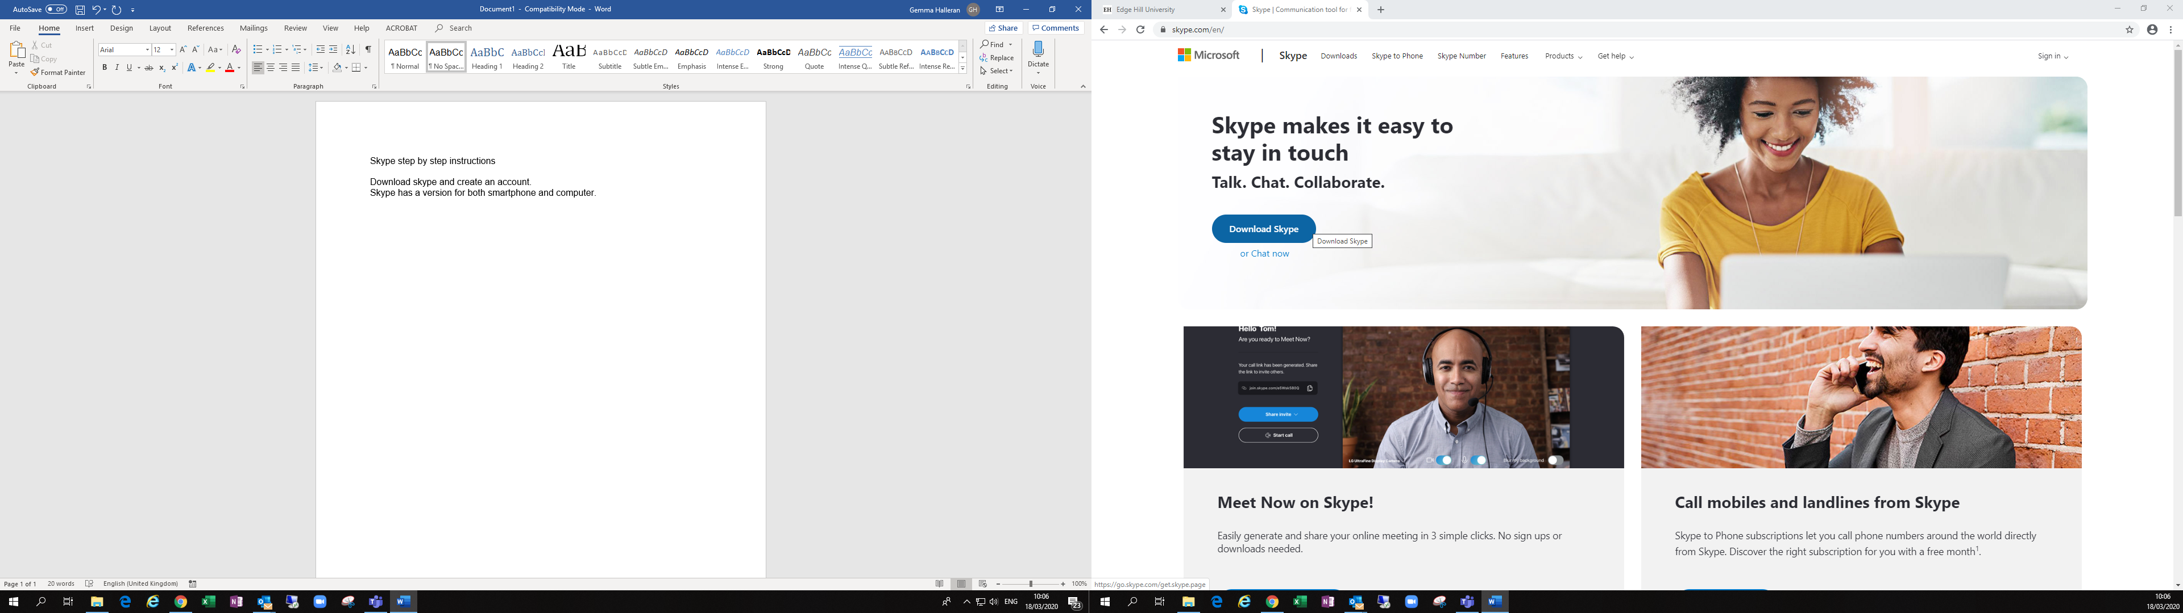

In the top right hand drop down, click on ‘use skype online’ and follow the instructions.

Here you can add a profile picture, test your microphone and speaker, and test your camera.

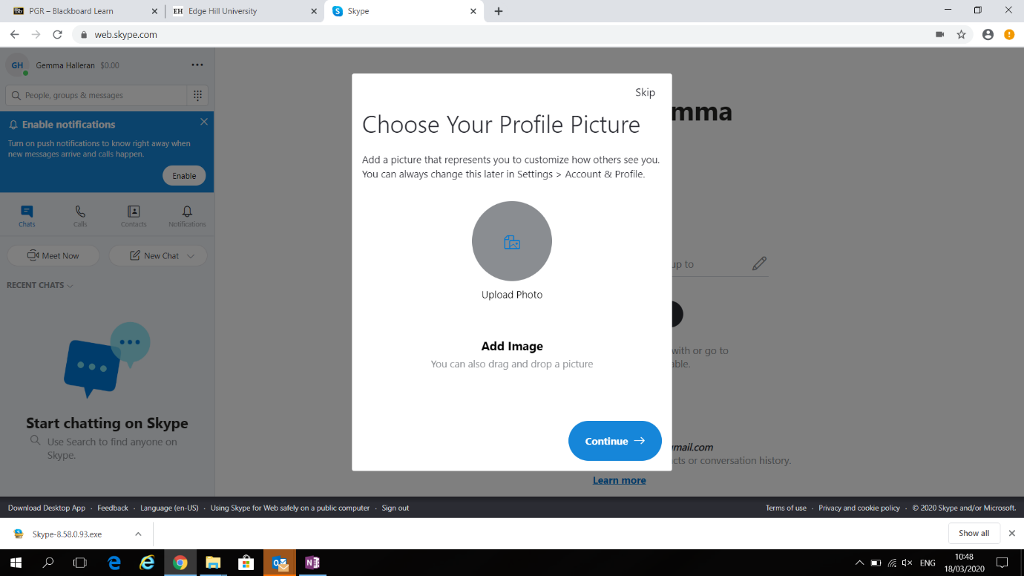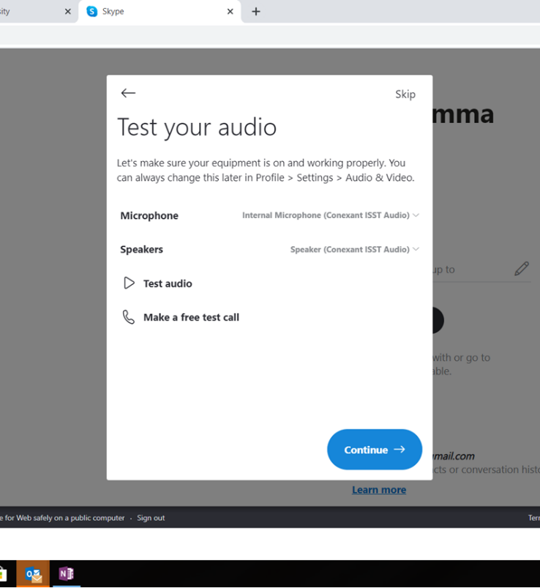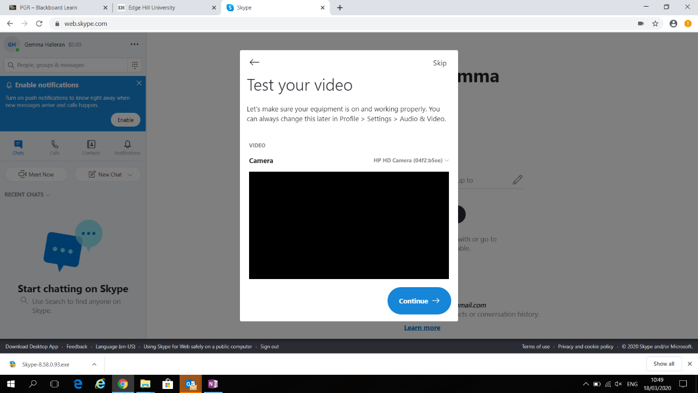

You will then be able to start a conversation by clicking meet now or creating a new call and adding your participants or by starting a conversation

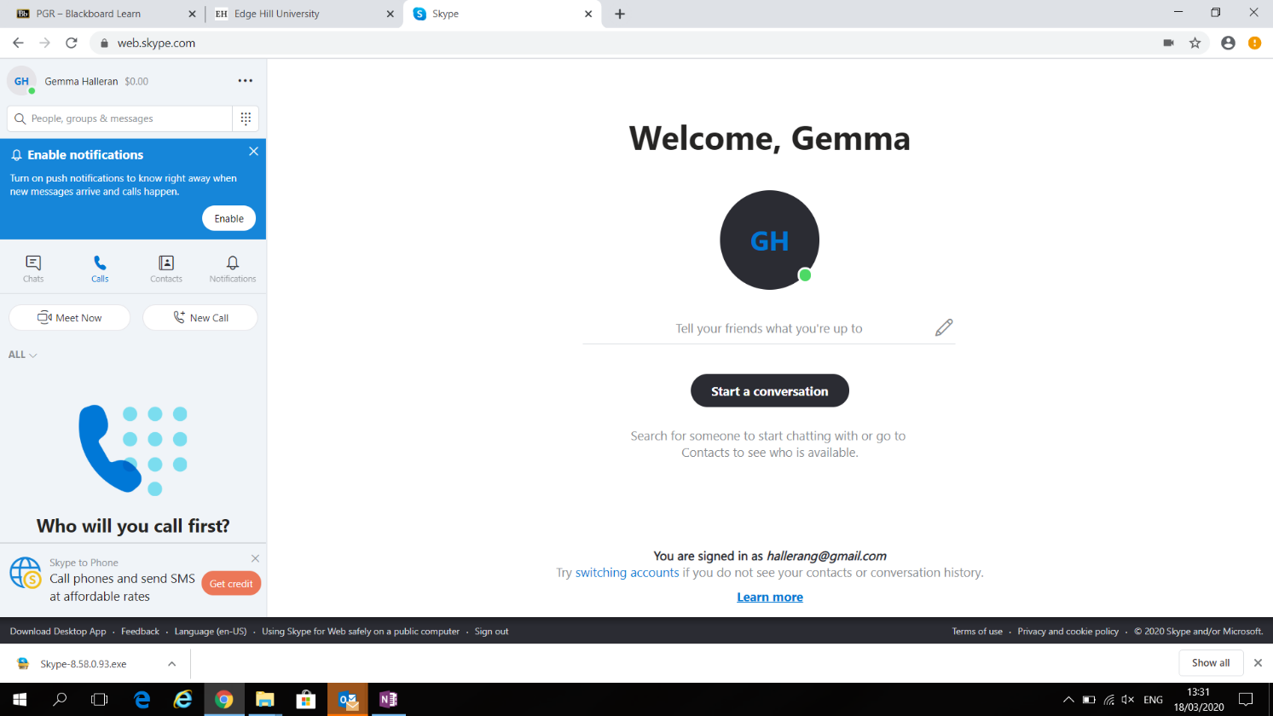

If you select ‘meet now’ skype will provide you with a link to share with participants who are on skype.

Click here to start call

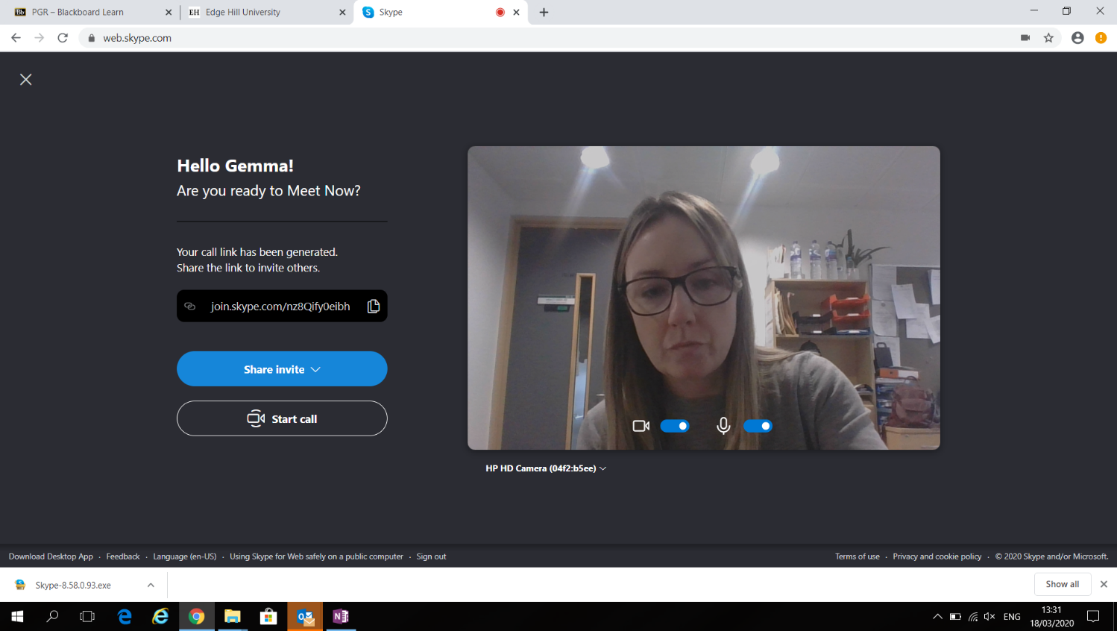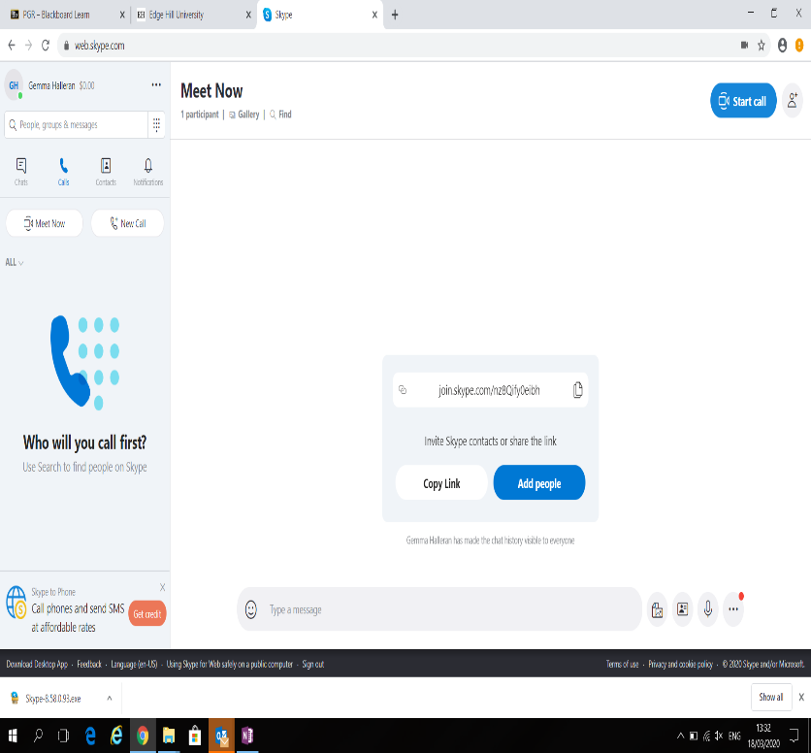

When the call is finished, you end the call by clicking on the red phone handle icon to hang up.

PLEASE NOTE: skype to skype calls are free, but if you call a mobile or landline from skype, you will need skype credit or subscription names and phone numbers.

Useful links:

<https://www.youtube.com/watch?v=S38e-t6rhKA>

<https://www.youtube.com/watch?v=fK_JGw8WUVY>

Appendix 3: Teams set up -step by step guide

The easiest way to set up, and hold, a viva using Teams is utilising the calendar invite function in the Outlook using your university account. If using Teams, this calendar invite can be managed by the administrator but it is up to the admin and chair to agree this. Any, and all, calendar invites including a link must be set up as ‘private’.

Please **do not** set up a Teams meeting using a pre-existing channel or chat feature. This is prohibited by IT Services as it is a data sharing risk with other files and folders. Any file sharing, if necessary, for vivas should be done using emails only.

Open your Outlook email calendar

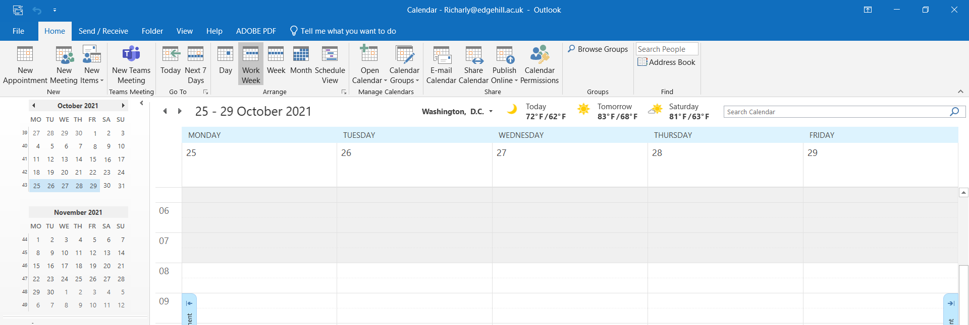

Select ‘New Teams Meeting’ at the top

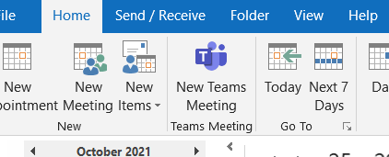

A new calendar invite will open with the Teams link embedded into the invite body.

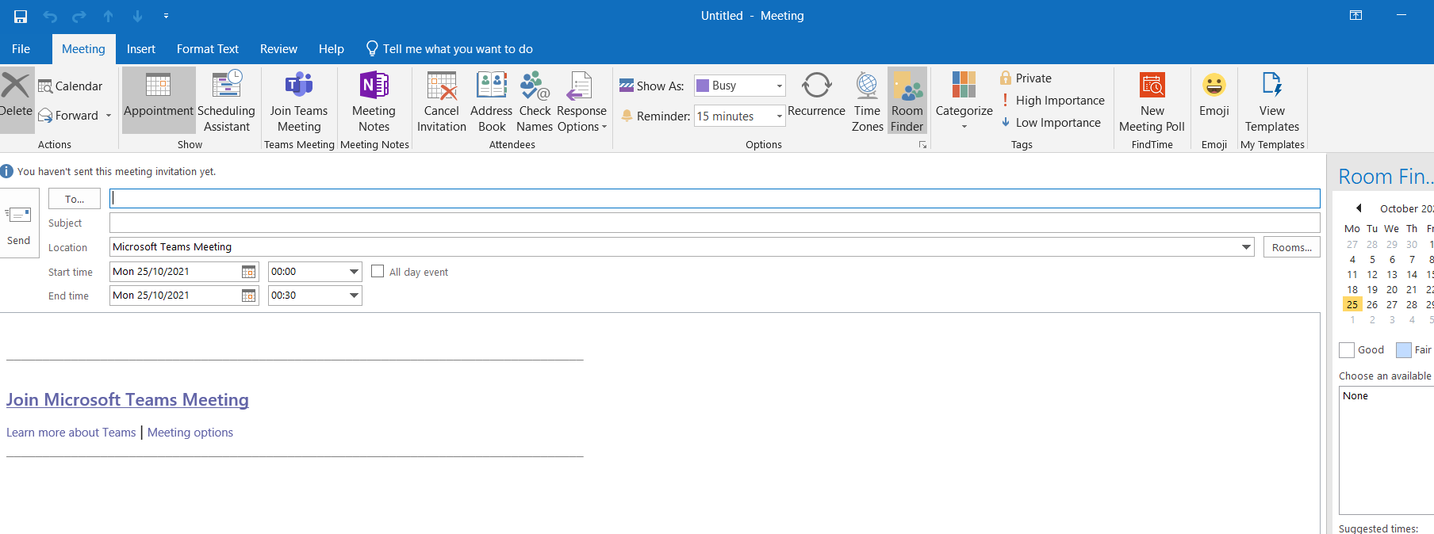

Please set up the date, time, attendees of the meeting as you normally would for any meeting. Ensure that the ‘private’ setting is selected before clicking send.

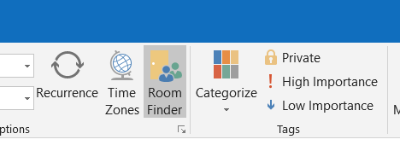

Teams does not have a waiting room function, unlike Zoom, so please set up separate meeting links for your pre, and post, examiners meetings, to that of the viva to ensure candidates do not accidentally join the meeting earlier than expected.

Should you wish to use the **live** **closed captioning** feature in Teams, please follow this step by step guide when in the call.[4] Please test this in advance of the meeting and if you have any issues with Teams please contact IT Services.

Appendix 4: chair guidance for video conferencing examinations

This documentation should be utilised in parallel with the relevant examination guidance documentation and the Research Degree Regulations, which are available on the PGR links page on Blackboard.

Conduct of the viva

Before the viva

Normally, all video conference vivas will be held using Zoom[5], although sometimes use of another platform may be necessary. It is important that the chair, candidate and examiners set up Zoom accounts, using their relevant institutional emails, in advance of the examination and communicate their details to the Graduate School examinations email address.[6] As noted in 2.2 above, if this platform is not appropriate, another mutually agreed platform can be utilised (e.g. Teams).

All individuals involved in the examination must have their university emails open in the event of difficulties with Zoom necessitating an alternative form of communication between the administrator, the chair and the examiners and candidate.

If the Graduate School licensed Zoom account is available, the administrator will support the chair to schedule the examination and create a Zoom link. The Chair will need to build in breaks for the candidate should they request it. If this account is already in use, the Chair’s free zoom account should be used, with 40 minute breaks built in around the Zoom time limit. The chair will ‘host’ the Zoom call and be responsible for inviting the examiners to the examination for their pre-meeting. During the pre-meeting, the chair and examiners will agree how best to intervene with questions for the candidate when, and if, a new question occurs to them. Once the pre-meeting has concluded, the chair will then invite the candidate to the examination. When using Zoom, the use of the ‘digital waiting room’ function may facilitate this process.

Security and video conferencing

Viva arrangements and calendar invites should all be set up securely, using the private/locking function in Outlook, and only sent to institutional email address of attendees.

*Zoom*

It is very important to ensure that access to the viva video conferencing information is only circulated using secure communication avenues, such as institutional email addresses and locked calendar invites. Meeting information, where possible, should be circulated to members of the examination team, and the administrator, no earlier than 24 hours before the examination has been scheduled. When scheduling a meeting using Zoom, the chair should utilise the ‘waiting room’[7] , ‘password’[8] and ‘lock room’[9] setting options to ensure access to the session is managed.

Chairs, as hosts of a Zoom meeting, can also enact the following should they feel it necessary in advance of the viva:

* Limit screen sharing amongst attendees using the host controls at the bottom of the screen.
* Turn off the option for attendees to share files, using institutional emails instead should it be necessary during the viva.[10]
* Restrict private discussions amongst other attendees.[11]
* Log IP should any unexpected attendees attempt to join the viva.[12]

Additional general video conferencing security guidance can be found in the footnotes of this page.[13] Should you have any questions about the security of the examination, please do not hesitate to contact the Graduate School directly.

*Teams*

If using Teams, this calendar invite can be managed by the administrator, but it is up to the admin and chair to agree this. Any, and all, calendar invites including a link must be set up as ‘private’.

Please **do not** set up a Teams meeting using a pre-existing channel or chat feature. This is prohibited by IT Services as it is a data sharing risk with other files and folders. Any file sharing, if necessary, for vivas should be done using emails only.

Teams does not have a waiting room function, unlike Zoom, so please set up separate meeting links for your pre, and post, examiners meetings, to that of the viva to ensure candidates do not accidentally join the meeting earlier than expected.

During the viva

It is important for the chair to introduce all members of the examination, explaining how the video conferencing will work, and explicitly state how examiners will intervene when, and if, a new question occurs to them. Please also reiterate to all attendees that they should have access to drinking water, and anything else they need, before the examination begins and provide them with the opportunity to ask any additional questions about the format.

The chair must be aware that some Zoom calls are capped at 40 minutes (if using a free account). It is the chairs responsibility to monitor the time of the examination. Chairs should build a break into each viva to coincide with the point at which the initial Zoom session expires, or, in the case of longer vivas, any subsequent 40-minute sessions. If the call needs to be re-dialled, the chair will do so following the same order as that used at the beginning of the viva.

All other required aspects of a standard *viva voce* examination remain necessary for a video conference alternative. The panel, however, must take into account the unusual nature of this examination format and how it may disrupt communication compared to a standard oral examination.

After the viva

The candidate must leave the call after the viva in order for the examiners and chair to make a decision regarding the recommendation to the Graduate School Board of Studies. Once a decision has been made, it is the responsibility of the chair to call the candidate once again for feedback.

Next steps

Communication of the necessary changes to the submission paperwork, if relevant, and any feedback must be communicated to the candidate in the standard way. The current turnaround times still apply to submit all paperwork and examination panels *cannot* give candidates extra time to complete their amendments as a result of the examination format.

*Appendix updated: 31 March 2022*

1. <https://www.edgehill.ac.uk/documents/research-degree-regulations/>
2. <https://www.edgehill.ac.uk/documents/files/research-degree-regulations.pdf>
3. <http://eshare.edgehill.ac.uk/15501/>
4. <https://support.office.com/en-gb/article/use-live-captions-in-a-teams-meeting-4be2d304-f675-4b57-8347-cbd000a21260>
5. <https://zoom.us/>
6. [graduateschool@edgehill.ac.uk](mailto:graduateschool@edgehill.ac.uk)
7. How to enable a waiting room in [Zoom](https://support.zoom.us/hc/en-us/articles/115000332726-Waiting-Room).
8. How to enable a password when accessing a [Zoom meeting](https://support.zoom.us/hc/en-us/articles/360033559832-Meeting-and-webinar-passwords).
9. The Host should click ‘security’ on the bottom and then click ‘lock room’ when necessary to block other participants joining the meeting. Click it again to unlock/re lock the room when the candidate enters.
10. How to disable this feature can be found here for [Zoom](https://support.zoom.us/hc/en-us/articles/209605493-In-meeting-file-transfer).
11. How to restrict chat for Zoom can be found [here](https://support.zoom.us/hc/en-us/articles/115004809306-Controlling-and-disabling-in-meeting-chat).
12. Further details can be found [here](https://support.zoom.us/hc/en-us/articles/360039017432-Dashboard-for-Meetings-and-Webinars).
13. [NCSC guidance](https://www.ncsc.gov.uk/guidance/video-conferencing-services-security-guidance-organisations); [UCOP guidance](https://www.ucop.edu/local-it-client-services/_files/security-tips-on-sharing-zoom-meeting-links-and-zoom-settings.pdf); [Kaspersky blog](https://www.kaspersky.com/blog/zoom-security-ten-tips/34729/)