Collaborate Tips:
  - Presenting With One Screen
Contents
Overview 1
Enable Guest Access + use another device 2
Alt + Tab 2
Resizing Windows and Snapping Windows 3
PowerPoint Read View 4
Normal View 5
Reading View 6
Video examples: 6
Alt + Tab 6
Resize and Snap Windows 6
Reading View in PowerPoint 6

Overview
Collaborate has many great features but also has a few drawbacks. One main frustration is the specific way you must present when using PowerPoint (full screen/slide show view) which means that you can’t see the Chat area.
This brief document takes you through the various methods you can employ to help you present whilst also being able to interact with the Chat without having to close any windows.

The techniques discussed here specifically relate to Windows 10 operating system although similar features and functions can be found on Apple Mac OS.

Keep an eye out for sessions where we will cover the techniques used in this document and help you to develop further skills in video production to improve the way you present with your content.

Enable Guest Access + use another device
One of the easiest ways to monitor chat is to use the Guest link to give yourself access on an additional device (this may be another computer or laptop, a tablet or a phone).
If you tried to login to the same session using your same details but on another device, it will state that you are already logged in so this is the reason for requiring the Guest link. This doesn’t mean that your students would be able to/have to connect via the Guest link, in fact this should be discouraged. By enabling the Guest link, you only need to give yourself the link (email it to yourself) so that you can log in as a Guest.
To do this:
- Go to the Collaborate session that you have set up
- Click on the link to Edit the session
- Click on the box to generate Guest Link
- Save (at the bottom of the Settings panel)
- Scroll back up to where the link has now been generated
- Copy the link
- Paste the link in an email to yourself
- Open the link on another device
- When asked for a name, enter something to identify yourself (e.g. ‘Chat’)

Alt + Tab
A simple way to cycle through all windows that you have open is to use the Alt + Tab keys. To see this in action:
- Hold down the Alt key (N.B. the one on the left not that Alt Gr key on the right)
- Tap the Tab key
- A display of all windows that are open/active will appear (keep the Alt key pressed at this point)
- Press the Tab key to select/scroll through each window in turn – it works through them in order from left-right, top-bottom.
- When you want to find the window that you need release the Alt key
This helps when presenting with PowerPoint in Collaborate because you can simply switch quickly between Slide Show view (you’ll notice 2 windows for PowerPoint – one is the document and one is the slide show) and the Collaborate window so you can access the chat.
When using this method, you may wish to have Chat audio notifications switched on so you can hear when a message is entered.
If you are sharing your screen, please be aware of the Droste Effect which will occur when switching back to Collaborate. This is nothing to worry about but a normal effect of a picture recursively appearing within itself (a sharing a screen which is sharing the screen and so on…).
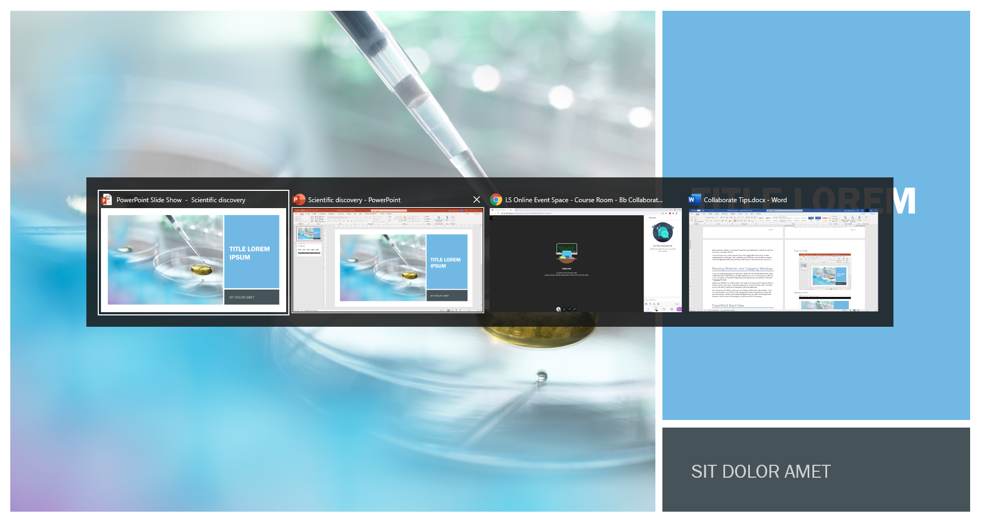

Resizing Windows and Snapping Windows
If you are sharing an application not necessarily a Slide Show, but another window such as Excel or Word then don’t forget that you can resize windows into your own configuration so that they can be seen clearly in Collaborate (Collaborate dynamically changes the resolution in the pane to maximise the view).
Additionally, Windows has a feature called ‘Snap’ where if you drag a window (by its top bar) to the left or right of your screen, it will automatically resize to exactly half the screen. It will then give you the option of which screen you want to fill the remaining half.
You may do this to fill half the screen with one window and then resize other windows. To do this, use the box icon next to the X in the top right-hand corner of any window to reduce the size of the window. Use the resize handles that appear when you hover over the edge of the window or over the corner of the window to customize the size of the window.

PowerPoint Read View
Most of the time when you are working in PowerPoint, you will be viewing it in ‘Normal’ mode. However, for delivery as a presentation but with control over the size of the presentation, you can use ‘Reading View’. This option can be found towards the bottom right-hand corner of the PowerPoint window:

You can resize this Reading View window to fit within the space over Collaborate. This will allow you to still navigate through the slides and have control of animations whilst also being able to see the Chat window to the right (which is actually the Collaborate window beneath the PowerPoint Reading View window!):
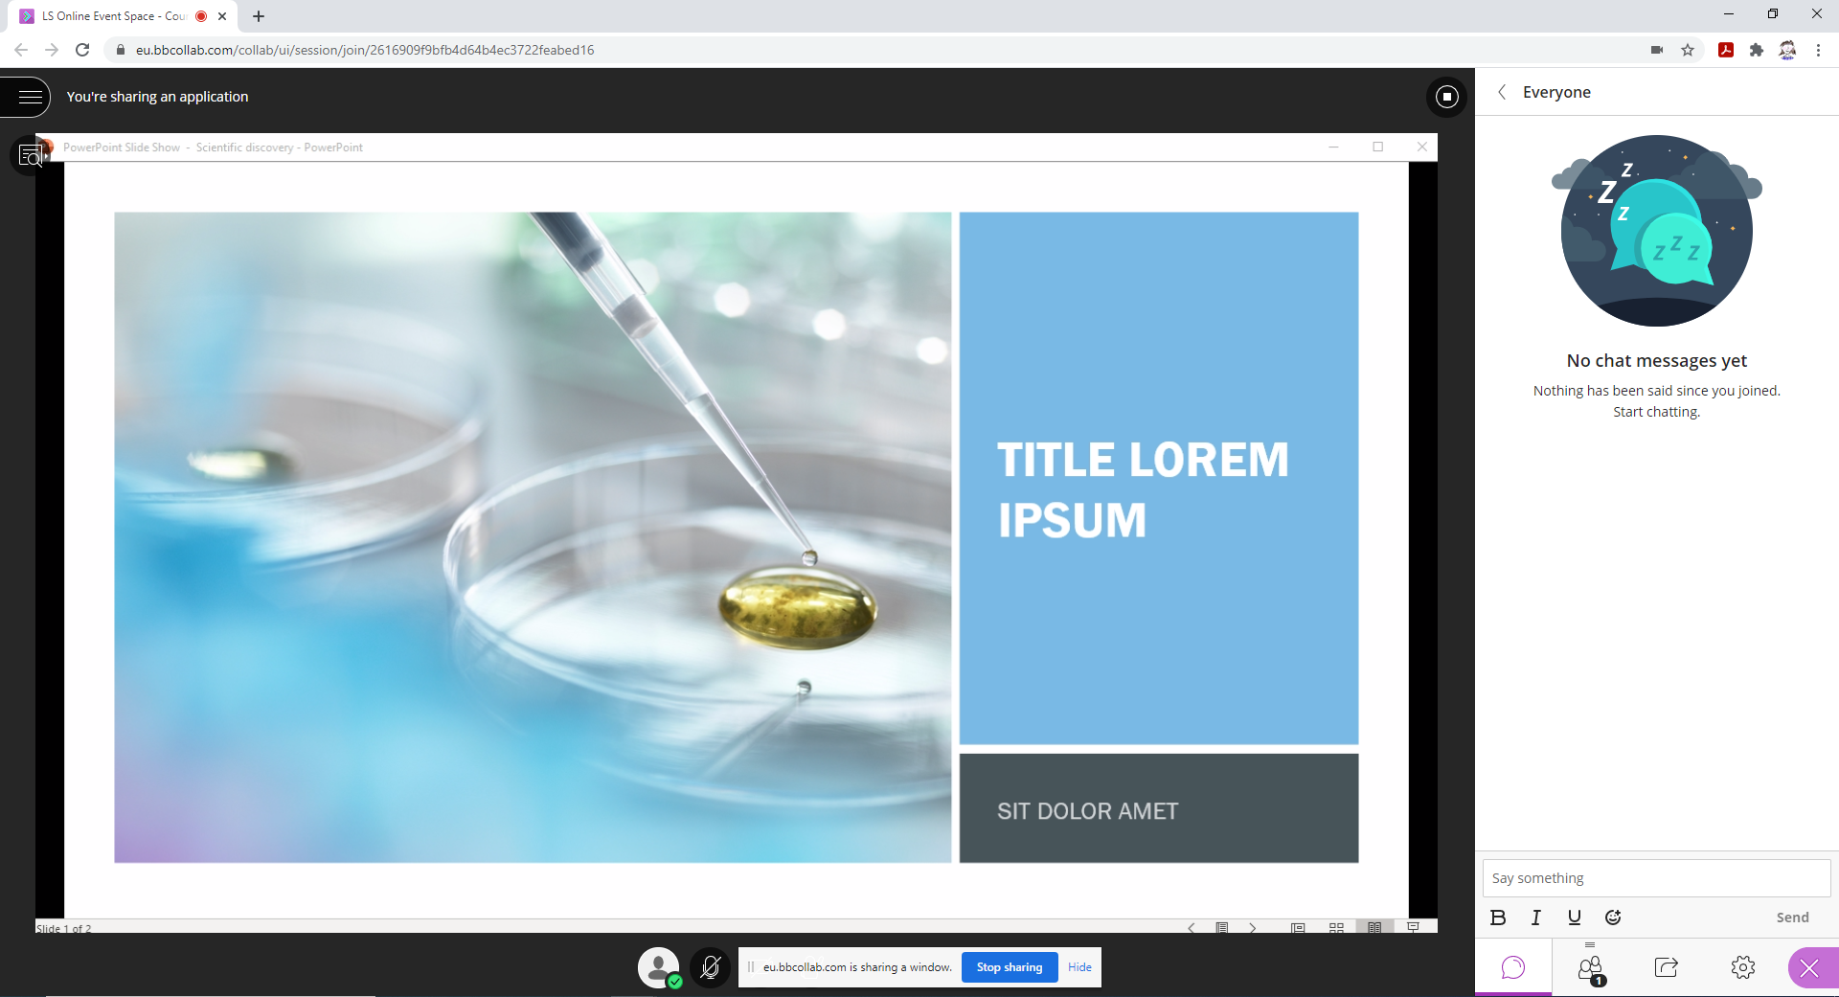

Normal View:
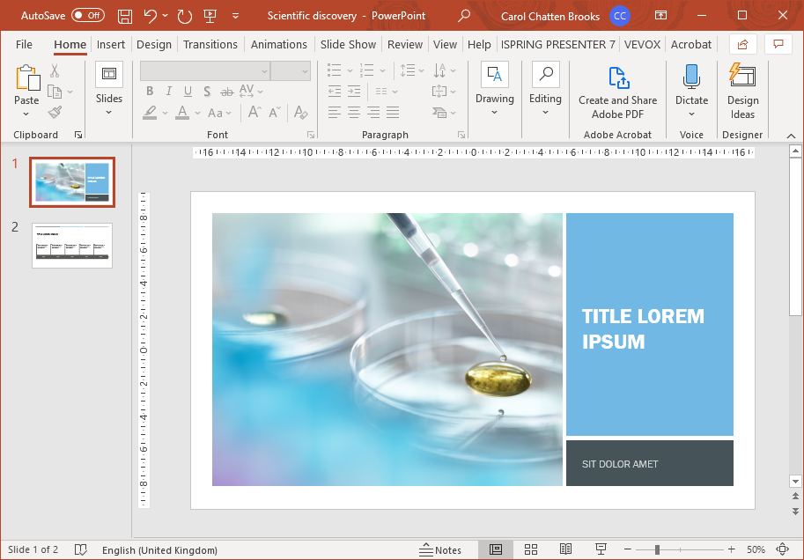

Reading View:

Video examples:
Double click to view video example

Alt + Tab

Resize and Snap Windows

Reading View in PowerPoint

