Dr David Allan and Prof Fiona Hallett
Edge Hill University
Capacity Building in Higher Education: Three Projects, Three Principles
This presentation will outline three EU funded international projects that explore the themes of social justice, inclusive educational practices, and access to tertiary education.

The projects (ASPIRE, CATALST and ALLVET) were designed to develop knowledge-exchange partnerships beyond the European Union including Georgia, Armenia, Vietnam, Laos, Russia and Kazakhstan. The innovative practices developed across these initiatives have resulted in high-quality research outputs and offer opportunities for further international collaboration and cross-cultural knowledge production.

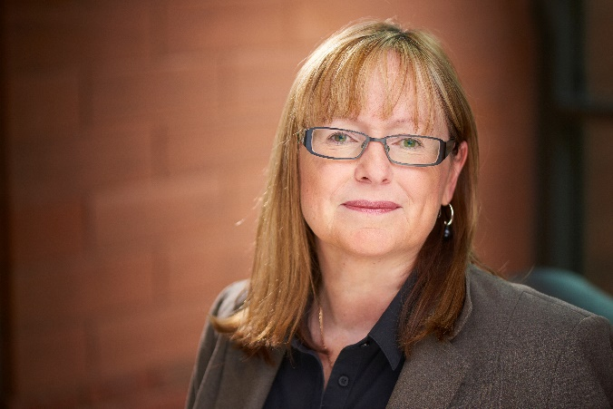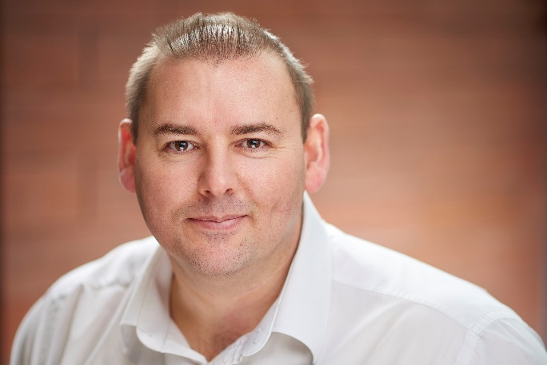
Professor Fiona Hallett Dr David Allan, Reader in Education

Research outputs include:

Allan, D., Hallett, F. and Hallett, G. (2020), Armenian teachers’ dichotomous perspectives on children with high‐functioning autism. J Res Spec Educ Needs, 20: 109-120.
Allan, D., Pham Hoai, A., & Le Nu Cam, L. (Accepted/In press). East meets West: Exploring the challenges of cross-cultural collaboration in pedagogical development. In C. Woolhouse, & L. Nicholson (Eds.), Mentoring in Higher Education: Case Studies of Peer Learning and Pedagogical Development PalgraveMacmillan.
Hallett, F., Allan, D. and Hallett. G, (2019) Reconsidering Inclusion: Western theory and post-Soviet reality. Disability Studies Quarterly, 39, 2.

Project websites:
https://catalyst-erasmus.com/
http://allvet-erasmus.com/uk/

Further research information:
https://research.edgehill.ac.uk/en/persons/david-allan
https://research.edgehill.ac.uk/en/persons/fiona-hallett

