2018 - 2019 Ally Course Report:

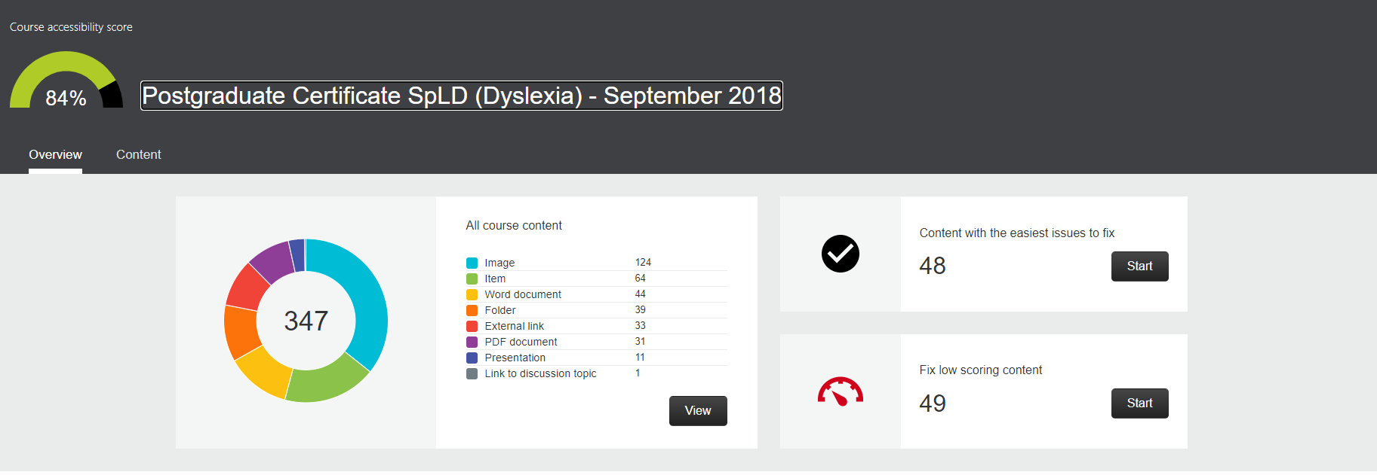

2019 – 2020 Ally Course Report:

