Student Guide to Blackboard Portfolios

Creating the Portfolio
Access the ‘Submission Dropbox’ page and select the assignment in question.
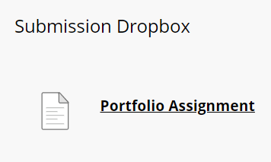
On the ‘Upload Assignment’ page select ‘Create Portfolio’.
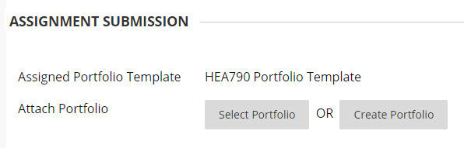
Give the portfolio a title and description to help you distinguish it from other portfolios. Select ‘Submit’.
A template has already been applied to the portfolio. You can see links to several pages to the left of the screen. The top page is displayed by default.

Adding Content to the Portfolio
In the centre of the screen there are several sections for you to add content to. Select the section that reads “Click here to add content” to open the text editor, or ‘Edit Artefact’ to upload existing files.
If you select ‘Add Personal Artefact’ you can either select items from the list, or choose ‘Add Personal Artefact’ to upload another file to the list.

Finding the Portfolio to Edit it Later
Once the portfolio has been created, you re-enter it again to make edits through the global navigation menu next to your name > Tools > Portfolios.
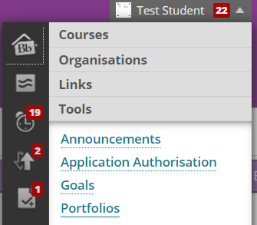

On the My Portfolios page you can find the card for your portfolio. Select ‘Edit’ to make changes, or View to see how the submitted version would look.
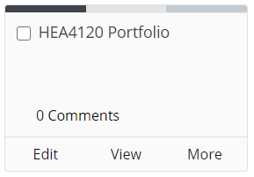

Submitting the Finished Portfolio

When the Portfolio is complete you can submit it by returning to the ‘Submission Dropbox’ page and selecting the assignment in question.
On the ‘Upload Assignment’ page select ‘Select Portfolio’.
On the ‘Select Portfolio’ page choose the correct portfolio and select ‘Submit’.
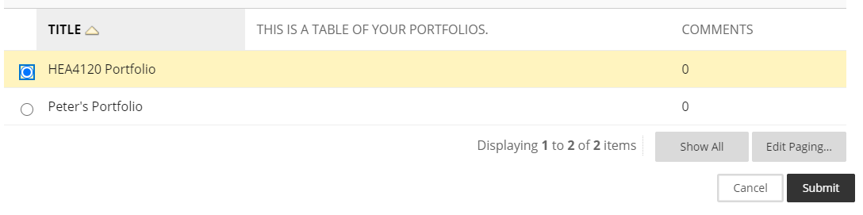
The name of the portfolio will appear in the ‘Assignment Submission’ section. If you are sure this is the correct portfolio, select ‘Submit’ at the bottom of the page.
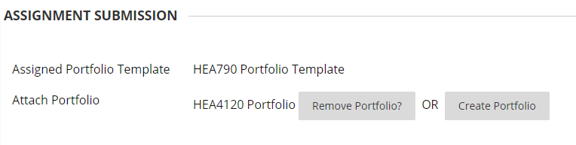

Viewing Feedback and Grades
Once the portfolio feedback and grades have been added, you can enter the assignment dropbox again. Feedback and grades are shown on the right-hand side.
