Staff Guide to Blackboard Portfolios

Creating a Portfolio Assignment and Selecting a Template
Portfolio assignments use the Blackboard ‘Assignment’ tool, rather than Turnitin.

On the assessment page select ‘Assessments’ > ‘Assignment’.
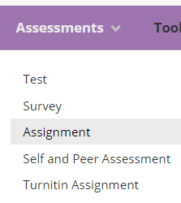

On the Create Assignment page add a name for the assignment, instructions, and due date. If you had Microsoft Word templates that you wanted the students to complete and upload as part of their portfolio you can add them through the ‘Assignment Files’ section.

Under ‘Grading’, you need to add a number to ‘Points Possible’. ‘100’ would be standard.

A key setting is under ‘Submission Details’ > ‘Assignment Type’ > ‘Portfolio Submission’.
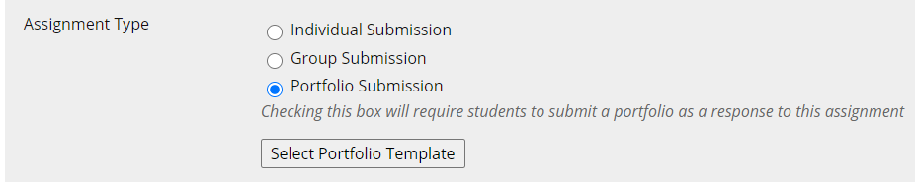

The ‘Select Portfolio Template’ page gives you a list of templates to choose from. Select one and then select ‘Submit’.

You can set other settings, such as Number of Attempts to ‘Multiple Attempts’ or ‘Unlimited Attempts’. I would recommend using ‘Unlimited Attempts’.

When you are happy with the settings select ‘Submit’.

Grading a Submitted Portfolio

You grade submissions from Blackboard Assignments by going to Control Panel > Grade Centre > Needs Grading.

In the list of ungraded assignments, select the name of the student in the ‘User Attempt’ column.
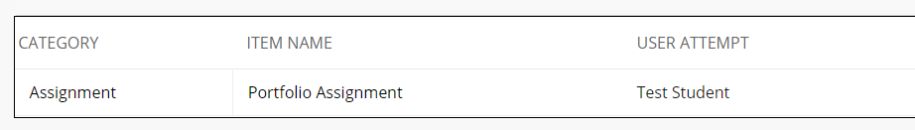

You can view the portfolio in the centre of the screen or select the download button on the right-hand side to download a .zip file containing the portfolio.

You can add a grade to the attempt box.

Click on the arrow below to open the ‘Feedback to Learner’ box.

Add some feedback and select ‘Submit’
