Turnitin Global Innovation Awards Images

Typical Turnitin Submission Process Flow and Responsibilities
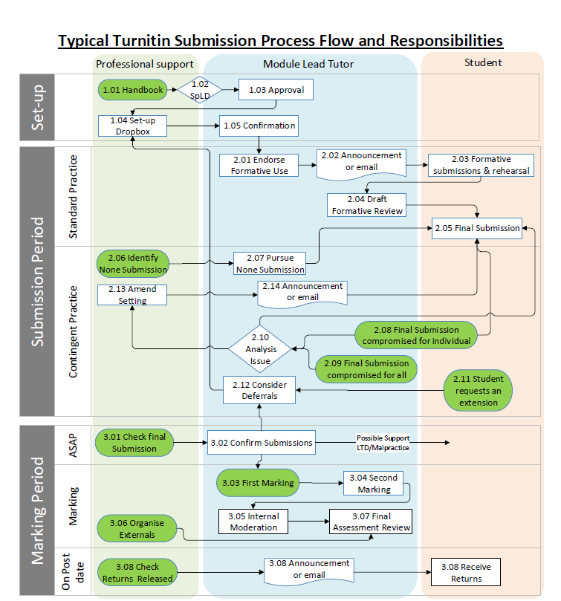

Dropbox Settings

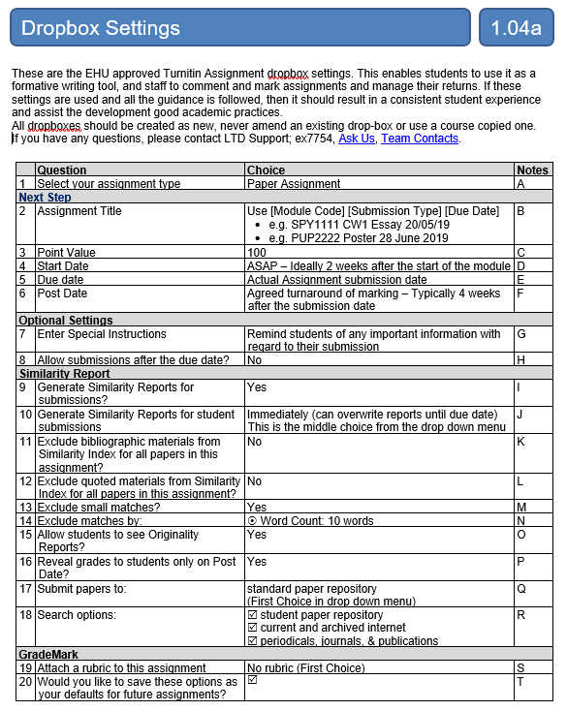

Student Help – Online TurnItIn Package

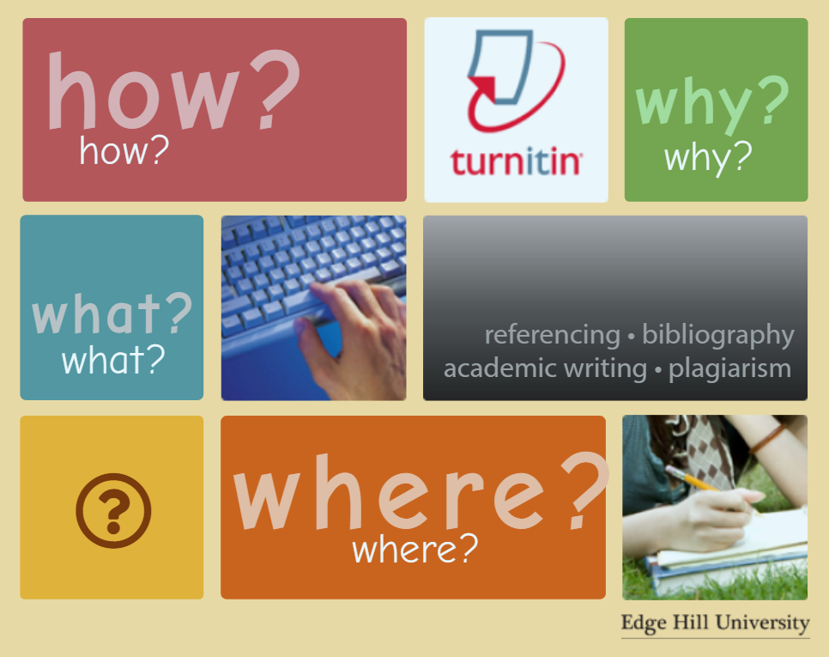

UniSkills Website

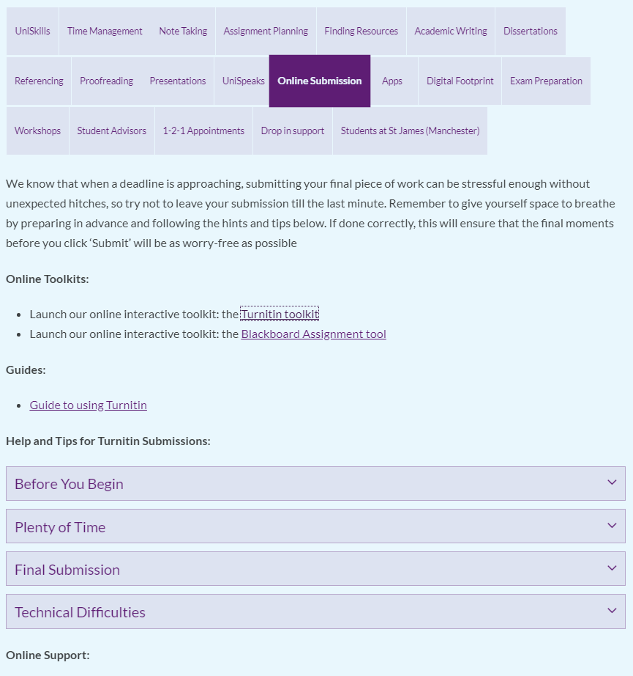

Keep Calm & Submit Student Advisor Led Workshops

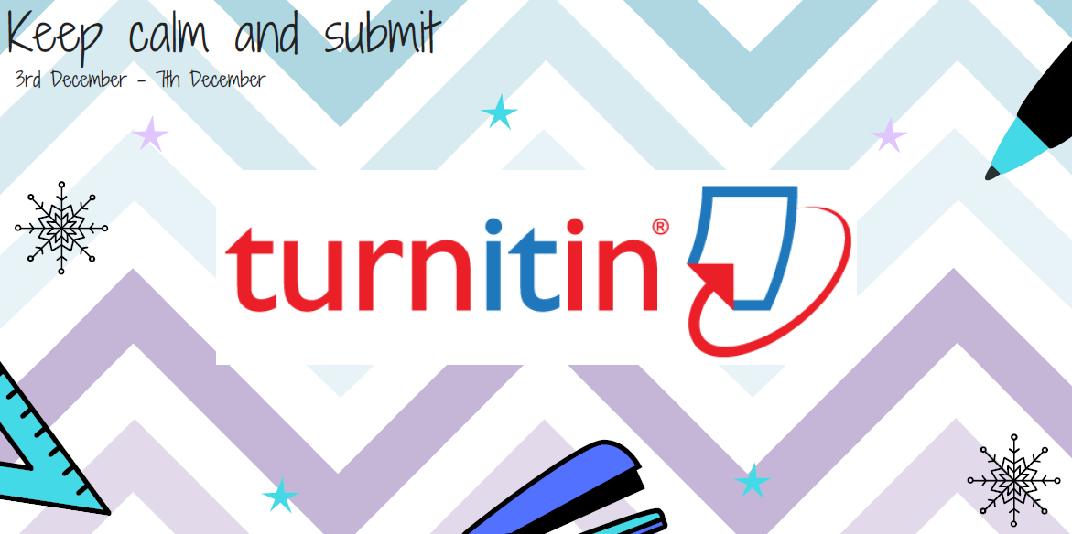
Turnitin Rubrics - Creating, Managing and Marking – Online Staff resource

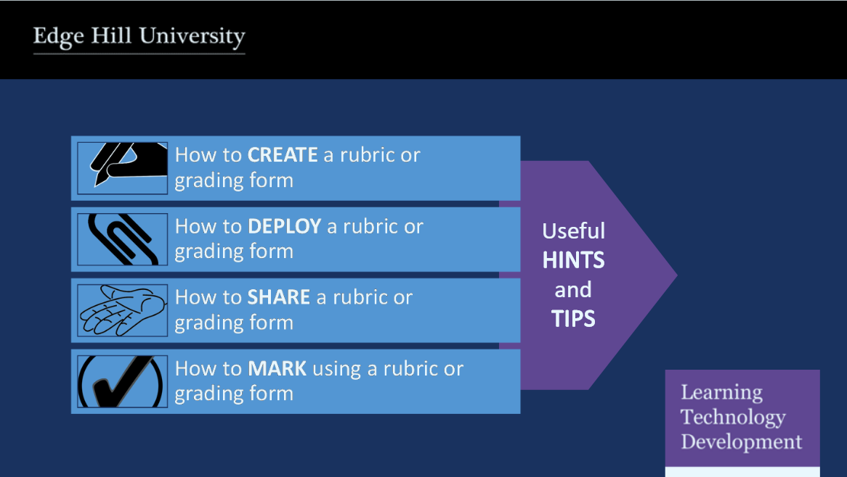

Managing late assessment submissions – Staff development session
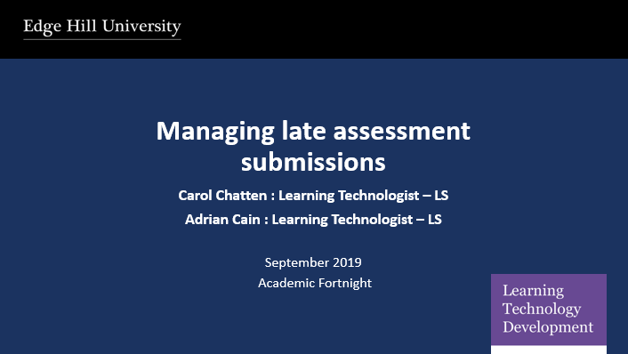

Staff Development session for studying Chinese academics
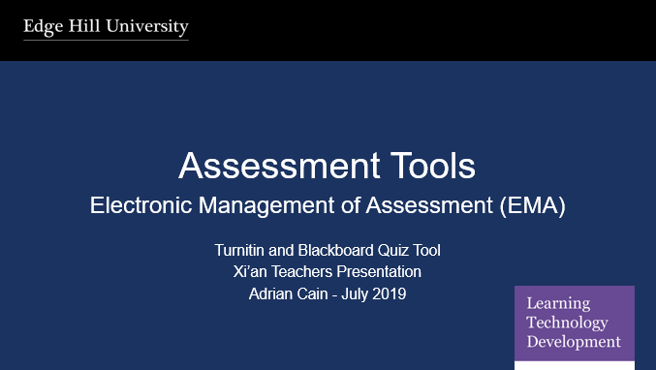

Staff Development session – Technologist and academic collaborate practice
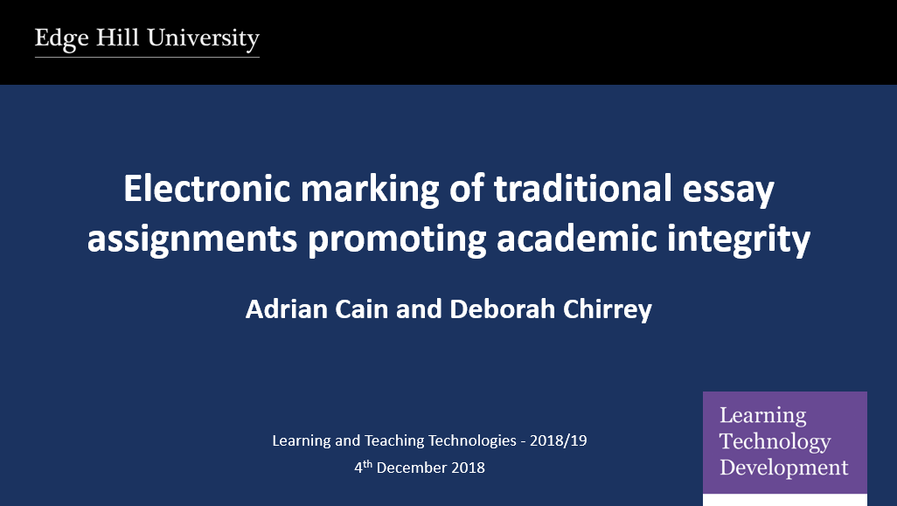

University Learning and Teaching Day presentation
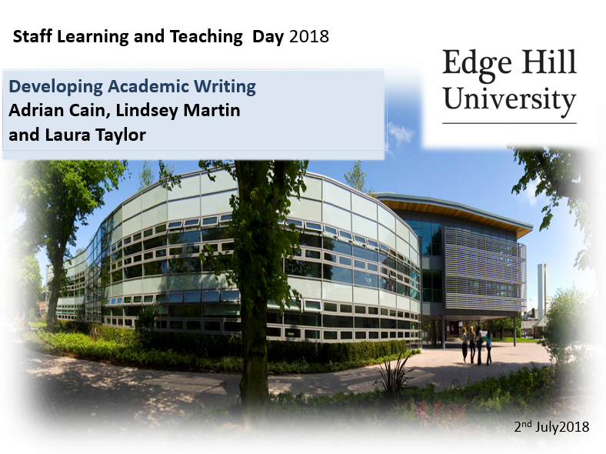
Staff Development Scheduled session
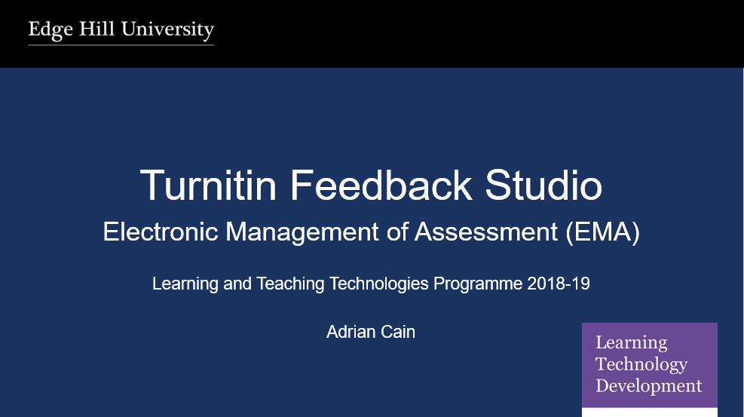

Staff Development – Academic Fortnight session
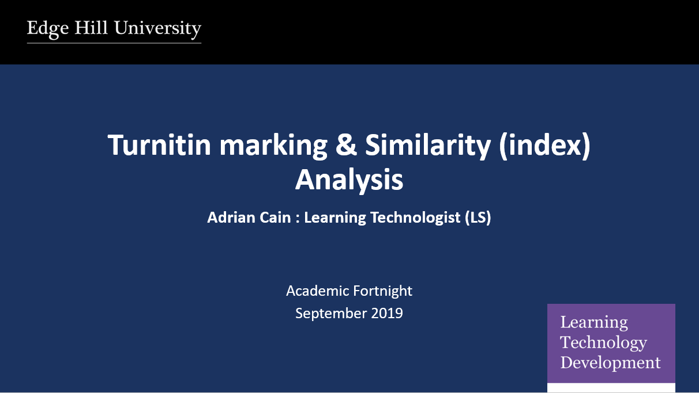

Students FAQs
