eShare
Guide

Uploading items
for Institutional Policy documents

Learning Services
eshare@edgehill.ac.uk
edgehill.ac.uk/ls
blogs.edgehill.ac.uk/ls

follow: EHULearnService

Guide to uploading items

You can find eShare at www.eshare.edgehill.ac.uk

Adding material is very straightforward.
- Save documents as a PDF before uploading to eShare (users of devices that do not run on Windows, such as iPads, for example, cannot open documents saved in Microsoft packages, but can open PDFs).
- Have the material you want to add in a place where you can easily access it – on your desktop, on a flash drive or in your usual server space.
- You can read the ‘Terms and Conditions’ for use of eShare – accessible from the foot of the eShare homepage.

Login to eShare with your University username and password.

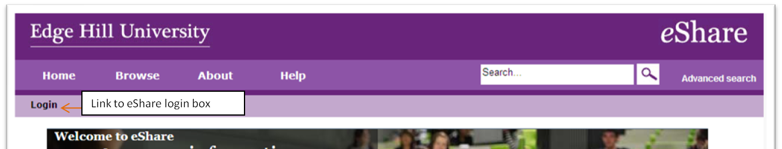

Enter your University
user name and password
Click on
‘My Resources’
to add a resource to eShare.

Click on My Resources and choose New Resource.

Click on File to select the document you want to upload.
Each document or link you upload will appear beneath the box:
IF you are uploading more than one document, Click Show options beneath the file to give each document a separate title. (Leave licence as ‘unspecified’.)

The title of the document.
Select a licence for the resource.

Click Update Metadata.
If you have uploaded several documents
you can re-order them using the blue arrows.

Complete the rest of the information about the item – take the information from the Web Information Form.

Type and 50-word summary
The title of the Policy
Please use the following text:
Please Download and read this document rather than reading the Preview (which shows the original, not the updated version).
Policy Owner
Policy Manager

Title. This is the title of the Policy / Regulation / Strategy / Code of Practice / Procedure / Guidance.

Description. The 50-word summary plus the ‘type’ from Web Information Form.

Authors. Name of Policy Manager.

Corporate Author. Name of Policy Owner.

Advice for re-use. Please use the following text:
Please Download and read this document rather than reading the Preview (which shows the original, not the updated version).

Tags. 1 Policy Management
2 The type of policy – i.e. Strategy/ Regluation/ Policy/ Code of Practice/ Procedure/ Guidance
3 Subject / Theme– e.g. Student Finance
4 alternative ways of expressing the above terms
Please use capital initials:

Viewing & Editing permissions
Set the permission level to World for external documents (those that will appear on our external website) and University for internal documents.

Editing permissions should be given to colleagues as assigned by the Policy Manager. Anyone with editing permissions can change the metadata – title, tags, viewing permissions, etc. plus they can upload new items to the resource.
(If urgent editing is required and none of those with editing permissions are available, please email: eshare@edgehill.ac.uk)

Editing permissions for the resource record are given to the author/s by default.
Viewing permissions are pre-set to University and can be changed by selecting the relevant tab.

Don’t forget to Save.

This is how the item will be displayed in eShare:

This is how the metadata will appear in eShare:

Linking to items

In My Resources, your uploaded items will be displayed (newest at the top). Click on the title to see information about the resource.

Option 1: This option will link directly to the resource and you will not see the eShare preview screen.

- Preview the resource and click on the individual document (so that it is highlighted in purple like the document called ‘Introduction to this topic’ in the screenshot below).
- Right click on ‘Download’
- Select ‘Copy Link Address’ or ‘Copy Shortcut’, then paste the URL into your document / Learning Edge page etc.

Right click Download
Then choose Copy link address

Option 2:

This option will link directly to the preview page where data about the resource will be available to the user.

- Preview the resource.

- Copy the Link on the right-hand side of the resource preview page.
- Paste this link into your document / webpages.

How to edit or update items in eShare

Please refer to the Policy Management Handbook for guidance on revising/updating.

A resource in eShare cannot be removed, and its URL is permanent. An item within that resource, however, can be deleted or replaced but its URL will change each time unless you use the following method.

First, save a copy of the new version of your document with a slightly different name

Open eshare, www.eshare.edgehill.ac.uk and login.

Click on the resource title to open it.

To edit or replace an item, go to the toolbox and choose ‘edit item’.

Then click on the File icon.

Click on ‘click to add supplementary files to this document’

And choose OK when you get this message:

Then choose your replacement file and Upload:

Click Apply

You will be returned to the Details screen. Click on the File icon once again:

Under ‘main file’, choose the new version of your document as Main file.

You can then delete the old version by clicking the blue crossed box. This is the preferred option. If you need to keep an archive of previous versions make sure that the latest version is the Main File.

Go to the bottom of the screen and click Save and Return.

