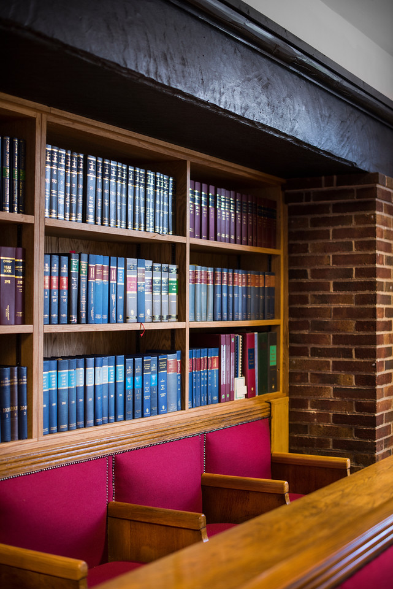

Learning Services

User Guide

askus.edgehill.ac.uk

User Guide

Learning Services

Contents

Create an account 1

Save to RefWorks Tool 1

Adding References 2

Manual Creation 2

Exporting references from the library catalogue 3

Exporting references from an online database 4

Folders 5

Adding and Removing Items from Folders 5

Reading a Document 6

Annotating a Document 6

Sharing Documents and Collaborating 7

Creating a Bibliography 9

Quick Cite 10

Custom Style Editor 10

Cite in Microsoft Word: Write-N-Cite 11

Syncing with Dropbox 14

Appendix 16

RefWorks Add-on for Google Docs 16

Browser bookmarks guidance 17

Disabling Pop-up blockers 19

**RefWorks**

RefWorks can help you to manage the research articles you are using and save the bibliographic information in one place. The information saved in RefWorks can then be used to create a bibliography.

# Create an account

Access RefWorks via the library catalogue [www.ehu.ac.uk/library](http://www.ehu.ac.uk/library) and select the RefWorks icon.

Once in RefWorks select the “create account” link.

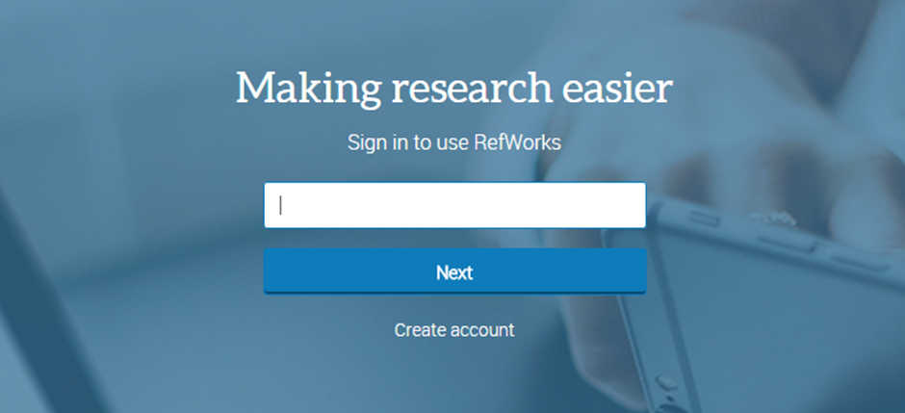

Complete the details required to sign up making sure you use your Edge Hill University email address.  Please note that your RefWorks log in details are personal to you – Learning Services cannot keep a record of RefWorks passwords.

For help and support when using RefWorks select the help icon at the top right of the screen. 

## Save to RefWorks Tool

The Save to RefWorks Tool enables you to add references and full-text to RefWorks from any website.

You can set up the Save to RefWorks tool. It can be found in the **Tools** menu under your name. There is guidance in RefWorks about how to set up and use the Save to RefWorks tool. If you want to do this, you must first ensure that the bookmarks/favourites toolbar on your browser is open. We have instructions for Internet Explorer, Firefox and Google Chrome in the appendix.

Simply drag the button onto the toolbar. This is an entirely optional step.

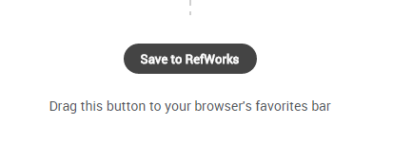

When you have completed a database search, select the records you want to add to RefWorks, then click the **Save to RefWorks** button to send them to your RefWorks account.

The references will appear in RefWorks in the **Last Imported** folder.

# Adding References

## Manual Creation

|  |  |
| --- | --- |
| This isn’t something you need to do very often, but if you have a tricky reference, you can add it yourself. Simply click on the + button and select ‘Create new reference’.  You can then select from the drop down menu the type of reference you wish to add. RefWorks will automatically display the fields you need to fill in. RefWorks will try and identify your reference and autocomplete the fields. |  |
|  |  |

The new reference will go into your **Last Imported** folder, unless you specify otherwise.

## Exporting references from the library catalogue

To export the details of a book to RefWorks, first go to the catalogue record for the book you need.

There is a **Save** button. Clicking on this brings up a pop-up box. At the bottom you can select **RefWorks.**

You will see a choice of two RefWorks products where you can send your reference - you need to select the blue RefWorks icon on the right.

RefWorks confirms that your reference has been added and it will go into your **Last Imported** folder.

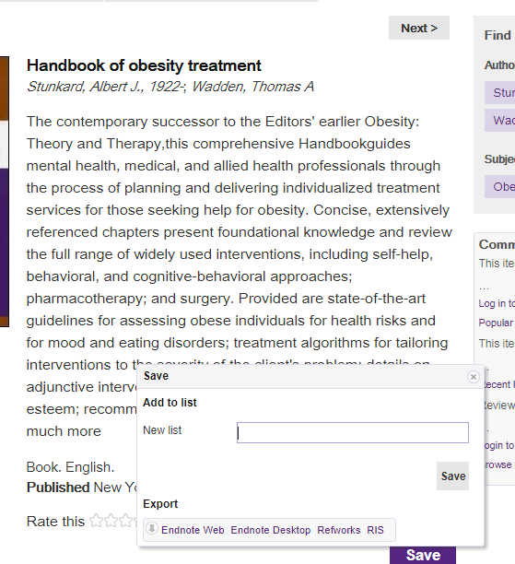

## Exporting references from an online database

If you are sending references from an online database to RefWorks, you need to be logged in to your RefWorks account and have the database open in the same browser.

Please note that every database will have a different way of saving articles to RefWorks. It is usually straight forward, but if not, the help function of the database will give you instructions.

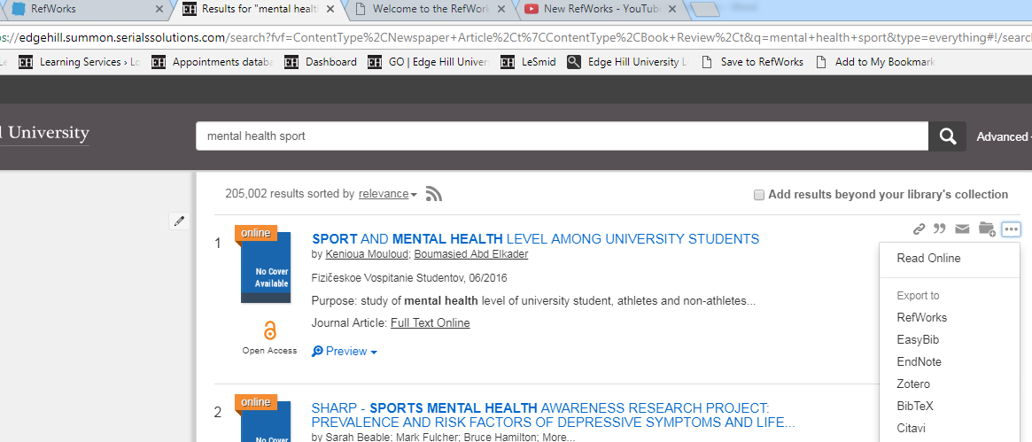

You can select the reference manager you want to use here

You will see a choice of two RefWorks products where you can send your references - you need to select the blue RefWorks icon on the right.

RefWorks confirms that your references have been added and they go into your **Last Imported** folder.

When your article’s details are in RefWorks, download the full-text of the article onto your computer. Select the citation in your **Last Imported** folder and click on the  icon. You can then drag and drop the pdf file, or upload it from your computer.

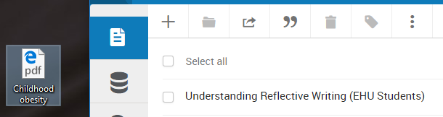

# Folders

|  |  |
| --- | --- |
| Folders are used within RefWorks to organise references. To create a folder, simply click “My Folders” on the left hand side of the page, then + Add a folder.  Name your folder and click “Save”. Your new folder will appear on the left hand side of the page under “My Folders”. References can be added to more than one folder.  To add a subfolder select a folder and click on the menu button to the right of the folder name. Select “Add subfolder” and give the new subfolder a name. |  |

## Adding and Removing Items from Folders

**Adding to a folder:** Once you have created a folder, you can start organising your items. From the **All Documents** or **Last Imported** view, click on an item and drag it into the folder of your choice.

You can also drag an item from one folder to another (the item will remain in the original folder as well). Click the folder name to view all the items within that folder.

**Removing items from a folder:** To remove an item from a folder, go to the folder and select the item(s) you wish to remove. Click the delete button. When you remove items from folders, they remain in RefWorks in the **All Documents** area.

To permanently delete items from RefWorks, go to the **All Documents** area, select the item(s) you wish to delete and click the **delete** icon.

Please note that if you delete items from your **Last Imported** folder, they will be permanently deleted from your RefWorks library and all folders.

Adding tags to references provides an additional way to organise and manage your research across RefWorks folders.  You can even search using a tag in the RefWorks search box.

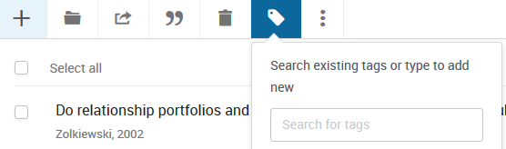

# Reading a Document

RefWorks has a built-in document reader. You can read and access supported documents anywhere, with just a web browser.

In order to read any documents, you must first bring the citation details and the full text into RefWorks. Export the article’s citation details into RefWorks, and download the full-text of the article onto your computer. Select the citation in your Last Imported folder and click on the  icon. You can then drag and drop the file, or upload it from your computer.

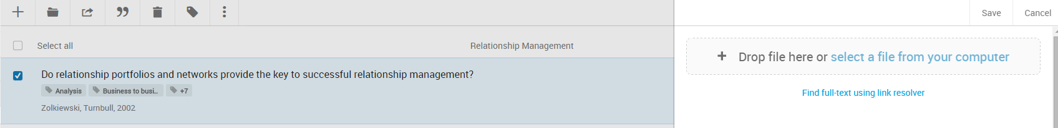

You can then click on the link to read the full text. If the item does not contain a document, the bibliographic data of the reference will be displayed instead.

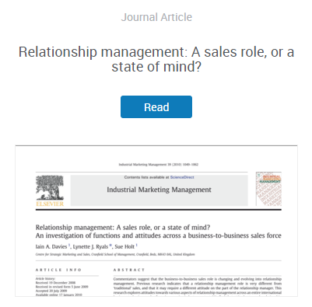

When reading a document, you have several options, all of which can be found on the tool bar on the top of the page:  
  


|  |  |
| --- | --- |
| * zoom in or out | * highlight |
| * print | * comment or add notes |
| * download document | * edit the references |

## Annotating a Document

You can annotate any of your own documents saved in RefWorks. You may be able to annotate documents shared with you if you have been given permission to annotate and/or modify the document.

To annotate a document, click on the name of the item to open it in RefWorks. Click the comment icon at the top of the page and select the text area you wish to comment on. Your comment will appear to the far right of the selected area. You have the option to change the colour of your comment by clicking on the colour of your choice in the comment itself. If you change the colour of your comment, the associated highlighted text annotation will be the same colour.

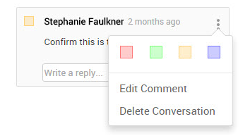

Comments can be edited or deleted at any time. To edit a comment, just click on the comment and make your changes. To delete a comment, click on the comment and click the “x” in the right-hand corner of the comment. Once you type a comment, it is automatically saved.

You can also highlight text within the document. Click the highlight icon  and drag your mouse across the text you wish to highlight. To remove highlighting, click on the highlighted area and select Delete Conversation.

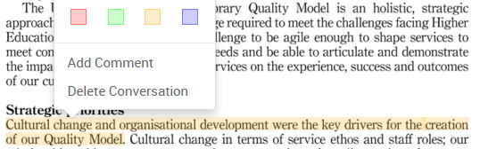

# Sharing Documents and Collaborating

With RefWorks you can give your colleagues access to any of your folders, to allow you to collaborate on projects.

To do this, simply click on the folder you wish to share, click the **Share & Export** button and choose **Share folder**.

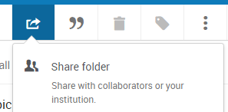

Put in your colleague’s email address and assign rights to that person. They can either read, annotate or modify the folder. Your colleague will get an email, with a link included, which allows them to access your folder. They have the option to accept or reject this link. If they don’t have a RefWorks account, they can set one up on the spot. There is no limit to the number of folders that you can share, or the number of people you can invite to share them. When you share a folder any sub-folders are also shared.

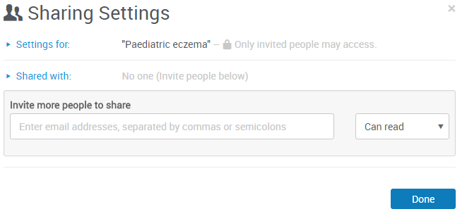

If you want to check who you've shared a folder with, hover over the folder you want to check. Then go to the **Share & Export** option, and click **Share folder.** You can change the rights at any time.

You can also change the sharing from "private" to "institution", which gives everyone in your institution access to your folder. RefWorks allows for sharing outside your institution, as long as that person also has a RefWorks account.

# Creating a Bibliography

You can easily create a bibliography from your All Documents area or any RefWorks Folder.  
Go to the folder you want and click the **Create bibliography** button and select **Create bibliography**.

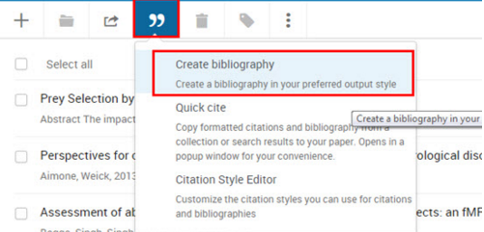

You can choose to create a bibliography for selected references or for all of the references in the folder.  
  
The Edge Hill referencing guide is used by most departments and is based on Harvard British Standard, however you can choose from a lengthy list of referencing styles in RefWorks.

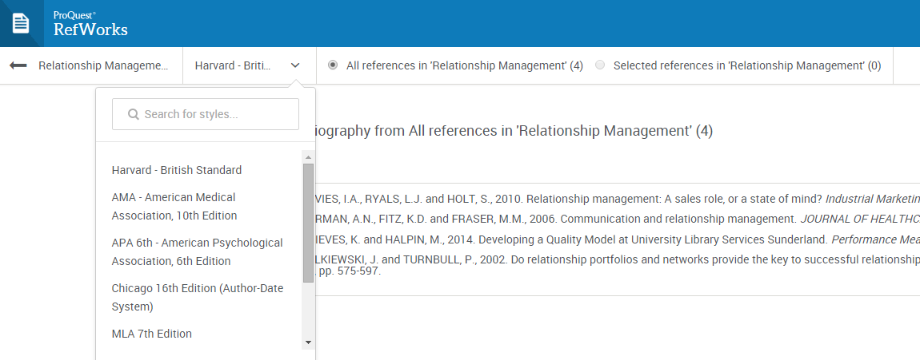

You may need to enable pop-up blockers to allow your bibliography to appear on screen. **Please see the appendix for further details on how to set this up for your browser.**

Your formatted bibliography will then be displayed for you to copy and paste into any word processing software. You should always double-check the bibliography with your department’s referencing style to ensure that it matches.

## Quick Cite

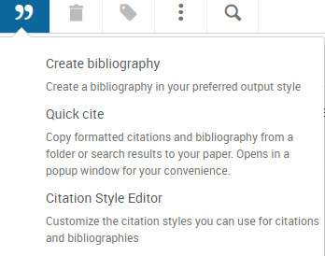

Quick cite enables you to quickly create a reference list. It can be found in the **Create Bibliography** menu.

When you have selected the folder containing the papers you want to cite, you will be asked to choose your preferred reference style, then the references you want to reference. A bibliography is generated which you can paste into your document.

## Custom Style Editor



If your preferred referencing style is not in RefWorks, you can use the Custom Style Editor to customise your citation style. You can find information to help you do this in the help section of RefWorks.

## Cite in Microsoft Word: Write-N-Cite

If you are on campus, EHU computers should already have Write-n-Cite for MS Word loaded. Please contact Learning Services if this is not the case. If you are doing this from your own computer, you need to download it from RefWorks. When you are logged into RefWorks click on your name in the top right hand corner and select **Tools**. Scroll down the page to **Cite in Microsoft Word**. There are versions for Mac, as well as Windows, so choose the one that best suits your needs. **Mac users need to be aware that you must first install Java on your machine if you want to use this feature**.

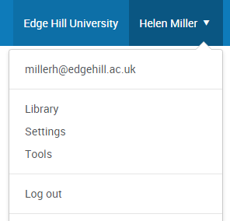 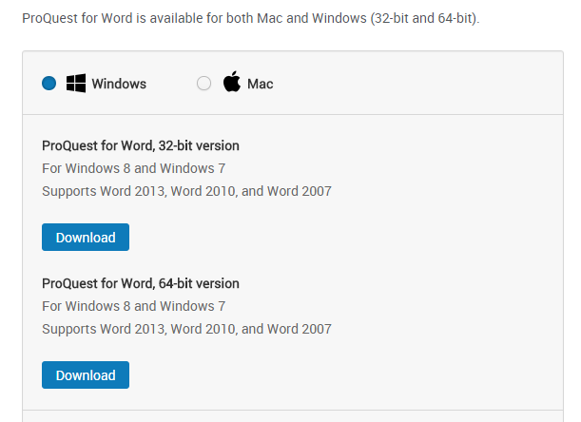

Once you have downloaded this, open a Word document. You will then see the RefWorks tab on the page. You need to log in to RefWorks, using your RefWorks usename & password.

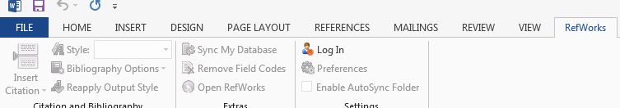

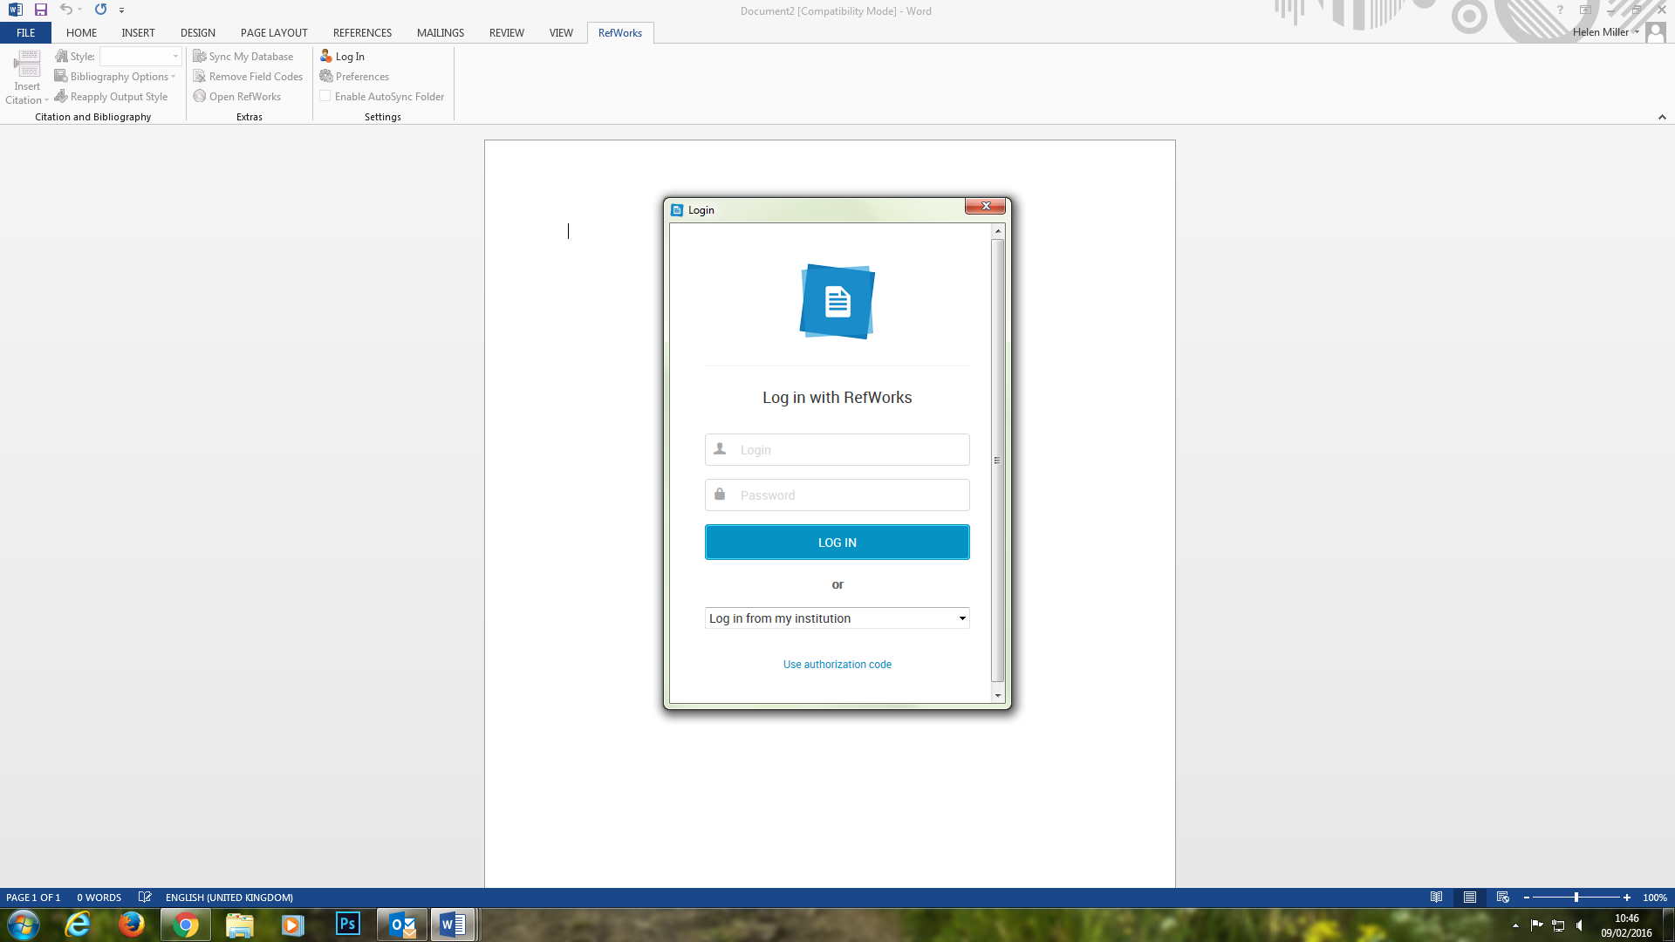

Login with your usual user name and password.

When you are logged in, you can set up your preferred referencing style. Most students will want to select Harvard-British Standard 2010, however other departments may ask for a different style. If you cannot find your required style in the menu, log-in to your RefWorks account and set up your favoured style in the menu there. This will then sync with Word and update for you.

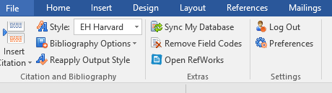

Type up your assignment as you normally would. When you wish to insert a citation, simply click the link in the top left hand corner and choose “insert new”.

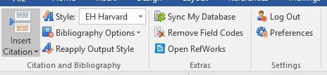

Choose the folder and then the reference you want to insert and click ok.

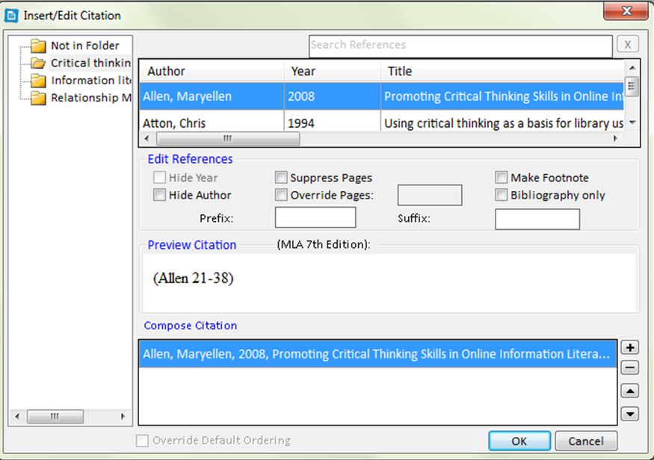

When you are writing your essay, it might look a bit like this test document. Double check the format on each citation to ensure it matches your referencing guidelines.

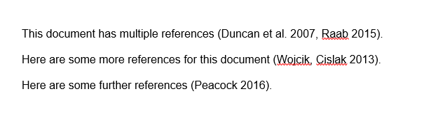

Once you have finished, click on Bibliography options in the menu and select **Insert Bibliography**.

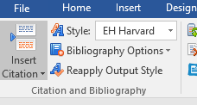

Your assignment will now look like this. Always remember to double check against the referencing guide for any errors!



# Syncing with Dropbox

If you already have a Dropbox account set up, you can sync it with RefWorks to push any of your saved documents to Dropbox. You can do this by clicking on your name and choosing Settings from the menu.

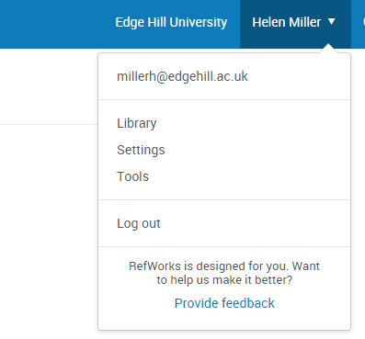

From there, scroll down the page and click on the Connect with Dropbox button, and enter your log-in details for that site. Your RefWorks documents will appear in the Dropbox Apps folder.

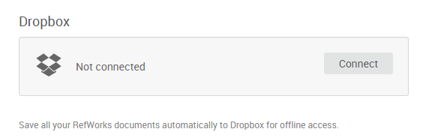

You’ll be asked to give RefWorks permission to create a folder in your Dropbox called “ProQuest RefWorks” in your Apps folder.  This is where RefWorks will place a copy of your articles.

You can only store your own articles in Dropbox – articles in shared folders are not included.

After you first set up your connection from RefWorks to Dropbox, newly uploaded documents you save to RefWorks are automatically saved in Dropbox as well.  When you remove a document from your RefWorks library, it will also be removed it from Dropbox.

**To disconnect your RefWorks account from Dropbox:**

1. Log in to RefWorks.
2. Click your name, then select “**Settings**”.
3. Scroll down and click the “**Unlink**” button in the Dropbox area of the page.

# Appendix

## RefWorks Add-on for Google Docs

If you are writing your document in Google Docs you can install an add-on to assist with citing references in your document and creating a bibliography. Click on your name and select tools from the menu, scroll down the page to ‘**Cite in Google Docs’**. Click on ‘**Get the Add-on**’ button and install the free add-on.

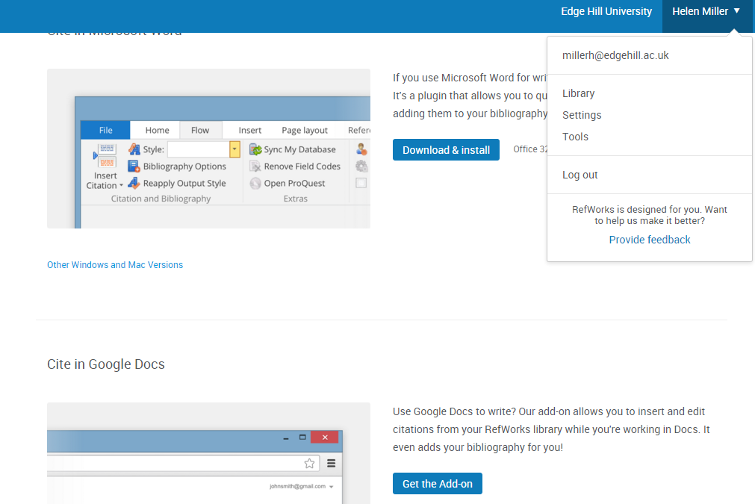

Start writing and when you are ready to insert your first citation, select **Add-ons**, **ProQuest** **RefWorks**, **Manage Citations**

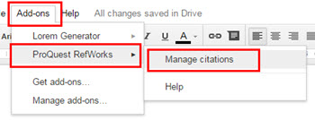

As you write your paper and insert your citations, you’ll see your bibliography format in your document.

You can share your document with anyone who has a RefWorks account and in addition to adding and editing text to your document, they can also add in-text citations from their RefWorks account.

For further help with the Google Docs Add-in select the help icon  at the top right of the screen.

## Browser bookmarks guidance

Microsoft Edge

For sites that you want quicker access to, save them to your Favorites bar by clicking the Add to Favorites bar button.

If the Favorites bar is not visible, select the  button in top right-hand side of browser, select **Settings** and turn the radio button **Show the favorites bar** to **On.**

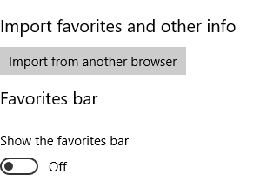

Firefox

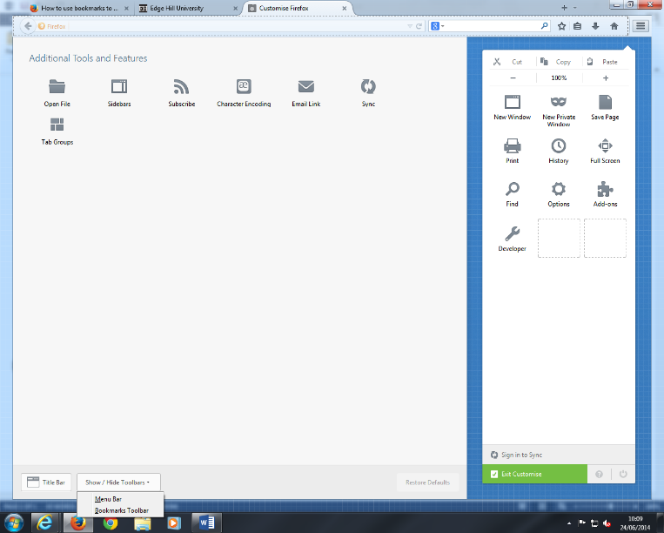Bookmarks Toolbar

1. Click the menu button and choose customise.
2. Click the Show/Hide Toolbars dropdown menu at the bottom of the screen and select Bookmarks tool bar.
3. Click the green exit customise button.

Chrome

The bookmarks bar contains all your bookmarks and bookmark folders created in Google Chrome. You can dock the bar directly underneath the address bar at the top of the browser window for easy access to your favourite sites.

**Dock the bookmarks bar**

1. Click the Chrome menu Chrome menu on the browser toolbar.
2. Select **Bookmarks**.
3. Select **Show bookmarks bar**.

You can also use the keyboard shortcuts **Ctrl+Shift+B** (Windows and Chrome OS) and **⌘-Shift-B** (Mac) to toggle the bar on and off.

**Hide or undock the bookmarks bar**

Right-click (or control-click on a Mac) the bookmarks bar and deselect **Show bookmarks bar**. When the bookmarks bar is undocked, you can always find it at the top of the [New Tab page](https://support.google.com/chrome/answer/2918032).

Once you have your bookmarks bar visible you can set up RefWorks Tools.



Select ‘Tools’ and then click on the install button 

Drag the ‘Save to RefWorks’ button to your bookmarks bar 

## Disabling Pop-up blockers

Microsoft Edge

Select the  button in top right-hand side of browser

Go to settings, then advanced settings.

The pop-up blocker can be found in advanced settings.

If you want to see pop-ups, **Block pop-ups** is switched to **Off**.

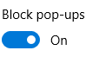

Chrome

Allow all pop-ups

You can allow pop-ups by disabling the pop up blocker.

Follow these steps:

Click the Chrome menu button cid:image001.jpg@01CFCD07.F2CED4A0

Select settings

Click show advanced settings

In the “Privacy section, click the Content settings button.

In the pop-ups section, select “Allow all sites to show pop-ups” Customise permission for specific websites by clicking manage exceptions.

Firefox

cid:image002.jpg@01CFCD07.F2CED4A0Menu – options, /content/

Select the pop-up windows

Select exceptions button then address and allow.