Instapaper

Getting Started

You can use Instapaper on a PC or download the app for your device from the relevant app store.

On a PC, go to www.instapaper.com and choose Create an Account. Once signed up, you will receive an email. Within this email will be links to download browser extensions. Click on the relevant one for the browser you use. The Instapaper browser extension will be added to your browser like this:

Adding Information

When browsing online, if you want to add a webpage to your Instapaper account to read later, you can simply click on this extension. A box will appear saying Saved and the webpage will then appear on your home page of your Instapaper account. You can then view this from any other device on which you have installed the Instapaper app.

However, be aware that if you save articles from Discover More in this way, Instapaper saves them as a link, meaning you will need Internet access to view them again and therefore you cannot use the full range of offline reading features available.

You can also organise your saved information into folders. Add a folder using the button on the left and give it a name. You can drag articles from your home page into a folder. When you use the web extension, you will now have the option to move something instantly into a folder, by clicking on the folder icon which appears.

Simply click on a saved page in Instapaper to read it. When reading, you have the options to change font style and background colour. You can also highlight selections of text and add coloured highlighting or notes.
There is also a search box at the top of the page which allows you to search your articles for a specific word.
Using the App

The app is available for Android and iPhone devices. Anything you have added from a PC will sync to your device, and vice versa.
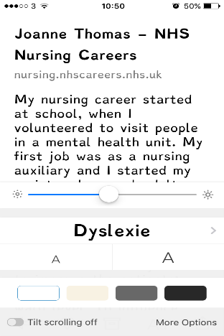
On your phone or tablet, you can change the font size and style of webpages you have saved, alter the background colour and add notes as you can with the web version.

There are options to ‘speed read’ and a text-to-speech option which reads the text out loud.

The app will work when offline or when you do not have wifi, so you are not restricted about when you can read stuff you have saved.

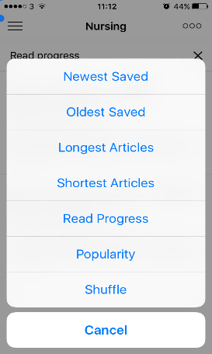
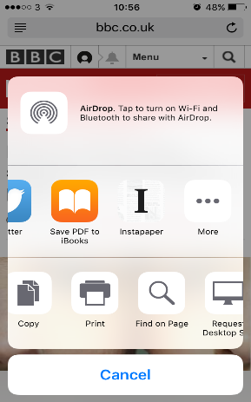
When reading online using a smart phone or tablet, you can still easily add to your Instapaper account.
It will become one of your saving/sharing options on your device, so when you find something you wish to add, click on share, click on Instapaper, and it will be dropped in.

Evernote

Getting Started

Evernote is available as a website or as an app. You can sign up for free at www.evernote.com.

Adding Notes

You can add a note by clicking on the + button. Here you can give your note a title, type your text and drag files across to attach them to your notes.

Creating Notebooks

You can create notebooks to organise your content in Evernote. This can be done by clicking on the notebooks icon on the left and then on Create a notebook. Give your notebook a name. This will then become an option into which you can save any notes you now make.

Clipping from the Web

Evernote has a web clipper which you can install in your browser to add anything you find online to Evernote. To do this, click Get web clipper and the extension will be added to your browser. Click on the little elephant logo to log in.

Once logged in, if you see an article, image or bit of text you would like to add to Evernote, click on the elephant icon and choose from the different options to add it to your account.

If you only want to save a few lines, highlight the section you wish to save and choose Selection from the options.

If you want to annotate what is on screen, choose Screenshot, select the area of the screen you wish to capture and then use the highlighting and other annotation tools to mark up the information.

When you go back to your Evernote account, the web clippings will be in your selected folder.

Using the App

The app is available to download for free from the app store. Anything you add using the online version is synced to your app and vice versa. You can read anything previously added from the web to Evernote even when you do not have internet access or wifi.

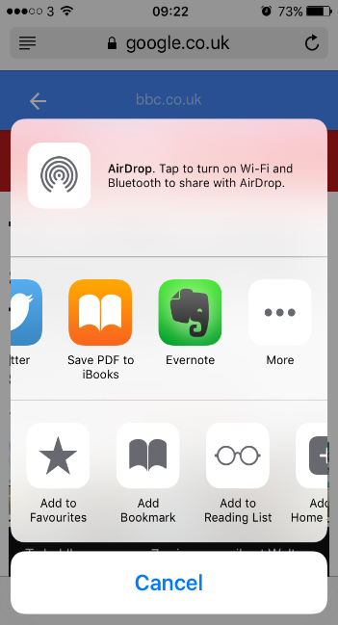
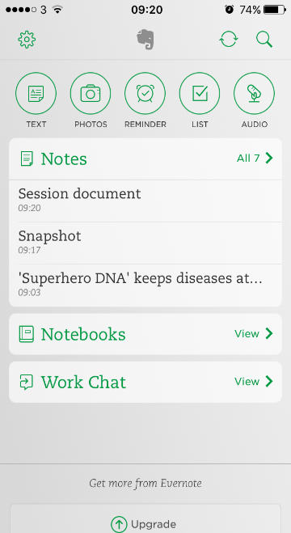
Through the app you can add text notes and photos as well as reminders or lists. You can also use the Audio feature to record and save speech.

There is a Search feature which you can use to search the text in your notes for a specific word or phrase.

You can still add to Evernote from the web when using your phone or tablet. It will become one of your saving/ sharing options on your device, so when you find something you wish to add, click on share, click on Evernote, and it will be dropped into the folder of your choice.

Sharing via the App

There is also an option within the app called Work Chat. This can be used to share notes or notebooks with others. You can give others permission to simply view the notebook or you can give them permission to edit it and invite others to join too.

Go Conqr

Once logged in at goconqr.com, choose what you want to create by clicking Create.

You can quickly create flashcards, quizzes and mind maps. You can also make groups with other users and share specific materials with them through Group – Create New Group.

As well as creating your own resources, you can use the search option to find and save resources made by other users.

