

Information Skills Foundation and HUG

Learning Services

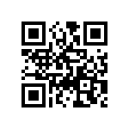
edgehill.ac.uk/ls
blogs.edgehill.ac.uk/ls
EHULearnService
EHULearnService

 | Section 1  Finding the Learning Services web pages

To get access to the Edge Hill Go Portal
- type the web address, www.edgehill.ac.uk in the address bar of your browser.
- Enter your username and password in the login box on the top right hand side

Login here
Link to Libraries and the Learning Services Web Pages

This will bring you to our Student portal called go.edgehill.ac.uk.

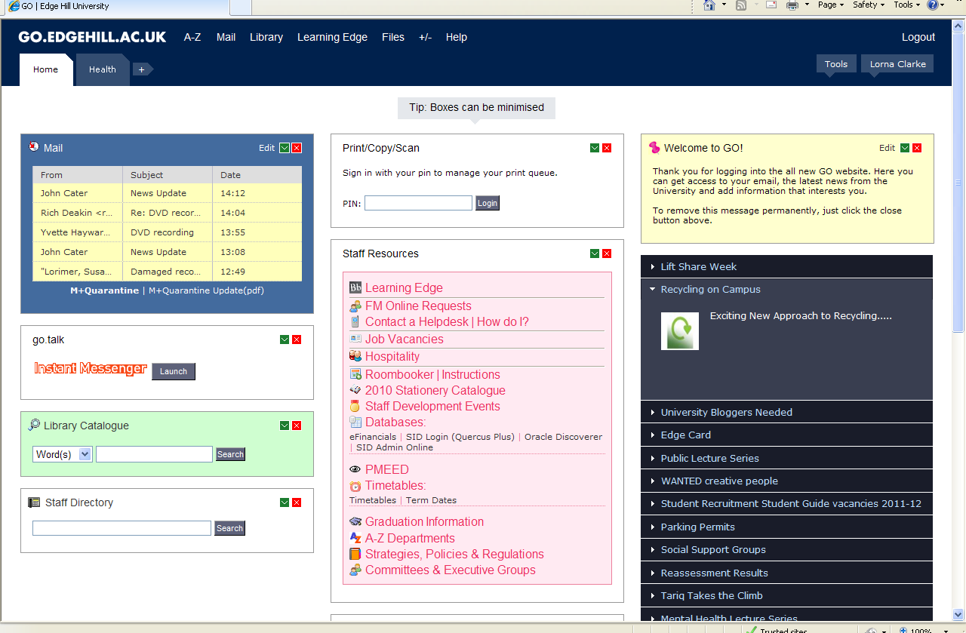
Library Catalogue
Student email
This page contains lots of links to other pages full of information relevant to your course including the library catalogue and the Learning Services Web Pages.

 | Section 2  Accessing the Learning Services Web Pages
For help with starting your research, access to study guides and a full list of the Databases and Journal collections that will support your studies, have a look at the Learning Services web pages: http://www.edgehill.ac.uk/ls or click on the link in the Go Portal.

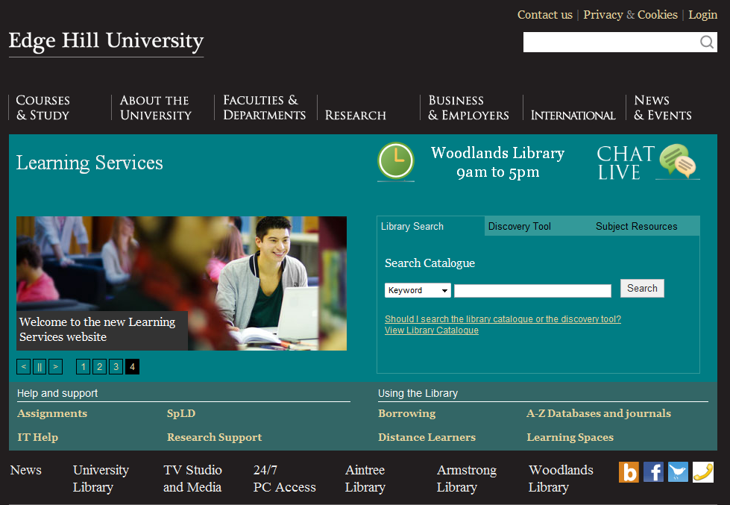

If you click on Subject Resources you can select your Faculty (Health), and you can see a list of all the relevant Journals, Databases, websites and e-book collections that are available for you to use.
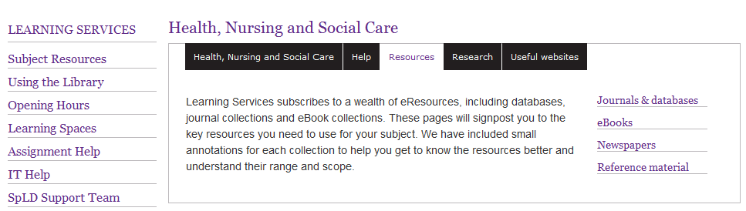
Click to see the full list of resources

 | Section 3  Using the Library catalogue

The library catalogue is a one-stop-shop for resources where you can search for books and other items and obtain direct access to full-text e-books, e-journals and online databases. You can also check your library record, and can renew and reserve items.

To access the library catalogue from the Go portal click on the Library Catalogue link or go to:

http://library.edgehill.ac.uk/

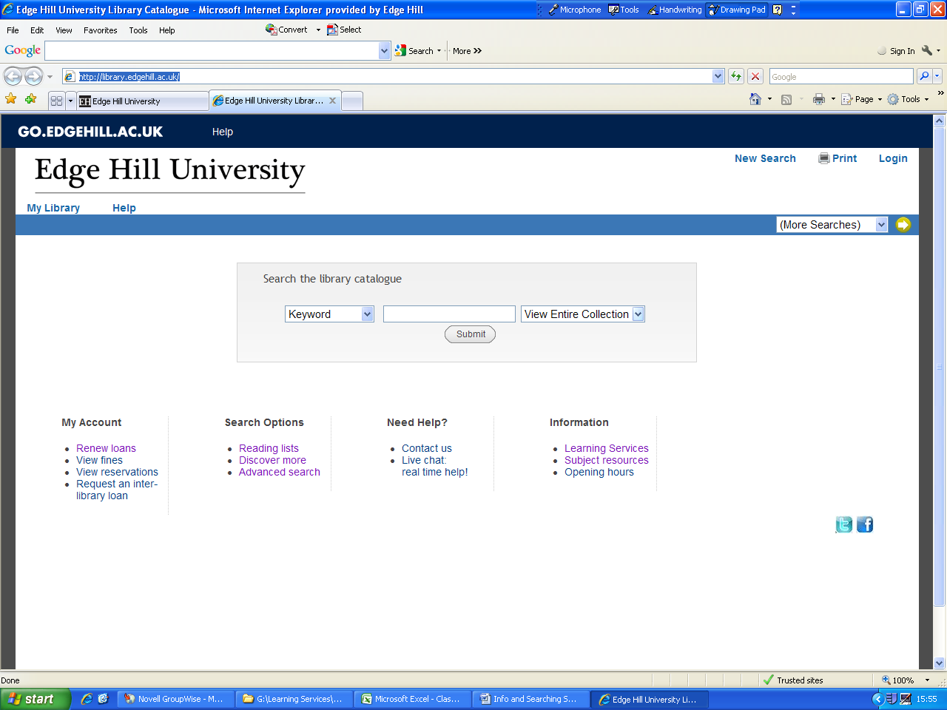
Search options

There are various ways to search the library catalogue. Using the drop down menus you can choose to search by

- Keyword e.g. child development
- Title if you know the title of the item you are searching for.
- Author if you know the author of the item you are searching for.
- Subject if you are looking for general subject material eg Health
- Class No e.g. WY 105 or 613.79 BEN
- Module Code e.g. FDH1146

Keyword Search

Choose New Search and select Keyword from the drop down menu on the left. Type in Study Skills and click Submit.

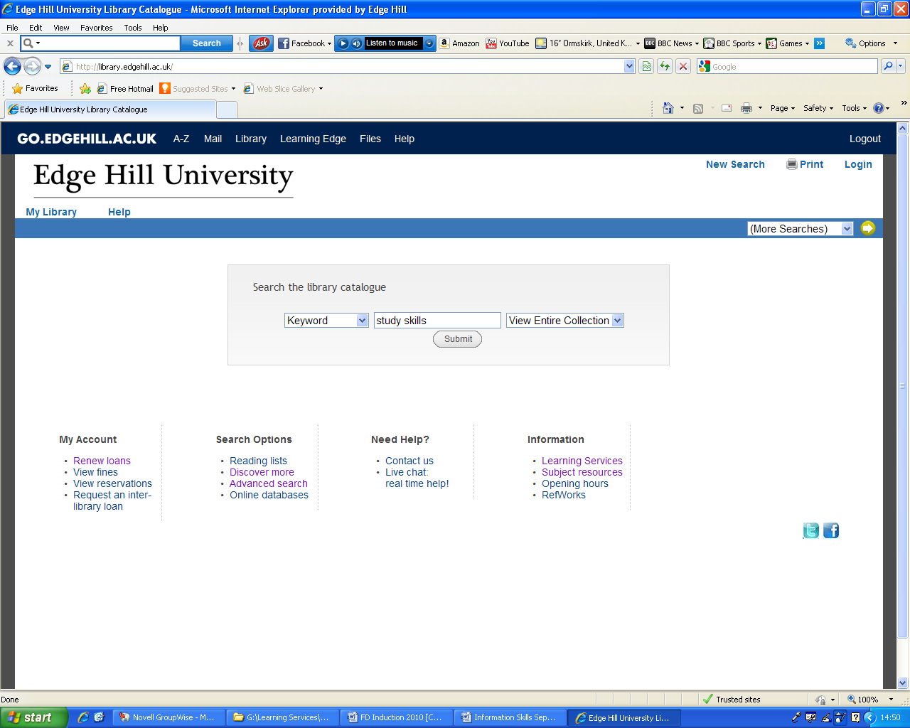

From the list find a title called Study skills for dummies and click on the title. The details of how many copies and at what sites will then be visible, showing you if the book is in or out. If all the copies are out, or all the copies at your site are out, then the request option will appear at the top of the screen. You can click on this and enter your username and password. We will then either hold the next returned copy, or get a copy from another site for you and email you to let you know
Request option
Location of each of the books
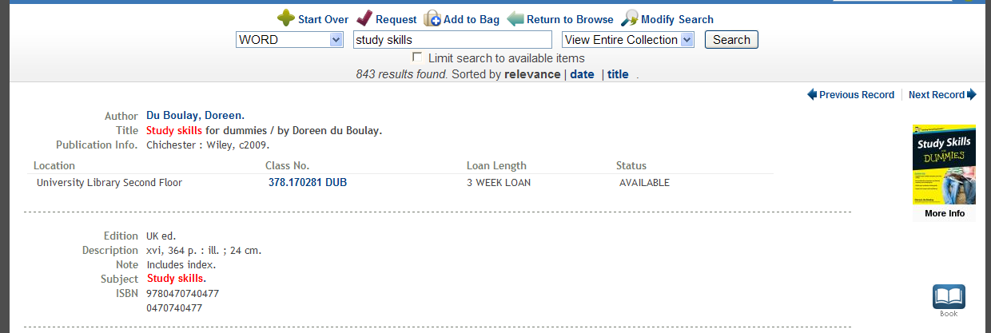

Reading List Search

From the drop down menu on the left select Module Code.
Then type in your module code without any spaces in the centre box and click on Submit.
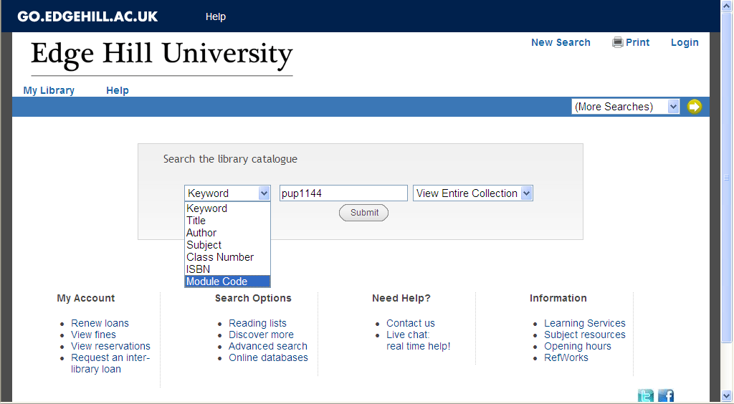
Select Module Code from the drop down list

All the items that are on this reading list will then appear. The list contains both titles of books and journals. Some reading lists also have digitised items, which are usually a chapter of a book or an article, which you can access in full text whilst you are studying a particular module.
If you click onto the title of a record that has appeared you will be able to see if there are any available copies for you to take out.


Section 4 Electronic Books

Learning Services have a core collection of over 52,000 electronic books. They are electronic versions of their printed counterparts and are accessed through the library catalogue.

In the search box, type in study skills and from the collections menu select Electronic Library. Then click on Submit to perform the search.
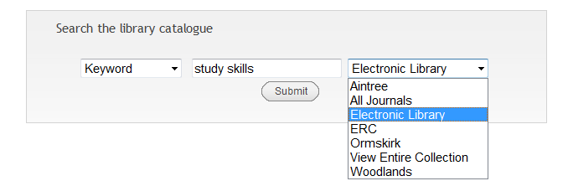

This will search our collection of e-books from a number of collections including Netlibrary, Ebrary and MyiLibrary..

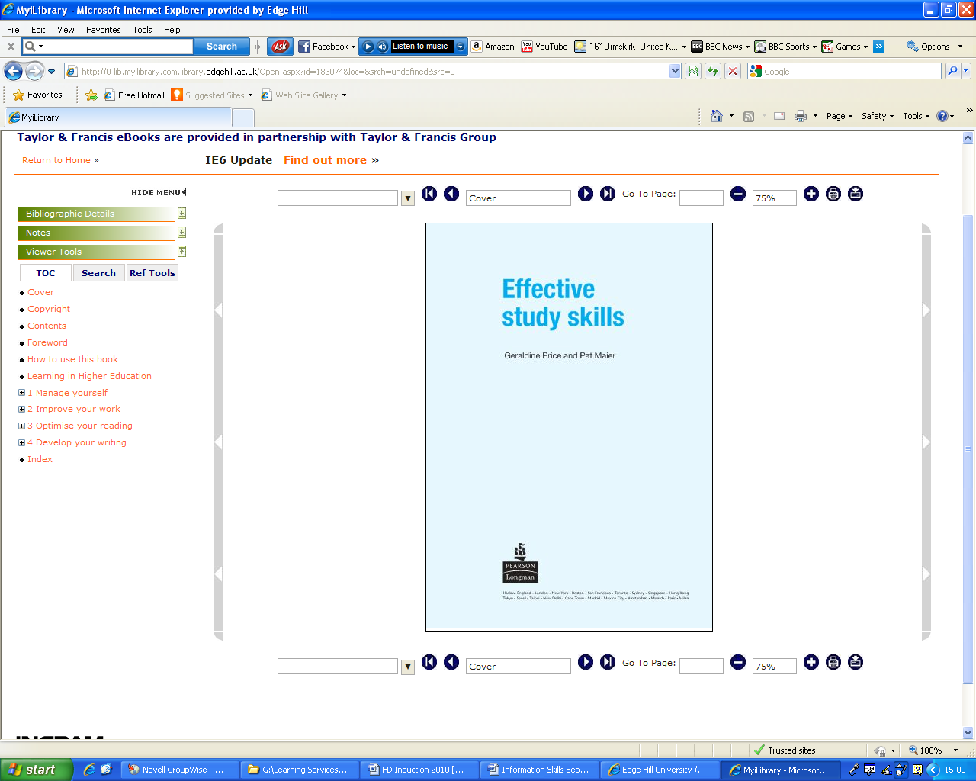
Search for keywords within this book
Click through the chapters

Front cover
Turn the pages

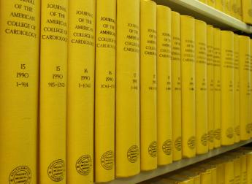 | Section 5  Using Journal articles to support your research
Why use journals?

Getting to know the journals in your subject area is crucial, as you need to find out which are relevant to your topic. Using journal references in your assignments will impress your tutor and gain you valuable marks. Journals are valuable sources of information because they:
- Keep you up-to-date with current ideas and practices
- Report on original research and experimentation
- Contain articles written by scholars in the field
- Provide "current state of play" overviews of a subject
- Can be extremely specialised

How to Recognise a Journal Reference or Citation

On reading lists and bibliographies, journal articles are written in a standard format. A reference to a journal article will look like this:
Hambridge, K (2011) Needlestick and Sharps injuries in the nursing student population. Nursing Standard 25 (27). 38-45.
This is broken down as follows:
Hambridge, K | Author of the article
(2011) | Year of publication
Needlestick and Sharps injuries in the nursing student population | Title of the article
Nursing Standard | Title of the journal the article comes from
25 (28). 38-45 | Volume, part and page numbers of the article

When you compile your bibliography for your assignments, you must use this format to quote journals. Marks will be lost for incorrectly formatted citations.
This referencing format is called the Harvard Referencing System.
For more information check the Learning Services web pages at:
http://www.edgehill.ac.uk/documents/learningServices/Harvard_Referencing.pdf
 Electronic Journal Collections
Discovery services are single search tools that provide fast and simple access to print and electronic material available through the library catalogue. The tool searches the Library Catalogue and the majority – although not all - of our electronic resources.
- From the library catalogue http://library.edgehill.ac.uk/
- Click on the Discover More link
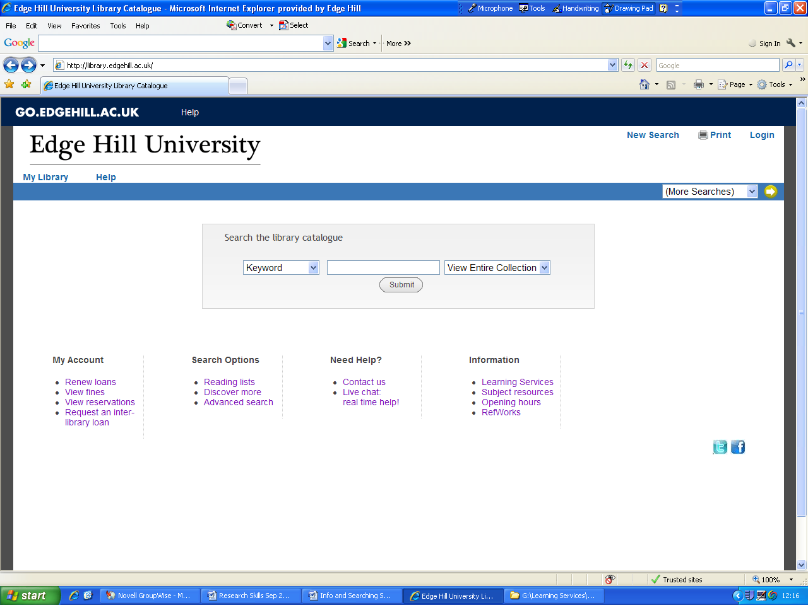

Type in some Keywords relevant to you Subject area:
Health promotion and Children

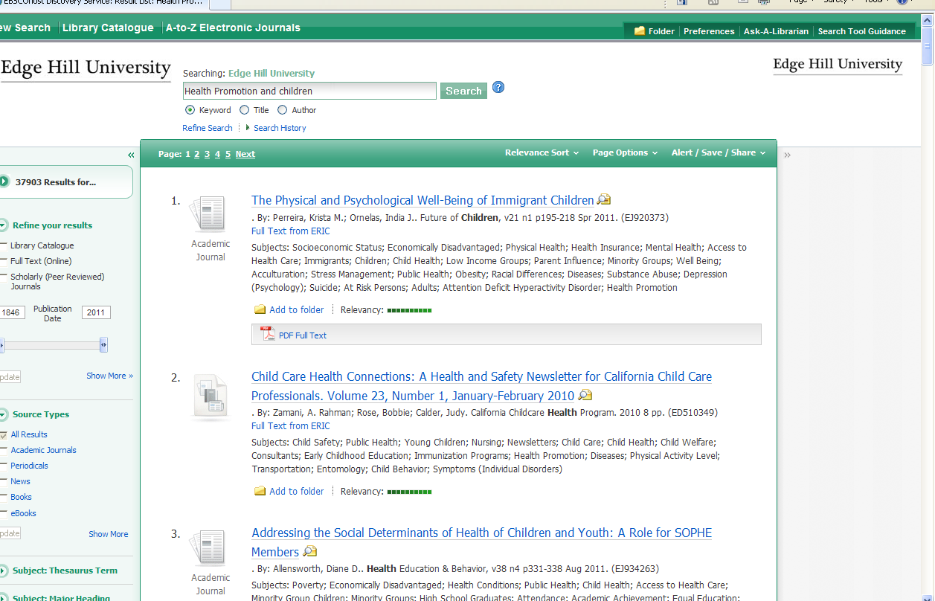

A list of all the resources it has found will be displayed. This will include books and journal articles. Have a look at some of the results.
Develop your search by narrowing down your subject area, adding more keywords, and being more specific to limit your results.
To view any of the articles you have found, click on the title.
Other databases you may find useful are Swetswise, Wiley Interscience, and Proquest Nursing Journals.

Some search tips
To use these resources effectively, you will have to learn some search techniques. These techniques are common to all electronic databases.

Focusing your research
Too much information
If you do a basic search for “health”, you will come up with an unmanageable amount of information.

Not enough information
If you do a basic search for “foot injury and students and university”, you will get no hits.

Hints & Tips

Combine keywords with the operators:

AND - Will find all of the words
OR - Will find any of the words
NOT - Will find the first but not the second word

“ ” Use "quotation marks" to search for exact phrases.
* The symbol * is used as a right-handed truncation character only; it will find all forms of a word.
For example, searching for econom* will find "economy", "economics", economical",etc.
? The symbol ? is used to replace any single character, either inside the word or the right end of the word.
? cannot be used to begin a word.
For example, searching for "wom?n" will find "woman" and "women." Searching for "t?re" will find "tire", "tyre", ”tore”, ect

