CINAHL

CINAHL provides indexing for more than 3,000 journals and contains more than 70 full text journals from the fields of nursing and allied health. It covers nursing, biomedicine, health sciences librarianship, alternative/complementary medicine, consumer health and 17 allied health disciplines.

How do I access the Cinahl?

- Like all our electronic resources, Cinahl is accessed through the Library Catalogue.
- Type Cinahl in the search box, choose ‘Electronic Library’ from the right drop-down menu and click ‘Go’.

Connect to the database by clicking on the link in the centre of the screen

How do I use Cinahl?

Enter your search term in to the box. Refine your search by using the And, Not, Or operators

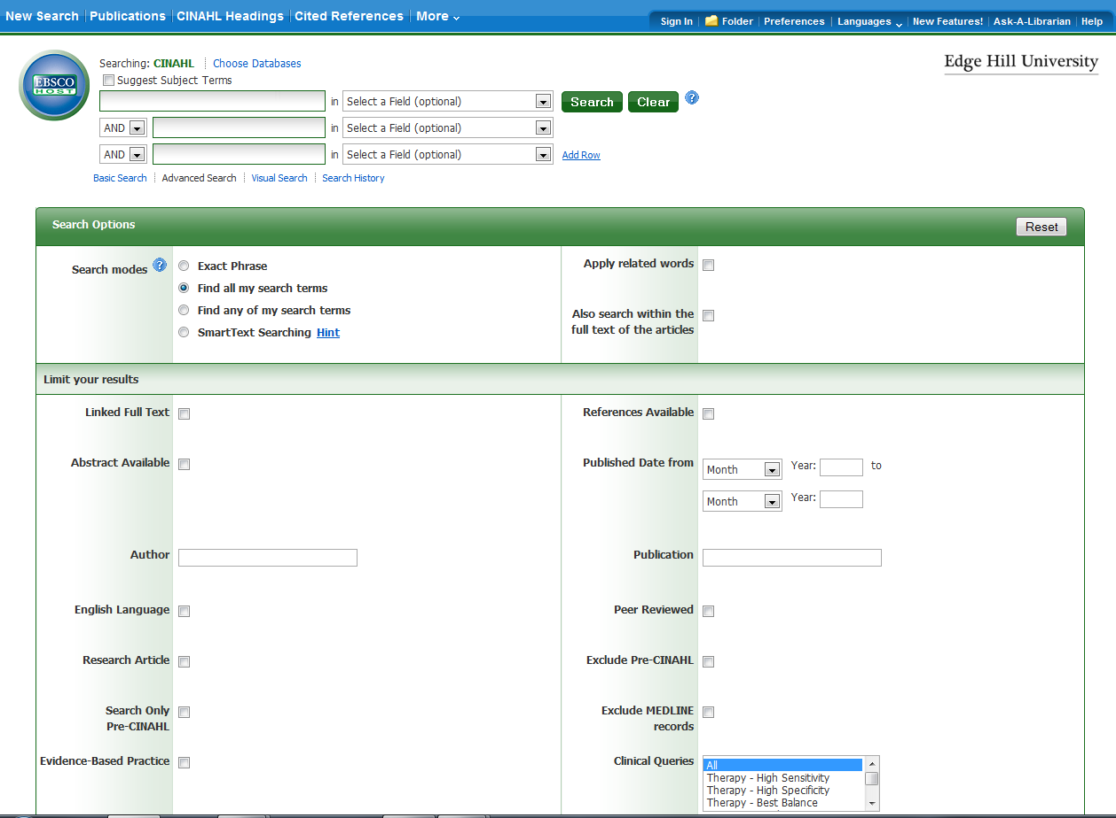

Ticking this box will ensure that you receive the best quality information
Tick this box to search for articles that are available in full text

SEARCH RESULTS

Click to add to folder
Number of search results

Click on PDF to view article in full text

Saving and Printing an article
Print or save a copy of the article

