INTERNURSE

A small collection of nursing journals covering nursing, midwifery, wound care, palliative care and nurse prescribing. The journals are peer reviewed and full text articles are available.

HOW DO I ACCESS INTERNURSE?

- Like all our electronic resources, Internurse is accessed through the Library Catalogue.
- Type Internurse in the search box, choose ‘Electronic Library’ from the right drop-down menu and click ‘Go’.
- Connect to the database by clicking on the link in the centre of the screen.

HOW DO I USE INTERNURSE?

To use these resources effectively you will have to learn some search techniques. These techniques are common to all electronic databases. If you do a basic search you will come up with an unmanageable amount of information. If your search is too specific you may come up with no hit

Click on the advanced search at the top right hand of the screen

Limit results to articles published within a certain date range
Refine your search by using the And, Not, Or operators

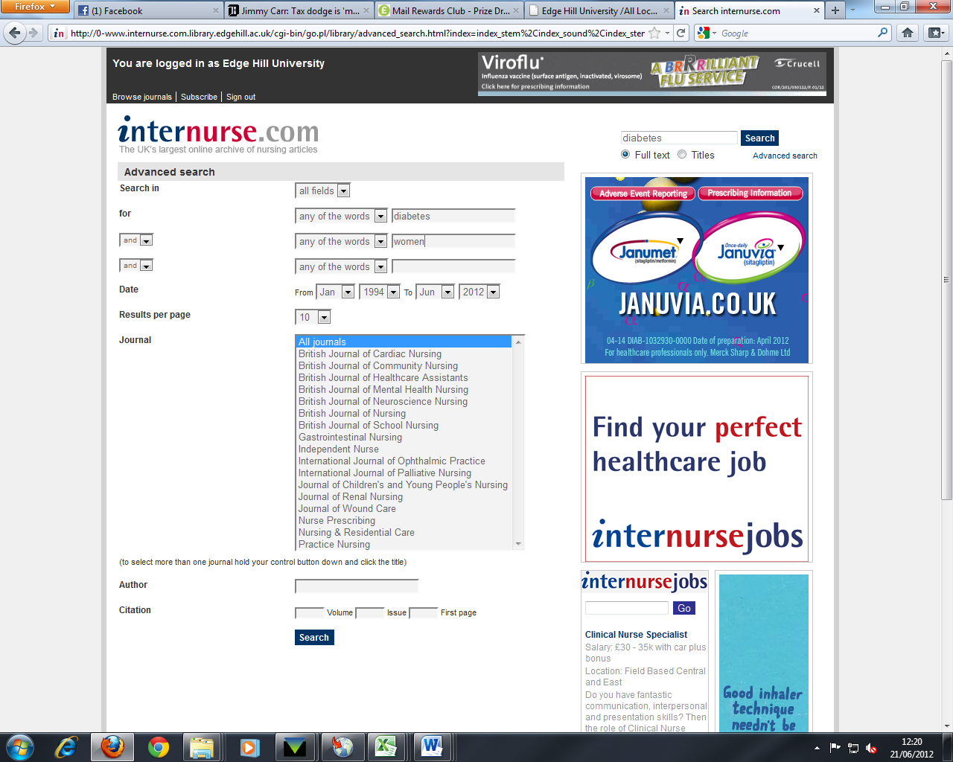

Click here to view article

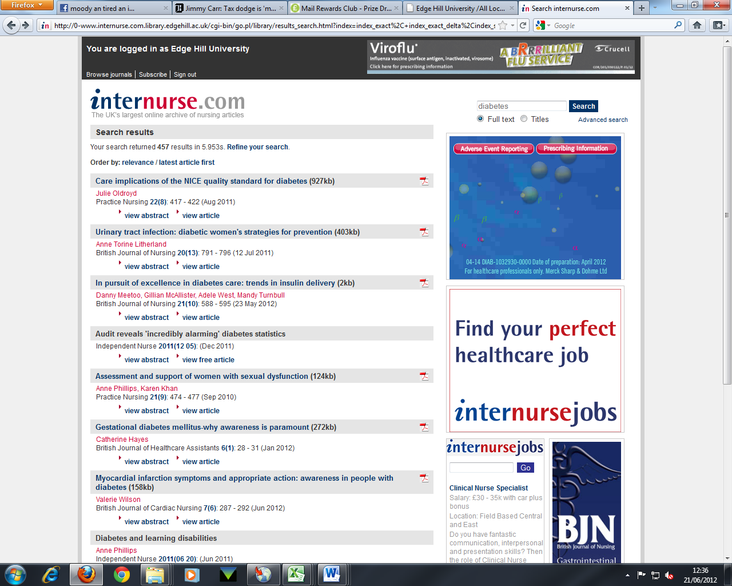
Print or save a copy of the article

