Fingerprints
This guide is for anyone with an academic profile in Pure.
Guide updated 31/10/2022
Contents
What is it? 1
Curate your fingerprint 2
Change the wording of certain fields 2
Omit a concept 2
Fingerprint sources 3

What is it?
- Pure will generate what it calls a fingerprint on certain types of record, including your person profile and outputs.
- It does this by mining the text in certain fields and matching it against a thesaurus containing thousands of concepts.
- These concepts that make up your fingerprint are then presented on the public portal as a collection of doughnut icons.
- On the landing page for the record in question, a summary fingerprint is shown.
- The more complete the doughnut, the closer the match the record has to that concept.
- If the user clicks on the Fingerprint section in of the public record, they can see the full fingerprint.
- Concepts in the full fingerprint are grouped by domains (broad subject areas).
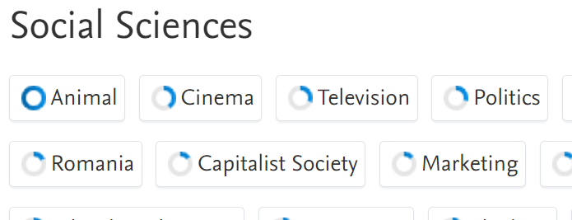
- If someone clicks on one of the concepts on the portal, they will see how many other records in Edge Hill’s Pure share that concept.
  - Clicking on one of those stats will take the person to a list of those relevant records.
  - For example, they (or you) can find other people who might be working on the same topics.
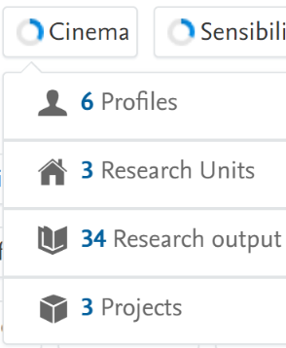

Curate your fingerprint
- While you can’t add your own concepts to the fingerprint, you can influence it.
- You need to log in to the Pure backend to do this.
- Any changes you make will begin feeding through to the portal immediately but the exact timescale will depend on what else the system is processing at the same time – the change could be public instantly or it could take a little while.
- Bear in mind that fingerprints will change as you add new information to the system so curation is not something that only needs doing once – you should do it periodically.

Change the wording of certain fields
- This is simply adding relevant text to the fingerprint source fields (below), to try and skew the fingerprint towards particular concepts.
- For example, tweaking your research interests in your profile, or descriptions on certain other content types, to include key phrases.
- You might not be able to do this for everything though – the title and abstract for a research output are not usually things you should alter.
- We can’t provide a list of concepts for you to target so this approach might require some trial and error.

Omit a concept
- You can open the record in question in the Pure backend, go to Fingerprints down the left-hand side. This shows all concepts associated with that record.
- Hover over a concept and you will see its weight as a percentage (the number behind the doughnut) and its subject domain. You will also see a red X icon.
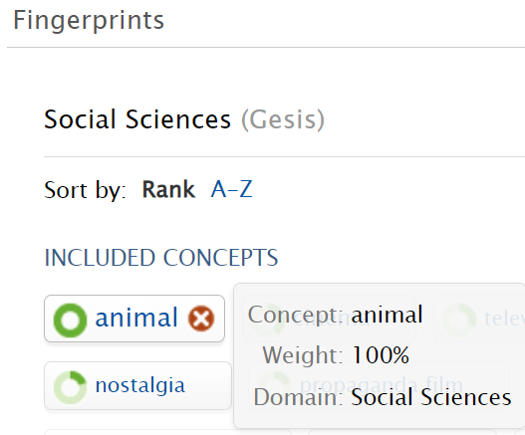
- Clicking the red X icon will move the concept into an omitted concepts section down the page.
- The omitted concept will be removed from that record – it will no longer be shown on it, nor will it be returned in a fingerprint concept search.
- The omitted concept is not deleted though – merely hidden.
  - Hover over it and you will see a green + icon. Clicking that will move the concept back into the included concepts section.
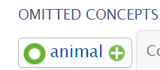
- You can even omit an entire domain.
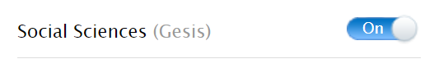
Note: omitting concepts will generally only affect the specific record you are changing. The exception to this is where a content type is influenced by connected records, as outlined below.
For example: omitting a concept on one output will not affect the fingerprint on other outputs but it will affect your profile fingerprint.

Fingerprint sources
Fingerprints are generated against the following content types in Pure, based on the specified fields.
- Profile: research interests. Also influenced by the outputs and prizes linked to you, as per below.
- Outputs: title and abstract (both must be present).
- Projects: any description field present. Also influenced by the outputs and awards linked to the project.
- Awards: any description field present. If no award description text is available, the fingerprint will be based solely on the description from the related project, provided there is one.
- Prizes: any description field present.
- Facilities/equipment: any description field present. Also influenced by the outputs and projects linked to the facility/equipment. If no description text is available, the fingerprint will be based solely on related outputs, provided there are any.
- Organisational unit: based on the outputs linked to the department/faculty in question.
- Whole university: all research outputs from the past 5 years. This fingerprint is shown on the portal home page.

