How to Add Caption.Ed to your Chrome Browser

- You will receive a link in your Caption.Ed welcome email to install the Caption.Ed extension to
Chrome. Click ‘Add to Chrome’, and then confirm by clicking ‘Add extension’ on the pop-up.

- You will see the following message. To get started, click the Caption.Ed icon and ‘Sign in’ with the
details you have been provided.
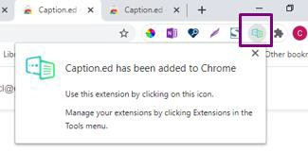

- If you don’t see the green Caption.Ed icon automatically added to Chrome’s extension toolbar as above, then you will need to pin it.

Click on the extension icon, then click the pin icon where you see Caption.Ed.
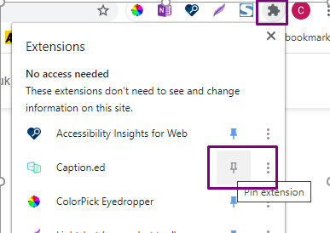

You will find a useful video introduction here: Using Caption.Ed for Browser

Edge Hill University Library and Learning Services 02/10/2020

