Library & Learning Services

Pure: Research Management Repository adding your research outputs

Contact:
REFCompliance@edgehill.ac.uk

Table of Contents
Access the Pure- Research Management Repository to add your research outputs 2
Types of research output 2
Adding details of your output 3
Adding your accepted manuscript 8
Copyright considerations and open access 10
Step by step -uploading your manuscript 11
Send your research output for validation 13
Messages in the Pure- Research Management Repository 15
Updating your research outputs 16
Specialist fields in the Pure- Research Management Repository 17
Importing details of your research outputs 18
Claiming content or disclaiming content 21
Policy Exceptions 23

Accessing Pure
You will only have access to the Pure Research Management Repository if you are a member of staff with a contract for either ‘teaching and research’ or ‘research only’. The other people with access are PGRs at doctoral level.

Login to Pure with your usual Edge Hill username and password.

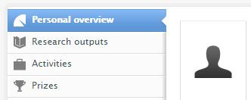
At a glance, you can see a personal overview of your work progress.

Type of Research Output

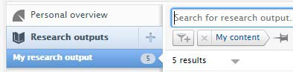
First, select Research Outputs.

Select Add new to view the submission guide.

Choose the relevant output needed from the most common types e.g. article, book etc. or browse the list of other templates

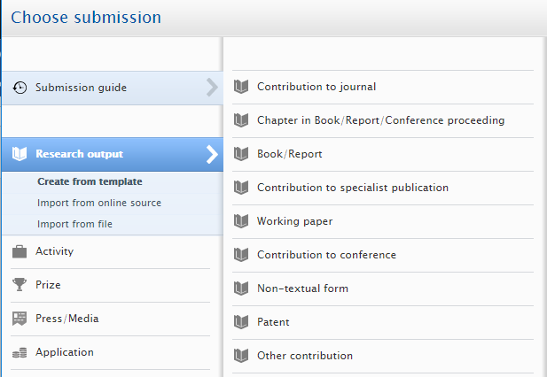

For REF compliance, the two eligible item types are journal articles or a conference proceeding article (ISSN).
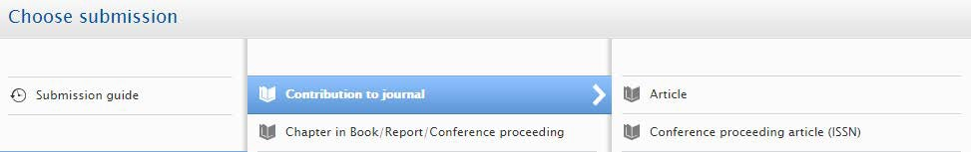

Adding details of your output

Now in edit mode, add the details of the publication. The we use here is a journal article. To ensure a meaningful deposit, please add as much information possible including the mandatory fields indicated by a red asterisk*

Under type, select ‘peer-reviewed’ or ‘not peer-reviewed’
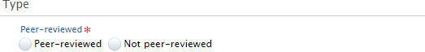

Add the publication status e.g. accepted/in press, e-pub ahead of print or published and add the relating date (Year, Month, Day)

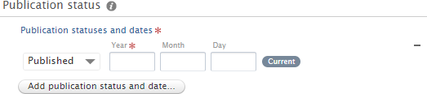

  - Edge Hill University will not be recording entries with a publication status of ‘in preparation’ or ‘submitted’. These items will not be validated and therefore won’t appear in the publicly searchable view of Pure
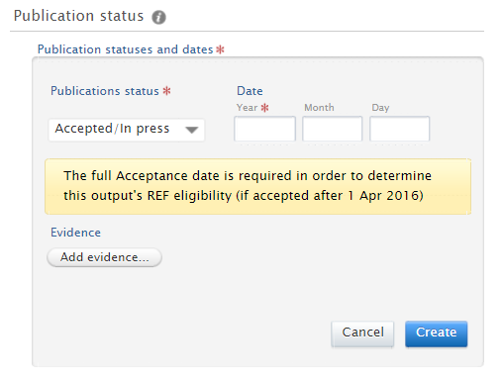
Act on acceptance: items need to be added to Pure on Acceptance/In Press. We will only record entries when they are in this version onwards. Although Pure only highlights the year as a mandatory field, the full acceptance date (Year, Month, Day) is required for journal articles and conference proceeding articles to determine an output’s REF Open Access eligibility (if accepted after 1st April 2016).

Add Evidence of the acceptance date as an attachment. This button requests that you evidence the acceptance date of any output that is subject to REF Open Access eligibility.

Evidence can take the form of:
    - the acceptance email/letter
    - a screenshot on the publisher’s site showing the acceptance date (if available)
    - if not available, the author may provide a statement explaining why the date provided has been chosen

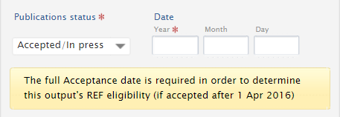
If one of these evidence types is not attached, it may delay the validation of the item record. Add the full acceptance date

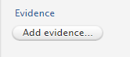
Attach the evidence you are adding

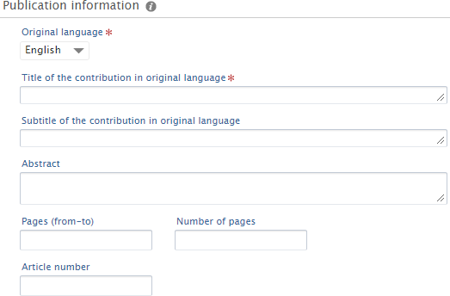
Add the publication information

All items need an abstract so that they are discoverable.
Publication information needs details such as pages (from-to)

Contributors and affiliations

This is the author field. Select Add person, search and select an internal author or create an external author.

If you are a researcher creating a research output, you will automatically be added as an author to the item and your faculty/division affiliation will be listed.

You can add co-authors in two ways:

If you have co-authored with other Edge Hill authors, search for colleagues in either search bar. Pure will suggest other Edge Hill authors that you regularly collaborate with.

Quick Add person button 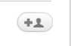 OR

Add person

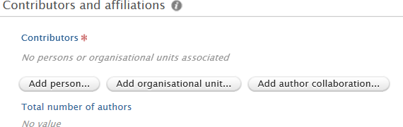
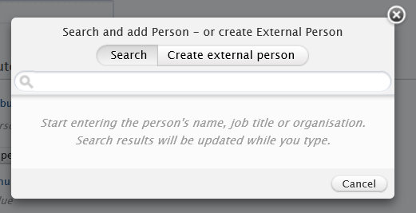

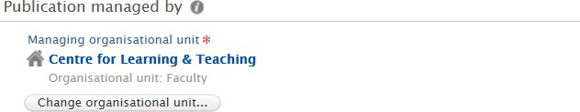
‘Publication managed’ by is usually automatically populated with faculty/department when the person/author is added as below.

If there is an external contributor on the output, ‘select create external person’ button to add them.

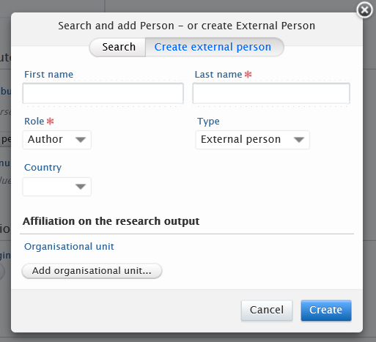

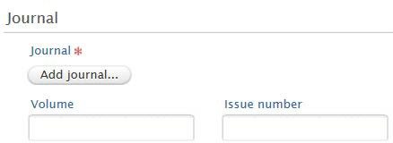
Now add the journal
or book publisher details.

When your co-author is a former member of staff

When adding a former member of EHU staff as a co-author, simply select them as you would an internal person when searching the name, but change the organisation affiliation to their current external organisation.
For more details please see this user guide on adding people to their content.

Adding your accepted manuscript

For an external person, please include all details and the external organisation that they are affiliated with by selecting ‘Add organisational unit’.

When completed select ‘Create’.

This is where you add electronic version(s) and related files and links.

In most cases, publisher copyright does not allow the full text of the final published version of an article to be included on Pure (ie the institutional repository) unless the research was supported by a funding body that operates an open access mandate or where a separate open access fee has been paid. Many publishers will, however allow inclusion of the author’s final peer reviewed version of a paper, the ‘Author Accepted Manuscript’ (AAM). This is the closest version you have to the published version - it includes any changes made following peer review, but can’t include any publisher formatting, logos, etc. Outlined in the diagram below.

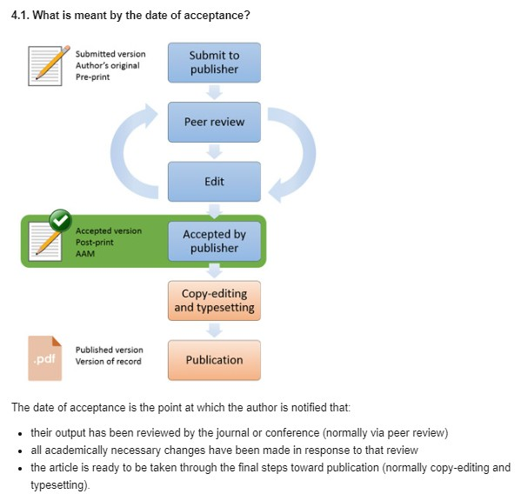

When adding articles from a journal or conference proceeding with an ISSN, please act on acceptance and add the accepted manuscript - this is the minimum for REF compliance. The accepted manuscript needs to be live Pure within 90 days of acceptance.

Other outputs such as book chapters only need the bibliographic details to be added to comply with the REF. However, in the spirit of open access many authors are depositing their accepted manuscript for book chapters if they have the publisher’s permission. Please do check with the publisher on your agreement and any embargo period prior to adding an accepted manuscript for a book chapter to Pure.

Double check the acceptance date has been entered as the date that the author is notified of acceptance following peer review and any other changes of an academic nature. The acceptance email will also have been added as evidence of this date.

Evidence can take the form of:
- the acceptance email/letter
- if there isn’t a letter/email, a screenshot of the publisher’s site showing the acceptance date (if available)

- if not available, please can the author provide a statement explaining why the date provided has been chosen
iii if not available, please the author is required to provide a statement explaining why the date provided has been chosen.

Copyright Considerations and Open Access
Q. Do I have permission to add the version of the journal article that I am attaching? Q. Is there a publisher embargo period?
Q. Which Creative Commons licenses have been agreed with the publisher?

You can quickly check the publisher’s copyright policy on self-archiving for a journal by using Sherpa Romeo: http://www.sherpa.ac.uk/romeo/index.php

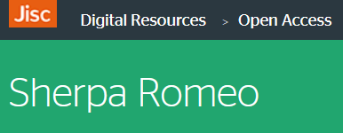
This shows the version of the article that you can upload and if there is a publisher’s embargo.

Please note the Creative Commons licence needs to be added for the documents uploaded, check with your publisher what you have agreed. Examples of the different types of Creative Commons licences are here https://creativecommons.org/licenses/

Note on embargo periods for articles

Some publishers impose an embargo on the free access of articles in their publications (so only subscribers to that publication will be able to view it).

If your article is subject to a publisher’s embargo you need to still deposit the final accepted manuscript within the 90-day period from acceptance to be Open Access REF Compliant.

Uploading a file using the status ‘embargoed’ ensures the file is not accessible until the end of the publisher’s embargo period. If it was not deposited as embargoed during the 90 days, it would not be open access compliant. When depositing on acceptance/in press as required please set the embargo end date initially to 1/1/2050. Depositing on acceptance/in press means that only once the full E-pub ahead of print/online publication date is available and added that the embargo length can be set.

The end date of the embargo will be based on the article online publication date, so it is important that you update with the E-pub ahead of print as soon as it is available to avoid it affecting eligibility for the REF. The accepted manuscript needs to be in Pure within 90 days of acceptance. Such embargoes must not exceed the following without good reason:

- 12 months for REF panels A and B
- 24 months for REF panels C and D
Open Access information https://go.edgehill.ac.uk/display/ls/Open+Access

Step by step - uploading your manuscript

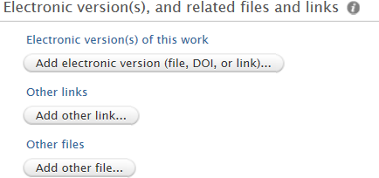
To upload the manuscript, select ‘add electronic version (file, DOI or link)’

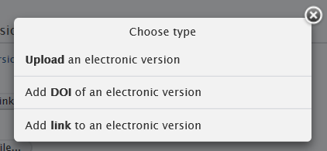
…and ‘Upload an electronic version’.

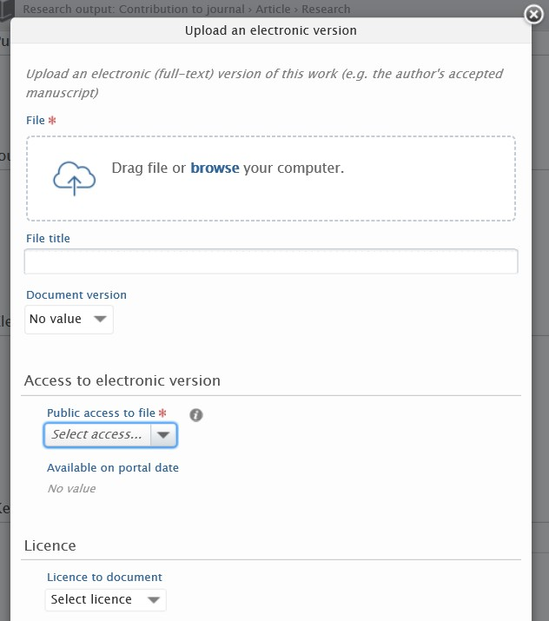
Then to upload from the file, select browse your computer, navigate to the location of the paper and select it.

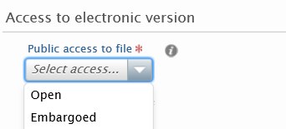
Set the public access to the file either open or embargoed. When embargoed is selected, the embargo end date is initially set to 01/01/2050 pending the availability of the E-pub ahead of print (online publication date) Embargoed items are not visible on Pure.

Add the licence agreed with your publisher to the document the most permissive is the CC BY licence were by the CC BY- NC-ND is the most restrictive. The default licence that will be applied by Library and Learning Services if not selected is CC BY-NC-ND. The creative commons licence cannot be changed once it is live in Pure.

Use consistent file titles. When a document is uploaded the title shows publicly on Pure. Please provide a sensible title as it cannot be changed later. An example could be ‘2019 Raising Standards’.

Select Create to save

Add any additional files. The DOI needs to be added if available. Add DOI of an electronic version. When a DOI is added this will state final public version and the public access would be set as no value.

Send your research output for validation

Adding keywords or subject areas will really help make your publication discoverable.

At the end of each completed record the Visibility should remain Public-No restriction as this relates to the metadata of the item being available on the portal rather than any attachment were the visibility set at the point of upload. Please do not change the default setting.

To send a message in relation to the research output please add a comment. A very important message to send is if there is an embargo period for example I have deposited the accepted/in press manuscript and the publisher has a 12-month embargo.
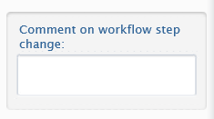

Select save at the end of the record with the status showing as for validation.

A notification will be sent to Co authors of the validation request and the output will go through to Library and Learning Services for validation to be added to the live archive.

Please note: you will need to complete a separate record for each output you wish to deposit but, if you are co-author with another EHU-based author, only one of you needs to do this for each output.

If you are not ready to send the item for validation as you need to check on some details, there is an option to save the record status as Entry in Progress. Saving a record, partially completed record as Entry in progress means the record will stay with you in your area to update at a later point.

Once saved the pending research output shows up under My personal tasks as Pending Research Output.
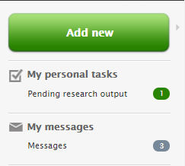

Messages in the Pure- Research Management Repository

The validation/revalidation process of research outputs is within the Pure- Research Management Repository system. If you receive a message relating to an output, this will appear under messages within the Pure- Research Management Repository system. If you receive an email notification in outlook and you need to request any changes or make amendments you would need to select the title of the publication that appears as a blue hyperlink and go through in to the Pure system to make these changes.
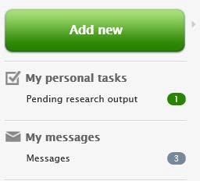

The comments will remain on the item record in the history and comments area and can be viewed at any time.

When items do not contain the minimum details to validate for REF Compliance they will be returned with a message. Please respond as soon as possible as any delay will affect validation of your output.
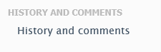

Updating your Research Outputs

To update a research output that you have added to Pure as ‘accepted/in press’ and is in Pure with the status validated, please login to your area and locate the item under My research output.

Open the record by selecting the title of the research output.

In edit mode update the publication status by adding in the E-pub ahead of print (online publication date). Make the changes and select save. If the output has an embargo, please send a message to make sure any adjustments are made to the embargo. This will then go through to the Library and Learning Services for revalidation.

The item will then show in the authors research output result list as revalidate.
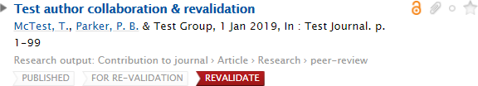

Once an item has been checked the status will be changed to validated.

Please be aware when items are validated and have this status at the bottom of the screen there is red cross if this is used your validated item will be permanently deleted.

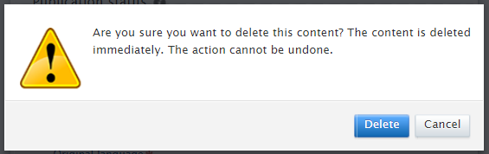

Specialist Fields in Pure

Adding an Event

The event section will most widely be used on conference items and Non-textual form such as a performance. When you select this option please complete all the relevant fields including start and end dates. When you have entered all relevant information select create.

Adding a Relation

Pure can relate an output to other content in the repository such as Research outputs, Activities, Projects and Impact.

Select the relationship button and search for a specific relevant item to link to. Selecting the REF compliance research output template
For REF compliance journal articles and conference proceedings with an ISSN need to be live in the Pure- Research Management Repository within 90 days of acceptance.

In Pure please ensure if you are adding an item that needs full REF Compliance that the relevant type.
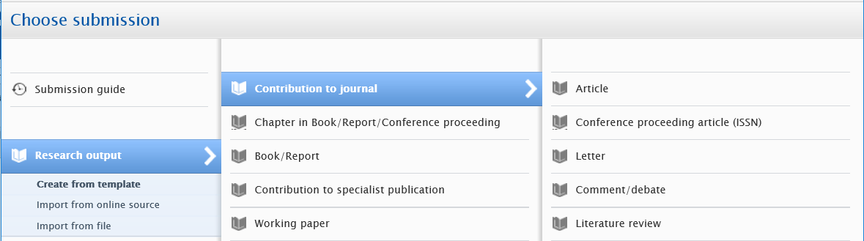

It is an article from a journal with an ISSN and it is a conference proceeding article (ISSN) Open Access policy information www.edgehill.ac.uk/research/oa/

Importing Details of your Research Outputs

On the submission guide there is also the option to import from online source and import from file. Once familiar with the Pure- Research Management Repository system making use of these options may help you save time adding the details of your research outputs. You will need to review for accuracy and edit any of the details that you import.

Select Import from file

You may be new to the institution and have several items that you need to add.

An example of some of the file types are BibTex which is recognised by the file extension .bib or RIS files recognised by the file extension .ris

Browse for the file and import.

The details will come through and the attachments can be added separately in to the record.

Once completed ensure that it is showing as For Validation and select save so that it goes through to Library and Learning Services for validation.

Select Import from online source

Whilst the full record with an uploaded attachment may not be available pulling through details were your article is available may help in some instances. Although depending on the publication status of your item for example when depositing on acceptance/in press these details may not yet be available online. These are the online sources currently available Mendeley, SSRN, PubMed and arXiv.org

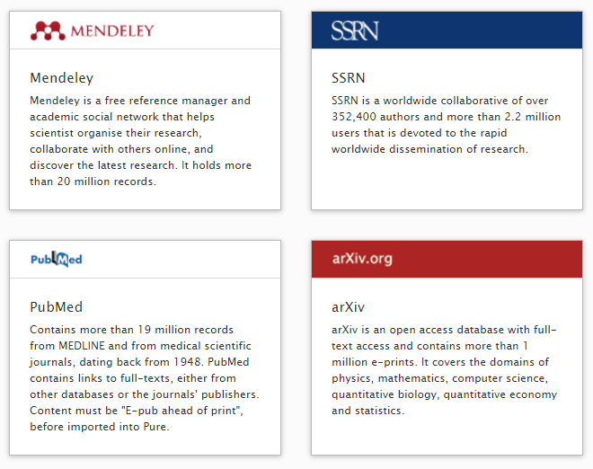

Once you have selected your online search you will be presented with search options. Different providers will offer you with different search functions. An example is PubMed that provides one search bar. Enter your search terms and select search. From the results list if you locate information that you need to bring through to Pure then select import.
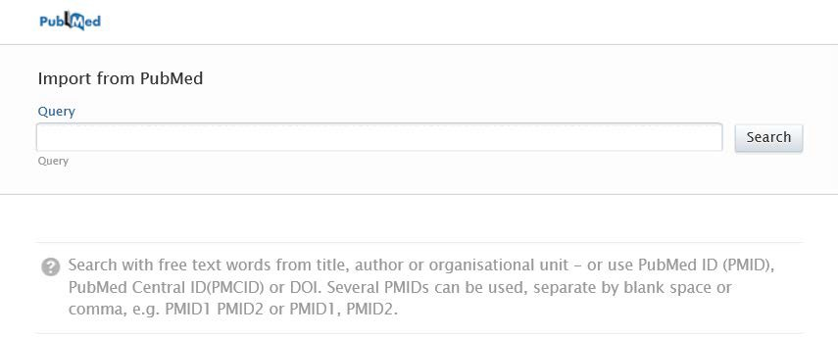

You can set Pure up to automatically search for your outputs from the online source. If you locate items using an automated feed, then do check prior to import that there is not an existing record. Please view the video that is available on setting this automated search.
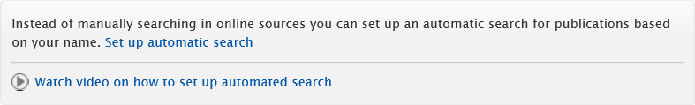

Pure will undertake an author match to determine and attribute all Edge Hill University authors. Any authors that are not matched will be listed as external authors.

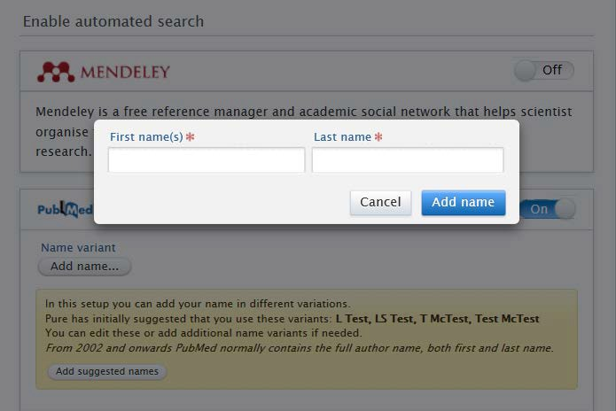

If the Pure has incorrectly matched to an Edge Hill author, you can select the arrow to the right of the name tab and select ‘No Match’. This person will be added as an external author.

Once you are ready select Import and review.

At this point you will be provided with a partially completed template containing the bibliographic details of the output. The amount of information included will vary depending on the place searched. Please check the details and any missing information where possible.

It is at this point that you would add any necessary documents to the record. The final step is to save the record for validation.

Once validated the new research output will appear in your research outputs profile and appear on the portal. However as importing details is an advanced feature which will improve overtime if the information required is not available via an import the record will need to be inputted manually.

Claiming or Disclaiming Content
On the rare occasion when you have accidently been attributed as an author to an output that is not yours you can remedy this in the Pure- Research Management Repository by disclaiming the content that is not yours. Select the gear icon to the right-hand side of the output details (the icon will only appear if you hover your mouse over it) and select Not mine- disclaim content and a message will be sent to Library and Learning Services who will review and update in relation to the request. The item will remain in your research outputs until Library and Learning Services has actioned your request.

Disclaim Content
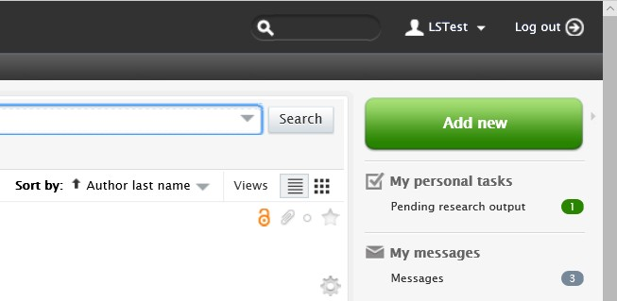

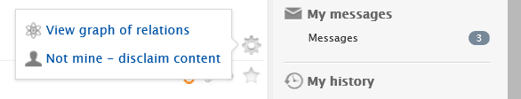

Please do include a message in relation to the request.
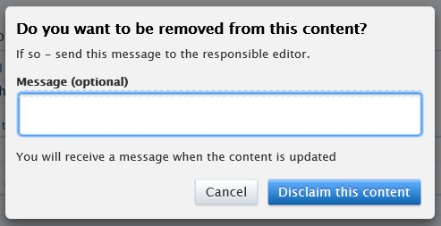

Claim Content

If there is an output in the Pure- Research Management Repository that has not been attributed to you and you need to be added as an author/contributor, you can claim the content. Locate the item in Pure.

Viewing your Research outputs, remove the My content filter
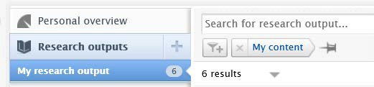
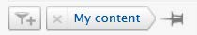

Find the item you need, using the search for research output…
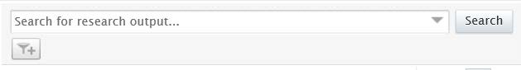

In the results list select the gear icon for the item you need to be attributed to.

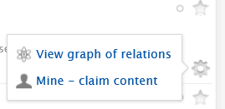
Select Mine- claim content

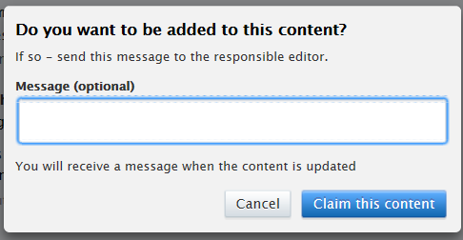

Once you have entered your message and selected the Claim this content a message will be sent to the Library and Learning Services who will review and update the record accordingly. The item will not appear in your research outputs list until Library and Learning Services has approved your request.

Policy Exceptions

It may be the case that your output falls within the scope of the Open Access policy but does not automatically comply with it, yet you believe there is a valid reason why it should still be considered compliant.

In such cases there is an option to select the relevant valid exception on deposit.
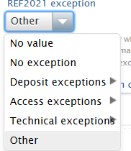

If none of the exceptions apply the item will remain non-compliant, the no exception needs to be selected by the author.

When an item is showing as non-compliant and a REF2021 exception or the no exception has not been selected the item will be returned for this to be confirmed.

Any questions?

We’re happy to help. Please contact the Research Support Team using REFCompliance@edgehill.ac.uk

